**INSTRUCTIONS: This is an SOP template; it is complete when**

**1) All form fields have been completed to reflect chemical/lab-specific information,** including adding relevant procedure information, or deleted inapplicable information; and

**2) SOP has been signed and dated by the PI and relevant lab personnel.**

Use safety data sheets (SDSs) as a resource for chemical-specific information. Text highlighted in gray indicates where information should be added or edited. Delete all instructions in red text and “Draft” watermark after the SOP is approved by PI.

Standard Operating Procedure forChemical(s)

REQUIRED - List chemical(s) and CAS numbers here

# Section 1 – Lab-Specific Information

| **Building/Room(s) covered by this SOP:** | Click here to enter text. |
| --- | --- |
| **Unit or department:** | Click here to enter text. |
| **Principal Investigator Name:** | Click here to enter text. |
| **Principal Investigator Signature/Date:** | Click here to enter text. |
| **This SOP was created by (if not PI): Name/Title/Date/Signature/Date** | Click here to enter text. |

# Section 2 – Hazards

REQUIRED -Identify the stock chemicals, intermediates, final compounds and wastes involved, and such factors as use of catalysts or inert compounds.

REQUIRED - Describe hazards associated with this/these chemicals

**Hazards may include, but are not limited to:**

* routes of exposure
* how exposure might occur
* target organs
* signs and symptoms of exposure
* expected by-product(s) if this SOP covers a laboratory process

**Obtain hazard information from SDS. Include regulatory information if chemical is a** [particularly hazardous substance](https://www.ehs.washington.edu/resource/particularly-hazardous-substances-655)**. Use** [**GHS Pictograms**](https://www.ehs.washington.edu/system/files/resources/GHS-pictograms-poster.pdf) **to indicate hazards; delete the pictograms that do not apply.**

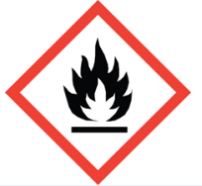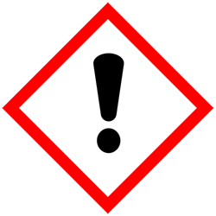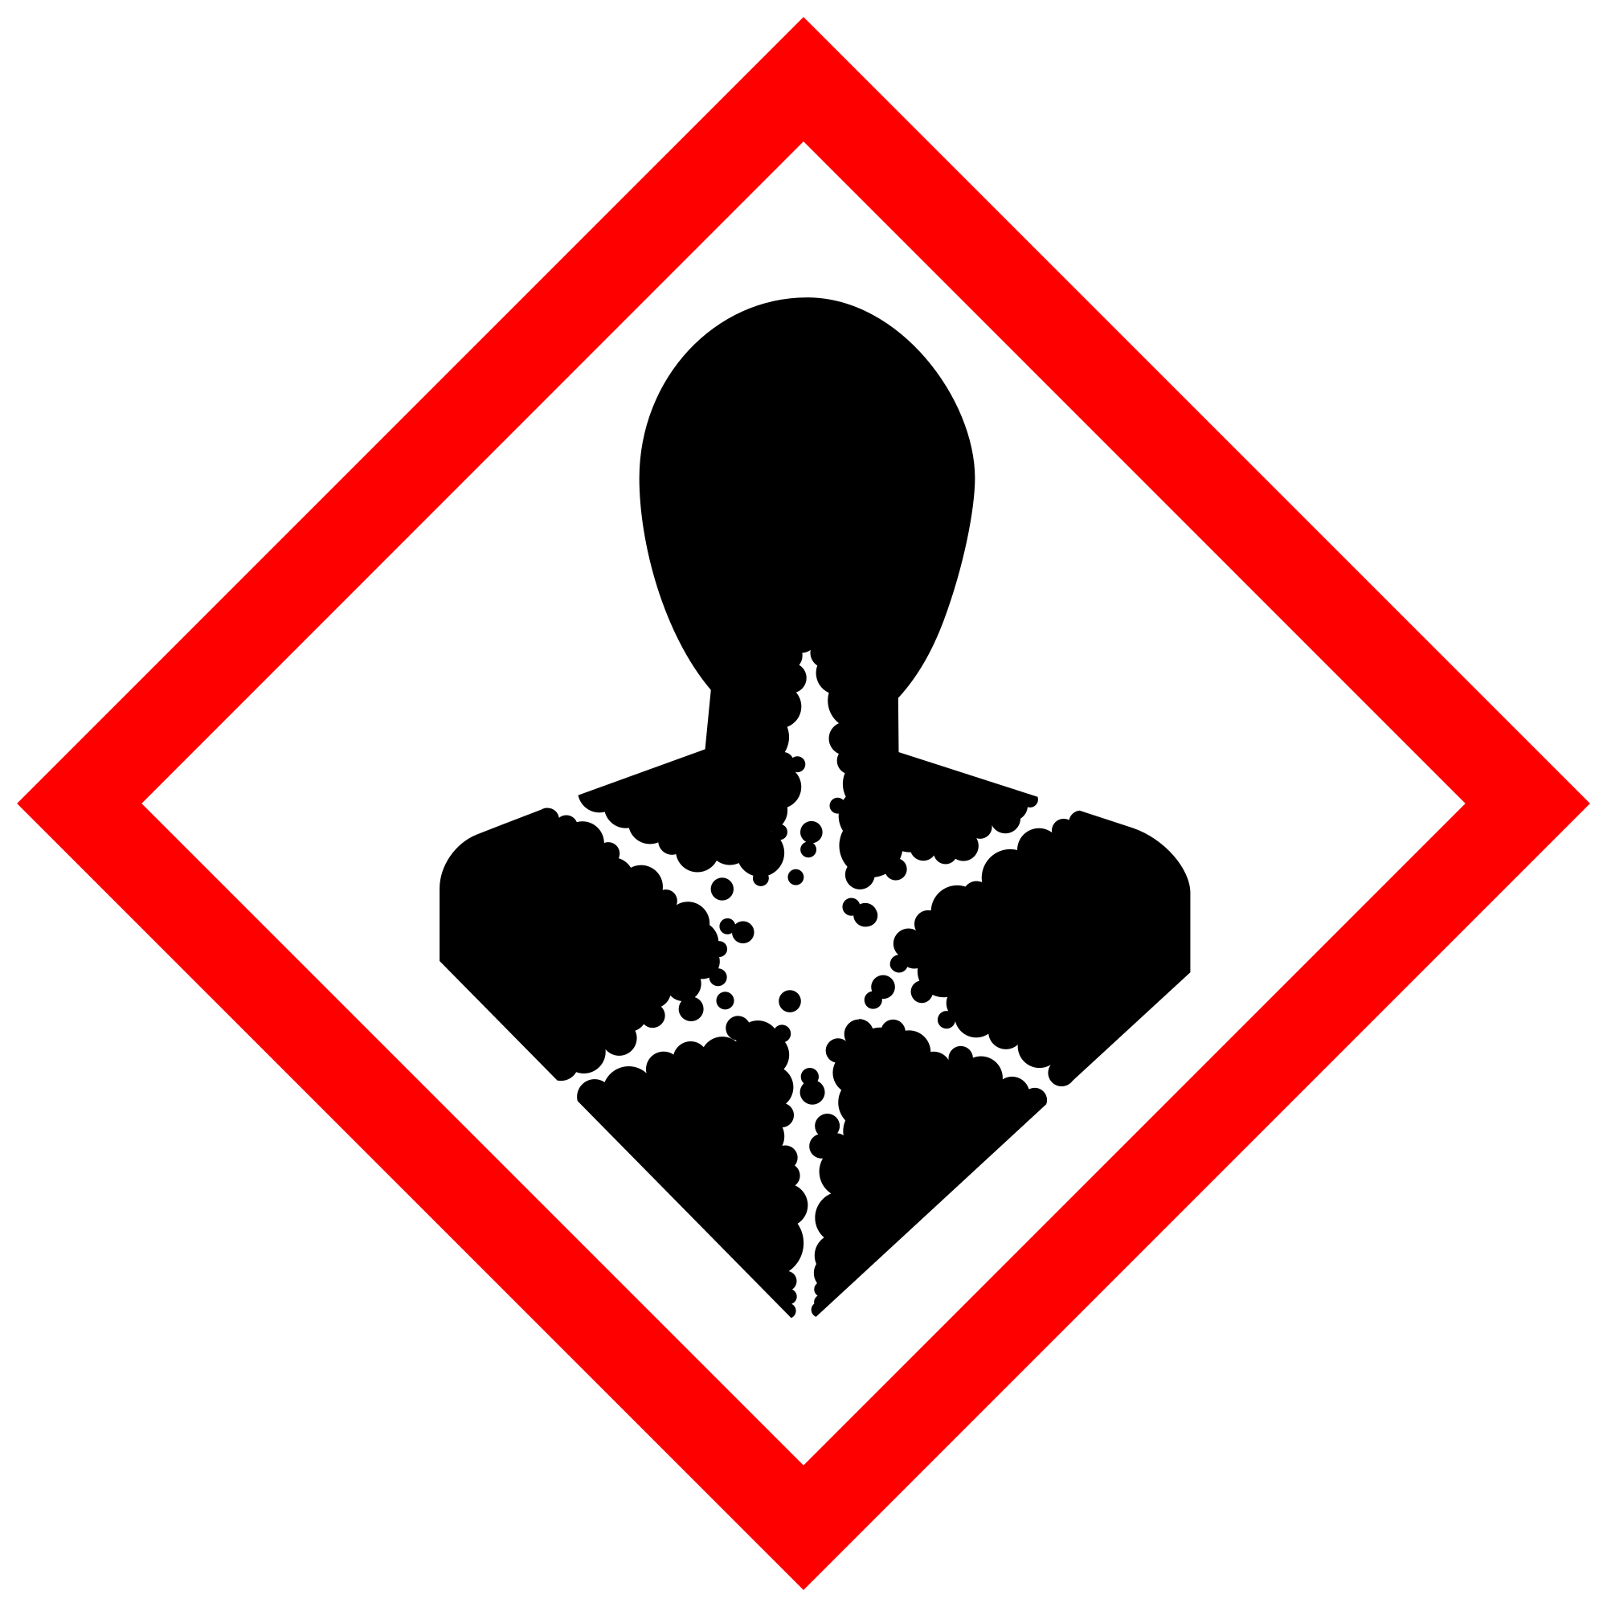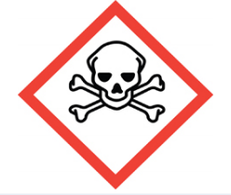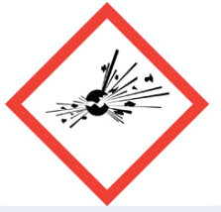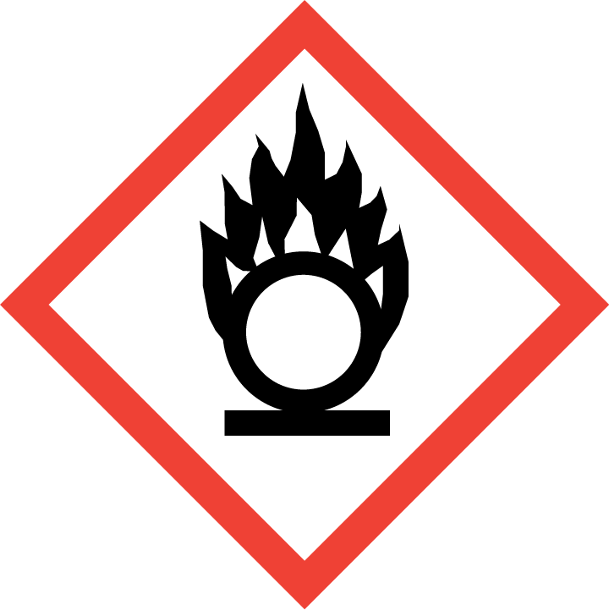 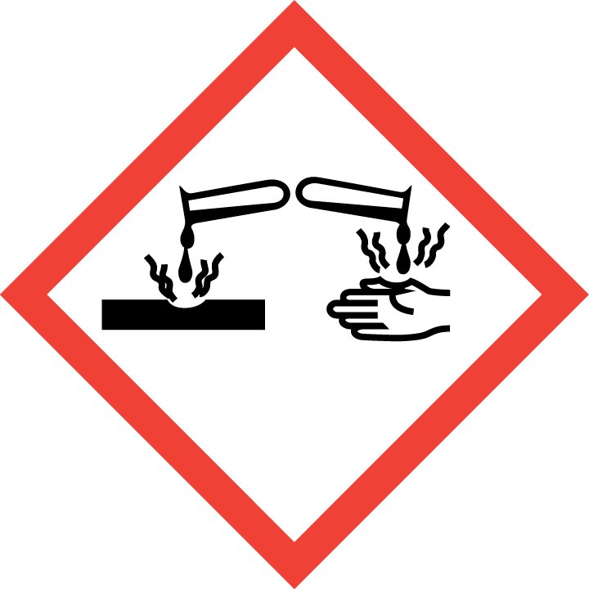 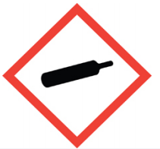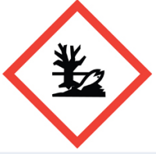

# Section 3 – Engineering Controls and Personal Protective Equipment (PPE)

Using certain classes of chemicals, including particularly hazardous chemicals (i.e., highly toxic, reproductive toxicity, select toxins, carcinogens, corrosives, strong oxidizers, otherwise dangerous), under certain conditions (e.g., at elevated temperatures) may require facility-specific engineering/ventilation controls. Refer to the chemical SDS and identification of [particularly hazardous substances](https://www.ehs.washington.edu/resource/particularly-hazardous-substances-655) in MyChem. Contact UW [EH&S](mailto:labcheck@uw.edu) at [labcheck@uw.edu](mailto:labcheck@uw.edu) for engineering control details.

**Engineering Controls:**

REQUIRED - Insert descriptions of lab-specific engineering or ventilation controls used to reduce chemical exposures (e.g.,fume hoods, snorkels, glove boxes, reverse flow laminar benches, biosafety cabinets, etc.) or specific equipment safety features.

**Hygiene measures:**

Avoid contact with skin, eyes, and clothing. Wash hands after removing PPE, before breaks, and immediately after handling the chemical. If chemical name(s) come(s) into contact with any PPE, the PPE shall be immediately removed and discarded properly. Any potentially exposed body parts should be washed immediately.

**PPE must be specified completely, such as type, and whether necessary for the entire process or at certain steps.** Refer to the chemical SDS(s) and [UW Laboratory Safety Manual](https://www.ehs.washington.edu/resource/laboratory-safety-manual-510) Section 5.b. for further guidance.

**Skin and body protection.** Chemically compatible laboratory coats that fully extend to the wrist must be worn and be appropriately sized for the individual and buttoned to their full length. Personnel must also wear full-length pants, or equivalent, and close-toe shoes. The area of skin between the shoe and ankle must not be exposed.

If a risk of fire exists, a flame-resistant laboratory coat that is NFPA 2112-compliant should be worn. Some FR fabrics (e.g., Nomex®, Rhovyl®, Kevlar®, etc.) are highly permeable and do not provide good chemical/acid resistance.

For chemicals that are corrosive and/or toxic by skin contact/absorption additional protective clothing (e.g.,face shield, chemically-resistant apron, disposable sleeves, etc.) are required where splashes or skin contact is foreseeable.

REQUIRED: Specify type of lab coats to be used (if multiple options are available) or list information on chemical-appropriate alternatives, such as chemical aprons.

**Hand protection.** Hand protection is/is not required for the activities described in this SOP.

**NOTE: Consult with your preferred glove manufacturer to ensure that the gloves you plan to use are compatible with the specific chemical being used.**

REQUIRED – Specify gloves or combination of gloves that are required. When possible, include the exact manufacturer and model information.

Gloves must be inspected prior to use, including a check for pinholes.

Use proper glove removal technique (without touching glove’s outer surface) to avoid skin contact with this product. Dispose of contaminated gloves after use in accordance with applicable laws and good laboratory practices. Wash and dry hands immediately after glove removal.

**Eye protection.** ANSI Z87.1-compliant eye protection is/is not required for all work with chemical(s). Ordinary prescription glasses will NOT provide adequate protection unless they also meet the Z87.1 standard and have compliant side shields.

REQUIRED - Specify minimum eye protection required (splash goggles, safety glasses, safety goggles, face shields).

**Respiratory protection.** Respiratory protection is/is not required for the activities described in this SOP.

REQUIRED - Specify if/when this chemical is allowed to be used outside of a fume hood and if additional respiratory protection is required for such work. Include expectations for completion of respirator fit-testing.

Respirators should be used as a last line of defense (i.e., after engineering and administrative controls have been exhausted), and when any Action Limit (AL) or Occupational Exposure Limit (OEL) has been exceeded or when there is a possibility that an AL/OEL will be exceeded. Respiratory protection may be needed if a dust, aerosol or vapor hazard is present *and* work is conducted outside of the fume hood. If any procedure may pose an external hazard, it should be eliminated or strictly isolated**.**

**If a potential exposure hazard cannot be eliminated, contact the EH&S** [Respiratory Protection Program](https://www.ehs.washington.edu/workplace/respiratory-protection) **administrator at uwresp@uw.edu, or call 206.543.7388** **to discuss respiratory protection or to enroll in the program so a respiratory protection analysis can be performed**. Program enrollment includes medical evaluation, training and fit testing for an appropriate respirator. Where air-purifying respirators are appropriate, use a full-face respirator with appropriate respirator cartridges as a backup to engineering controls. Use a full-face supplied air respirator if it is the sole means of protection.

# Section 4 – Special handling and storage requirements

REQUIRED - Insert descriptions of any additional administrative controls (e.g., restrictions on procedure/quantity/work equipment/work locations/unattended operations/etc.), including controls that may be chemical-specific (e.g., peroxide formers). Specify limits, if any, to the amount of chemicals/reactants during process.

Specify practices beyond general laboratory rules that are required for the chemical(s).

Identify best practices used to minimize accidents (temporary hazard signs when personnel are absent, etc.)

Describe special storage requirements: Secondary containment? Locked cabinet? Incompatible chemical groups? Container type(s); special precautions.

Describe transport requirements.

* Clean the [specify ventilation control]upon completion of tasks with [specify cleaning solution]*.*
* Clean all contaminated surfaces with [specify cleaning solution] and dry.
* Place all contaminated disposable items in appropriate laboratory waste for disposal.
* Non‐disposable/re‐usable utensils, glassware, and other surfaces contaminated with [chemical(s)] must be decontaminated at the end of the laboratory work session. Complete this inside [specify ventilation control]before removing any of the items.
* When work is completed, remove gloves and wash hands with soap and water.

Users of chemicals are required to follow [labeling requirements](https://www.ehs.washington.edu/chemical/chemical-container-labels) when transferring chemicals to secondary containers and when labeling containers with chemical waste, UW-synthesized chemicals, [peroxide-forming chemicals](https://www.ehs.washington.edu/resource/ehs-guidelines-peroxide-forming-chemicals-168), and [Chemicals of Interest](https://www.cisa.gov/appendix-chemicals-interest). Requirements for labeling containers and templates for creating labels are available on the [EH&S website](http://www.ehs.washington.edu/chemical/chemical-container-labels).

Check [Section 2 of the Lab Safety Manual](https://www.ehs.washington.edu/resource/laboratory-safety-manual-510) and the [Chemical Compatibility Chart](https://www.ehs.washington.edu/system/files/resources/Incompatible_Chemicals_Focus_Sheet.pdf) on the EH&S website for incompatible chemical groups.

Special storage precautions may include keeping away from heat, light, air, flames, sources of ignition.

Check [Section 2 of the Lab Safety Manual](https://www.ehs.washington.edu/resource/laboratory-safety-manual-510) for information on chemical transport practices.

# Section 5 – Spill and accident procedures

REQUIRED - Insert descriptions of any specialized spill clean up procedures for materials used in this SOP, including the procedures for corrosive spill cleanup. Additional details of lab-specific spill cleanup should be provided if applicable.

**Spill response procedures must be developed based on the chemical and potential spill or release conditions.**

* [Spill response procedures](https://www.ehs.washington.edu/chemical/chemical-spills-laboratories) must be developed based on the chemical (refer to SDS) and potential spill or release conditions and using the appropriate spill kit.
* Differentiate small vs. large spills, spills in hood vs. outside of hood. For example, spills less than 100mL within fume hood may be safely handled by staff, spills greater than 10mL outside of fume hood may not be handled by staff. Note quantities and concentrations specific for this/these chemical(s).
* Differentiate liquid vs. powder spills: materials and procedures.
* Include appropriate/additional PPE required for spill cleanup. For chemicals that are corrosive and/or toxic by skin contact/absorption, additional protective clothing (e.g., face shield, chemically-resistant apron, disposable sleeves, etc.) are required where splashes or skin contact is foreseeable.
* Determine whether/when EH&S must be contacted: Typically the chemical, conditions, and size of spill will be deciding factors. If in doubt, [contact EH&S](https://www.ehs.washington.edu/popular-services/hazardous-material-spills).

Chemical spills must be cleaned up as soon as possible by properly protected and trained personnel. All other persons should leave the area.

Describe how spills or accidental releases should be handled and by whom.

Clean up spills using contents of the laboratory spill kit:[describe specific types of spill clean-up materials required].

Specify any signage, entry restrictions that are required.

Describe PPE required for cleanup.

Do **not** attempt to clean up any spill if **not** trained or comfortable. Evacuate the area and call 9-1-1 on campus phone for help. If the spill is out of control, call 9-1-1. If a person is injured, exposed or suspected of being exposed, call 9-1-1 and follow the EXPOSURE PROCEDURES (below).

Spill area must be cleaned up in the following manner: Describe cleaning materials and methods, for example: clean spill area thoroughly with detergent solution followed by clean water.

Spill cleanup materials must be disposed of in the following manner: Describe packaging and disposal of waste materials, for example: double bag all waste in plastic bags labeled with the contents. Submit request to EH&S for pickup.

For questions on spill cleanup, contact EH&S spill consultants at 206‐543‐0467 during normal business hours (Monday-Friday, 8 a.m. to 5 p.m.).

Any spill, exposure or near miss incident requires the involved person or supervisor to complete and submit the [Online Accident Reporting System (OARS)](https://www.ehs.washington.edu/workplace/accident-and-injury-reporting) form on the EH&S website within 24 hours (8 hours if serious injury or hospitalization) at oars.ehs.washington.edu.

**Exposures:** If a person is injured, exposed, or suspected of being exposed to [chemical(s)], follow procedures listed here:

INSERT IF APPLICABLE - Descriptions of any specialized emergency procedures for locations outside of a UW campus or facility.

**Perform first aid immediately.**

Refer to SDS for additional chemical-specific guidance; include pertinent information here.

* **Inhalation exposure**: Move out of contaminated area; get medical help.
* **Sharps injury** (needle stick or subcutaneous exposure): Scrub exposed area thoroughly for 15 minutes using warm water and sudsing soap.
* **Skin exposure:** Use the nearest safety shower for 15 minutes; stay under the shower and remove clothing; use a clean lab coat or spare clothing for cover‐up.
* **Eye exposure:** Use the eye wash for 15 minutes while holding eyelids open.

**Get Help.**

* **Call** 9-1-1 or go to nearest Emergency Department (ED); provide details of exposure:
  + - Agent
    - Dose
    - Route of exposure
    - Time since exposure
* **Bring** **the SDS and this SOP** to the Emergency Department
* **Notify your supervisor** as soon as possible for assistance
* **Secure the area** before leaving; lock doors and indicate spill if needed

**Report the incident to Environmental Health & Safety**.

* **Notify** **EH&S immediately** after providing first aid and/or getting help.
  + During business hours (M‐F/8‐5), call 206‐543‐7262.
  + Outside of business hours, call 206‐685‐UWPD (8973) to be routed to EH&S Staff On Call.
* The involved person or supervisor submits the UW Online Accident Reporting System (OARS) form on the EH&S website within 24 hours (8 hours if serious injury or hospitalization) at oars.ehs.washington.edu.

Refer to SDS for additional chemical-specific guidance; include pertinent information here.

# Section 6 – Waste accumulation and disposal procedures

REQUIRED - Describe specific waste disposal procedures for all waste streams generated with this/these chemical(s). Include appropriate containment practices, storage locations, and any specific storage or handling practices. If relevant, include instructions for updating chemical inventories.

Describe any applicable neutralization or treatment of wastes to ensure safe handling and minimize the amount of hazardous waste.

Refer to the SDS and [UW Laboratory Safety Manual](https://www.ehs.washington.edu/resource/laboratory-safety-manual-510), Section 3 for guidance on waste handling, labeling, accumulation, storage and pickup.

Per [UW Administrative Policy Statement 11.2](https://www.washington.edu/admin/rules/policies/APS/11.02.html), the University of Washington Environmental Health & Safety Department has full responsibility for collection of hazardous waste for the University, all its campuses, and off-site locations; **University laboratories cannot contract with an outside vendor to collect hazardous waste.**

**Be aware that many laboratory accidents happen from inadvertent disposal of** [**incompatible wastes**](https://www.ehs.washington.edu/system/files/resources/Incompatible_Chemicals_Focus_Sheet.pdf) **into the same waste container.** Therefore, identify different waste streams as appropriate.

**Accumulate waste at the point of generation** in a sturdy, [compatible container], with a securely-closable/screw‐top lid.

Vented lids may be appropriate for certain chemicals. Email [labcheck@uw.edu](mailto:labcheck@uw.edu) with questions.

Manage chemical and hazardous chemical waste separately from other waste streams such as biohazardous waste. Never autoclave chemical waste because it can produce hazardous chemical vapors, aerosols, and explosive reactions.

In certain cases, chemical waste can be treated and disposed of into the sanitary sewer or exchanged with other University units. [Chemical treatment and recycling](https://www.ehs.washington.edu/chemical/chemical-treatment-and-recycling) and [chemical exchange](https://www.ehs.washington.edu/chemical/chemical-exchange) options and are available on the EH&S website.

**All chemical waste containers must be labeled** with a [UW Hazardous Waste Label](https://www.ehs.washington.edu/chemical/hazardous-chemical-waste-disposal). Refer to [How to Label Chemical Waste Containers](https://www.ehs.washington.edu/system/files/resources/how-to-label-chemical-waste-containers.pdf).

To request a collection of chemical waste, submit a form on the [Chemical Waste Disposal](https://www.ehs.washington.edu/chemical/hazardous-chemical-waste-disposal) webpage on the EH&S website or directly in [MyChem](https://www.ehs.washington.edu/chemical/mychem) inventory. Contact EH&S at 206.616.5835 or [chmwaste@uw.edu](mailto:chmwaste@uw.edu) with questions.

Work area decontamination procedures as appropriate for the chemical in use should be followed.

REQUIRED - Insert descriptions of decontamination procedures for equipment, glassware, and controlled areas (e.g., glove boxes, restricted access hoods, perchloric/hot acid fume hoods, or designated portions of the laboratory) where this/these chemical(s) is/are used.

Visit the [Hazardous Material Disposal and Recycling](https://www.ehs.washington.edu/popular-services/hazardous-material-disposal-and-recycling) webpage on the EH&S website for information on disposing, recycling and surplusing materials.

# Section 7 – Protocol (Add lab specific Protocol/Procedure here)

REQUIRED - Insert or attach detailed laboratory-specific procedures for the process, hazardous chemical(s), or hazard class. You may also include any relevant supporting resources such as journal citations, etc. that are applicable.

Refer to Section 2 of the [UW Laboratory Safety Manual](https://www.ehs.washington.edu/resource/laboratory-safety-manual-510) on the EH&S website for additional guidance on chemical management and preparation for use for [particularly hazardous substances](https://www.ehs.washington.edu/resource/particularly-hazardous-substances-655) (PHSs).

**NOTE:** Any deviation from this SOP requires approval from Principal Investigator.

# Section 8 – Special Precautions for animal use (___Yes ___No)

Use of [chemical], in animals will be documented and approved by [IACUC](https://oaw.uw.edu/iacuc/).

Annotate “N/A” if no animal exposure is involved. If chemicals are being administered to animals, describe how employees should protect themselves from contaminated animals and animal waste below. Include all restricted access, chemical administration, aerosol suppression, PPE, and waste disposal procedures required.

Describe how employees should protect themselves from contaminated animals and animal waste.

|  |  |  |
| --- | --- | --- |
| [**PARTICULARLY HAZARDOUS SUBSTANCE**](https://www.ehs.washington.edu/resource/particularly-hazardous-substances-655) **INVOLVED?** | **YES:** | **Sections #9 to #11 are Mandatory** |
| **NO:** | **Sections #9 to #11 are Optional.** |

EH&S flags [Particularly Hazardous Chemicals](https://www.ehs.washington.edu/system/files/resources/Criteria-designate-particularly-hazardous.pdf) in [MyChem](https://www.ehs.washington.edu/chemical/mychem)based on hazards**.**

# Section 9 – Approvals required

All staff working with [chemical] must be trained on this SOP prior to starting work. They must also review the [chemical] SDS, and it must be readily available in the laboratory. All training must be documented and maintained by the PI or their designee.

Describe any requirements for obtaining authorization before use of the chemical for the procedure, operation, or activity can be performed.

Examples:

* A worker must have [specific training] documented before performing described procedure for the first time.
* A medical examination must be completed prior to respirator use (for lead, dust, pathological organisms).
* Other authorizations required before a person can independently perform a process using a particularly hazardous substance.

# Section 10 – Decontamination

Include work area decontamination procedures as appropriate for the chemical in use:

REQUIRED - Insert descriptions of decontamination procedures for equipment, glassware, controlled areas (e.g., glove boxes, restricted access hoods, perchloric/hot acid fume hoods, designated laboratory areas), include cleaning solutions and materials.

# Section 11 – Designated area

# REQUIRED - Identify specific areas where the particularly hazardous chemicals may be used (e.g., glove boxes, restricted access hoods, perchloric/hot acid fume hoods, or designated portions of the laboratory).

# Section 12 – Documentation of training (signature of all users is required)

* Prior to using substances included in this SOP, laboratory personnel must be trained on the hazards described in this SOP, how to protect themselves from the hazards, and emergency procedures.
* Ready access to this SOP and to a Safety Data Sheet for each hazardous material described in the SOP must be made available in the lab space(s) where these substances are used.
* The Principal Investigator (PI), or Responsible Party, if the activity does not involve a PI, must ensure that their laboratory personnel have attended appropriate laboratory safety training (and refresher training where applicable).
* Training must be repeated following **any** revision to the content of this SOP.
* Training must be documented. This training sheet is provided as one option; other forms of training documentation (including electronic) are acceptable but records must be accessible and immediately available upon request.

**I have read and understand the content of this SOP:**

| **Name** | **Signature** | **Date** |
| --- | --- | --- |
| Click here to enter text. |  | Click here to enter a date. |
| Click here to enter text. |  | Click here to enter a date. |
| Click here to enter text. |  | Click here to enter a date. |
| Click here to enter text. |  | Click here to enter a date. |
| Click here to enter text. |  | Click here to enter a date. |
| Click here to enter text. |  | Click here to enter a date. |
| Click here to enter text. |  | Click here to enter a date. |
| Click here to enter text. |  | Click here to enter a date. |
| Click here to enter text. |  | Click here to enter a date. |
| Click here to enter text. |  | Click here to enter a date. |
| Click here to enter text. |  | Click here to enter a date. |
| Click here to enter text. |  | Click here to enter a date. |