Title: Assessing the validity of cognitive and reading tests for Russian-speaking adolescents at risk for dyslexia: ROC-curve analysis.

Journal: Annals of Dyslexia.

Additional analysis 1
We additionally fitted five separate binomial logistic regression models, where the status of the participants (TD or D) was a dependent variable and the results on each test and participants’ grade were fixed predictors. We also added participants’ school as a random intercept. Since we wanted to examine the effect of each test we built separate models for each test individually as in the initial analysis. The results of this part of the analysis were shown in Table 1. The results in five chosen tests (except the PVC test) significantly differentiated adolescents with and without reading difficulties.
Table 1 The results of the regression analysis for all six models
Model | Variables | Values | Standard error | z value | p value
M1 | Phonological test | -12.63 | 6.40 | -1.97 | .049
 | Grade | -0.39 | 0.48 | -0.81 | .420
Random effects | σ² | 3.29
 | τ₀₀ _{school} | 22.43
 | ICC | 0.87
 | N_{school} | 21
 | Observations | 129
 | Marginal R² / Conditional R² | 0.059 / 0.880
M2 | Visual test | -3.53 | 2.70 | -1.31 | .191
 | Grade | -0.51 | 0.47 | -1.07 | .285
Random effects | σ² | 3.29
 | τ₀₀ _{school} | 70.89
 | ICC | 0.96
 | N_{school} | 21
 | Observations | 129
 | Marginal R² / Conditional R² | .010 / 0.956
M3 | Word reading test | -0.08 | 0.03 | -2.39 | .017
 | Grade | -0.52 | 0.46 | -1.15 | .251
Random effects | σ² | 3.29
 | τ₀₀ _{school} | 14.38
 | ICC | 0.81
 | N_{school} | 21
 | Observations | 129
 | Marginal R² / Conditional R² | 0.132 / 0.838
M4 | Pseudoword reading test | -0.08 | 0.04 | -2.04 | .042
 | Grade | -0.35 | 0.45 | -0.78 | .435
Random effects | σ² | 3.29
 | τ₀₀ _{school} | 10.05
 | ICC | 0.75
 | N_{school} | 21
 | Observations | 129
 | Marginal R² / Conditional R² | 0.106 / 0.779
M5 | Text reading test | -0.05 | 0.02 | -2.59 | .010
 | Grade | -0.25 | 0.43 | -0.58 | .561
Random effects | σ² | 3.29
 | τ₀₀ _{school} | 6.86
 | ICC | 0.68
 | N_{school} | 21
 | Observations | 129
 | Marginal R² / Conditional R² | 0.211 / 0.744
M6 | Text comprehension score | -0.92 | 0.38 | -2.40 | .017
 | Grade | -0.82 | 0.51 | -1.61 | .107
Random effects | σ² | 3.29
 | τ₀₀ _{school} | 32.68
 | ICC | 0.91
 | N_{school} | 21
 | Observations | 129
 | Marginal R² / Conditional R² | 0.060 / 0.914

Additionally, we built a binomial logistic regression model, where the participants’ status was the dependent variable and their grade was the only fixed predictor (with the participants’ school added as a random intercept). We applied ANOVA to compare this model with the former six models including test results as a fixed predictor. It showed that models M1, M3, M5, M6 were significantly better when the test results were added (p-value < .05). Hence, we decided to leave test results as fixed predictors in the models for conducting ROC-curve analysis.

ROC-curve analysis for all tests
We plotted the ROC-curves for each test that we used in this study, involving the results of the regression analysis reported in Table 1. We also calculated the areas under the curves (AUC), which showed the share of correctly differentiated participants (see Table 2). The final ROC-curves and the corresponding AUC-indicators were added to the plots on Figure 1. All of the models showed high levels of AUC-scores (>0.95). This conclusion was made based on the provided threshold (>0.80) for considering the tests as effective instruments (Çorbacıoğlu & Aksel, 2023).
Table 2 Areas under the curves (AUC) for each binomial regression model
Model | AUC
M1. Phonological test + grade + (1|school) | 0.971
M2. Visual test + grade + (1|school) | 0.969
M3. Word reading test + grade + (1|school) | 0.970
M4. Pseudoword reading test + grade + (1|school) | 0.954
M5. Text reading test + grade + (1|school) | 0.959
M6. Text comprehension score + grade + (1|school) | 0.989

Fig. 1 ROC-curves for each test in the study
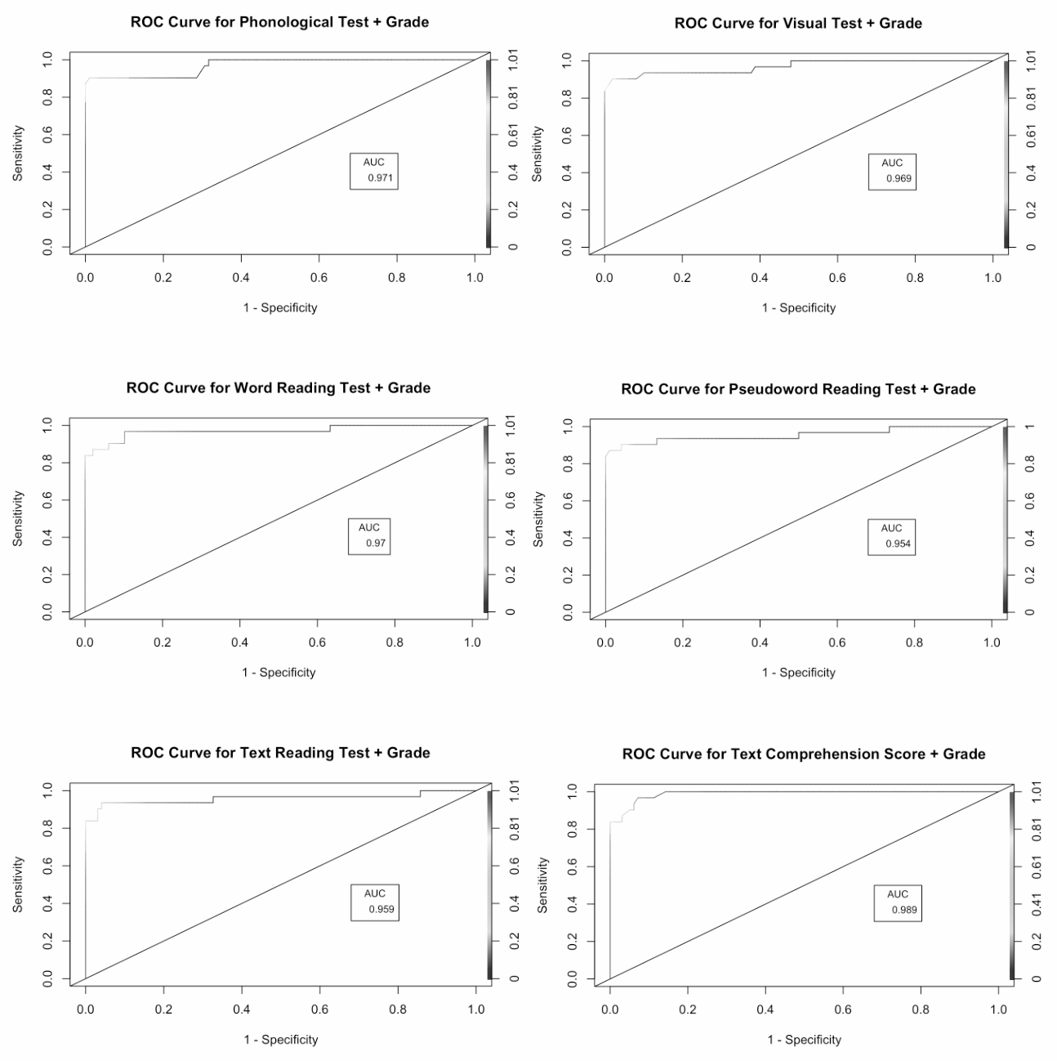

Additionally, we investigated at what level the chosen tests were able to identify participants with and without reading difficulties. To do this, we used the true positive, false negative, true negative, and false positive rates of each model to calculate the sensitivity and specificity scores for each test. The results are presented in Table 3. We found that the PVC test was the most accurate in identifying the TD adolescents (specificity score = .97), other tests showed the same high level of specificity (specificity score = .95). This part of the analysis also showed that the best instruments for defining adolescents with reading difficulties were the CSP, word, pseudoword and text reading tests (sensitivity score = 1.00). The least sensitive was the PVC test (sensitivity score = .93).
Table 3 The indicators from the confusion matrices for all six models
Models | True positive | False negative | True negative | False positive | Sensitivity | Specificity
M1. Phonological test + grade + (1|school) | 26 | 0 | 98 | 5 | 1.00 | 0.95
M2. Visual test + grade + (1|school) | 28 | 2 | 96 | 3 | 0.93 | 0.97
M3. Word reading test + grade + (1|school) | 26 | 0 | 98 | 5 | 1.00 | 0.95
M4. Pseudoword reading test + grade + (1|school) | 26 | 0 | 98 | 5 | 1.00 | 0.95
M5. Text reading test + grade + (1|school) | 26 | 0 | 98 | 5 | 1.00 | 0.95
M6. Text comprehension score + grade + (1|school) | 26 | 1 | 97 | 5 | 0.96 | 0.95

