**PROOF OF CONCEPT: LDO Dental Clinic Management System**

# Executive Summary

**Overview**:

• LDO Dental Office is a 20-year dental office serving approximately 500 patients.

• The office has three dentists, five hygienists, and three office staff.

**Business Problems**/**Challenges**

• High hygienist turnover.

• Dentists considering office expansion due to increased demand.

• Office staff concerned about customer service and workload.

• Manual record keeping.

The **LDO Dental Office** is facing significant challenges in managing its operations due to manual record-keeping. As the patient base grows, the office staff finds it challenging to efficiently handle patient records, appointment scheduling, drug tracking, and supplier information. This leads to delays in patient management, inefficiencies in drug administration tracking, and risks of human error in handling critical medical data.

The current system has proven inadequate in handling the increasing volume of patients and appointments. The complexity of challenges requires a computerized system for handling more customers without additional staff.

**Proposed Solution to Address the Challenges Faced by LDO Dental Office:**

This proposal presents a Proof of Concept (POC) for the Dental Clinic Management System (DCMS), an automated business management IT system designed to address the challenges faced by LDO Dental Office. This solution streamlines and automates key operations through a comprehensive platform integrating patient management, appointment scheduling, drug tracking, and supplier records.

The proposed system will replace manual processes, increasing operational efficiency and reducing human error. This will ultimately lead to an improved patient experience and better tracking of drugs and procedures.

**Implementation Strategy:**

To ensure a smooth transition to the Dental Clinic Management System (DCMS), we will implement a comprehensive engagement strategy that includes hands-on training for all staff, detailed user manuals, and ongoing support. This approach will maximize system adoption and enhance operational efficiency, ultimately improving patient care.

**Key Benefits of Dental Clinic Management System (DCMS):**

**1.Patient Entry Record Management:**

**Streamlined Patient Registration Form**: Digital forms simplify the registration process, allowing patients to quickly provide essential information, reducing wait times.

**Automatic Database Updates**: After the form is completed, the system automatically updates the central database, ensuring that patient data remains current and easily accessible.

**Efficient Information Management**: Simplified data entry allows staff to manage patient information with reduced errors and improved accuracy.

**2.Patient Details Retrieval Dashboard:**

* **Interactive Dashboard Interface**: The dashboard offers a visual representation of patient data, making navigation easy and enhancing the user experience for clinical staff.
* **Accessible Medical Histories**: Doctors and hygienists can quickly access comprehensive patient histories, including drug allergies and notes from previous visits, aiding in treatment decisions.
* **Efficiency in Treatment Decisions**: By minimizing the time required to find patient records, the dashboard streamlines decision-making, leading to better patient outcomes and reduced error rates.

**3. Track/Record Drug and Drug Administration:**

The system tracks drug administration details for each patient, enhancing safety and accountability. This provides staff with a complete history of which drugs were used for each patient, resulting in improved patient safety and care through accurate drug tracking. Additionally, this feature helps with management and ordering drugs.

**4.Track Drug Supplier Details**:

* Detailed Supplier Information Records: DCMS creates a central repository of supplier details, ensuring easy access to crucial information about drug sources and compliance.
* Expiry Date Monitoring: The system actively tracks expiry dates of medications, enabling timely disposal and reordering of supplies, which minimizes wastage and enhances patient safety.
* Drug Disposal and Recall Procedures: By maintaining comprehensive records of drug suppliers, DCMS facilitates efficient recall management and proper drug disposal methods.

**5. Online Patient Registration Form:**

* Streamlined Appointment Scheduling - Patients can choose appointment types and available staff, enhancing user experience and ensuring appropriate consultations.
* Convenience for Patients - By allowing online registrations, the DCMS reduces the administrative burden on staff and gives patients control over their scheduling.
* Optimized Resource Allocation - The system automatically assigns appointments to relevant healthcare resources based on patient needs, improving workflow within the clinic.

**6.Dashboard for Dental Staff to View Scheduling Details:**

* Unified Appointment Management System: The centralized dashboard allows staff to manage all appointments from one interface, eliminating confusion and enhancing reporting.
* Effective Staff Scheduling: Optimized scheduling enables better planning for dentists and hygienists based on patient flow and demand patterns.
* Preventing Double Bookings: By utilizing real-time data, the system drastically reduces the chances of scheduling conflicts, ensuring better patient flow and satisfaction.

By adopting the DCMS, LDO Dental Office will streamline operations and reduce staff workload while enhancing overall patient care. The system’s scalability will enable data-driven decisions regarding office expansion and effectively address the growing patient demand.

# Use Cases (User Scenarios)

1. **Patient Record Management (Office Staff Use Case):**

* The office staff uses an automated system to enter and manage patient records via a user-friendly form accessible on both desktop and tablet devices. This reduces paperwork and minimizes errors. When retrieving patient data, staff can search by **Patient ID** to access comprehensive medical history and drug intake details.

1. **Appointment Scheduling (Patient Use Case):**

* Patients can book appointments online by selecting either a **Cleaning** or **Dental Procedure**. The system automatically displays available **Hygienists** or **Dentists** based on the selection. Once the appointment is confirmed, both the patient and office staff can view the appointment on the dashboard, with the system tracking upcoming appointments and ensuring no scheduling conflicts.

1. **Accurate Drug Administration Tracking (Dentist/Hygienist Use Case):**

* During dental procedures, dentists or hygienists record the drugs administered in the system, tracking essential details such as batch, dosage, and form for each patient. This ensures accurate drug administration, facilitates future retrieval in case of recalls or side effects, and helps maintain compliance with safety regulations.

1. **Drug Disposal Tracking Use Case (Office Staff Use Case):**

* The Office staff manages drug inventory and disposal through the system. Expired or damaged drugs are logged, with Supplier and Drug Batch details. This organized approach ensures regulatory compliance for drug disposal and tracking for potential recalls.

1. **Inventory Management (Office Staff Use Case):**

* Office staff can keep track of drug inventory through the system, monitoring the quantities of drugs on hand. When stock levels reach a predefined threshold, the system will prompt staff to place orders, ensuring that essential supplies are always available and preventing disruptions in patient care.

1. **Reporting and Analytics (Office Staff Use Case):**

Office staff can generate reports on patient visits, treatment outcomes, drug usage, and staff performance through the system. This functionality provides valuable insights for decision-making, helps identify trends, and supports strategic planning for the dental office.

# Business Rules and Assumptions

1. **Patient Appointment Types**:
   * Patients must select between **Cleaning** (handled by a Hygienist) or **Dental Procedure** (handled by a Dentist). The system automatically allocates the relevant medical staff, preventing scheduling conflicts and ensuring **specialized treatment**.
2. **Multiple Bookings**:
   * A patient can book multiple appointments, and each booking will generate a **unique** **AppointmentID**. This ID will be associated with specific **procedures** and **medical staff**, ensuring complete tracking of the patient's dental history.
3. **Unique Patient ID**:
   * Every patient is assigned a **unique PatientID** when their records are entered. This ensures that every subsequent appointment, drug administration, and medical history entry is linked back to the **same ID**, allowing for **consistent and accurate patient records**.
4. **Drug Administration Tracking**:
   * Each drug administered is tracked by **DrugBatch and DrugID**, ensuring compliance with drug administration and recall processes. The system allows the office to maintain **full visibility** over which drugs were used for specific patients, assisting with audits or investigations into **side effects or drug recalls**.
5. **Supplier and Drug Tracking**:
   * Every **DrugBatch** is tied to its corresponding **Supplier**. This enables the office to quickly track and contact suppliers in the event of **recalls, faulty batches, or expired drugs**. Supplier performance data can also be monitored, ensuring **only reliable suppliers** are used.

# Entity Relationship (ER) diagram

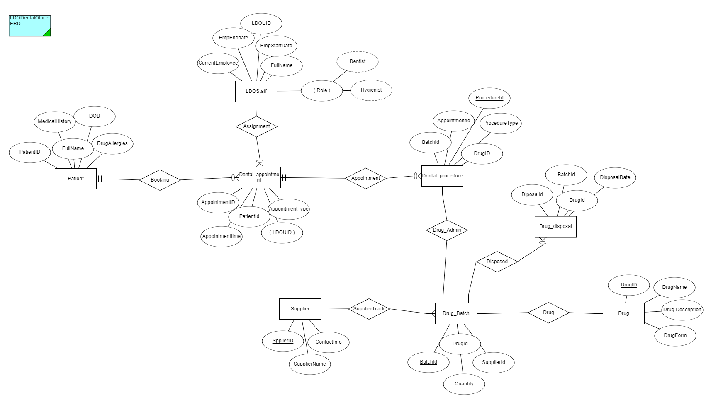

# Relational Data Model/Schema

# Patient Entry Form Screenshots

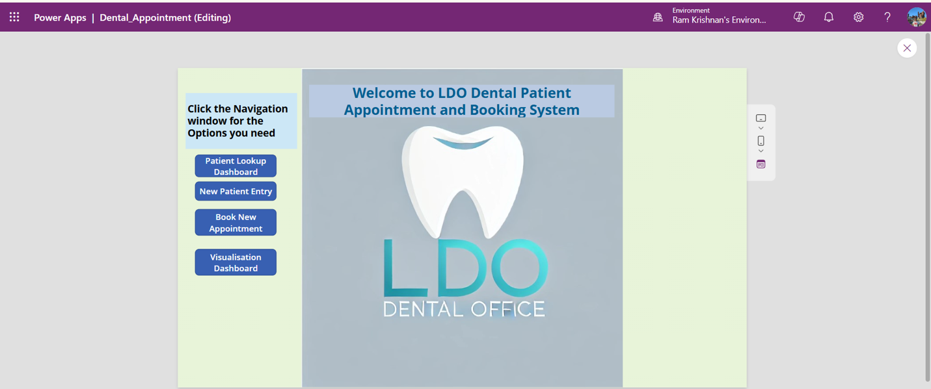

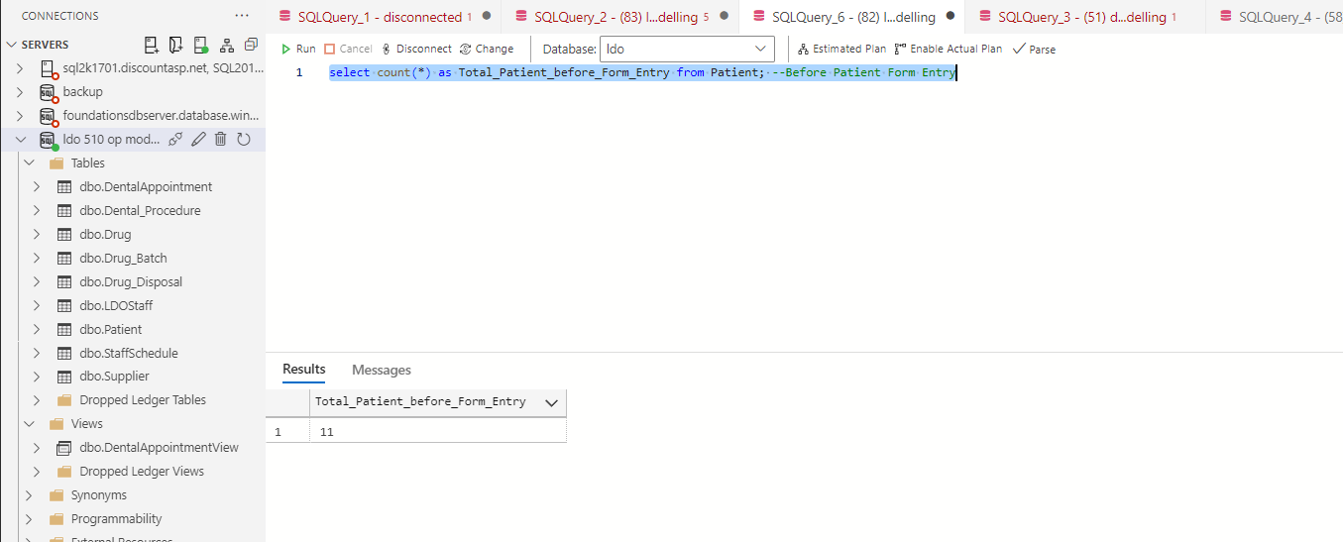

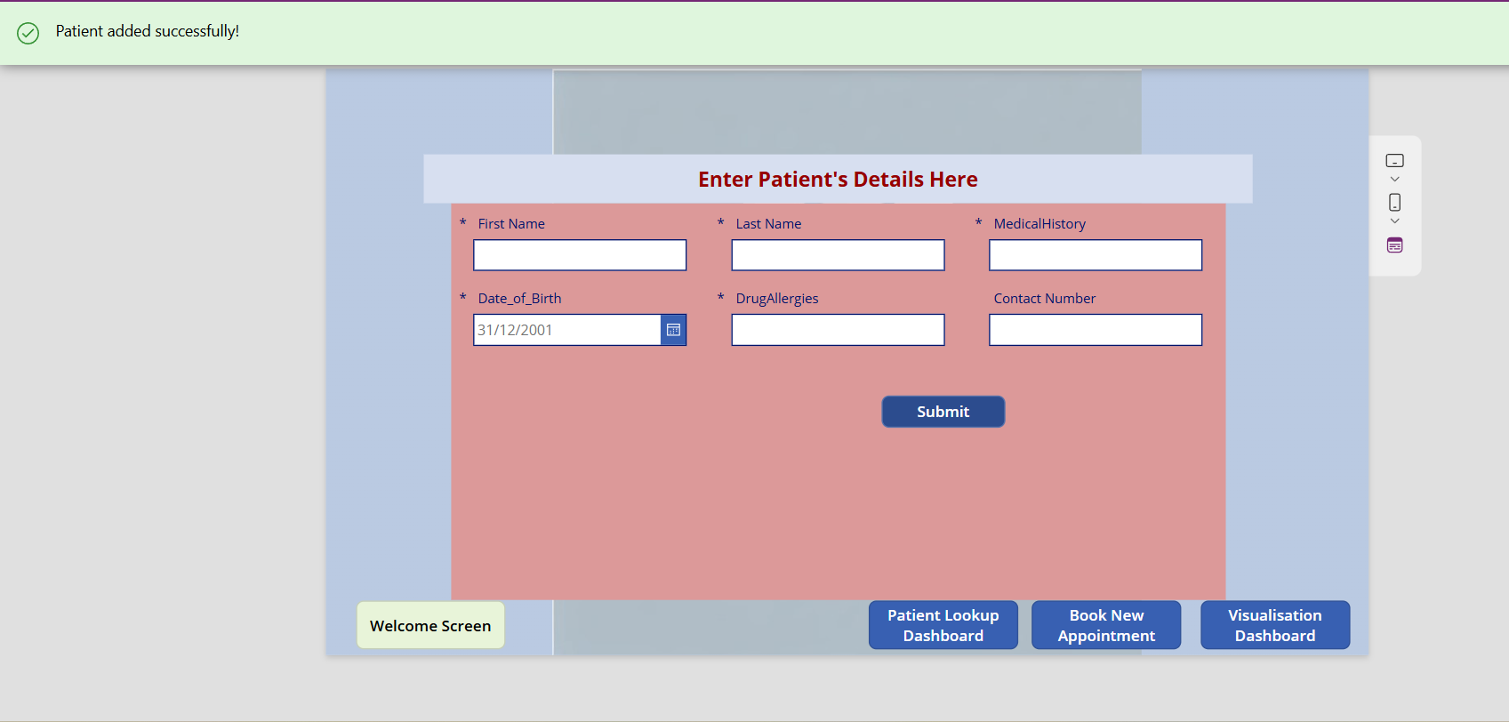

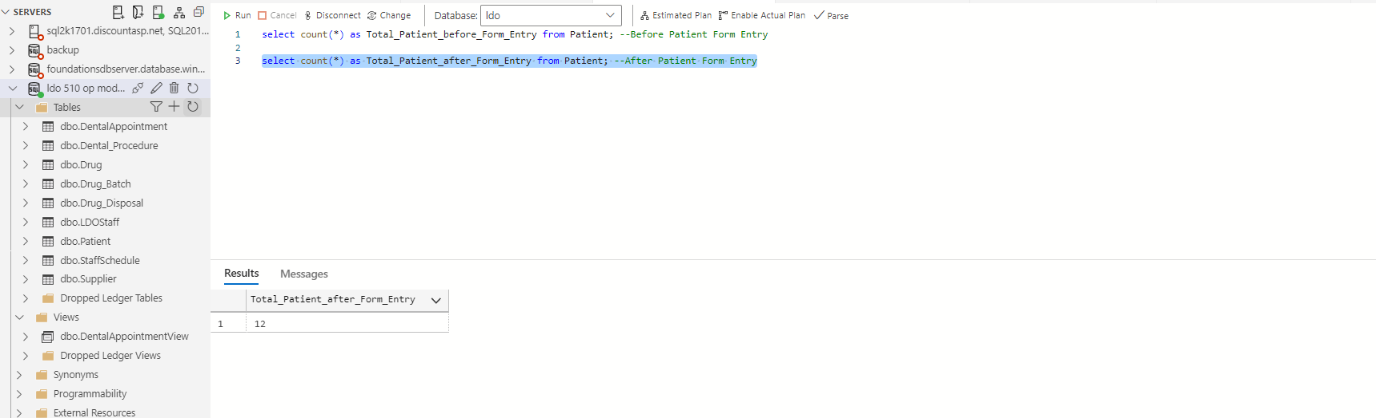

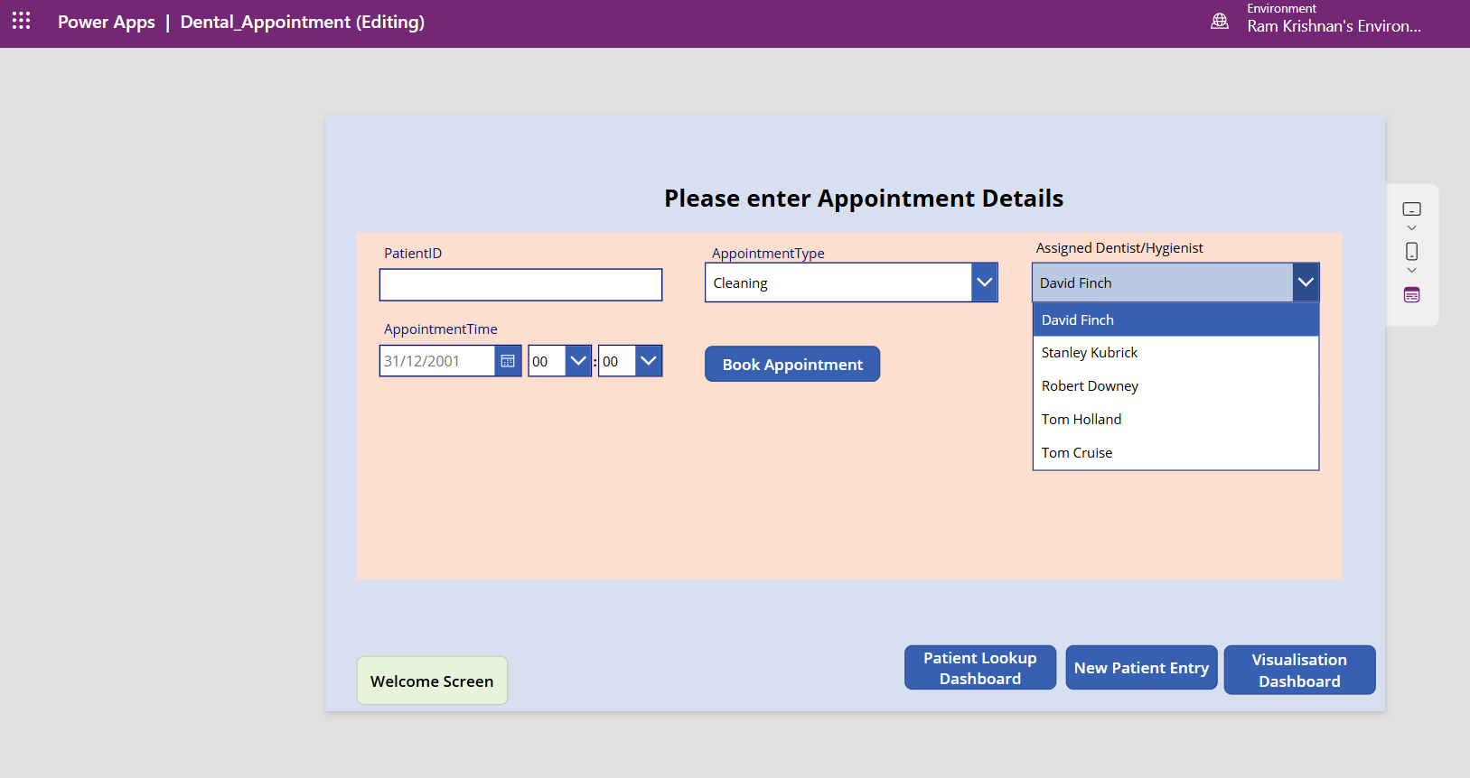

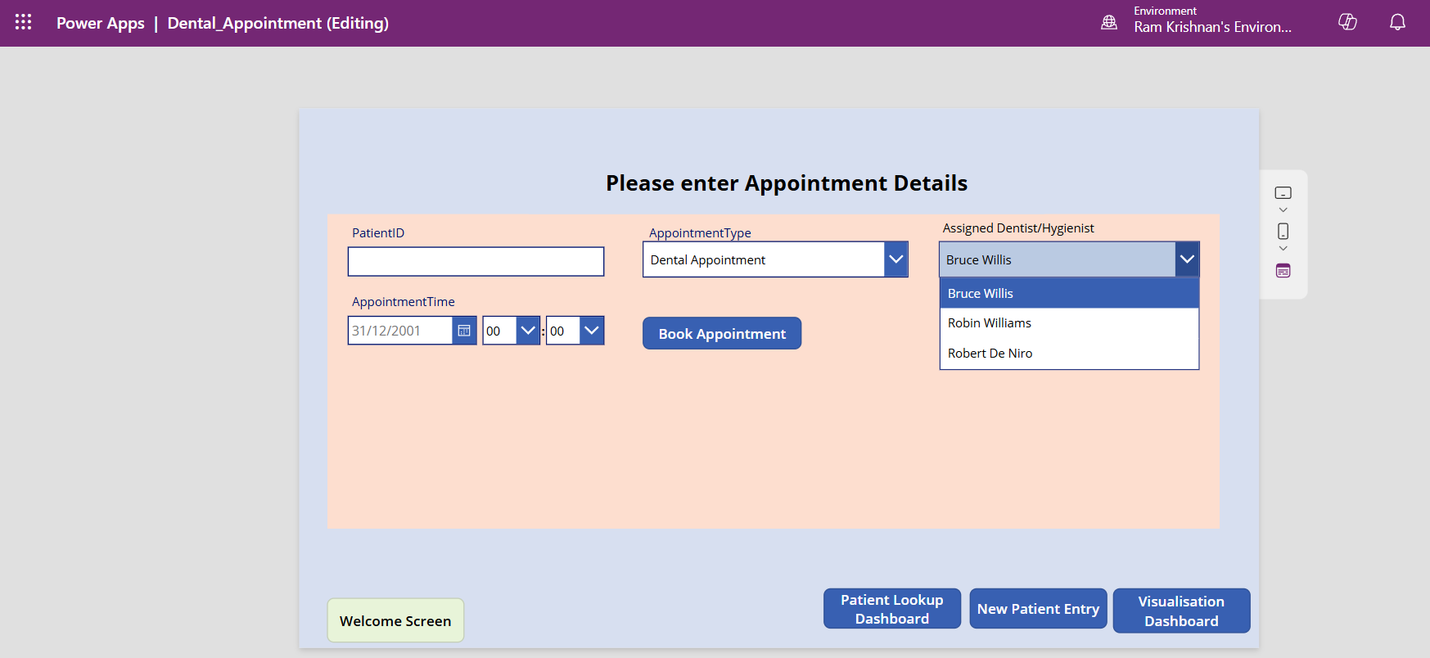

# Patient & Drug Management Dashboard and KPIs Screenshot

1) Patient Lookup Table

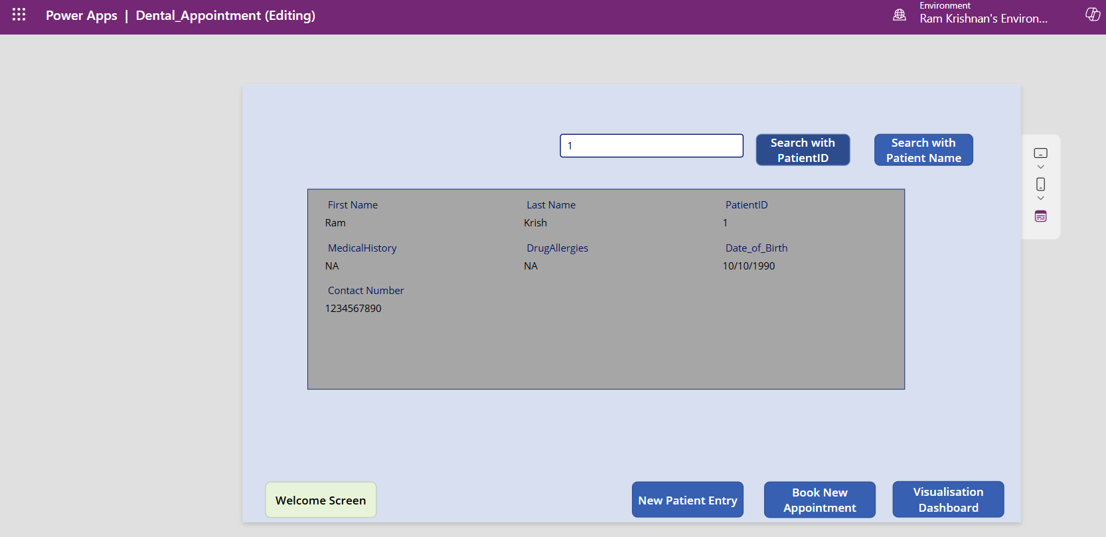

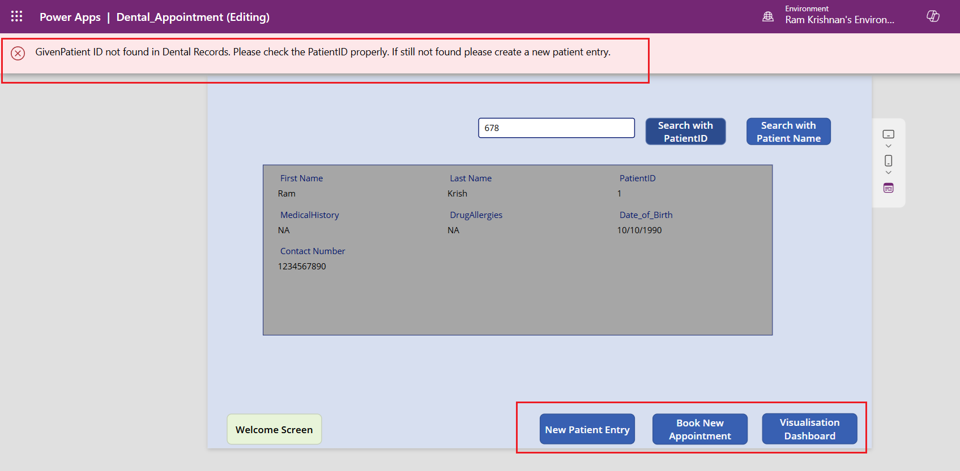

2) Drug Batch details and records tracking

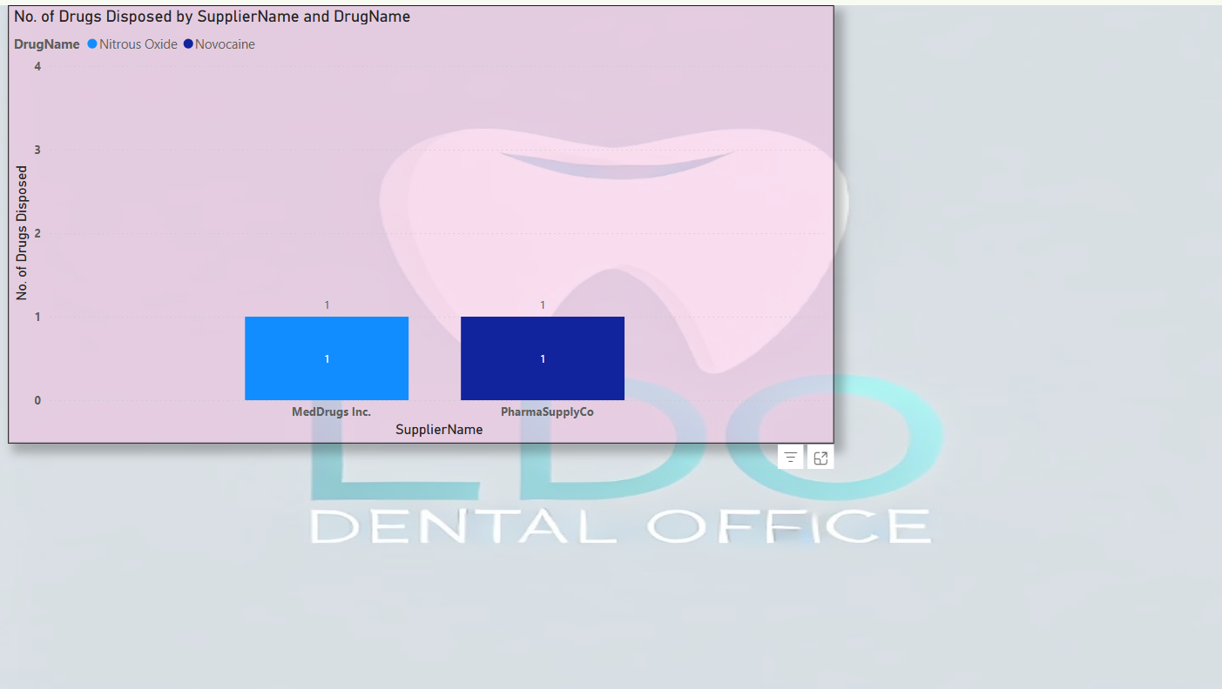

3) Patient Appointment Tracking and Lookup

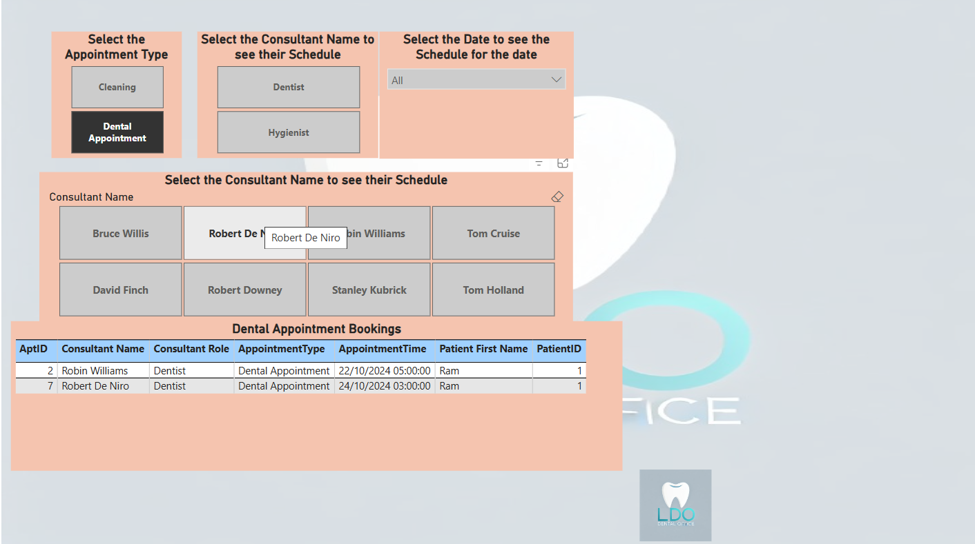

4) Doctor’s visit hours schedule based on Patient Appointment Schedule Patterns

5) Another User case: Based on number of Patients a Doctor/Hygienist sees in a particular day/time open another Doctor office for efficient patient handling system

# Additional Information regarding the POC Solution:

This application is designed to automate the manual tasks performed by the office staff and includes full operational functionality to be hosted on both web and mobile platforms.

The components needed to access this application is listed below,

* DCMS Mobile/Tablet QR Code

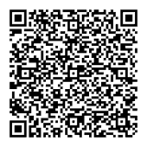

WebLink:[LDO DCMS](https://apps.powerapps.com/play/e/105ec9f1-611d-e363-901f-fa19d5eb8b0c/a/263e19b4-8d46-4caa-82d3-8fb46d979ff6?tenantId=f6b6dd5b-f02f-441a-99a0-162ac5060bd2&sourcetime=1730065972038)

* Azure SQL Data Studio for Backend Database Querying (backend functionalities)
* Additional Suggestions: The LDO DCMS (Dental Clinic Management System) is designed with scalability in mind, allowing for the addition of numerous other use cases and functionalities as needed. While the current POC focuses on a specific set of features and functionalities, as outlined in the Proposal document, the system can be easily expanded to include additional capabilities in the future such as,
  + **Automatic Appointment Reminders**:
    - **SMS/Email Notifications**: The system can send automatic reminders to patients via SMS or email a few days before their scheduled appointments. This helps reduce missed appointments and ensures that patients are well-prepared.
    - **Customizable Reminder Frequency**: Allow patients to customize how frequently they would like to receive reminders (e.g., 1 day before, 3 days before).
  + **Enhanced Drug Inventory Management**:
    - **Real-time Drug Inventory Tracking**: Track the usage of drugs in real-time, ensuring that the inventory is updated as drugs are administered during procedures.
    - **Low Stock Alerts**: Automatically notify staff when the stock of certain drugs or supplies falls below a predefined threshold to ensure timely reordering.
  + **Customizable Reports and Analytics**:
    - **Advanced Analytics**: Generate customizable reports for different metrics, such as patient inflow, revenue by procedure, drug usage, and more.