|  |
| --- |
| **Veterinary Practice Management System with Chatbot**  Developed For  Cremisoft Development Pvt. Ltd.,Ahmedabad  Report Part- II (Sem – VI) Submitted For  The Partial Fulfillment Towards The Degree of  **Bachelor of Computer Applications (BCA)**  By  Ayushi Mistry         Tanya Jagyasi           Rahul Patel  **Under the Guidance of**  External Guide Internal Guide  Mr. Sunil Jagyasi Prof. Riddhi Kundal  (Owner) FCAIT, BCA  Cremisoft Development Pvt. Ltd. Ahmedabad |
|  |
| **Faculty of Computer Applications & IT BCA Programme**  **Ahmedabad** |

GLS UNIVERSITY

Faculty of Computer Applications & IT, BCA Programme Ahmedabad

CERTIFICATE

This is to certify that

1) Ayushi Mistry

2)Tanya Jagyasi

3) Rahul Patel

Student/s of Semester- VI BCA (TYBCA), FCAIT, GLS University has/have successfully completed the System Development Project Part-II, System Design, Testing and Implementation work on

“Veterinary Practice Management System with Chatbot ” as a partial fulfillment of the study of Third year Semester-VI, Bachelor of Computer Applications(BCA).

Date of Submission: 17th March, 2021

**Prof. Riddhi Kundal Prof. Tripti Dodiya**

Project Guide Project Co-Ordinator

**ACKNOWLEDGEMENT**

We are thankful to all those persons who have directly or indirectly contributed to create this project and helped us lot to make it a great success. We would get and useful experience that will change our career.

We grab this opportunity to introduce the project of **Veterinary Practice Management System** as a part of our 6 Semester BCA.

We would like to thank my Project guide **Prof. Tripti Dodiya** for providing a vision about the system. we have been greatly benefited from their regular critical reviews and inspiration throughout my work.

We would like to express my sincere thanks to our **Dean R.P Soni Sir** and my internal guide **Prof. Riddhi Kundal** who gave me an opportunity to undertake such a great challenging and innovative work. we are grateful to them for their guidance, encouragement, understanding and insightful support in the development process.

We are extremely thankful to each and every faculty member of **Faculty of Computer Applications.** As they share their valuable time with us for our project and solve our problem.

Last but not the least we would like to mention here that we are greatly indebted to each and everybody who has been associated with our project at any stage but whose name does not find a place in this acknowledgement.

**INDEX**

|  |  |  |
| --- | --- | --- |
| **No.** | **Description** | **Page No.** |
|  |  |  |
| 1 | Company Profile |  |
|  |  |  |
| 2 | Project Profile |  |
|  |  |  |
| 3 | System Requirement |  |
|  |  |  |
|  |  |  |
| 4 | Existing System |  |
|  |  |  |
| 5 | Proposed System |  |
|  |  |  |
| 6 | Admin panel Screenshots |  |
|  |  |  |
| 7 | Reports |  |
|  |  |  |
| 8 | Sample Screen layouts |  |
|  |  |  |
| 9 | Conclusion |  |
|  |  |  |



**COMPANY PROFILE**

**Company Name**: Cremisoft Development Pvt. Ltd

**Owner Name**: Mr.Sunil Jagyasi

**E-mail:** sunil@cremisoft.com

**Contact No:** 7567002073



**Project Profile**

**Project Title: Veterinary Practice System with Chatbot**

**Project Description:**

**Web Application for veterinary System for small- to medium-sized practices:**

* The goal of this application is to create tool for managing the work flow of a veterinarian. This application is assigned to keep track of patients, appointments, procedures and medication. The second goal is mostly people run small scale animal practice without a real office or business premises so this application is easy to use and learn for various purposes in low budget and also time saving in emergency. The main features are Search, Booking an appointment, the ability to get receipts and invoices, Inventory Control and Purchasing, Payment options, patients-Doctors databases, medication and also they can communicate via this app to their doctors in emergency situations.so the user can check easily availability of everything on app at any time and also get training option how to keep healthy their pets.
* In veterinary practice management system, we are going to use an Odoo framework which has almost everything which requires to manage animal hospital.
* This Odoo module provides many different features to manage veterinary animal clinic management such as pet details management, Appointments, Pet Hospitalization, Laboratory-Lab Test, Invoicing management etc. along with different reports, Medication History, Lab tests etc.

* **CHATBOT DESCRIPTION:**
* We are using a chatbot to stimulate human conversation. Chatbot is basically a user interface (UI), but instead of going through a complicated UI, a system integrated with a chatbot is preferred.
* The chatbot platform processes users query, also once interpreted, it enquires about it in common language and passes this information to the user in a way that user understands.

**Tentative Project Module Names with Description:**

**We are representing the ERP module for veterinary practice management system.**

**Admin Module:**

* Admin can add doctors and also update and delete it.
* Inventory Control Management and Purchasing.
* Admin can view the appointment and invoice.
* Admin can also manage payment activities if require.
* Can view user’s feedback

**User Module:**

* User can register and login.
* Can view the doctors.
* Book an appointment
* User can reschedule an appointment
* Can view reports and invoice
* Make an payment using Cash or Card
* Can view history of treatment
* Can Communicate with doctors in case of emergency (when doctor is available)
* Can Communicate with chatbot
* Can give feedback

**Doctor Module:**

* Can login
* View and Confirm appointment
* Can view Pet’s history about treatment

**System Requirement**

**Software Used**:

* **Frontend:**
  + Visual Studio Code/PyCharm
    - For Python and AI Chatbot
  + Odoo Framework
* **Backend:**
  + PHPmyAdmin
    - For Postgresql

**Existing System**

[Veterinary Management ERP technology solutions](https://www.hvantagetechnologies.com/products/erp/veterinary-medical-module/) at [Hvantage Technologies](https://www.hvantagetechnologies.com/) Which Has Following Features:

* Pet information portal
* Appointment scheduling
* Laboratory inventory
* Notification reminder
* ICU information portal
* Invoice Records
* Pediatrics details
* Warehouse management records

**Proposed System**

The project maintains two levels of users:

* Administrator Level
* User Level:
  + Owner
  + Doctor

Which includes Activities like**:**

Maintaining Pet Details, Providing Prescription and Diet Advice.

Providing and Maintaining all Kinds of tests for Billing and Report generation.

AI ChatBot : The chatbot platform processes users query, also once interpreted, it enquires about it in common language and passes this information to the user in a way that user understands.

**ADMIN PANEL SCREENSHOTS**

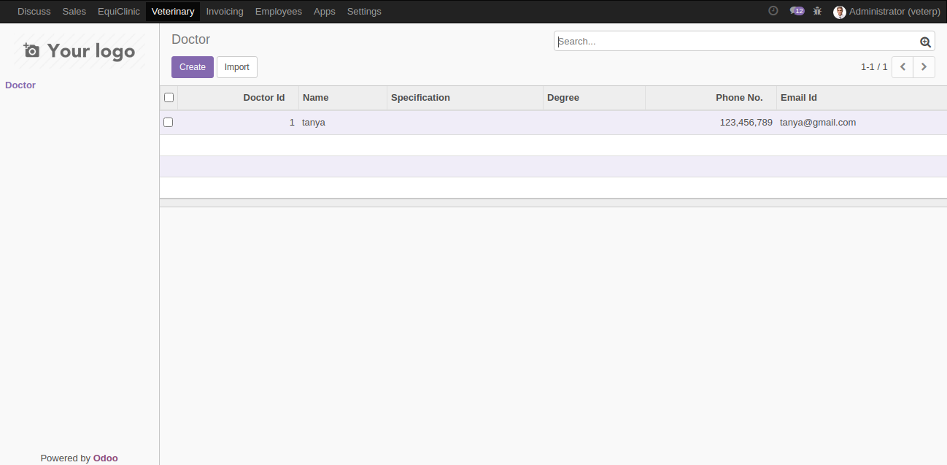

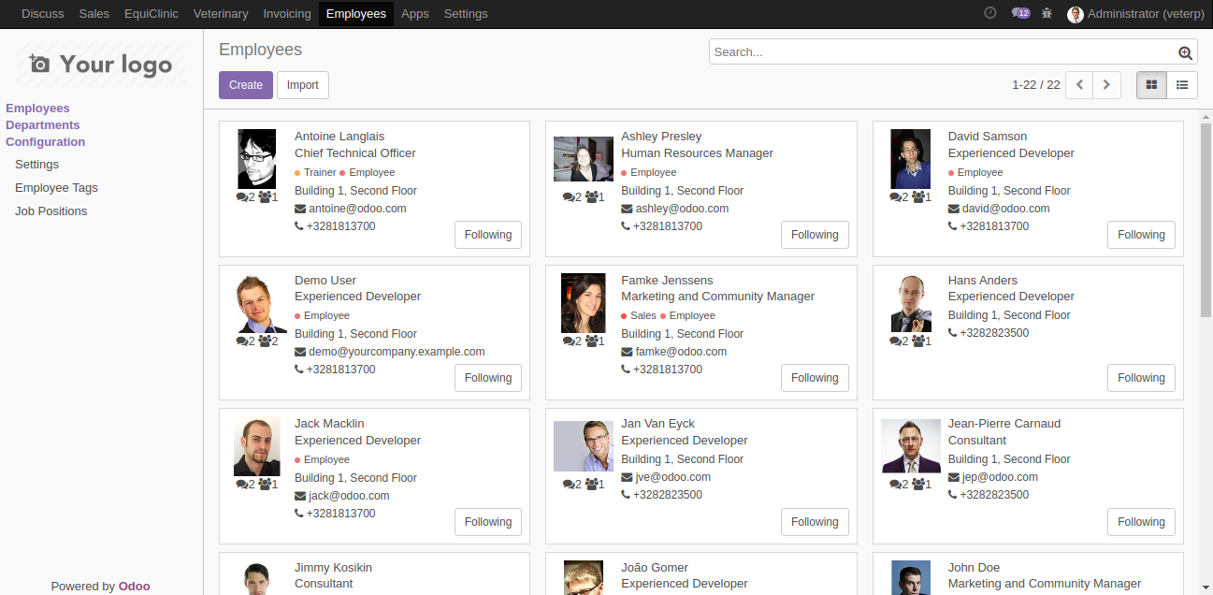

**ADMIN PANEL SCREENSHOTS**

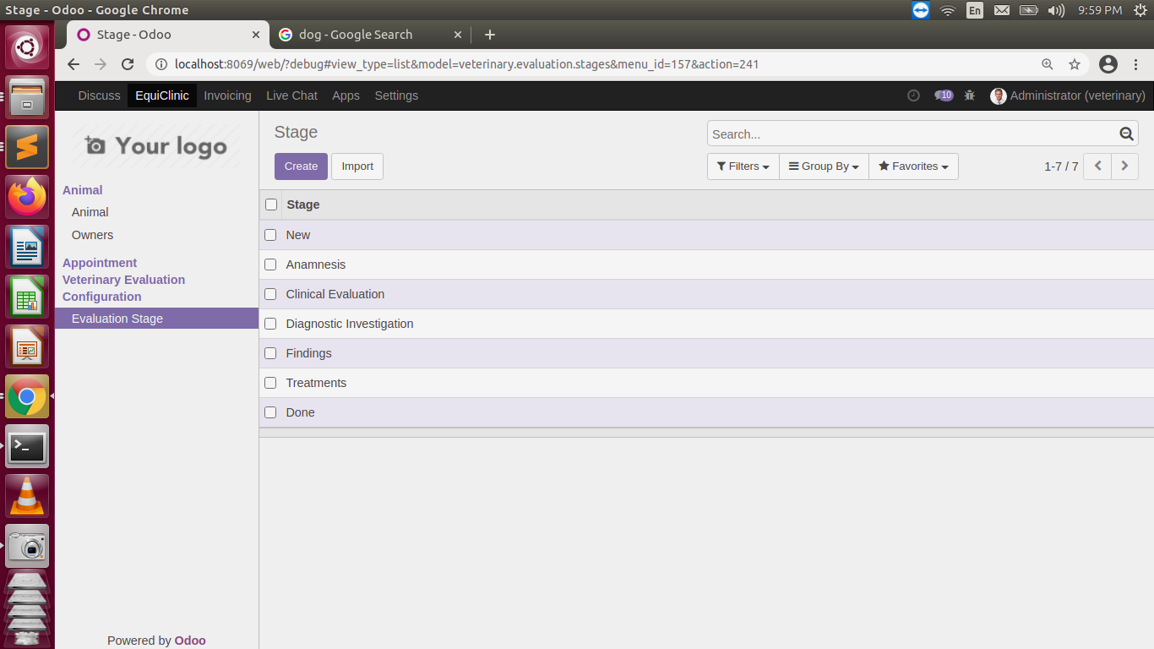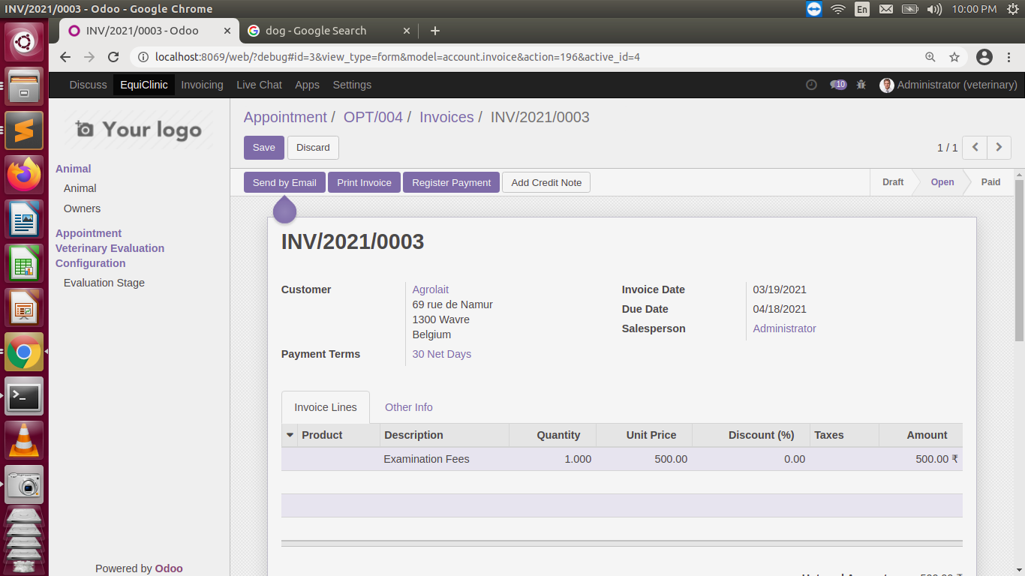

**ADMIN PANEL SCREENSHOTS**

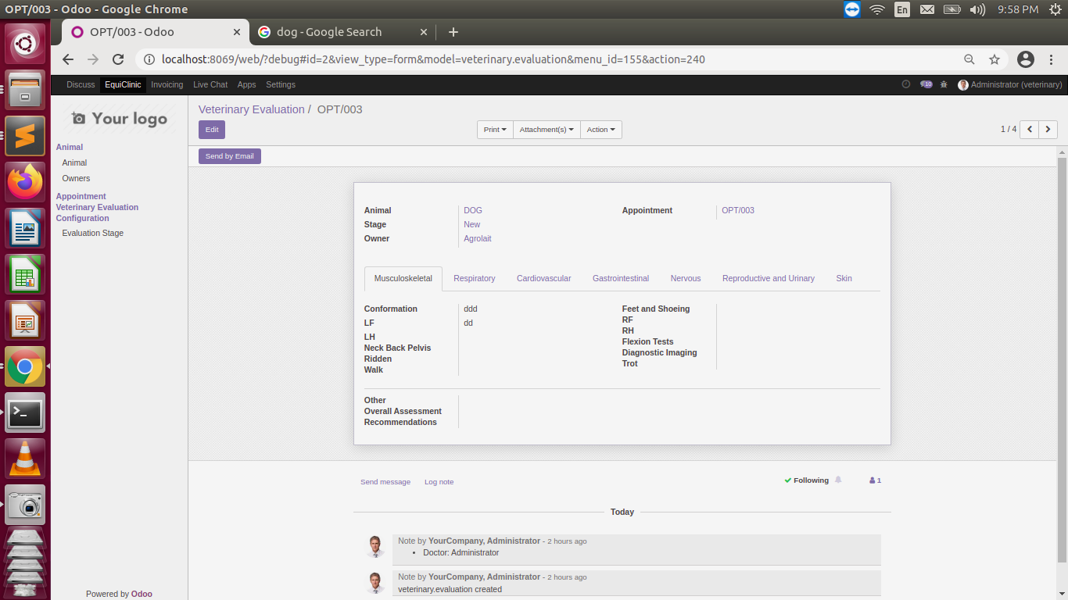

**ADMIN PANEL SCREENSHOTS**

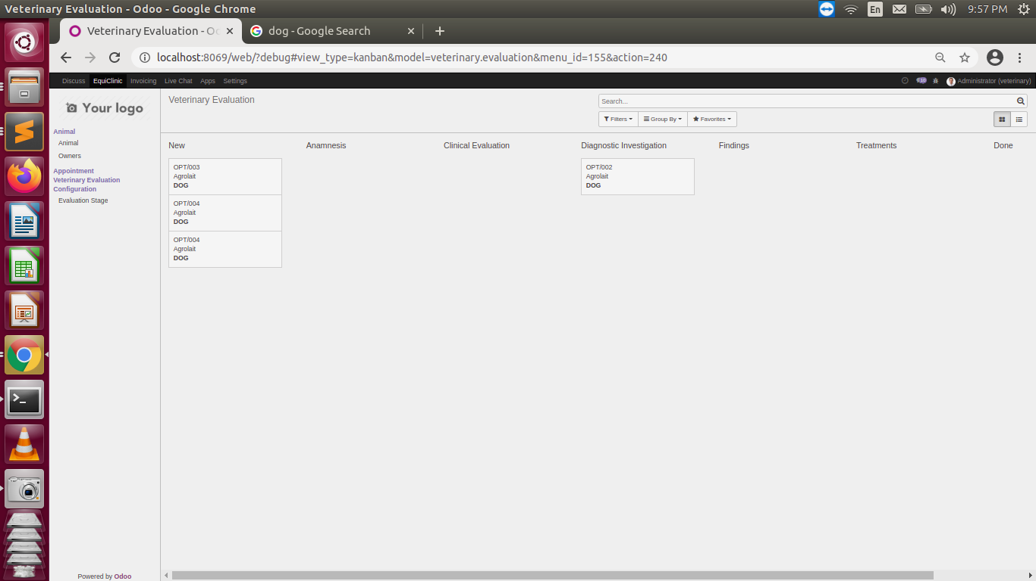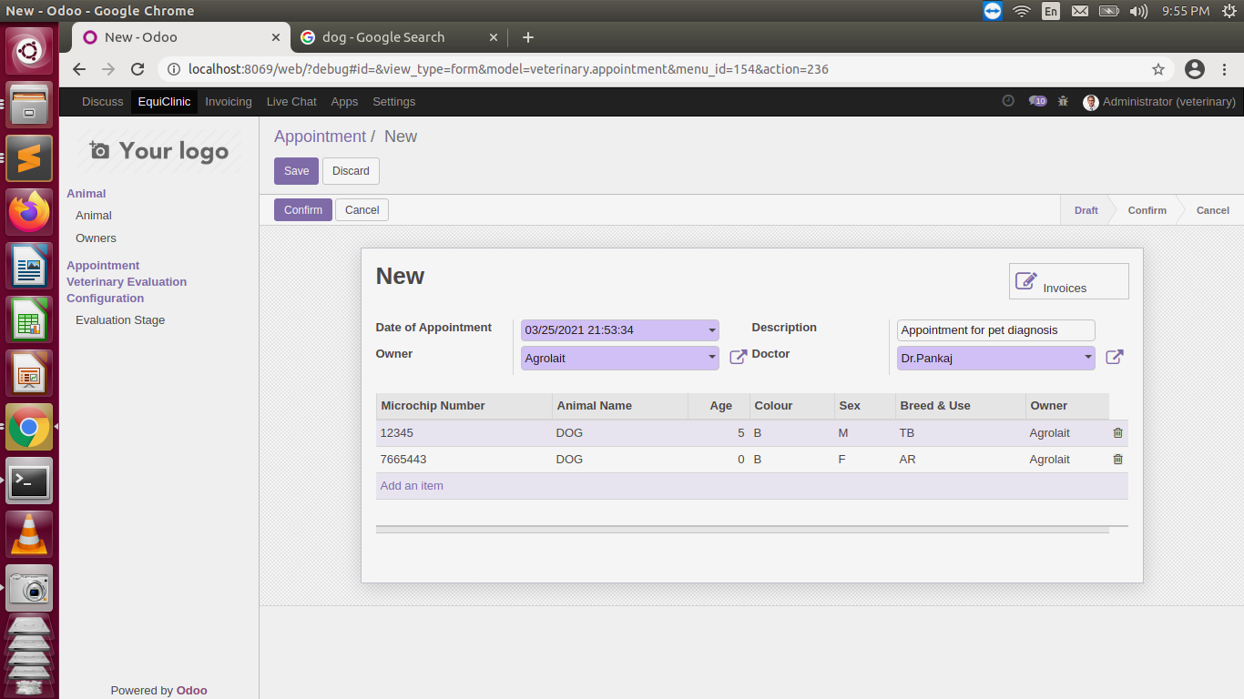

**ADMIN PANEL SCREENSHOTS** 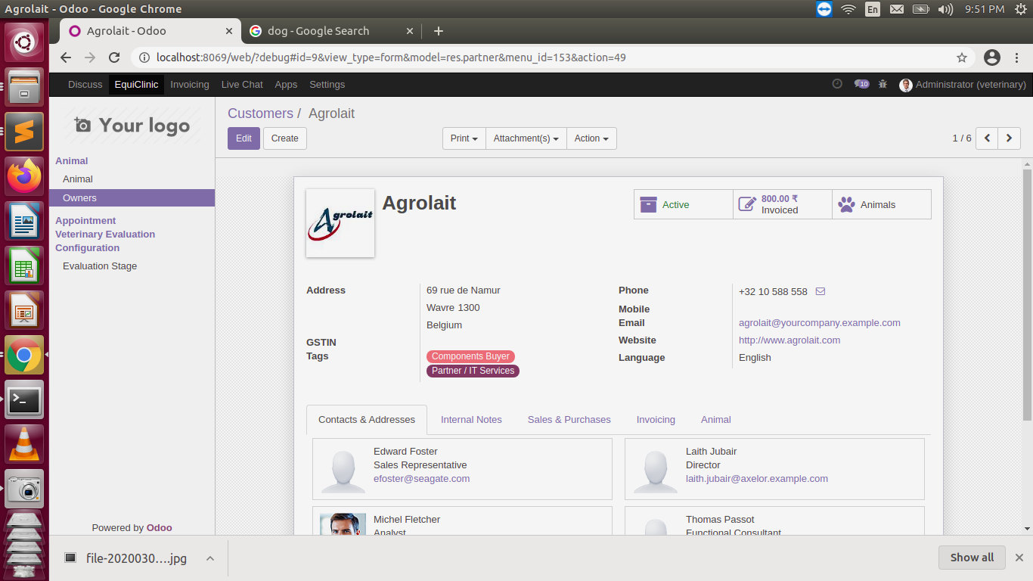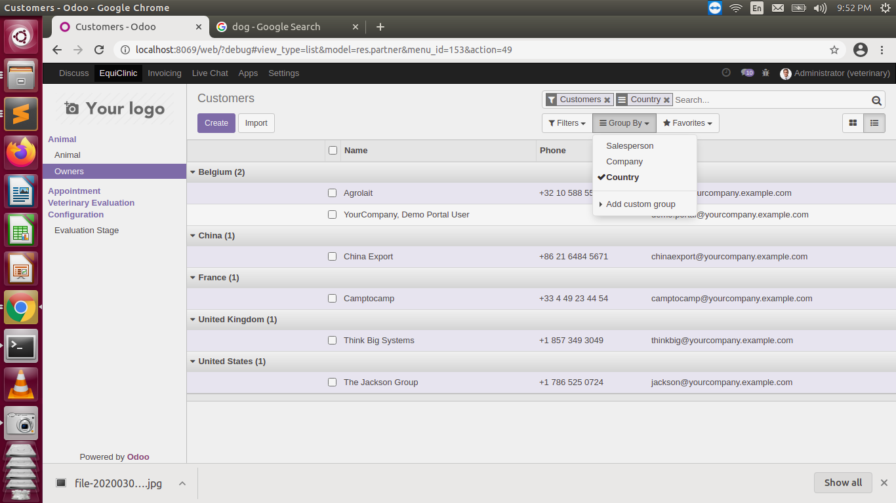

**ADMIN PANEL SCREENSHOTS**

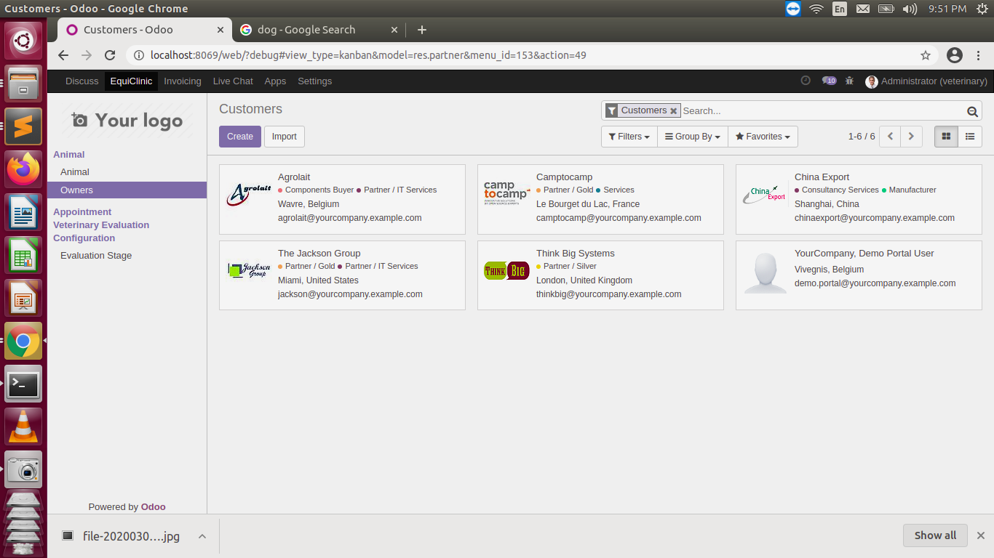

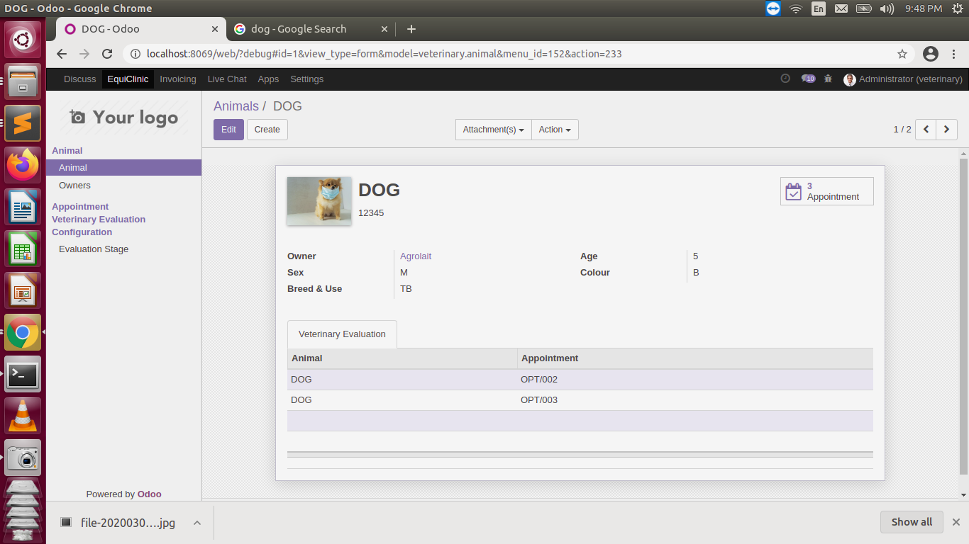

**ADMIN PANEL SCREENSHOTS**

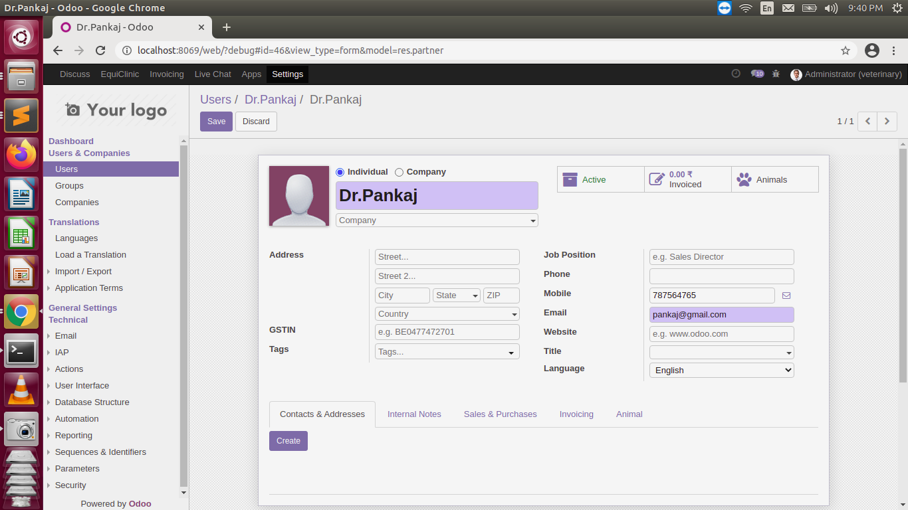

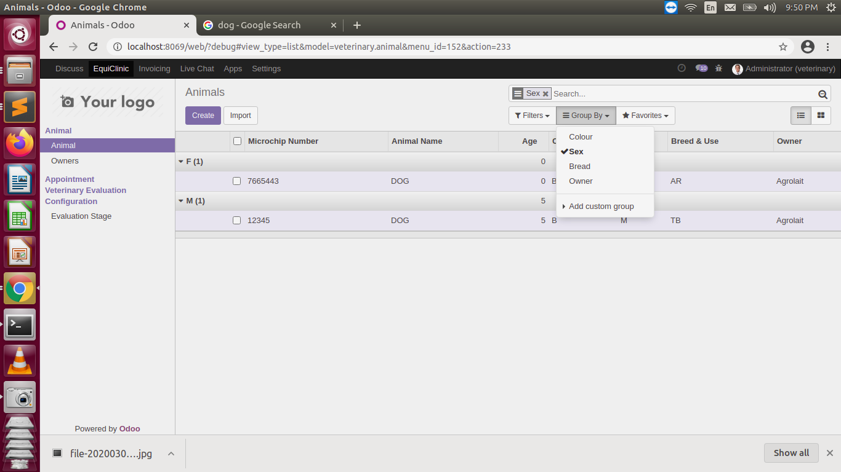

**ADMIN PANEL SCREENSHOTS**

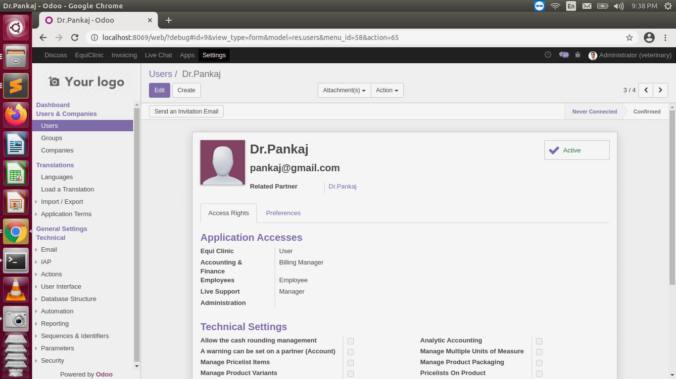

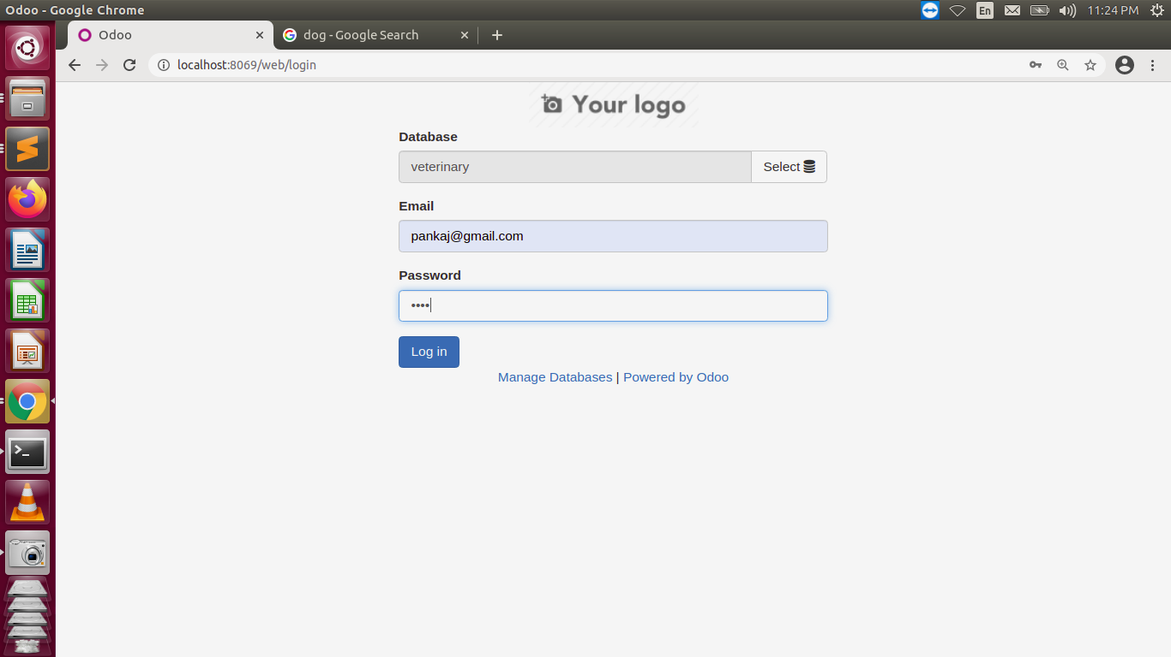 **SCREEN LAYOUTS**

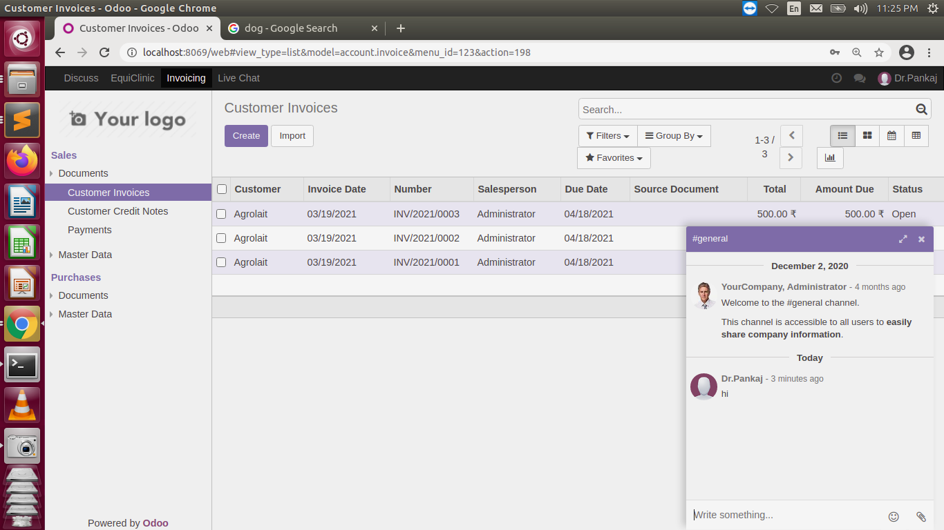

**SCREEN LAYOUTS**

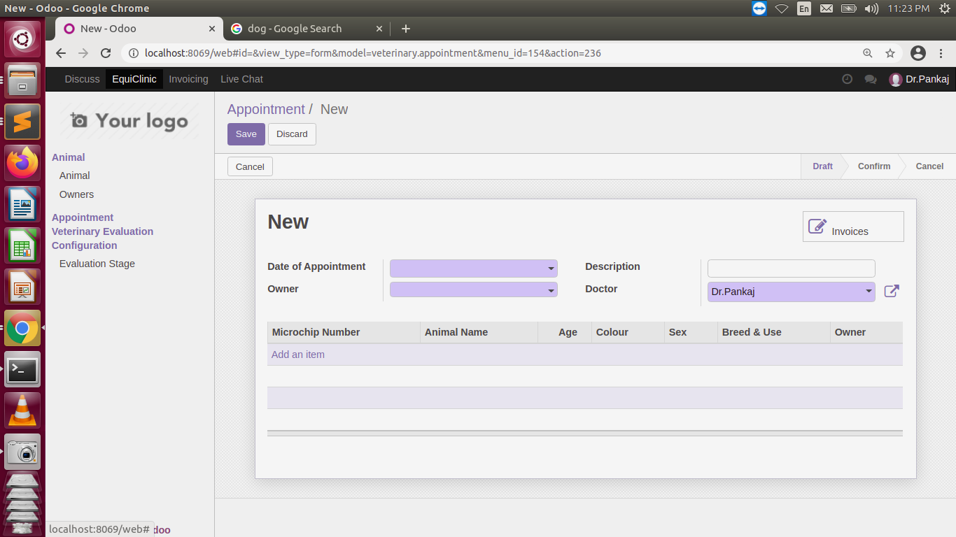

**SCREEN LAYOUTS**

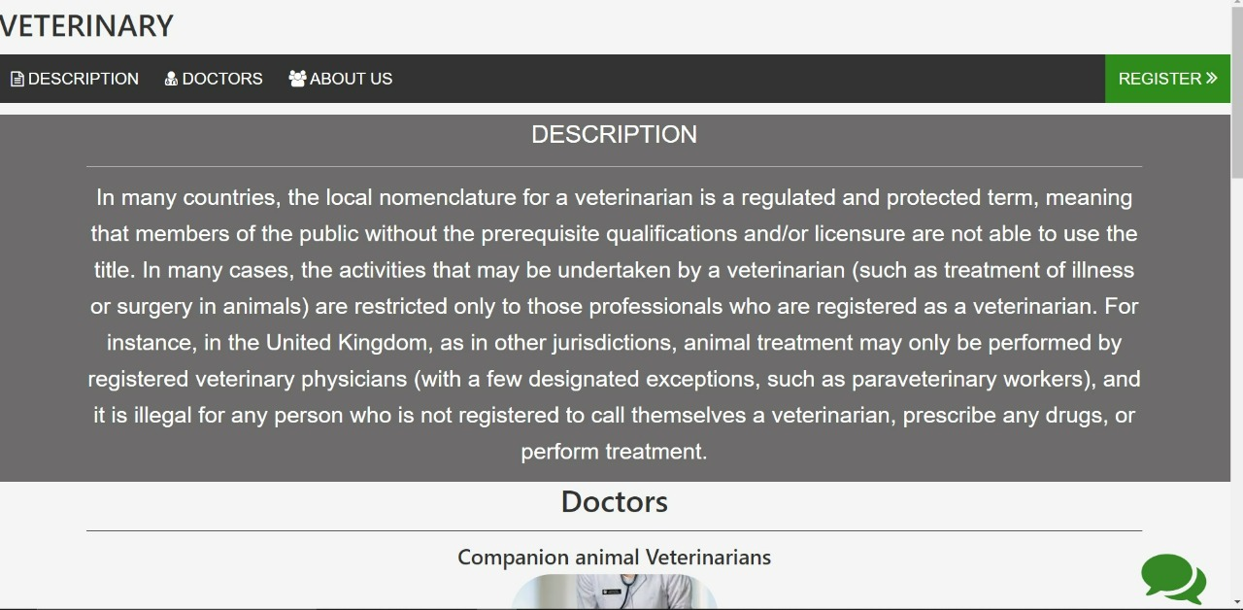

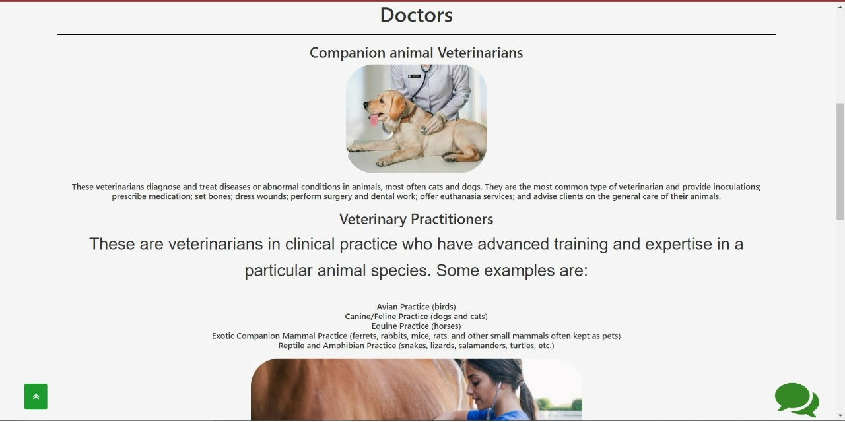

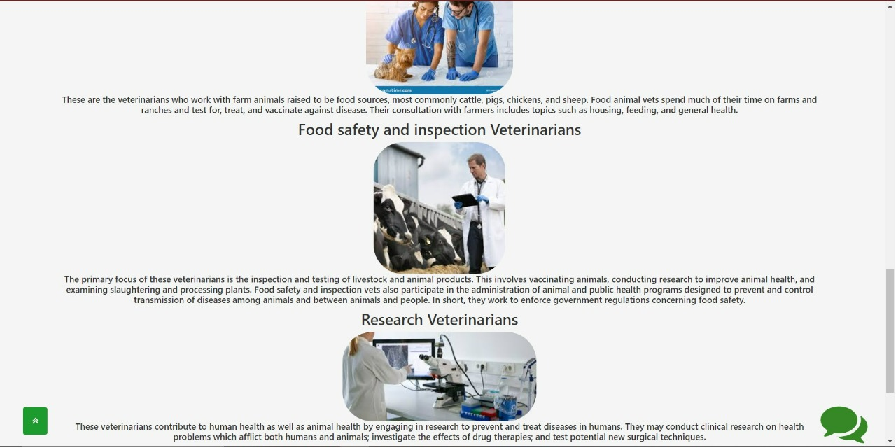**SCREEN LAYOUTS**

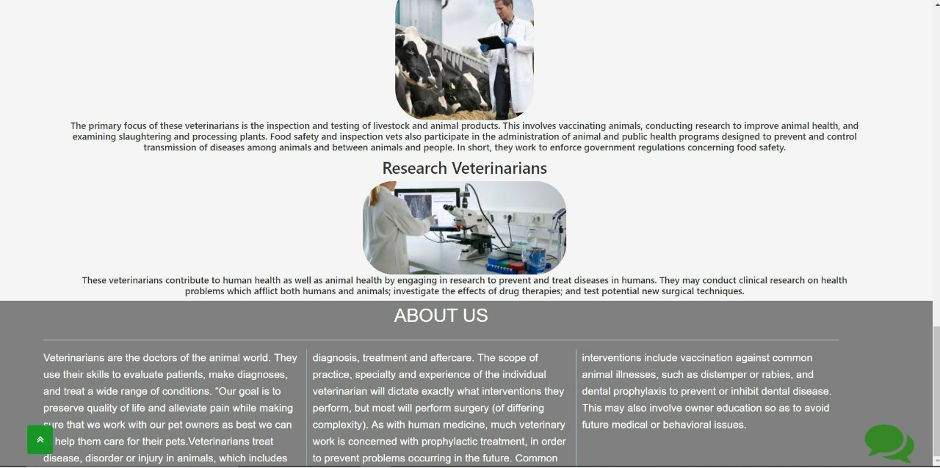

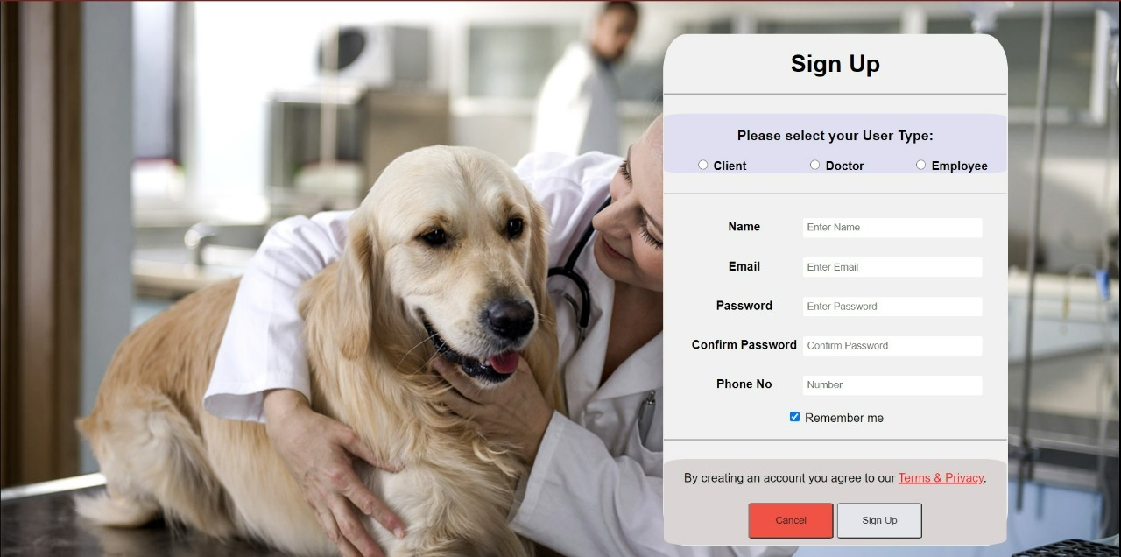 **SCREEN LAYOUTS**

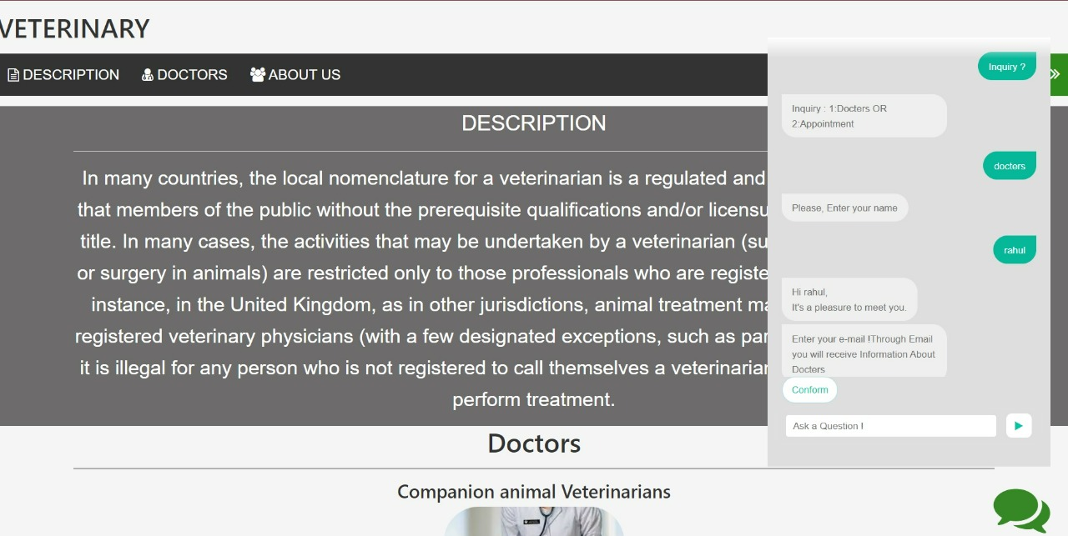

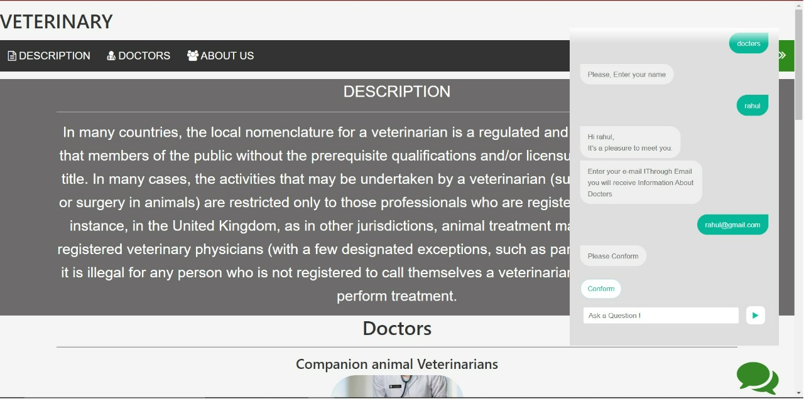 **SCREEN LAYOUTS**

**Conclusion**

The project “Veterinary Clinic Management System” is for computerizing the working in a hospital. The software takes care of all the requirements of an

average hospital and is capable to provide easy and effective storage of information related to patients that come up to the hospital.

It generates test reports; provide prescription details including various tests, diet advice, and medicines prescribed to patient and doctor. It also provides injection details and billing facility on the basis of patient’s status whether it is an indoor or outdoor patient.

The system also provides the facility of backup as per the requirement. And it also has an AI Chatbot for the users, so that they will be able to interact for their problems.