**Project 4: Lighting**

**Screenshots**

1. **With Red moving light**

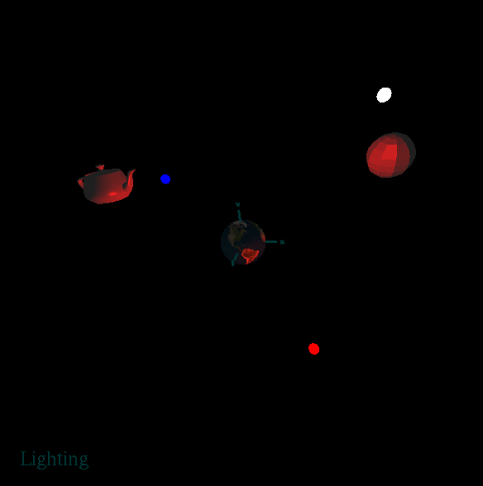

1. **With Blue light**

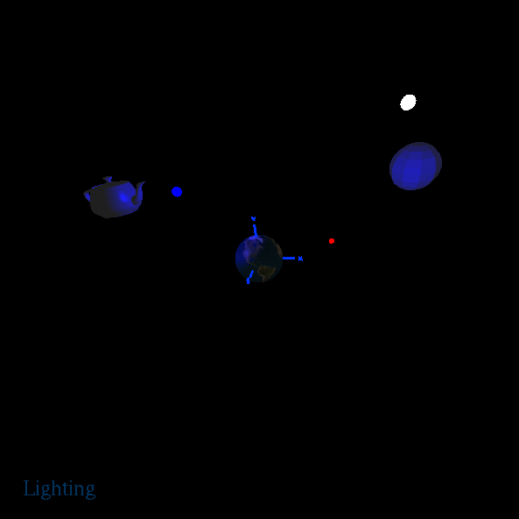

1. **With White light**

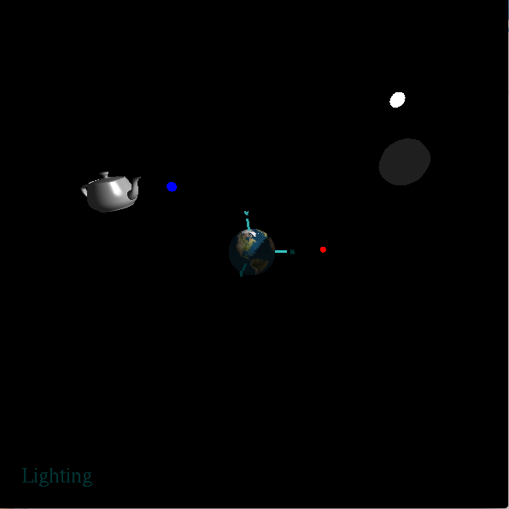

1. **All together**

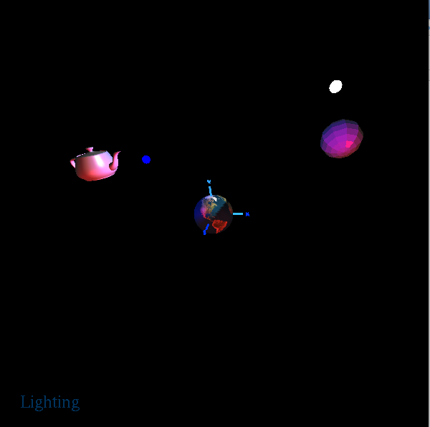

**Youtube Video Link:**

<https://www.youtube.com/watch?v=l76VmSvHcYs&t=3s>