UNLOX- ARTIFICIAL INTELLIGENCE-JULY
MINOR PROJECT – 1

PROJECT TITLE: EXPLORATORY DATA ANALYSIS ON OLX CARS DATASET
STUDENT NAME: TANYA KRISHNA
BATCH: ARTIFICIAL INTELLIGENCE – JULY
DATE: 21/07/26
DATASET NAME: OLX CARS DATASET
DATASET SOURCE: https://www.kaggle.com/datasets/abdullahkhanuet22/olx-cars-dataset
COLAB NOTEBOOK LINK: https://colab.research.google.com/drive/1qZyS_jtjyhLS1jEeX13S7R79H8fZebi_?usp=sharing

INTRODUCTION
Exploratory Data Analysis (EDA) is an important step in understanding a dataset before performing further analysis. In this project, I have performed EDA on an OLX Cars Dataset containing information about cars listed for sale. The dataset contains details such as car name, make, model, manufacturing year, kilometers driven, price, fuel type, transmission, registration city, condition, seller location, and other features. The main purpose of this project is to understand the dataset, clean the available data, identify patterns and relationships between different car attributes, detect possible outliers, and represent the findings using suitable visualizations. The complete analysis was performed using Python libraries such as Pandas, NumPy, Matplotlib, and Seaborn.

OBJECTIVE
The main objectives of this project are:
- To understand the structure and characteristics of the OLX Cars dataset.
- To inspect the rows, columns, and data types.
- To identify missing values and duplicate records.
- To clean the dataset wherever required.
- To perform descriptive statistical analysis.
- To study the distribution of different car attributes.
- To analyze relationships between variables such as price, year, fuel, transmission, and kilometers driven.
- To identify outliers and unusual observations.
- To visualize meaningful patterns using different types of charts.
- To obtain useful insights from the dataset.

DATASET OVERVIEW
The dataset contained 9179 rows and 18 columns before the cleaning process.
The main attributes available in the dataset are:
Column | Description
Ad ID | Unique identification number of the advertisement
Car Name | Name of the car
Make | Manufacturer or brand of the car
Model | Model of the car
Year | Manufacturing year of the car
KM's driven | Distance travelled by the car
Price | Listed selling price of the car
Fuel | Type of fuel used by the car
Registration city | City where the car is registered
Car documents | Availability or status of car documents
Assembly | Assembly type of the car
Transmission | Type of transmission
Condition | Condition of the car
Seller Location | Location of the seller
Description | Description provided by the seller
Images URL's | URLs of images associated with the listing
The dataset contains both numerical and categorical variables. Numerical variables mainly include Year, KM's driven, and Price, while variables such as Make, Model, Fuel, Transmission, Condition, and Registration city are categorical.

DATA QUALITY AND DATA CLEANING
I checked for missing values, duplicate records, incorrect data types, and unusual values in numerical columns. The missing values in the ‘Car Profile’ column were handled by replacing them with the mode of the column. The ‘Description’ column was removed as it was not required for the analysis. I also checked for duplicate records using the duplicated() function. The data types of all columns were checked to ensure that the variables were suitable for further analysis.
Box plots were used to identify possible outliers in numerical variables such as Price and KM's driven.
The following data cleaning steps were performed:
- Checked the first and last records of the dataset.
- Checked the shape and structure of the dataset.
- Checked the data types of all columns.
- Identified missing values.
- Checked for duplicate records.
- Filled missing values in the Car Profile column using the mode.
- Removed the Description column as it was not required for the analysis.
- Checked categorical columns for unique values and inconsistent categories.
- Used box plots to identify possible outliers.

DESCRIPTIVE ANALYSIS
Descriptive statistics were used to get a basic understanding of the numerical variables in the dataset.
The describe() function was used to calculate values such as:
- Count
- Mean
- Standard deviation
- Minimum value
- Maximum value
- 25th percentile
- 50th percentile
- 75th percentile
The numerical variables mainly included Year, KM's driven, and Price.
From the descriptive analysis, I was able to understand the general price range of cars, the range of kilometers driven, and the distribution of manufacturing years.
Categorical variables were also analyzed using frequency counts to understand the most commonly available fuel types, transmission types, car makes, and other categories.

VISUAL EXPLORATORY DATA ANALYSIS
Different types of visualizations were used to understand the dataset more clearly.
The following charts were created as part of the analysis:

1. Price Distribution
Chart Type: Histogram
Observation: The histogram shows that car prices are widely distributed across the 9,179 listings, with most cars concentrated in the lower-to-middle price range and a few high-priced listings appearing as potential outliers.
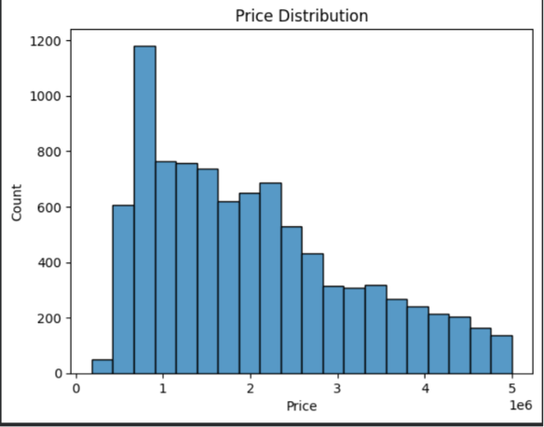

2. Fuel Type vs Transmission
Chart Type: Count Plot
Observation: The count plot shows that Petrol is the most common fuel type and Manual transmission is more frequently listed across the dataset.
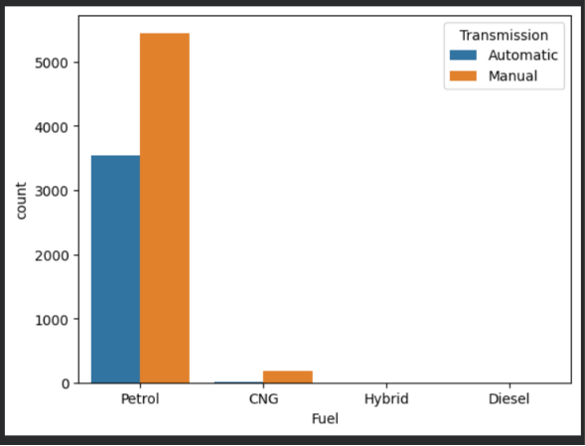

3. Correlation Heatmap
Chart Type: Heatmap
Observation: The correlation heatmap shows the strength of relationships among the numerical variables Year, KM's driven, and Price, helping identify how these factors are associated with each other.
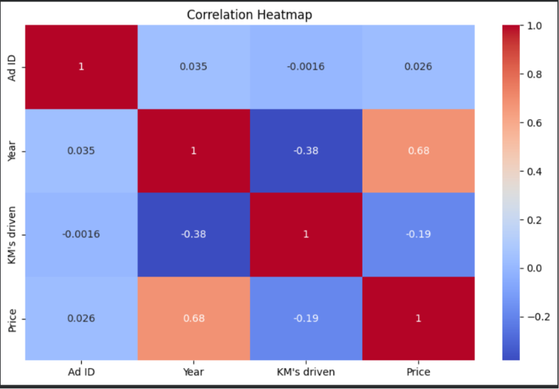
KEY FINDINGS
- The Fuel column shows that Petrol cars are the most frequently listed among the 9,179 car records in the dataset.
- The Transmission column shows that Manual cars are more commonly listed than cars with other transmission types.
- The Price column shows considerable variation in listed car prices, with most listings concentrated in the lower-to-middle price range and a few high-priced cars appearing as potential outliers.
- The analysis of the Year and Price columns indicates that newer cars generally have higher listed prices than older cars, although the price is also influenced by other factors.
- The analysis of KM's driven and Price suggests that cars with higher kilometers driven generally tend to have lower resale prices, although this relationship is not the same for every listing.
- The comparison of Make and Price shows that the listed prices vary across different car manufacturers, with some manufacturers having higher-priced cars than others.
- The box plot analysis of Price and KM's driven identifies unusual high-price and high-mileage listings that may represent genuine variations in the used-car market.

CONCLUSION
In this project, I performed Exploratory Data Analysis on 9,179 OLX car listings using Python. The analysis focused on important attributes such as Year, KM's driven, Price, Fuel, Transmission, and Make to understand the patterns and relationships in the dataset. The analysis showed that Petrol cars and Manual transmission cars are the most commonly listed, while car prices vary considerably across different listings and manufacturers. The relationship between Year and Price indicates that newer cars generally have higher listed prices, while KM's driven also appears to influence the resale price of cars. The visual analysis using histograms, count plots, box plots, scatter plots, and a correlation heatmap helped identify price variations and possible outliers. Overall, this project helped me understand how data cleaning, descriptive statistics, and visualization can be used to extract meaningful insights from a real-world automobile dataset.

