Source Code Management Lab Report
-Tanyasree Mannur
Introduction
1. What is Git?
Git is a distributed version control system (VCS) used to manage and track changes in source code during software development. It was created by Linus Torvalds in 2005 to handle the development of the Linux kernel.
Purpose of Git
• Tracking Changes:
Git records every modification made to files in a project. Developers can revisit earlier versions, compare changes, and restore previous states if needed.
• Collaboration:
Multiple developers can work on the same project simultaneously. Git merges contributions, resolves conflicts, and ensures everyone’s work is integrated smoothly.
• Branching & Merging:
Developers can create branches to experiment or develop new features independently. Once tested, these branches can be merged back into the main project.
• Distributed System:
Unlike centralized systems, every developer has a full copy of the repository, including its history. This makes Git fast, reliable, and resilient to data loss.
• Accountability & Transparency:
Each change is linked to the author, timestamp, and commit message, making it easy to understand why and when changes were made.
( In short, Git helps teams collaborate efficiently, maintain code quality, and manage project history without chaos.)
2. Version Control
Concept:
Version control is a system that records changes to files over time, allowing developers to track, manage, and restore different versions of a project. It acts like a detailed history log, showing who made changes, what was changed, and when those changes occurred.

Importance in Software Development
• Collaboration Made Easy:
Multiple developers can work on the same project without overwriting each other’s work. Version control merges contributions and resolves conflicts.
• Change Tracking:
Every modification is documented. Developers can roll back to previous versions if something breaks or compare changes to understand how the project evolved.
• Experimentation with Safety:
Developers can create branches to test new features or ideas without affecting the main codebase. If successful, the branch can be merged; if not, it can be discarded.
• Accountability:
Each change is linked to a specific contributor, making it clear who introduced what and why.
• Disaster Recovery:
Since version control systems often store complete project history, they protect against accidental deletions or corruption.
(In essence, version control is the backbone of modern software development, ensuring teamwork, reliability, and efficiency.)
3.GitHub
Definition:
GitHub is a cloud-based platform for hosting Git repositories. It provides a web interface and additional tools that make it easier to use Git, especially for collaboration and project management. Essentially, GitHub is where developers store their code online, share it with others, and manage projects together.
Role in Collaboration
• Central Repository Hosting:
Teams can push their local Git repositories to GitHub, making the code accessible to everyone involved in the project.
• Collaboration Tools:
GitHub supports pull requests, code reviews, and discussions, enabling developers to propose changes, review each other’s work, and merge updates seamlessly.
• Issue Tracking & Project Management:
Developers can log bugs, assign tasks, and track progress directly within GitHub, keeping everything organized.
• Open Source Community:
Millions of open-source projects are hosted on GitHub, allowing developers worldwide to contribute, learn, and share code.
• Integration & Automation:
GitHub integrates with CI/CD pipelines, testing tools, and deployment systems, helping teams automate workflows and deliver software faster.
4. Difference Between Git and GitHub
Aspect | Git | GitHub
Definition | A distributed version control system (VCS) used to track changes in code. | A cloud-based platform that hosts Git repositories and adds collaboration features.
Purpose | Manages code history, branching, merging, and version tracking locally or on servers. | Provides a central place to share repositories, review code, and collaborate online.
Scope | A tool installed on your computer; works offline. | A web service that extends Git with social and project management features.
Collaboration | Developers share code by pushing/pulling repositories manually. | Developers collaborate via pull requests, issues, discussions, and integrated workflows.
Ownership | Open-source software created by Linus Torvalds. | Owned by Microsoft, offering additional services like GitHub Actions (CI/CD) and GitHub Pages.
Basic Git Commands
1.Command
cat filename
Description
This command displays the contents of a file directly in the terminal. It is commonly used to quickly view the text stored inside a file without opening an editor.
Output
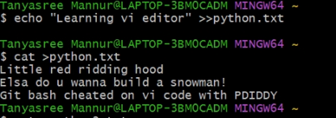

2. Command
echo "text-content" > filename
Description
This command writes text into a file. If the file does not already exist, it will automatically be created. If the file exists, its previous content will be replaced with the new text.
Output
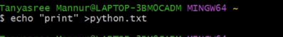

3. Command
echo "text" >> filename
Description
This command appends text to an existing file. Unlike the previous command, it does not remove the existing content but adds new text at the end of the file.
Output
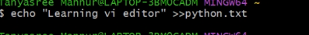

4. Command
cat > filename
Description
This command creates a new file and allows the user to type text directly into the terminal. After typing the text.
Press Ctrl + D saves the content and exits.
Output
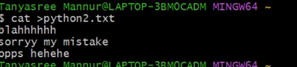

5. Command
cat >> filename
Description
This command allows the user to add additional text to an existing file without deleting its previous content.
Output


6. Command
cat file1.txt > file2.txt
Description
This command copies the content from one file to another file. The contents of file1.txt are written into file2.txt.
Output

7. Command
nano file.txt
Description
This command opens the Nano text editor in the terminal to create or edit a file. Users can type and modify text inside the file and save it using keyboard shortcuts.
Output
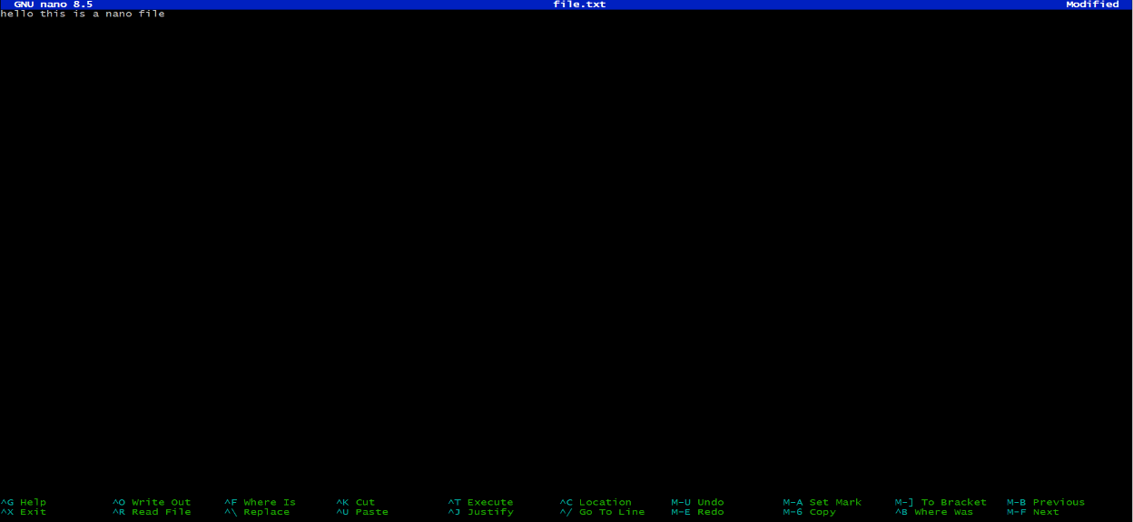

8. Command
git var GIT_EDITOR
Description
This command checks and displays the default editor that Git uses for editing commit messages and other Git-related files.
Output
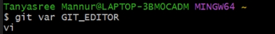

9. Command
git config --global core.editor "vi"
Description
This command sets the vi editor as the default text editor for Git operations such as writing commit messages.
Output

10. Command
vi filename.txt
Description
This command opens a file in the vi text editor. If the file does not exist, the vi editor will automatically create a new file with the specified name.
Output


vi Editor Commands
11. Command
i
Description
This command switches the vi editor to Insert Mode, allowing the user to type and insert text before the current cursor position.
Output

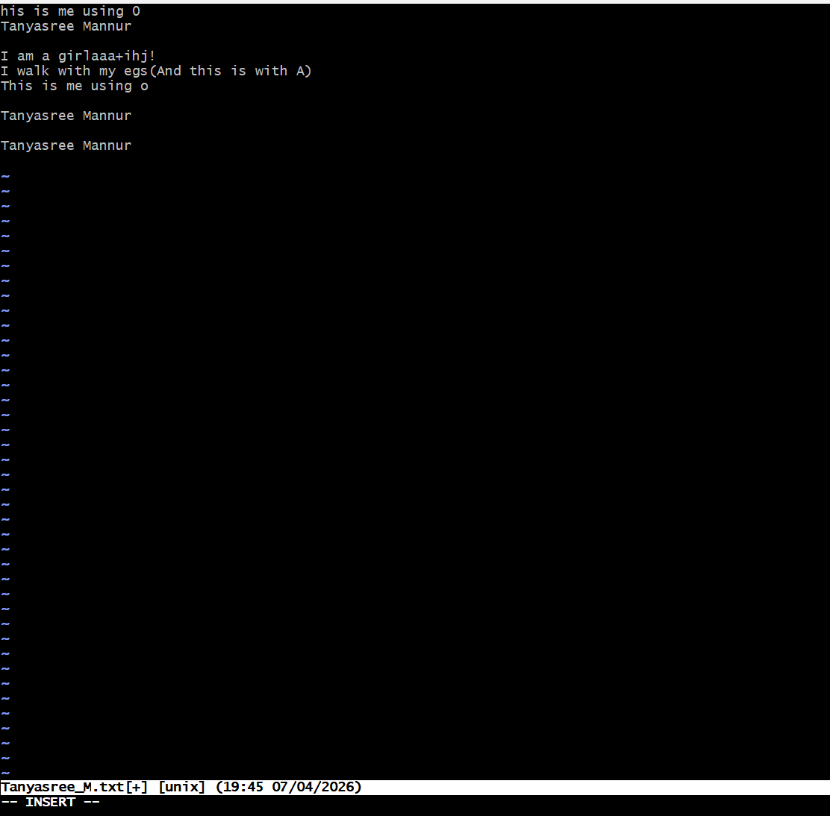

12. Command
a
Description
This command inserts text after the current cursor position in the vi editor.
Output

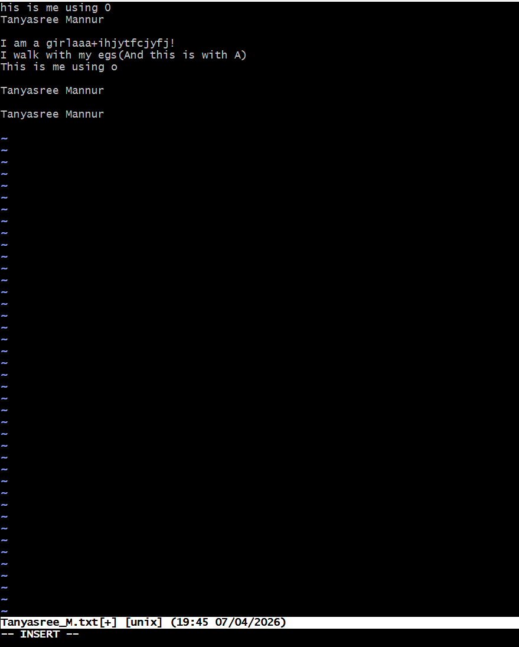

13. Command
:w
Description
This command saves the current file in the vi editor without exiting the editor.
Output

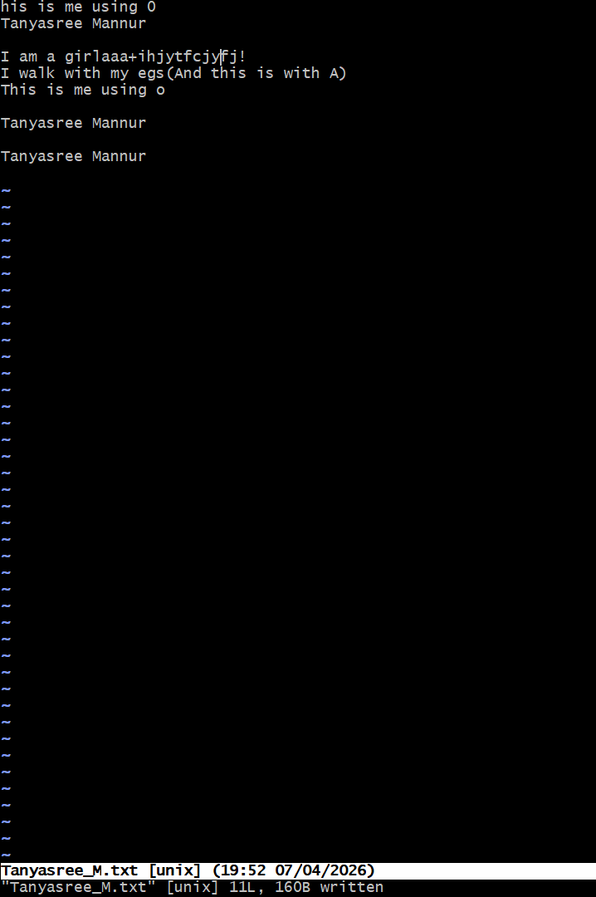

14. Command
:q
Description
This command exits the vi editor.
Output
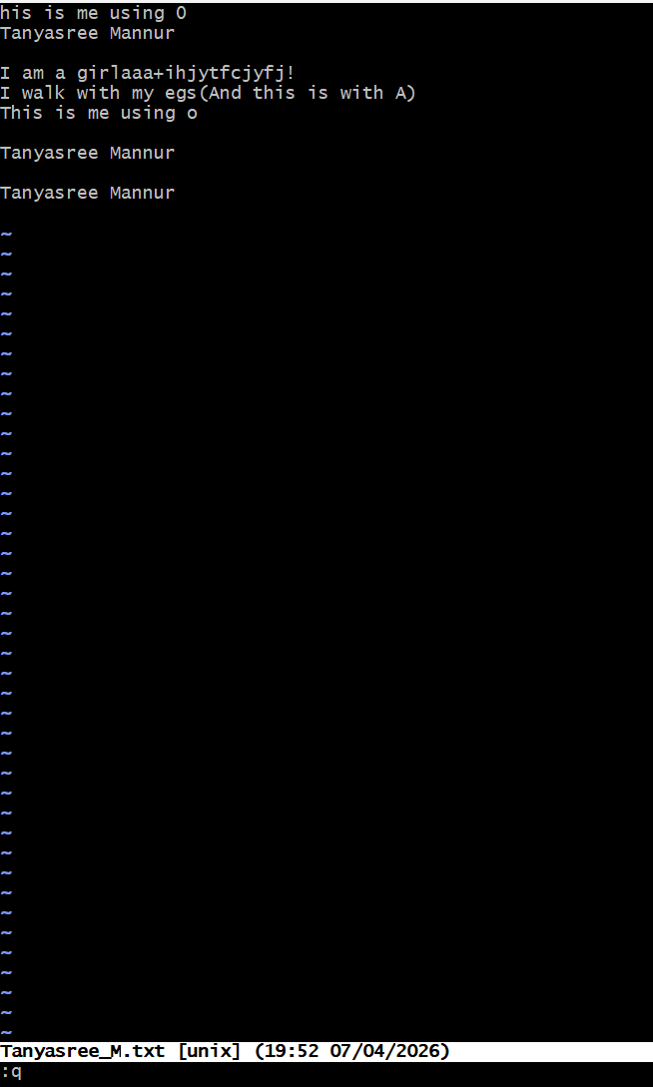
15. Command
:wq
Description
This command saves the file and then exits the vi editor.
Output
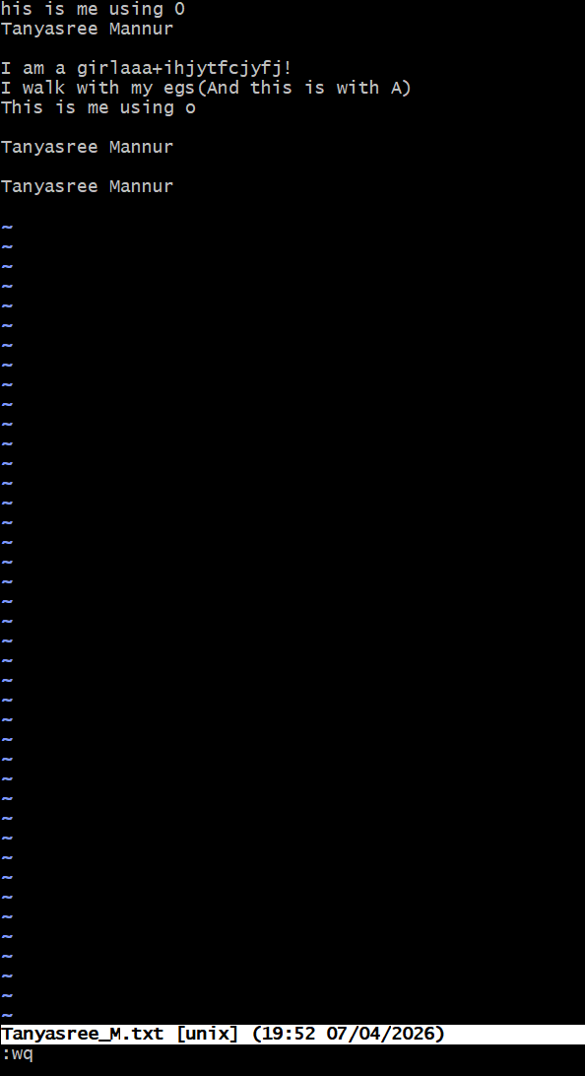
16. Command
:q!
Description
This command exits the vi editor without saving any changes made to the file.
Output
