|  |
| --- |
|  |
| create TABLE PERSON ( |
|  | driver_id varchar2(20), |
|  | name varchar2(20), |
|  | address varchar2(20), |
|  | PRIMARY KEY (driver_id) |
|  | ); |
|  | create table car( |
|  | reg_num varchar(10), |
|  | model varchar(10), |
|  | year int, |
|  | primary key(reg_num) |
|  | ); |
|  | create table accident ( |
|  | report_num int, |
|  | accident_date date, |
|  | location varchar(20), |
|  | primary key(report_num) |
|  | ); |
|  | create table owns( |
|  | driver_id varchar(10), |
|  | reg_num varchar(10), |
|  | primary key(driver_id,reg_num), |
|  | foreign key(driver_id) references person(driver_id), |
|  | foreign key(reg_num) references car(reg_num) |
|  | ); |
|  | create table participated( |
|  | driver_id varchar(10), |
|  | reg_num varchar(10), |
|  | report_num int, |
|  | damage_amount int, |
|  | primary key(driver_id,reg_num,report_num), |
|  | foreign key(driver_id) references person(driver_id), |
|  | foreign key(reg_num) references car(reg_num), |
|  | foreign key(report_num) references accident(report_num) |
|  | ); |
|  | insert into person values('&driver_id','&name','&address'); |
|  | select * from person; |
|  | insert into car values('&reg_num','&model', &year); |
|  | commit; |
|  | select * from car; |
|  | commit; |
|  | insert into accident values(&report_num,'&accident_date','&location'); |
|  | commit; |
|  | select * from accident; |
|  | insert into owns values ('&driver_id','&reg_num'); |
|  | commit; |
|  | insert into participated values ('&driver_id','&reg_num',&report_num,&damage_amount); |
|  | commit; |
|  | select * from participated; |
|  | update participated set damage_amount=25000 where reg_num='KA053408' and |
|  | report_num=12; |
|  | commit; |
|  | select * from participated; |
|  | insert into accident values(16,'15-MAR-08','Domlur'); |
|  | select * from accident; |
|  | select count(distinct driver_id) CNT from participated a, accident b where |
|  | a.report_num=b.report_num and b.accident_date like '%08'; |
|  | select count(report_num) CNT from car c,participated p where c.reg_num=p.reg_num and |
|  | model='LANCER' |
|  |  |

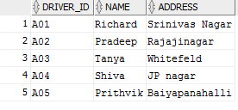

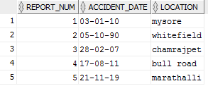

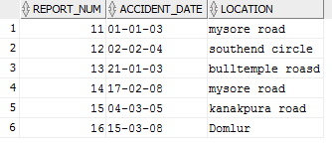

accin08.PNG

lancer.PNG

