**TEST PLAN**

**the functions of the “ Stories” in VKontakte**

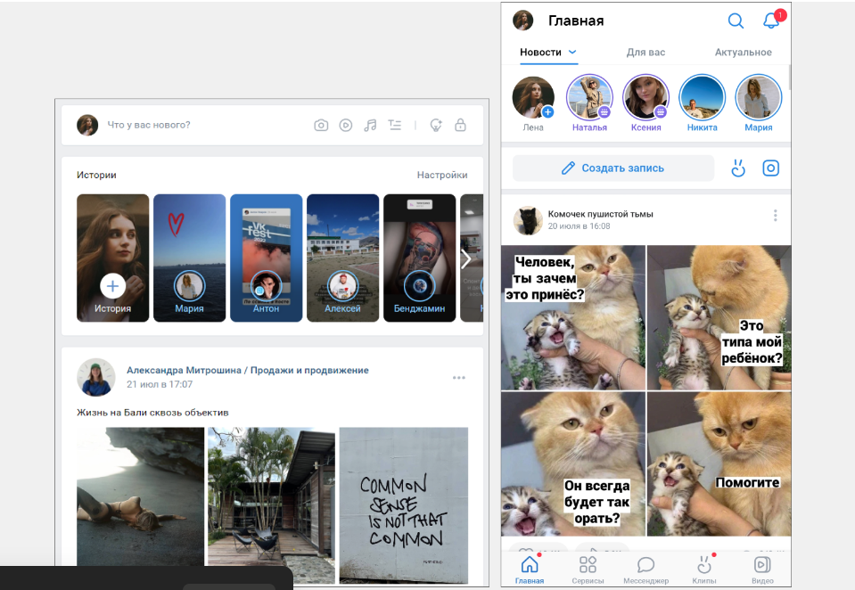

**Created by:** Tatiana Savonevich, Sophia Shashkova, Valeria Kulakovskaya

**2023** [*Академия BELHAR*](https://belhard.academy/)

**Glossary**

| ID | Identifier |
| --- | --- |
| QA | Quality Assurance |

# 

# 

TEST PLAN IDENTIFIER

REFERENCES

INTRODUCTION

TEST ITEMS (FUNCTIONS)

SOFTWARE RISK ISSUES

FEATURES TO BE TESTED

FEATURES NOT TO BE TESTED

APPROACH (STRATEGY)

1. Testing levels

Types of testing:

2. Testing tools

3. Meetings

4. Measures and metrics

ITEM PASS/FAIL CRITERIA

SUSPENSION CRITERIA AND RESUMPTION REQUIREMENTS

TEST DELIVERABLES

REMAINING TEST TASKS

ENVIRONMENTAL NEEDS

STAFFING AND TRAINING NEEDS

RESPONSIBILITIES

SCHEDULE

PLANNING RISKS AND CONTINGENCIES

APPROVALS

# **TEST PLAN IDENTIFIER**

Testing is carried out by the company "VK Company".

Document: TP_001263_180323

Moscow, 125167, Leningradsky Prospekt 39, p. 79

# **REFERENCES**

| Date | 18.03.2023 |
| --- | --- |
| Version | 10.0.4 |
| Project Plan | Test the functionality of the functions in the VK application |
| High Level design document | RR_0025 |
| Detail design document | RR_0026 |
| Development and Test process standards | RR_0027 |

# **INTRODUCTION**

*“Stories” in VKontakte are a format of vertical publications that disappear from the feed after 24 hours. They are displayed at the very top of the feed. They can be published both in your personal profile and in the community.*

***This Test Plan document for the VKontakte application supports the following objective:***

* Testing the new feature of the app 'Stories';
* Identify the risks that may occur when using the function;
* Describe the methods and strategies that have been used to test the feature;
* Provide an assessment of the work that has been done.

The project will have three levels of testing: modular, system/integration and acceptance.

The details for each level are discussed in the "Approach" section and will be further defined in the plans for a specific level.

The estimated timeframe for this project is two (2) weeks, so any delays in the development process or in the installation and verification of third-party software can have a significant impact on the test plan. Acceptance testing is expected to take one (1) day from the date of submission of the application from system test and will be conducted in parallel with the current application process.

# **TEST ITEMS (FUNCTIONS)**

The function we are testing is "Storis". The user should be able to post the maximum possible number of stories without problems, without encountering problems.

***Storis functions to be tested:***

* The existence of an "Add to Story" button;
* Configuration of the function with the gallery and the phone camera;
* Using masks when switching to "Camera" mode;
* Presence of buttons "Live", "Clip", "Video history", "QR-scanner", “Ping Pong” when switching to "Camera" mode;
* Adding media files (Photo/Video);
* Ability to edit media files;
* Display of photos and videos in "Stories" after pressing the "Done" button.
* History display within 24 hours.

# **SOFTWARE RISK ISSUES**

| **Risk** | **Solution** |
| --- | --- |
| 1. Information specified in the requirements is not up to date | The testing and development team needs to be informed when items in the requirements are changed and new requirements are added for the application. |
| 1. Unclear requirements from the client | Communication with the customer needs to be properly set up for knowing exactly what features he/she wants to see in the application |
| 1. Application version that does not support the new feature | The customer needs to be informed that the new feature needs to be adapted to the new version of the app. |
| 1. Leakage of users' personal information, such as geolocation, photos and other information. | The introduction of strict privacy and security rules related to the use of the "Storis" function.Conduct regular checks for malicious content, using machine learning algorithms to identify unwanted contacts |
| 1. The possibility of infection with malware and viruses when interacting with other applications. | Development of regular updates and fixes for the application to eliminate vulnerabilities and risks. Teaching users the rules of security and privacy when using the “Storis” function |

# **FEATURES TO BE TESTED**

Below is a list of items to be tested in the feature ‘Stories’.

| **To be tested** | **Risk level** |
| --- | --- |
| Adding photos | High |
| Adding video files | High |
| Creating and publishing stories | High |
| VK Clips | Middle |
| Pin Pong | Middle |
| Live Broadcast | Middle |
| QR scanner | Middle |
| Viewing “Stories” by other users | Middle |
| Deleting stories | Middle |
| Editing posts (adding text, stickers, hashtags, geolocation, effects, filters creating polls) | Middle |

# **FEATURES NOT TO BE TESTED**

| **What will not be tested** | **Why it will not be tested** | **Risk level** |
| --- | --- | --- |
| 1. Messages (including voice and video) | tested earlier and are currently working stably. | Low |
| 2. Uploading photos and videos | tested earlier and are currently working stably. | Low |
| 3. Likes | tested earlier and are currently working stably. | Low |
| 4. Joining communities and groups | tested earlier and are currently working stably. | Low |
| 5. Comments | tested earlier and are currently working stably. | Low |
| 6. Music | tested earlier and are currently working stably. | Low |
| 7. Games | tested earlier and are currently working stably. | Low |
| 8. Feed | tested earlier and are currently working stably. | Low |
| 9. Videos | tested earlier and are currently working stably. | Low |
| 10. Services | tested earlier and are currently working stably. | Low |

# **APPROACH (STRATEGY)**

## ***1. Testing levels***

***Testing levels:***

**Smoke test:**

1. Installing the application

2. Registration or login (if the user is registered)

3. Log in to the main page and profile

**Critical Path Test:**

1. Check all the functions in the "stories" section

**Extended test**

1. Checking the story editor

## Types of testing:

**UNIT** testing will be conducted by the developer and will be approved by the head of the development team. Confirmation of unit testing (a list of test cases, examples of output data, printouts of data, information about defects) must be provided by the programmer to the team leader before the unit testing is accepted and transmitted to the tester. All information about unit testing will also be provided to the testing specialist.

**DATA** testing is carried out by the development department, since the testing department works using the "black box" method.

**ACCEPTANCE** testing will be conducted by the actual end users with the help of the test manager and the head of the development team.

The programs will start acceptance testing after all critical and major defects have been fixed.

| **Type of testing** | **By whom is conducted** | **The essence of the test** |
| --- | --- | --- |
| **DYNAMIC** testing | Сonducted by the testing department | Conducting testing by downloading the application. |
| **USER** **INTERFACE** testing | Сonducted by the testing department | Everything is clear and convenient |
| **FUNCTIONAL** testing | Сonducted by the testing department | Checking that the app is loading, the stories are displayed on the main page at the top. The "stories" section is displayed on the left (a circle with the user's photo, a circle at the bottom plus "add a story") |
| **LOAD** testing | Сonducted by the testing department | Publication of stories (photos, videos), videos, clips of different duration (up to the maximum possible), in the maximum possible quantity |
| **STRESS** testing | Сonducted by the testing department | Creating a situation where all users of the application publish a large number of stories at the same time, which leads to server overload. |
| **SECURITY** testing | Сonducted by the testing department | Checking that when a user restricts the viewing of their stories to certain users, these users do not see these stories. They are not displayed to these users.  The app requests access to the camera and gallery before allowing you to upload a photo. |
| **CONFIGURATION** testing | Сonducted by the testing department | Checking that the history function works on different devices and on different operating systems |
| **INSTALLATION** testing | Сonducted by the testing department | After downloading the application, we see that all the functions of the "Stories" section are available to the user and work. |
| **NEGATIVE** testing | Сonducted by the testing department | Uploading more stories than the maximum allowed. An attempt to take advantage of the improvements without updating the application. An attempt to upload a video from the gallery to the history, which is longer than the maximum possible time. |
| **DOCUMENTATION** testing | Сonducted by the testing department | Checking the documentation for the completeness of the description of the application and its functionality |

## *2. Testing tools*

When testing the "stories" section, the "black box" and "gray box" method will be applied, since testing will be carried out from the user's point of view to make sure that all the functions of the "stories" section work.

The team uses the following test design techniques: Equivalent Classes, Boundary Values, Pairwise Testing.

The main testing is regression, because we check that the application works without problems.The main

During testing, such operating systems were used as: Windows 10 (version 21 h2, 64-bit operating system), Google Chrome browser version 111.0.5563.65

*The following tools will be used to test the Product:*

| **Description** | **The tool** |
| --- | --- |
| Test-case storage tool | Redmine |
| Bug tracking system | Jira |
| Reporting tools | Word, Excel |
| Streamline software testing processes | TestRail |
| Android and ios emulation, android connection during debugging;  Redefinition of geolocation and substitution of User-Agent;  Simulating a slow network connection;  Viewing information about errors in the code in the console tab. | Chrome DevTools |
| For forming diagrams and diagrams | draw.io |

## *3. Meetings*

The testing team will meet 2 times a week to assess the progress made to date and identify error trends and problems as early as possible. The head of the testing team will also meet with the developers and the project manager once a week. Additional meetings may be convened as needed in emergency situations.

## *4. Measures and metrics*

The following information will be collected by the development team during the unit testing process. This information will be provided to the testing team when the program is launched, as well as provided to the project team once a week.

1. Defects in modulus and severity.

2. The source of the defect (requirement, design, code)

3. The time spent on the elimination of defects by defects, only for critical and basic. All minor defects can be summed up together.

# **ITEM PASS/FAIL CRITERIA**

Before starting testing, you need to review the requirement, if there are any questions, clarify them, write a test case.

| **ID** | **Summary** | **Result** |
| --- | --- | --- |
| T-001 | When you enter the main page, the stories are displayed at the top | Pass |
| Т-002 | A circle with the user's photo is displayed at the top left, and the "add history" circle is a plus at the bottom | Pass |
| Т-003 | When you click on (+ (add story)), the gallery is connected | Pass |
| Т-004 | The application requests access to the gallery | Pass |
| Т-005 | The user can upload photos/videos selected from the gallery to the history | Pass |
| Т-006 | Going to the "stories" section, the camera appears and a selection of functions appears at the bottom (regular story, video story, clip, live broadcast, QR scanner, ping pong) | Pass |
| Т-007 | You can choose the front camera or the front | Pass |
| Т-008 | Before you start shooting, the app must request access to the camera | Pass |
| Т-009 | There is access to masks | Pass |
| Т-0010 | When uploading a photo from the gallery, or after taking a photo in the section itself, the editor appears | Pass |
| Т-0011 | After the story is published, the user's circle is surrounded by a blue frame | Pass |
| Т-0012 | The story lasts 15 seconds | Pass |
| Т-0013 | The history is available for viewing to all users | Pass |
| Т-0014 | The user's stories are not seen by those to whom he has restricted access | Pass |
| Т-0015 | The history is displayed in the profile for 24 hours and then it is deleted itself | Pass |
| Т-0016 | The user can delete the history at any time | Pass |
| Т-0017 | The QR code function should scan a QR code, including a photo | Pass |
| Т-0018 | The “ping pong” function should shoot a video for 15 seconds and play it back and forth | Pass |
| Т-0019 | The clip can be shot within 3 minutes and edited | Pass |
| Т-0020 | The ability to conduct live broadcasts | Pass |

All scheduled tests have been carried out, no errors have been found, the function works without problems.

# **SUSPENSION CRITERIA AND RESUMPTION REQUIREMENTS**

*The criteria for suspending tests are:*

1. Server overload and system failures. Testing will resume after the problem is fixed.

2. Temporary suspension due to the resolution of issues that arose during the testing process. For example: the maximum possible number of stories per day is 20. We are trying to upload 21 stories, we can't, we are going to figure out why (see the requirement)

# **TEST DELIVERABLES**

Test deliverables can be found in the following table by linking.

|  | **Link** |
| --- | --- |
| Requirements | [<Link>](https://vk.com/) |
| Test plan | [<Link>](https://drive.google.com/drive/folders/1Z2QMnov_Omm2F29UTYqk0JC-PQv6SQbh) |
| Acceptance test plan | [<Link>](https://vk.com/) |
| Test logs and staff turnover reports | [<Link>](https://vk.com/) |
| Functional Specification | [<Link>](https://vk.com/) |
| Terms of Use | [<Link>](https://vk.com/) |
| Checklist for the new "Storis" function | [<Link>](https://vk.com/) |
| Test cases | [<Link>](https://vk.com/) |
| Bug reports | [<Link>](https://vk.com/) |
| Test Result Report | [<Link>](https://drive.google.com/drive/folders/1hL_jbfSZdM6NtFGeDYz1YEG9V7DYgrnR) |

# **REMAINING TEST TASKS**

| **Description** | **Build version** | **Responsibility** | **Detail design document** |
| --- | --- | --- | --- |
| Checking the functionality of the profile settings | 1.0.1 | 1. Tatiana Savonevich 2. Sophi Shashkova 3. Valeria Kulakovskaya | RR_0017 |
| Checking the functionality of sending messages | 2.0.1 | 1. Tatiana Savonevich 2. Sophi Shashkova 3. Valeria Kulakovskaya | RR_0018 |
| Checking the functionality of adding friends | 3.0.1 | 1. Tatiana Savonevich 2. Sophi Shashkova 3. Valeria Kulakovskaya | RR_0019 |
| Checking the functionality of creating and joining conversations | 4.0.5 | 1. Tatiana Savonevich 2. Sophi Shashkova 3. Valeria Kulakovskaya | RR_0020 |
| Checking the functionality of advertising and promotion | 7.0.1 | 1. Tatiana Savonevich 2. Sophi Shashkova 3. Valeria Kulakovskaya | RR_0021 |

# 

# **ENVIRONMENTAL NEEDS**

Community administrators and editors can publish stories in the community. You can download stories from your smartphone and PC.

There are functions available for community stories — masks, stickers, graffiti, text, videos and you can attach links.

You can respond to stories with a message — it is sent to messages to the community or with your own story;)

It is forbidden to place third-party advertising in stories and they must comply with the rules of the VKontakte website

*Technical parameters:*

The duration is no more than 15 seconds.

The file size should not exceed 10 MB.

Video codec: H.264.

Audio codec: AAC.

Photo size 1080*1920 px

Video size 720*1280 px

Vertical format photos and videos

# **STAFFING AND TRAINING NEEDS**

To ensure complete and proper testing from a learning perspective, the following areas need to be considered.

A. Developers and testers will need to be trained in the basic operations of the EDI interface. Before the final adoption of the project, the operational staff will also need to undergo full training in the EDI communication process.

# **RESPONSIBILITIES**

| **Post** | **Member** | **Responsibilities** |
| --- | --- | --- |
| Test Project Manager | 1 | * Performing management control; * Providing management reporting; * Generating reports. |
| Test Designer | 1 | * Identifying, prioritising and ensuring the development of test cases; * Test plan development; * Testing model development; * Assessment of testing efficiency. |
| QA | 1. Tatiana Savonevich 2. Sophi Shashkova 3. Valeria Kulakovskaya | * Creating and executing test cases; * Capturing results; * Requirements testing; * Generating bug reports; * Replay of bugs; * Recommendations for functionality improvement ; * Black-box testing; * Regression testing; * Recording the work process in the system. |

# **SCHEDULE**

| **Date** | **Task** | **Who performed** |
| --- | --- | --- |
| 02.03.2023 | Requirements analysis | 1.Tatiana Savonevich  2.Sophi Shashkova  3. Valeria Kulakovskaya |
| 03.03.2023 | Development of a test plan | 1.Tatiana Savonevich  2.Sophi Shashkova  3. Valeria Kulakovskaya |
| 06.03.2023 | Creating test documentation | 1.Tatiana Savonevich  2.Sophi Shashkova  3. Valeria Kulakovskaya |
| 07.03.2023 | Testing Team Meeting | 1.Tatiana Savonevich  2.Sophi Shashkova  3. Valeria Kulakovskaya |
| 09.03.2023 | Start of testing | 1.Tatiana Savonevich  2.Sophi Shashkova  3. Valeria Kulakovskaya |
| 14.03.2023 | Testing Team Meeting | 1.Tatiana Savonevich  2.Sophi Shashkova  3. Valeria Kulakovskaya |
| 17.03.2023 | Completing testing and creating a report | 1.Tatiana Savonevich  2.Sophi Shashkova  3. Valeria Kulakovskaya |

# **PLANNING RISKS AND CONTINGENCIES**

| **Risk** | **Solution** | **Responsible employee** |
| --- | --- | --- |
| 1. Smoke test failed | Sending a problem report to the lead, waiting for a response on resumption of work. | QA |
| 2. Inconsistency between the finished product and the customer's prototype | The issue is handled by the project manager as well as the testing team. Postponement of the release date and correcting the requirements. | Project manager, QA |
| 3. The function was developed late | Transmission of information to the lead and test manager to postpone project release and carry out the required tests. | QA |
| 4. Critical system failures | Delaying the release of the project, identifying the causes of critical failures and fixing them. | QA |
| 1. Termination of funding | Resolution of the issue by the project manager. | Project manager |
| 1. Inability to carry out the necessary tests due to a postponement of the project's deadline. | Resolution of the issue by the project manager. | Project manager |

# **APPROVALS**

| **Role** | **Data** |
| --- | --- |
| Project Manager |  |
| Business Analyst |  |
| Designer |  |
| Frontend developer |  |
| Backend developer |  |
| QA-engineer |  |

# 