

**Soi Aroylatics**

COR1305

Spreadsheet Modelling and Analytics

G7 Team 2

AY 2019-2020 Term 2

|  |  |  |
| --- | --- | --- |
| **Name** | **Student ID** | **Email** |
| Lim Li Yao | 01359331 | liyao.lim.2018@business.smu.edu.sg |
| Melissa Anna Dittmer Jia Xin | 01371563 | madittmer.2018@socsc.smu.edu.sg |
| Tan Jie Ying | 01371293 | jieying.tan.2018@accountancy.smu.edu.sg |
| Tan Qiu Long Matthew Ian | 01328522 | matthew.tan.2018@sis.smu.edu.sg |
| Tan Yin | 01331040 | yin.tan.2018@sis.smu.edu.sg |

|  |
| --- |
| **1 ABOUT THE COMPANY** |

Soi Aroy is a Singapore-based food and beverage business, focusing on Thai cuisine. There are currently two branches operating in Sim Lim Complex and SMU’s campus. Both branches’ operations began in 2018 and 2019 respectively. Soi Aroy has received significant media coverage and has been featured in multiple well known newspapers in Singapore.

|  |
| --- |
| **2 PROJECT SCOPE** |

**Methodology**

To improve the current business through the use of modelling and optimisation functionalities in Microsoft Excel. Necessary sales, cost and information on marketing events will be provided by the company. Information on external events in SMU and other proxy data will be retrieved from publicly accessible domains.

|  |  |  |
| --- | --- | --- |
| **ISSUES** | | |
| * Has been making a loss since the beginning of operation * Especially low sales volume during certain periods of the year, particularly university holiday periods for both branches * Current marketing and promotional events are ineffective in improving sales * Owner is uncertain of how to capitalize on events held in or nearby SMU which provide a surge in foot traffic * Lack of foresight on future sales and unable to plan accordingly | | |
| **SOLUTION** | **METHODOLOGY** | **PURPOSE AND BENEFITS** |
| Forecasting of sales based on seasonality trends | Projection of sales using functions such as the TREND() function.  Use of dashboards to display sensitivity and seasonality analysis. | To empower the business owner of future sales to plan future inventory.  To understand the effectiveness of current and future marketing strategies. |
| Forecasting of new marketing and optimal pricing strategies | Price optimisation using Excel solver based on calculated parameters. | Understanding customer favourites and trending menu items to determine inelastic goods.  Finding the optimal pricing strategy to achieve desired profit and sales growth required by the sole proprietor in SMU’s outlet.  Matching optimal marketing (promotional) strategies to external events held in SMU. |

|  |
| --- |
| **3 INFLUENCE DIAGRAM** |

In the subsequent sections of the proposal, the following legend will be used to represent the input and output values required in the influence and black box diagram

|  |  |  |
| --- | --- | --- |
|  | **Legend** |  |
| Input | **Decision** |  |
| **Parameter** |  |
| **Historical** |  |
|  | **Intermediate** | Output |
|  | **Result** |
|  | **Key Result** |

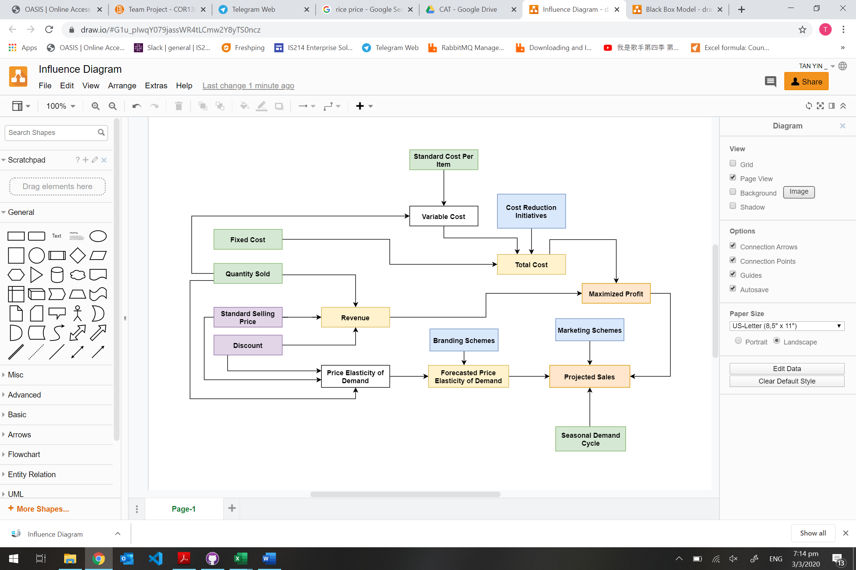

|  |
| --- |
| **4 BLACK BOX MODEL** |

