SYAZMI SYAKIRA BT MOHD RUDZLAN (A16 CS0209) SECTION 2

**TUTORIAL LAB**

1.  Determine root for when using newton method,ε= 0.005

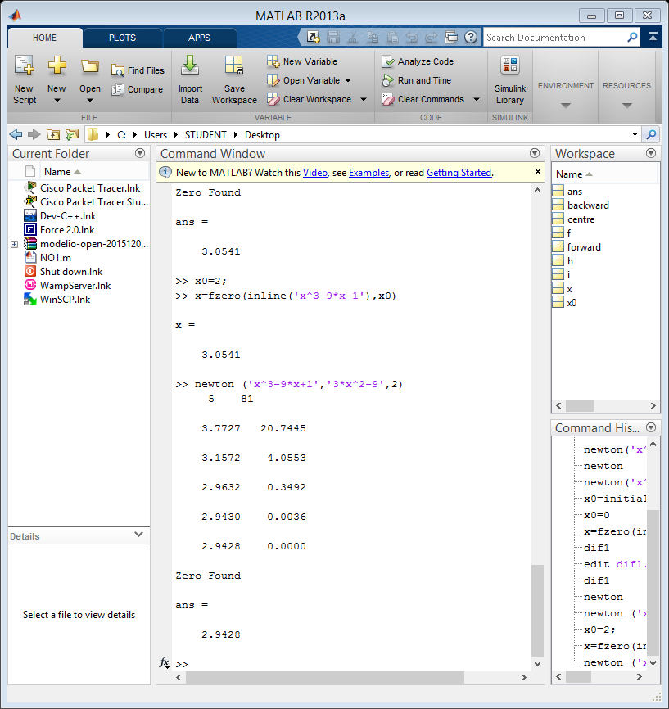

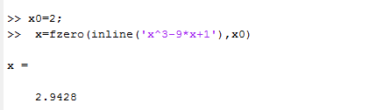2. Verify the answer in 1) by using build in MATLAB function fzero.

1. 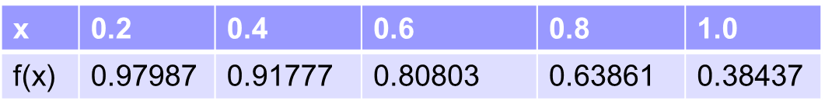Given

a) Determine first derivative for f’ (0.6) using

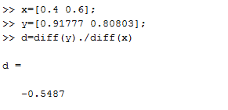-two point forward difference

-two point backward difference

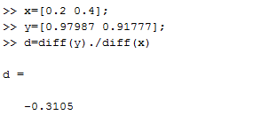

- three point centre difference

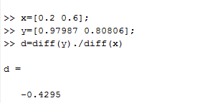

b) Determine second derivative for f’’ ( 0.4 ) using

* + - Three point centre difference