# Angular Workshop – Recipes

Create a basic recipe store app to store **users** and **recipes**. The app should have functionality to **register**/**login**/**logout** users. Authenticated users can **list** all recipes, **create** recipes, show a **detailed** page, **edit** and **delete** all recipes. Use **Firebase** for back-end. Handle **errors** using **toastr**.

## Firebase

Create a new app at [Firebase](https://console.firebase.google.com). Enable **email authentication** and set the **read** and **write** properties to work with **authentication**.

In your angular app you need to install firebase (**npm install firebase --save**) and inside the **ngOnInit** lifecycle hook at **app.component.ts** initialize the app defining the **app key** and the **domain name**:

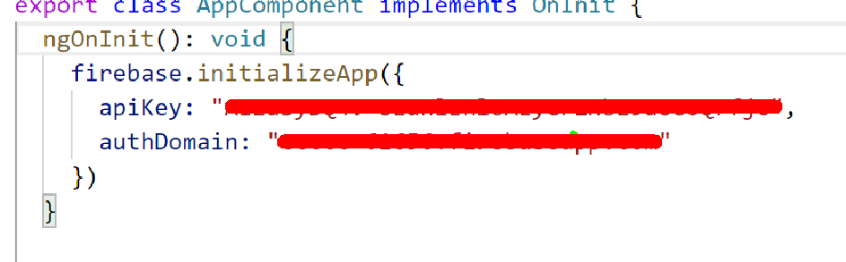

Import the provided **recipes JSON** and you are ready to go.

## Authentication

### Sign Up

Signing up users is done by using the **firebase.auth().createUserWithEmailAndPassword()** function which returns a promise.

### Sign In

Signing up users is done by using the **firebase.auth().signInWithEmailAndPassword()** function which returns a promise.

### Logout

Signing out users is done by using the **firebase.auth().signOut()** function

### Token

Retrieve the token using **firebase.auth().currentUser.getIdToken()** and set the token inside the service.

## Recipes

### List All Recipes

**(GET) -> {appDomain}/recipes/.json?auth={token}**

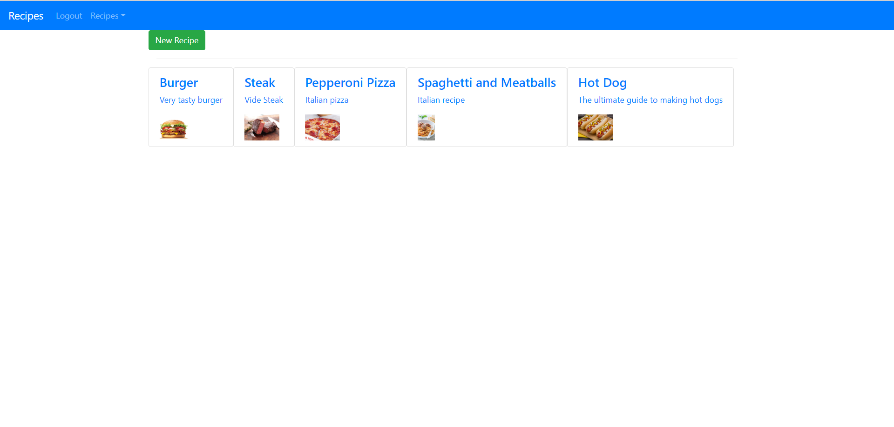

### Create Recipe

**(GET) -> {appDomain}/recipes/.json?auth={token}**

**BODY: { name: “Burger”, imagePath: “http…”, description: “some burger” }**

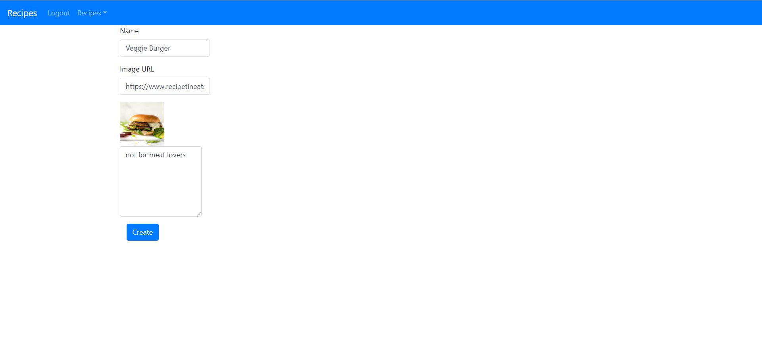

### Get By Id

**(GET) -> {appDomain}/recipes/{recipeId}/.json?auth={token}**

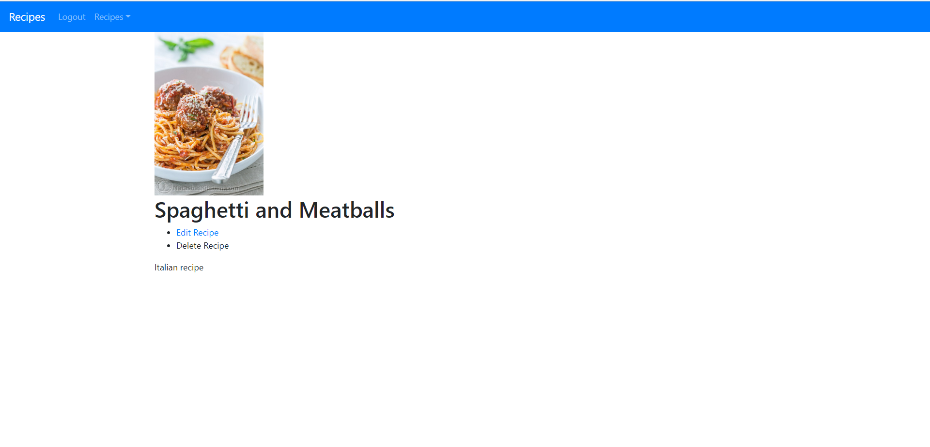

### Edit Recipe

**(PATCH) -> {appDomain}/recipes/.json?auth={token}**

**Body: { id: { description: “”, imagePath: “”, name: “” } }**

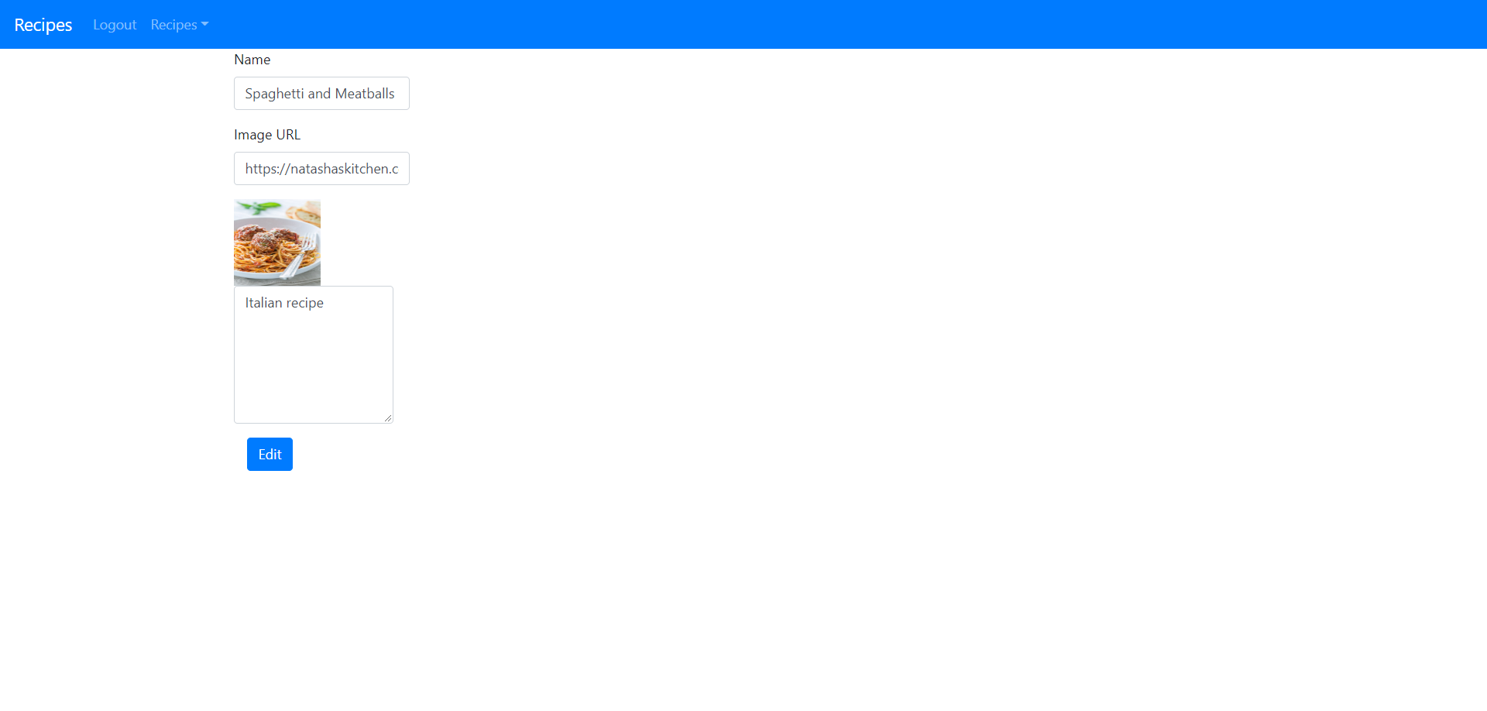

### Delete Recipe

**(DELETE) ->** **{appDomain}/recipes/{recipeId}/.json?auth={token}**