# Homework: Basic Tree Data Structures

This document defines the **homework assignments** for the ["Data Structures" course @ Software University](https://softuni.bg/trainings/1147/Data-Structures-June-2015).

## Introduction

You are given a **tree of N nodes** represented as a set of N-1 pairs of nodes (parent node, child node). Below are the operations that you are going implement.

|  |  |  |  |
| --- | --- | --- | --- |
| **Input** | **Comments** | **Tree** | **Definitions** |
| 9  7 19  7 21  7 14  19 1  19 12  19 31  14 23  14 6  27  43 | N = 9  Nodes: 7🡪19, 7🡪21, 7🡪14, 19🡪1, 19🡪12, 19🡪31, 14🡪23, 14🡪6  P = 27  S = 43 |  | Root node: 7  Leaf nodes: 1, 6, 12, 21, 23, 31  Middle nodes: 14, 19  Leftmost deepest node: 1  Longest path: 7 -> 19 -> 1 (length = 3)  Paths of sum 27: 7 -> 19 -> 1 7 -> 14 -> 6  Subtrees of sum 43: 14 + 23 + 6 |

## Root Node

Write a program to read the tree and find its **root** node:

|  |  |  |
| --- | --- | --- |
| **Input** | **Output** | **Tree** |
| 9  7 19  7 21  7 14  19 1  19 12  19 31  14 23  14 6 | Root node: 7 |  |

Hints

Use the recursive Tree<T> definition. Keep the **value**, **parent** and **children** for each tree node:

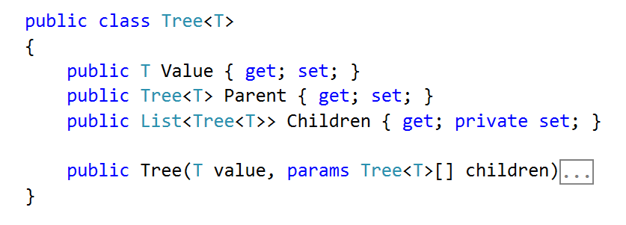

Modify the Tree<T> **constructor** to **assign a parent** for each child node:

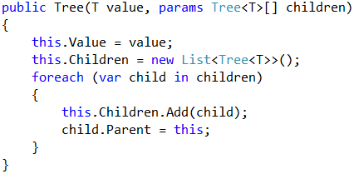

Use a **dictionary** to map nodes by their value. This will allow you to find the tree nodes during the tree construction (when you read the input data, you get the node values):

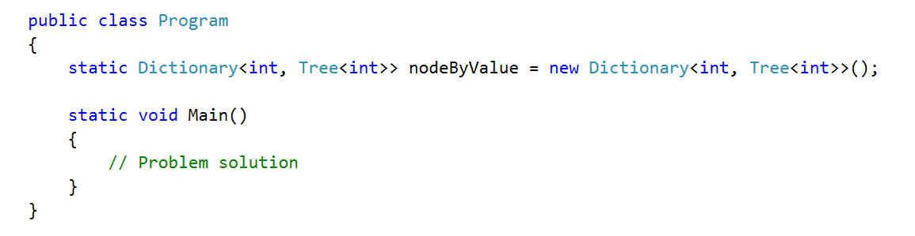

Write a method to **find the tree node by its value or create a new node** if it does not exist:

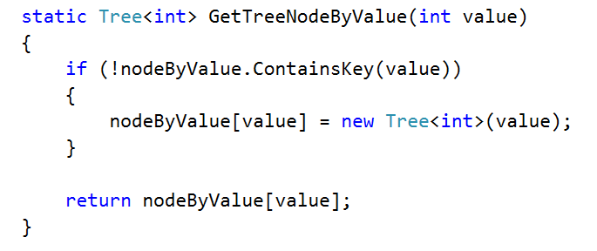

Create a method for adding an edge to the tree

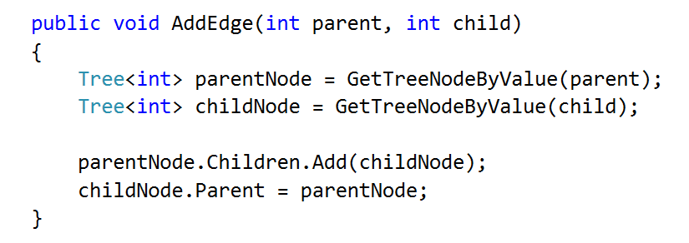

Now you are ready to **create the tree**. You are given the **tree edges** (parent + child). Use the dictionary to lookup the parent and child nodes by their values:

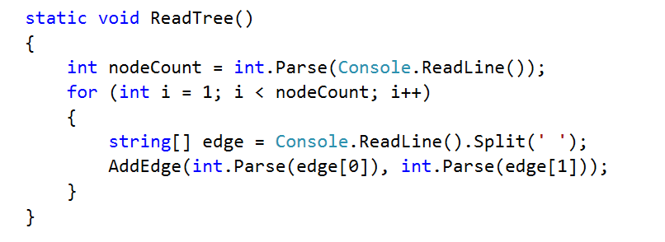

Finally, you can find the root (the node that has no parent)

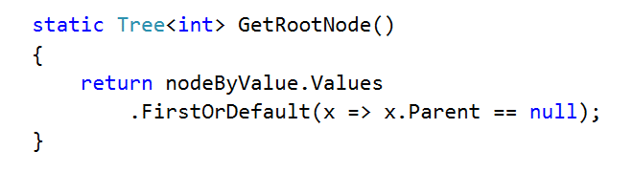

## Print Tree

Write a program to read the tree from the console and print it in the following format (each level indented +2 spaces):

|  |  |  |
| --- | --- | --- |
| **Input** | **Output** | **Tree** |
| 9  7 19  7 21  7 14  19 1  19 12  19 31  14 23  14 6 | 7  19  1  12  31  21  14  23  6 |  |

Hints

Find the root and recursively print the tree

## Leaf Nodes

Write a program to read the tree and find all **leaf** nodes (in increasing order):

|  |  |  |
| --- | --- | --- |
| **Input** | **Output** | **Tree** |
| 9  7 19  7 21  7 14  19 1  19 12  19 31  14 23  14 6 | Leaf nodes: 1 6 12 21 23 31 |  |

Hints

Find the all nodes that have no children

## Middle Nodes

Write a program to read the tree and find all **middle** nodes (in increasing order):

|  |  |  |
| --- | --- | --- |
| **Input** | **Output** | **Tree** |
| 9  7 19  7 21  7 14  19 1  19 12  19 31  14 23  14 6 | Middle nodes: 14 19 |  |

Hints

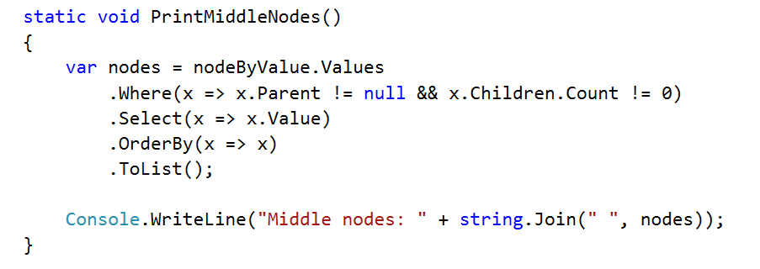

## * Deepest Node

Write a program to read the tree and find its deepest node (leftmost):

|  |  |  |
| --- | --- | --- |
| **Input** | **Output** | **Tree** |
| 9  7 19  7 21  7 14  19 1  19 12  19 31  14 23  14 6 | Deepest node: 1 |  |

## Longest Path

Find the **longest path** in the tree (the leftmost if several paths have the same longest length)

|  |  |  |
| --- | --- | --- |
| **Input** | **Output** | **Tree** |
| 9  7 19  7 21  7 14  19 1  19 12  19 31  14 23  14 6 | Longest path: 7 19 1 |  |

## All Paths With a Given Sum

Find all paths in the tree with **given sum** of their nodes (from the leftmost to the rightmost)

|  |  |  |
| --- | --- | --- |
| **Input** | **Output** | **Tree** |
| 9  7 19  7 21  7 14  19 1  19 12  19 31  14 23  14 6  27 | Paths of sum 27:  7 19 1  7 14 6 |  |

## * All Subtrees With a Given Sum

Find all **subtrees with given sum** of their nodes (from the leftmost to the rightmost). Print subtrees in **pre-order** sequence

|  |  |  |
| --- | --- | --- |
| **Input** | **Output** | **Tree** |
| 9  7 19  7 21  7 14  19 1  19 12  19 31  14 23  14 6  43 | Subtrees of sum 43:  14 23 6 |  |

# Exercises: Binary Search Trees

This document defines the **exercise assignments** for the ["Data Structures" course @ Software University](https://softuni.bg/trainings/1857/data-structures-january-2018). You can submit your **C#** code in the SoftUni Judge System - <https://judge.softuni.bg/Contests/604/Binary-Search-Trees-CSharp-Exercise>. You can submit your **Java** code in the SoftUni Judge System - <https://judge.softuni.bg/Contests/607/Binary-Search-Trees-Java-Exercise>.

# Implement BST Operations

You are given a skeleton, in which you will find implemented the following operations:

* void Insert(T) – Recursive implementation
* void EachInOrder(Action<T>) – In-Order traversal
* bool Contains(T) – Iterative implementation
* BST<T> Search(T) – Returns copy of the BST
* IEnumerable<T> Range(T, T) – Returns collection with the elements found in the BST. Both borders are **inclusive**.
* DeleteMin() – Deletes the smallest element in the tree. Throws exception if the tree is empty.

You will need to implement the rest of the operations, that are defined below:

|  |  |  |  |
| --- | --- | --- | --- |
| C# Method | Java Method | Return Type | Exception C#/Java |
| **DeleteMax()** | deleteMax() | void | C# - InvalidOperationException Java -IllegalArgumentException |
| **Count()** | size() | int |  |
| **Rank(T)** | rank(T) | int |  |
| **Select(int)** | select(int) | T | C# - InvalidOperationException |
| **Ceiling(T)** | ceiling(T) | T | C# - InvalidOperationException |
| **Floor(T)** | floor(T) | T | C# - InvalidOperationException |
| **Delete(T)** | delete(T) | void | C# - InvalidOperationException Java - IllegalArgumentException |

## Delete Max

Implement a **method** which **deletes** the **max** **element** in a BST (Binary Search Tree). If the tree is empty it should throw exception. The logic is similar to the DeleteMin() method, but you need to traverse the tree to the right.

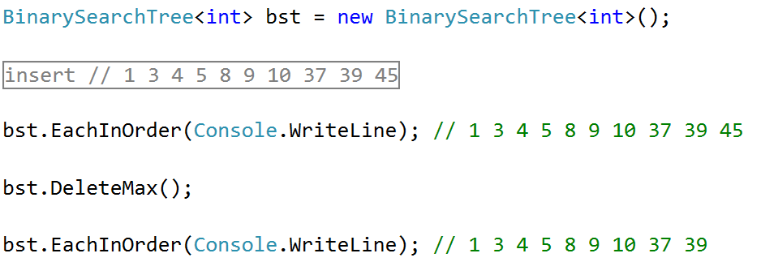

## Count

Implement a **method** which returns the count of elements in the BST.

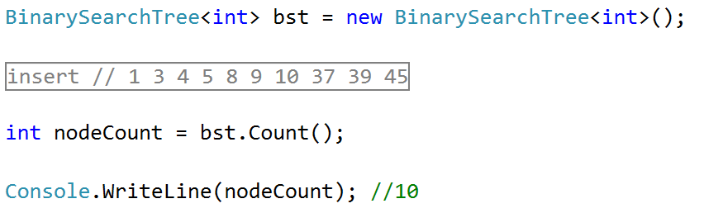

### Hints

In order to implement the count, we will create a new field in our Node class:

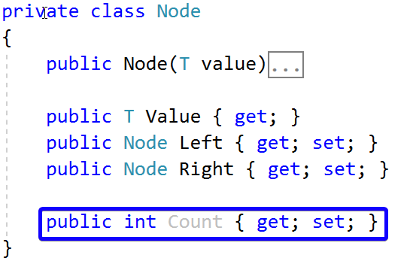

Now we can create new method Count(Node), which will recursively find the count of elements:

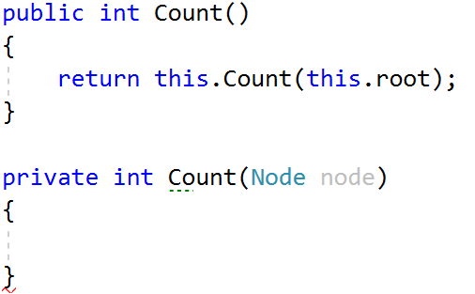

If our current node is null, we will return 0. Otherwise, we will return the count of our current node:

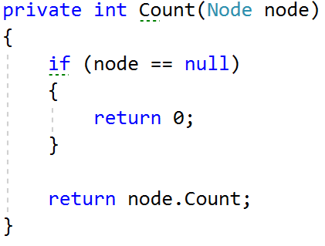

Now we only have to modify our Insert() method. It will set the count of elements of our new node to the count of its children nodes plus itself:



Next, we need to find a way to update the recalculate the count for each node when DeleteMin() is invoked. One way would be to change the DeleteMin() implementation to be recursive:

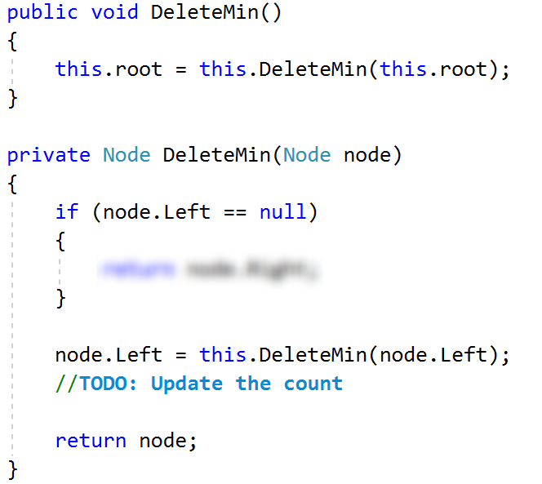

What will happen if our tree is empty and we call DeleteMin()? **Fix** it. Our count is ready.

## Rank

Implement a **method** which **returns** the **count** of elements **smaller** **than** a given **value**.

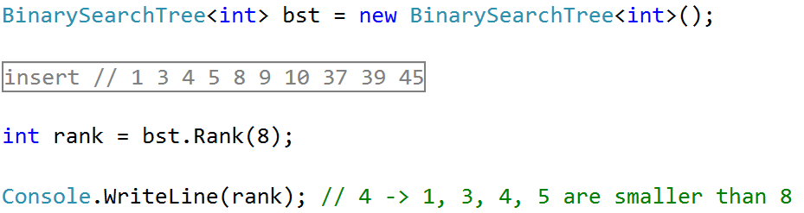

### Hints

Create a new recursive method that will return 0 if the node is null:

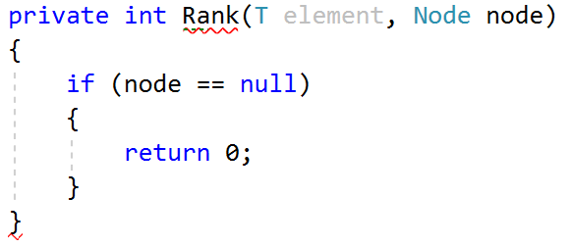

Then, we need to **compare the element** with the value of the node we are currently looking at. If the element is **smaller**, we can **go to the left**. If its **larger**, we need to **get the count of the left** elements and **go to the right**. If we **find the element**, we will return the **count of elements**, **smaller** than it.

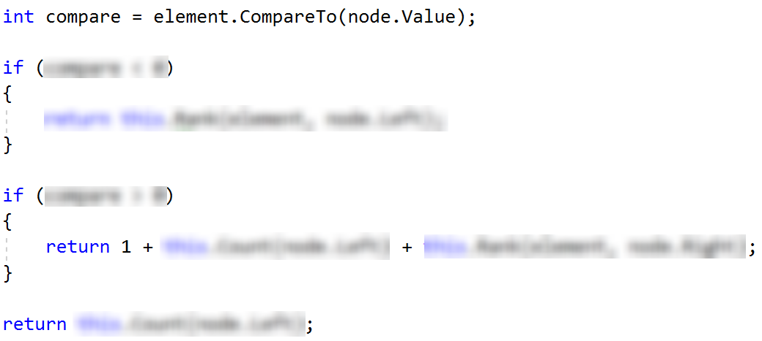

You can try it out, it should work as expected.

## Select

Implement a **method** which accepts a number (**n**) and **returns** the first **element** which has exactly **n** elements **smaller** than it. Use the logic from Count() and Rank() to implement it.

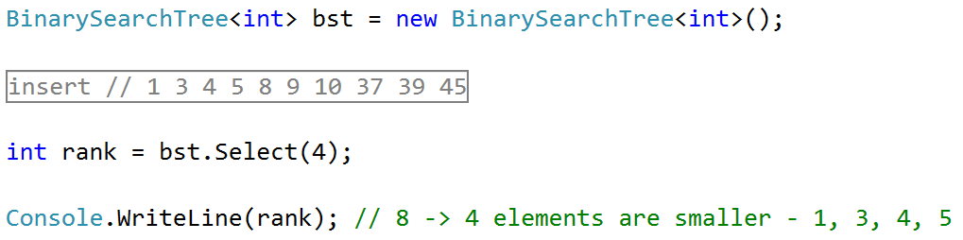

## Floor

Implement a **method** which **finds** (returns) the **nearest** **smaller** **value** than given in the BST. This operation is similar to DeleteMin().

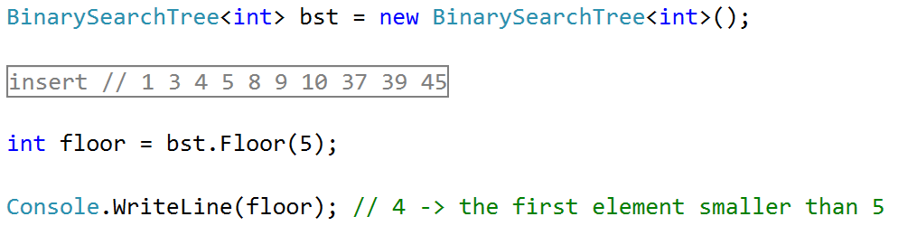

## Ceiling

Implement a **method** which **finds** (returns) the **nearest** **larger** **value** than given in the BST. This operation is similar to Floor() and DeleteMax().

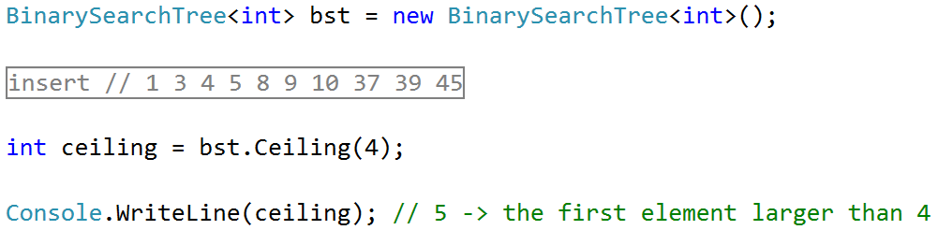

## Delete*

Implement a **method** which deletes a node with given value.

