# QA Automation Exam 11.06.2017

## Flags and IPs

Create a test with Selenium WebDriver which does the following:

1. **Navigate** to <https://www.countries-ofthe-world.com/>
2. Open page with **all countries** in the world
3. Get all names and with them **navigate directly** to <http://flagpedia.net/bulgaria>. (You are **NOT** allowed to open <http://flagpedia.net/index> in this test)
4. Scroll down to the **bottom of the page** and take screenshot of **map** (don't zoom in/out). Save it in directory "Screenshots" in your project. With file name **{countryName}-{CapitalName}-{Code}.jpg**
5. Navigate to <http://services.ce3c.be/ciprg/>
6. Get all **IP Ranges** for all **European** countries and save them in directory "CountryIPs" in your project. With file name **{Country}.txt**

There are 30 points for this task and they are given for:

* **Page Object Model – 5 points**
* **Base Page – 5 points**
* **Screenshots – 10 points**
* **IP Ranges – 10 points**

Screenshots of maps have to look similar to this:

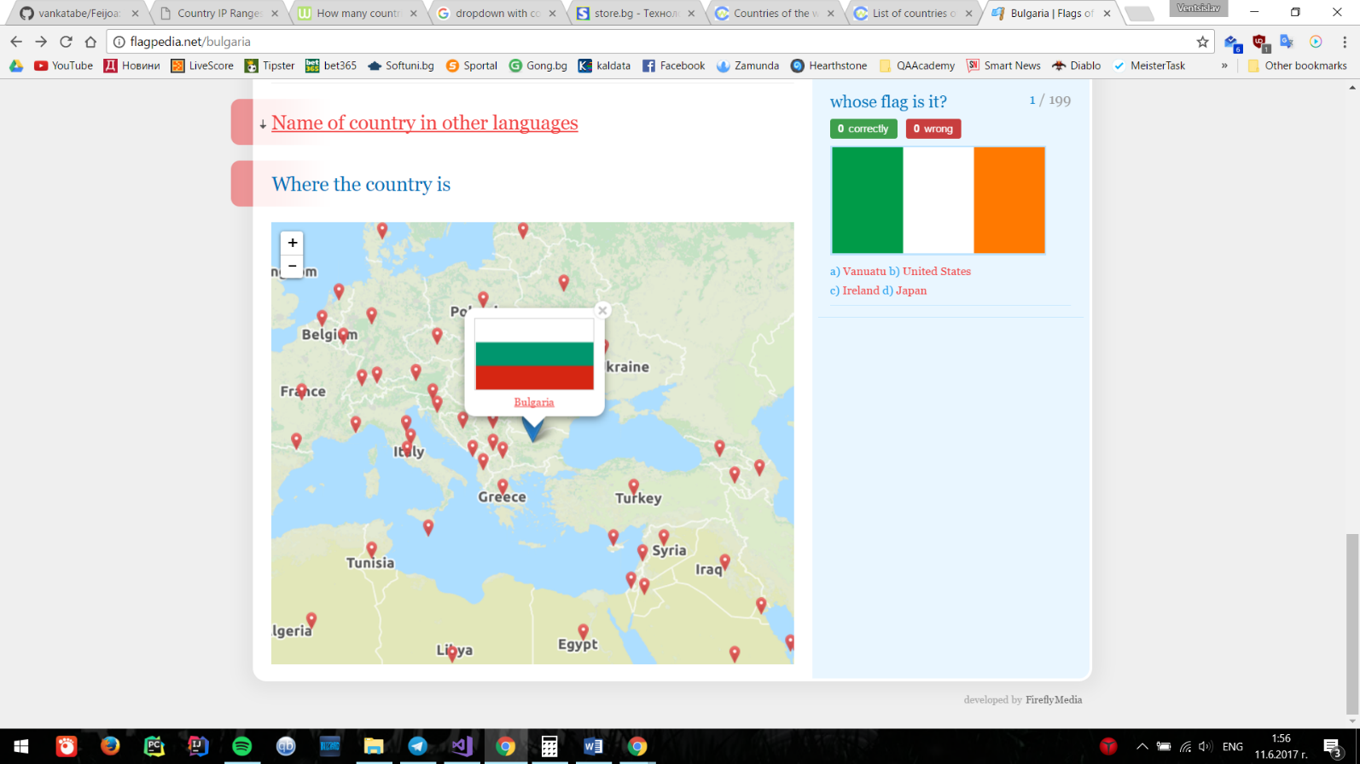

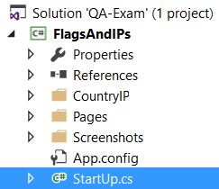At the end your project have to have at least this directory structure:

### Hints

* Country names from **Countries-Ofthe-World** and **Flagpedia** have a little differences
* There are multiple elements, which can be used for scrolling in **Flagpedia**
* Look for **list of European countries** in sites from previous steps
* Use **PeerGuardian** format for IP Ranges

### Bonus

You can earn bonus **10 points** if you extract **IP Ranges for all countries in the world**!

## United Nations Standard Products and Services Code

Create a Soap UI Test Project for <http://www.webservicex.net/GenericUNSPSC.asmx?WSDL>

Create a test suite against GenericUNSPSCSoap12 with steps:

1. Execute request to **GetUNSPSCSegments**
2. Get Segment value for "**Live Plant and Animal Material and Accessories and Supplies** "
3. With Property Transfer use segment number in **GetUNSPSCFamilyBySegment**
4. Get Family value for "**Live animals**"
5. With Property Transfer use Family number in **GetUNSPSCClassByFamily**
6. Get Class value for "**Livestock**"
7. With Property Transfer use Class number in **GetUNSPSCCommodityByClass**
8. Assert that in response have 16 results
9. Assert that in response you have results for Cats, Dogs, Goats, Camels and Primats (like your trainer ☺ )

For each requests you have to have 3 asserts:

* Valid HTTP Status Codes - 200 OK
* Response SLA - 500ms
* Soap response

For this task you will get **10 points**