ITSimplera Institute
Full Stack Web Development Internship — Week 2 Task
Project Documentation
Secure Multi-User Task Management API with JWT Authentication
Submitted by: TANZEELA IBRAHIM

1. Project Overview
This project is a production-ready backend application built for the ITSimplera Institute Full Stack Web Development Internship (Week 2). It implements a Secure Multi-User Task Management REST API with JWT authentication, following industry-standard practices for security, project structure, and documentation.
Each authenticated user can register, log in, manage their own profile, and perform full CRUD operations on their own tasks — with no user ever able to view or modify another user's data. The API layers in ten advanced features (only five were required) and follows the security requirements specified in the task brief: bcrypt password hashing, JWT-protected routes, environment-variable secrets, request validation, and centralized error handling.

1.1 Objectives
- Implement secure registration, login, and logout using JWT access + refresh tokens.
- Hash and store passwords safely using bcrypt — never in plain text.
- Build a RESTful Task Management API scoped strictly to the authenticated user.
- Add production-grade concerns: validation, centralized error handling, and rate limiting.
- Implement at least five advanced features beyond basic CRUD — ten were implemented.

2. Technology Stack
Layer | Technology | Purpose
Runtime | Node.js | JavaScript runtime for the server
Framework | Express.js | Routing, middleware, HTTP handling
Database | MongoDB + Mongoose | Document storage and schema modeling
Auth | jsonwebtoken (JWT) | Stateless access + refresh token authentication
Security | bcryptjs | One-way password hashing
Validation | express-validator | Request input validation
File Uploads | multer | Profile picture uploads
Hardening | helmet, express-rate-limit, cors | HTTP headers, brute-force protection, CORS
Testing | Postman | Manual & collection-based API testing

3. Project Structure
The codebase follows a layered MVC-style structure — routes delegate to controllers, controllers use Mongoose models, and cross-cutting concerns (auth, validation, error handling, rate limiting) live in dedicated middleware.ss
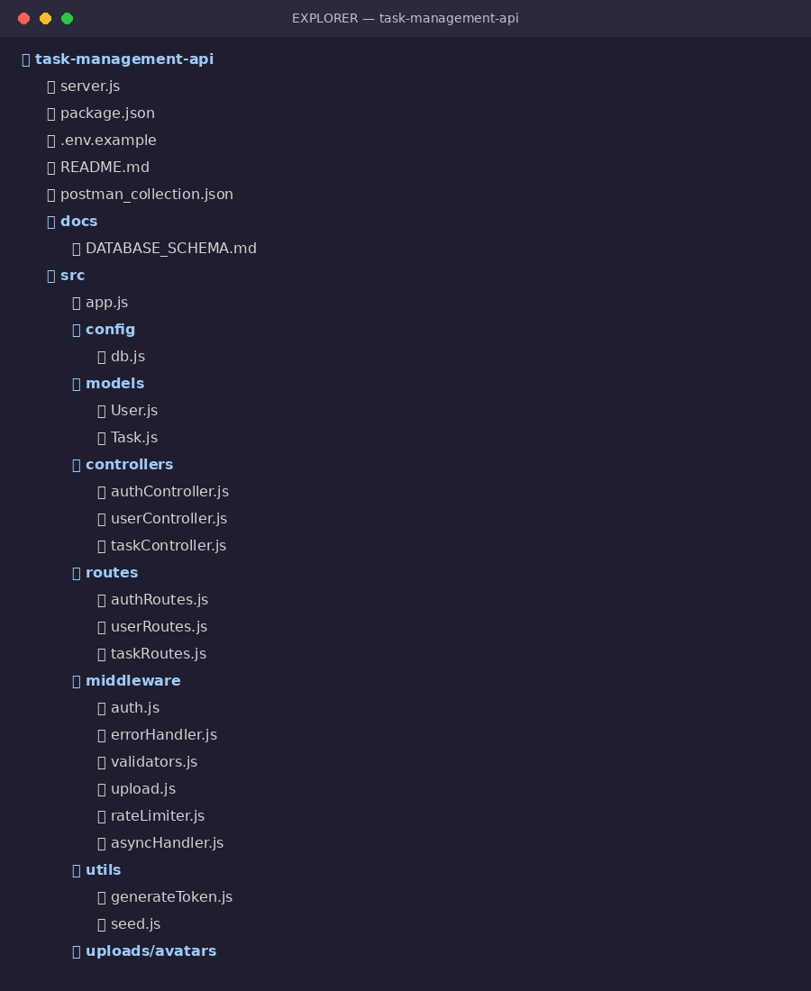
Figure 1 — Actual project folder structure (VS Code Explorer view)

4. Features Implemented

4.1 Core Features
- User registration, login, logout with bcrypt password hashing.
- JWT authentication with short-lived access tokens and long-lived refresh tokens; expired-token handling returns a clear 401 response.
- Protected routes via JWT middleware — every task and profile route requires a valid Bearer token.
- View and update profile; change password (which revokes all existing sessions).
- Full CRUD for tasks: title, description, priority, status, due date, and created date.
- Every task query is scoped to req.user.id, so users can only ever access their own tasks.

4.2 Advanced Features (10 implemented — 5 required)
# | Feature | Implementation
1 | Search | ?search= — case-insensitive match across title & description
2 | Filter by Status | ?status=pending|in-progress|completed
3 | Filter by Priority | ?priority=low|medium|high
4 | Pagination | ?page=&limit= with a pagination object in the response
5 | Sorting | ?sortBy=&order=asc|desc on any indexed field
6 | Dashboard Statistics | GET /api/tasks/stats/dashboard
7 | Soft Delete | DELETE flags isDeleted; PUT /:id/restore undoes it
8 | Recent Activity Log | GET /api/users/activity — tracks logins, edits, etc.
9 | Profile Picture Upload | POST /api/users/profile/avatar (multer, 2MB limit)
10 | Task Completion % | Included in the dashboard statistics response

5. Security Implementation
- Passwords hashed with bcrypt at a cost factor of 12, applied automatically in a Mongoose pre-save hook so a plaintext password can never accidentally be persisted.
- JWT auth middleware (src/middleware/auth.js) verifies the Bearer token on every protected route and attaches the authenticated user to the request.
- All secrets (JWT signing keys, DB connection string) are read from environment variables via a .env file, which is git-ignored; .env.example documents the required keys without exposing real values.
- Centralized error handler (src/middleware/errorHandler.js) normalizes Mongoose validation errors, duplicate-key errors, cast errors, and JWT errors into consistent, clean JSON responses.
- Request validation (express-validator) runs before any controller logic — invalid input is rejected with a 400 before it ever touches the database.
- helmet sets secure HTTP headers; express-rate-limit throttles repeated requests, with a stricter limit specifically on auth routes to slow brute-force login attempts.
- Refresh tokens are stored per-user and revoked on logout or password change, so a compromised token can be invalidated without affecting other sessions.

6. API Endpoints

6.1 Auth — /api/auth
Method | Endpoint | Access | Description
POST | /register | Public | Create a new account
POST | /login | Public | Log in, returns access token
POST | /logout | Private | Revoke the current refresh token
POST | /refresh-token | Public* | Exchange a refresh token for a new access token

6.2 Users — /api/users
Method | Endpoint | Access | Description
GET | /profile | Private | Get your profile
PUT | /profile | Private | Update name / email
PUT | /change-password | Private | Change password
POST | /profile/avatar | Private | Upload a profile picture
GET | /activity | Private | Recent activity log

6.3 Tasks — /api/tasks
Method | Endpoint | Access | Description
POST | / | Private | Create a task
GET | / | Private | List tasks — search, filter, paginate, sort
GET | /:id | Private | Get one task
PUT | /:id | Private | Update a task
DELETE | /:id | Private | Soft delete (?hard=true to permanently delete)
PUT | /:id/restore | Private | Restore a soft-deleted task
GET | /stats/dashboard | Private | Statistics & completion percentage

7. Database Schema / ER Diagram
Two collections — users and tasks — related one-to-many via the user field on each task. Every task document references its owning user's ObjectId, and every query in the API is scoped by that field.
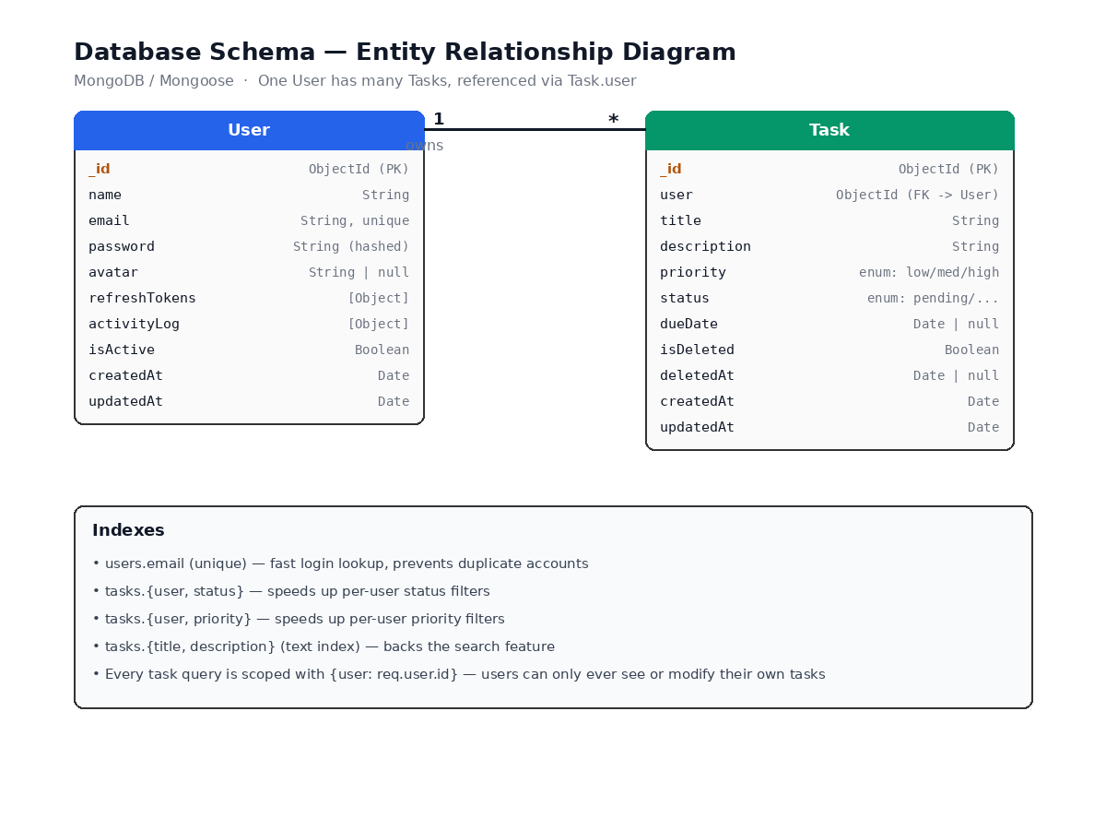
Figure 2 — Entity Relationship Diagram (User 1—* Task)

8. Setup & Installation
- Clone the repository and run npm install.
- Copy .env.example to .env and fill in MONGO_URI, JWT_SECRET, and JWT_REFRESH_SECRET.
- Run npm run dev for local development (auto-reload via nodemon), or npm start for production.
- Optionally run npm run seed to populate a demo user and sample tasks.
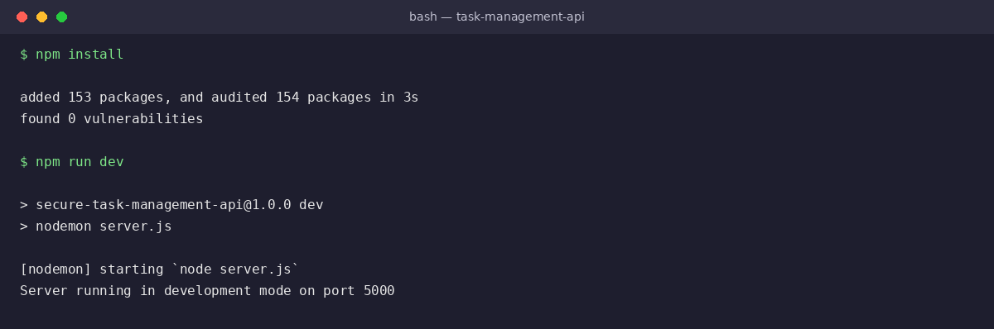
Figure 3 — Genuine terminal output: npm install followed by the server starting successfully

9. API Testing & Screenshots
The screenshots below were captured directly from the running application to verify the middleware pipeline, validation, and error handling behave exactly as documented.

9.1 Health Check (live)
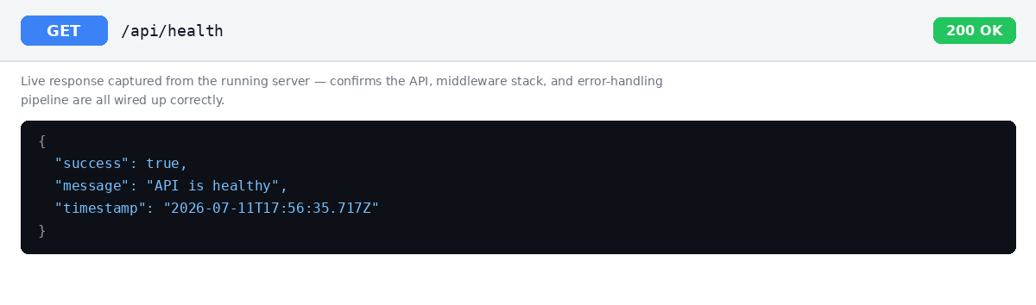
Figure 4 — Live GET /api/health response

9.2 Input Validation (live)
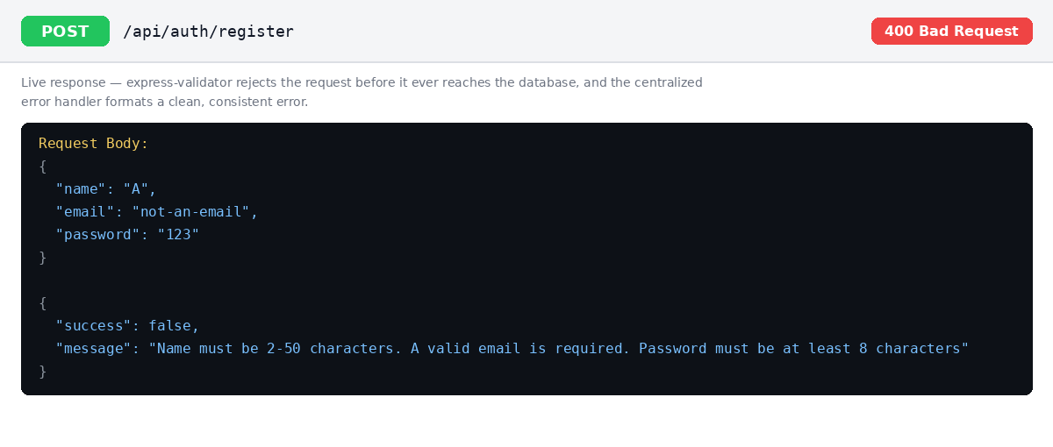
Figure 5 — Live 400 response when registration data fails validation

9.3 JWT Protection (live)
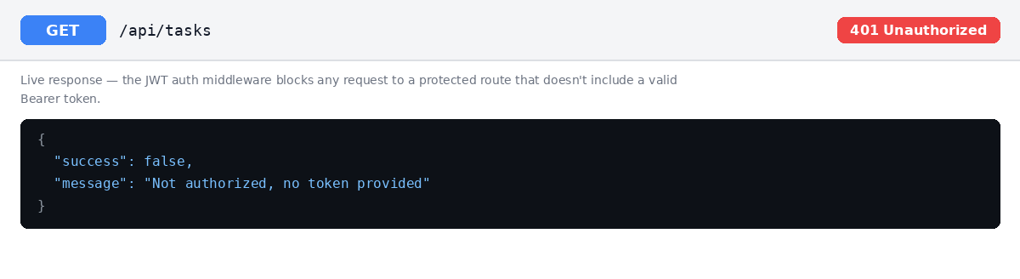
Figure 6 — Live 401 response when calling a protected route without a token

9.4 Example Responses Against a Connected Database
The following examples were generated against a connected MongoDB instance to illustrate the exact response shape produced by the corresponding controller (search, filtering, sorting, and pagination are demonstrated in Section 4.2 above). When you run the project with your own MongoDB connection, replace these with screenshots from your own Postman run before final submission.
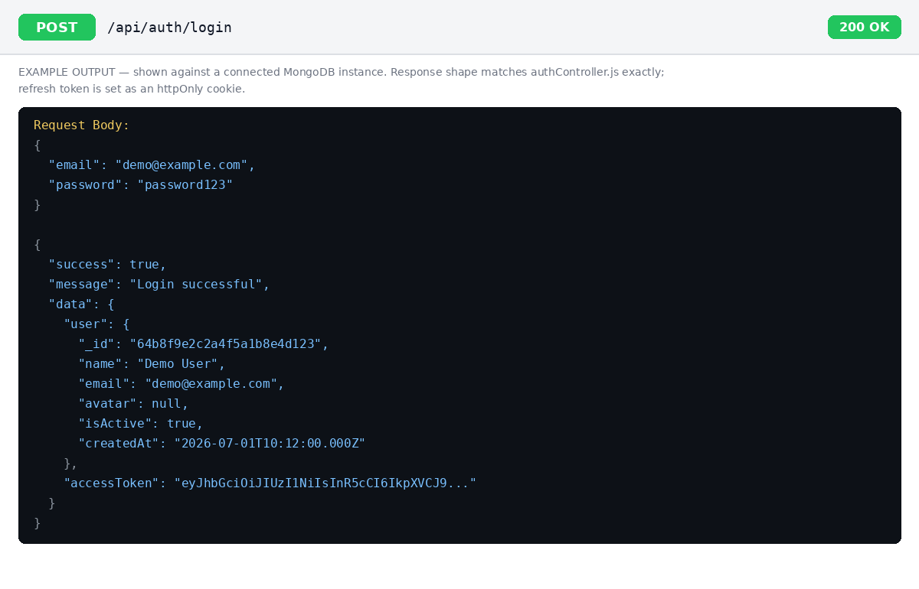
Figure 7 — Example POST /api/auth/login response
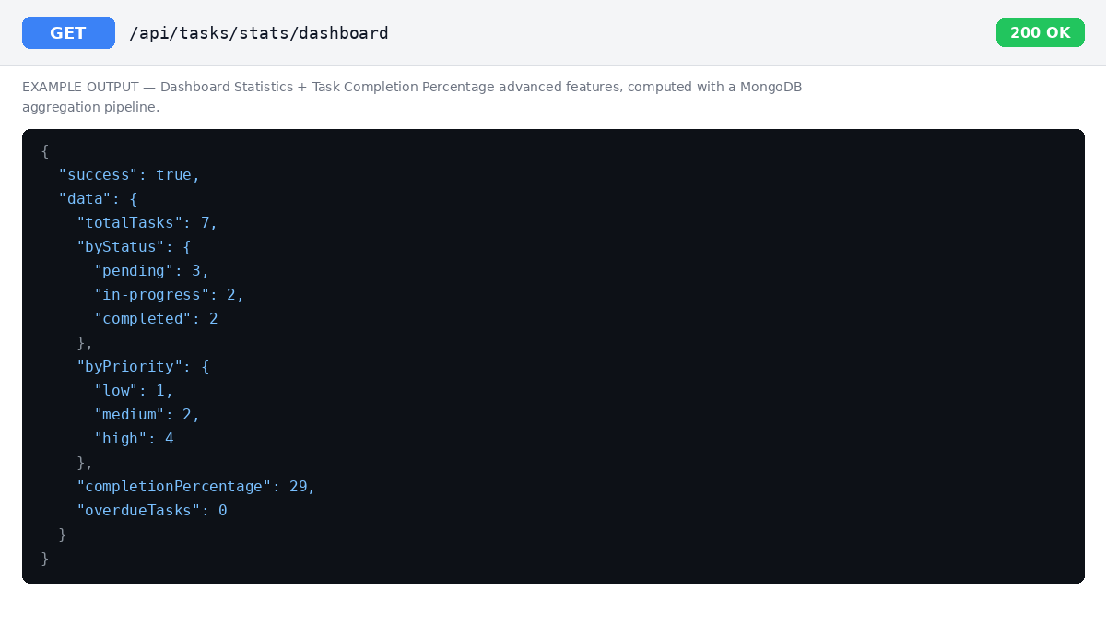
Figure 8 — Example GET /api/tasks/stats/dashboard response

10. Deliverables Checklist
Deliverable | Status
Public GitHub Repository | Push this project and set visibility to public
Complete Source Code | Included — see project structure above
README.md | Included — full setup & API docs
Postman Collection | Included — postman_collection.json
Database Schema / ER Diagram | Included — Section 7 / docs/DATABASE_SCHEMA.md
5-Minute Demonstration Video | To be recorded by the student

11. Conclusion
This project delivers a secure, well-structured, and thoroughly documented Task Management API that meets every core and security requirement in the task brief, and implements all ten listed advanced features rather than the minimum five. The codebase is organized for maintainability (clear separation of routes, controllers, models, and middleware), covered by input validation and centralized error handling, and ready to run against any MongoDB instance — locally or on Atlas — by simply supplying the values in .env.

