Industry Day Map:
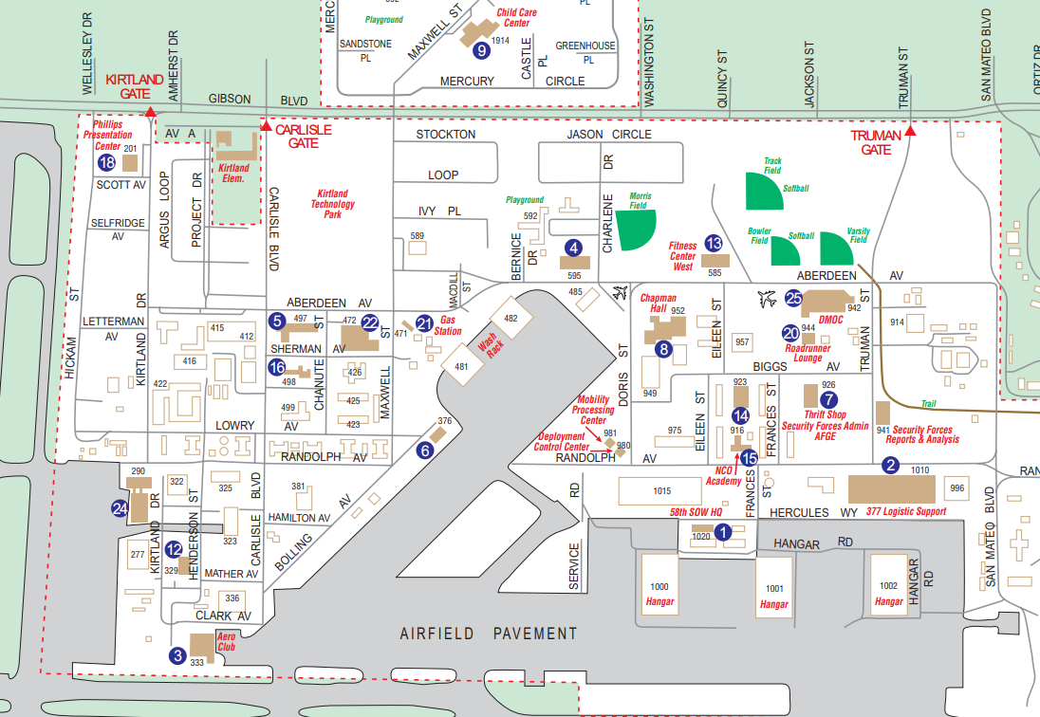

The blue arrow denotes building 414 where industry will be held. There is parking available across the street from the building. The address is:

Building 414, Conference Room 3
3548 Aberdeen Ave SE
Kirtland AFB, NM 87117

