

Mini Project Report: Singapore Resale Flat Prices

CB0494: Introduction to Data Science and Artificial Intelligence
Name: | Matric No.: | Class:
Lua Wei Chong | U2221639C | CBE 21 Group 17
Tan Zhi Xuan | U2220110A | CBE 21 Group 17

Background
About one in four buyers of resale Housing Board flats paid cash over valuation (COV) in 2022 [1]. COV is the difference between the purchase price and the Housing and Development Board’s (HDB) valuation, which has to be paid in cash and cannot be covered by loans or CPF. Additionally, the buyer’s duty stamp (BDS) will be affected as the payable BDS is calculated based on whichever is higher, the purchase price or HDB’s valuation [2]. Due to the current robust HDB resale market, the median COV paid is approximately $30,000 [3]. Comparing to the median monthly household income of $10,869 in 2023, the COV and BDS can amount to about 3 months' worth of household income, which can significantly affect your financing plans [4].
Since 2014, HDB ceased the publication of their resale flat valuation, and presently, buyers only have access the HDB’s valuation after price agreement with the buyer [1]. Hence, rather than potentially paying extra money after the agreement of the price, it is wiser to understand the prospective resale price for negotiation with the seller to avoid COV. This can be achieved through data analysis of HDB’s past resale price to predict the future resale price, which is how HDB determine the price of flat [5]. In our study, we focused on flats in central area which we deemed as the most attractive as the number of employed resident working in central area is highest and most workers prefer ease of transport to their workplace [6].

Problem Statement
Amidst the robust HDB resale market and lack of information regarding HDB’s valuation of flat, buyers are unknowingly paying COV.

Objective
The aim of this project was to conduct data analysis and machine learning to avoid paying cash over valuation for optimal home financing in the CBD area.

Technique Used

Data Exploration
Firstly, data exploration was done for each of the variables to study their correlation with the resale price. Boxplot was used for the categorical variables, flat type, street name, storey range, flat model, block numbers while time series plot was used for month and lease commence date. For numerical variables (lease remaining and floor square area), a heat map was plotted to visualize the correlation. From the various plots, potential trends were observed and discussed.

Linear Regression
Since the 2 numerical variables are positively correlated with the resale price, they were used to predict the resale price by using bi-variate and multi-variate linear regression to obtain the linear equations. Hence, for a given remaining lease and floor square area, the resale price of a flat can be predicted by inputting the parameter into the equation, which will serve as HDB’s valuation of the flat. If the predicted resale price is lower than the quoted price by seller, COV will be incurred.

Anomaly Detection
Since only a small fraction of buyers pay COV (1 in 4), the resale price they paid can be considered as outlier. Hence, the excessive resale price in the dataset will most likely incur COV, which can be determined using anomaly detection for both lease remaining and floor area with the fraction of anomalies at 0.25. By using scatterplot of the anomaly points, the visualisation of the anomaly can be obtained. The two anomaly models can then be applied on new dataset, which was obtained current listings for resale flat from PropertyGuru. If the listing’s floor square meter and quoted resale price of the flat is detected as an anomaly, COV will most likely be incurred.

Result

Categorical Variables
From the boxplot of categorical variables, it was observed that street name and block number do not have trends with the resale price. For the street name and block number, a possible reason for the lack of trend is that when customers are considering buying a flat, they are highly unlikely to consider the street name and block numbers unless the block number is auspicious. Most buyers are more likely to prioritize the street location such as accessibility to MRT over the street name and block. For the model type of an HDB, they are categorized according to the building projects and HDBs of different model type will have different floor areas [7]. Hence, the flat model is already reflected under the floor area and remaining lease, which are more useful parameter to predict resale price.
From the boxplot of purchasing month and resale, it is observed that there is no general trend as the spread of resale price for each month is about the same. Hence, it is unlikely that the month of purchase is crucial in predicting the resale price. However, the median price for each month was observed to fluctuate. Hence, a time series plot was employed to determine if the price fluctuates significantly with each month using the average resale price for each month. From the time series plot, it was observed that July has the lowest average resale price, which makes it the best month to buy and April, August, and November have the highest average resale price. For the time series plot of the lease commence date and resale price, it was observed that the average resale price increases as the lease commence date is nearer. Hence, it is an important variable in predicting the resale price of flats.
For the boxplot of storey range and flat type against resale price, it was observed that the higher the storey range or flat type, the higher the resale price. From the boxplot for storey range, 3 clusters can be observed from the boxplot where the median resale price spikes; cluster 1 (low floor): 01-18, cluster 2 (mid floor): 19-27, cluster 3(high floor): 28-51. From the boxplot of flat type and resale price, it was observed that the median and spread of resale price for each flat type are very different. A general trend was observed whereby the higher the number of rooms, the higher the resale price. Hence, this suggests that both storey range and flat type are positively correlated with resale price and are important variables in predicting the resale price.
However, as analysis of categorical variables is not within the scope of our content, basic observation of plots was done to determine their effect on resale price which will affect whether COV will be incurred. Thus, future work should explore the usage of different machine learning tools such as one-hot encoding to process categorical variables and quantify its relationship with resale price to predict the valuation by HDB.

Linear Regression
From the heatmap plot of resale price and floor area, it was observed that the correlation between resale price and floor area and lease remaining is quite high at 0.76 and 0.83 respectively. Thus, these variables are determined to be crucial in determining the resale price.
From the bi-variate and multi-variate regressions, the multi-variate linear regression has the highest train and test R² of 0.8037 and 0.6432 respectively, making it the most reliable to predict resale price.
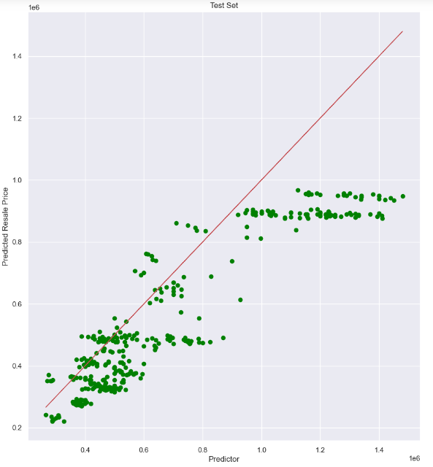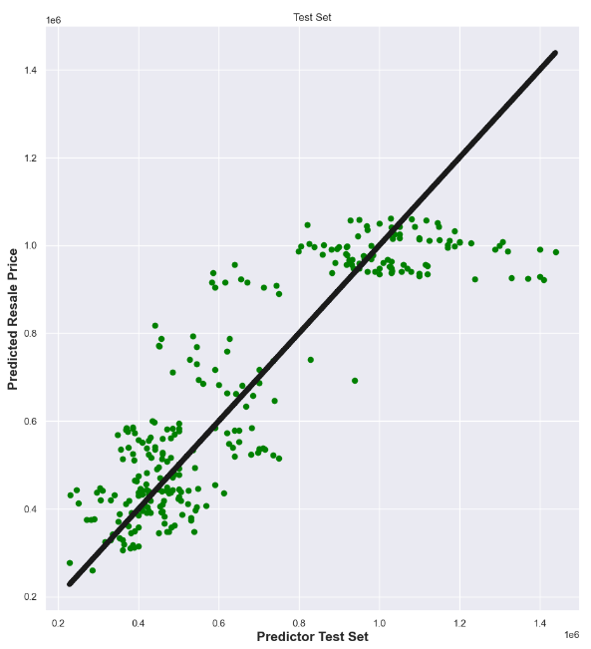
Random Splitting
Ordered Splitting
Figure I. Linear regression for ordered and random splitting respectively
From Figure I, the test plot was observed to have clusters as circled in blue, which suggest that orderly splitting for test-train data might not be very accurate. Therefore, the 80-20 random splitting technique was employed for more accurate testing. For-loop was used to compute the R² 100 times and the average of the R² values was considered, which is more accurate as random splitting will vary the R² value with each run. It was observed that through random splitting, the R² improved for test (0.766) but decreased for train (0.768). Nevertheless, it was determined to be more accurate than orderly splitting since the R² for train and test are closer to each other and the clusters were no longer spotted in the test data. To obtain the trendline, for-loop was used to compute the coefficients and intercepts 100 times and the average was taken, which is expressed as follows:
Resale Price = 5505.457 *(floor area in m²) + 940.433*(lease remaining in month) - 572938.272

By substituting the floor area and leasing remaining, obtained from PropertyGuru’s current flat listing in central area [8], into the equation, the predicted resale price can be computed.
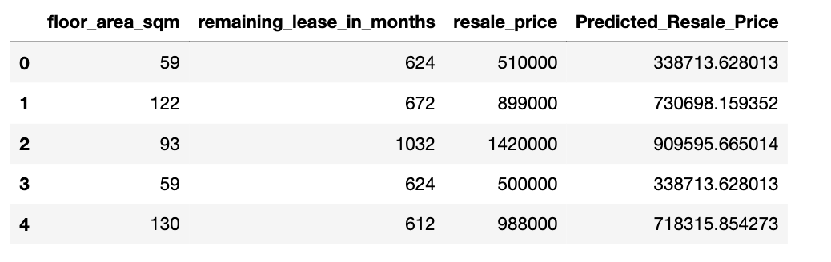
Figure II. Comparison of Predicted Resale Price and quoted resale price
From Figure II, it was observed that all the predicted resale price is lower than the resale price, which might not be very accurate as only 1 out of 4 buyers are paying COV and the probability of selecting 5 random flat to have COV is quite low. Additionally, HDB’s valuation of flat takes into consideration of categorical variables as well which were not included in our linear regression model. Hence, the accuracy of the regression model is insufficient in predicting the resale price to estimate whether COV will be incurred. The regression model should only serve as an estimation of the resale price and future work should enhance the regression model by including categorical variables in the regression model.

Anomaly Detection
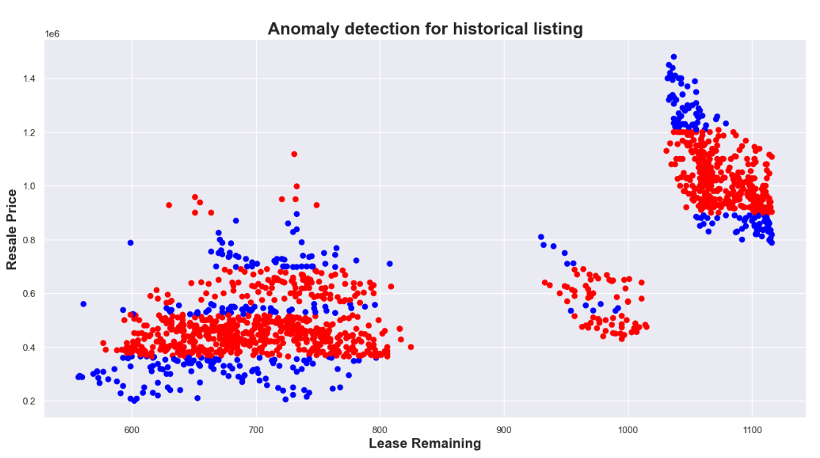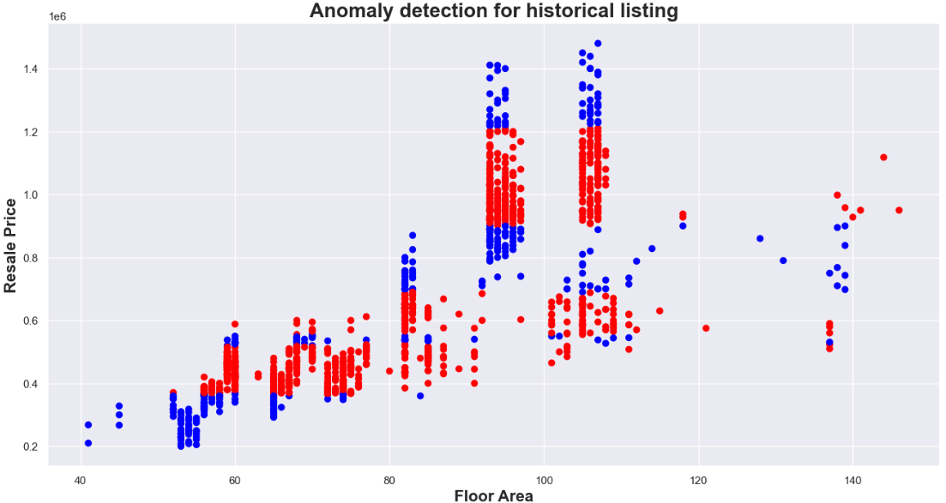
Figure III. Anomaly detection model for floor area and lease remaining respectively.
As regression model is not accurate in predicting COV, anomaly detection was used to identify potential COV. As COV is an overvaluation, the anomaly should arise on top when the price is too high for a certain floor square meter or remaining lease. However, from Figure III, it was observed that anomalies were detected when the resale price is low when the lease remaining and floor area is low as circled, which could suggest anomaly due to undervaluation. Hence, not all the anomalies might be COV, only those abnormally high resale price on the top is most likely COV. Thus, there is a need to self-evaluate the potential anomaly when applying the model.
To test the capability of the model, the anomaly detection model trained for both the variables, floor area and remaining lease, was applied to the same property listing from PropertyGuru used for evaluating the linear regression model and the plots are as follows:
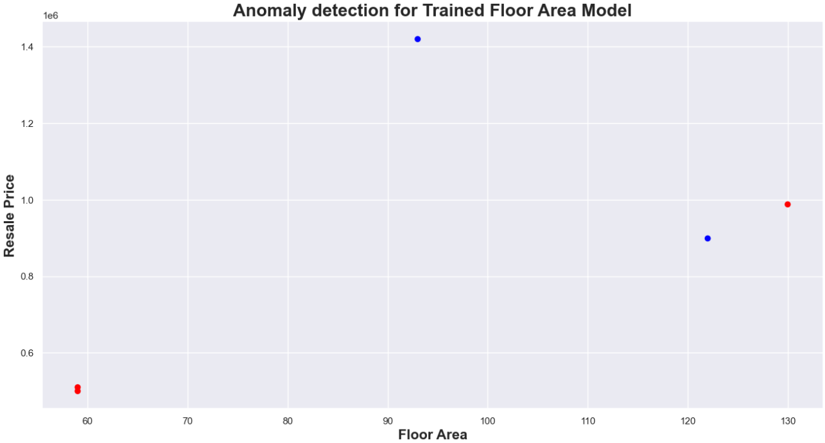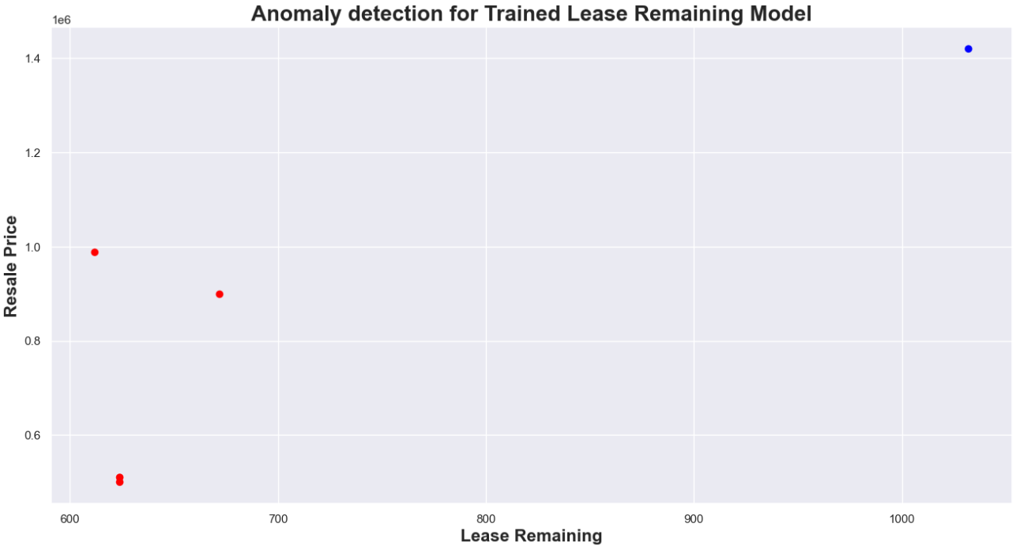
Listing Number 2
Listing Number 1
Listing Number 1
Figure IV. Scatterplot after application of trained model for floor area and lease remaining.
From Figure IV, comparing the anomaly detection after application of trained models for both lease remaining and floor square meter, it was observed that the both anomaly model managed to detect listing number 2 as circled in blue, with respect to Figure II, as anomaly. The listing number 2 anomaly is most likely valid as the resale price is high for the given floor area and lease remaining when compared to Figure III. However, listing number 1 was detected as anomaly as circled in red for trained floor area model and not for trained lease remaining model. Based on self-evaluation, it should not be an anomaly for COV but possibly undervaluation as for the given floor area meter, the resale price tends to be lower when compared to Figure IV. Hence, listing number 2 is most likely due to COV while listing number 1 could be due to undervaluation.
Hence, to a certain extent, the anomaly model can verify whether the current listing will incur COV but will need self-reasoning to make sense of the anomaly detected.

Conclusion
In conclusion, basic data exploration was performed to study the correlation of the variables and resale price. It was found that flat model, street name and block number little correlation with resale price while purchasing month, lease commence date, storey range, flat type, lease remaining, floor area have high correlation with resale price and important in predicting resale price.
From linear regressions of numerical variables, it was found that multi-variate regression is the best at predicting resale price with the highest R² of 0.766. From the regression, a trendline equation was obtained to predict the HDB’s valuation of flat. However, it might not be accurate as the 5 random current listing taken from PropertyGuru was predicted to be overvalued. This could be due to the categorical variables not being included in the linear regression although they are important in predicting resale price due to limitation of techniques taught. Future work should incorporate them into multi-variate linear regression model to predict the resale price.
Lastly, from the anomaly detection model to identify COV, it was found that the models can identify whether the listing will incur COV but ultimately, there is a need self-reasoning to make sense of the anomaly detected. Future work should explore multi-variate anomaly detection such that both trained model for floor area and lease remaining detects the same listing as anomaly.

Reference
[1] Z. Abdullah, "One in four resale HDB flat buyers paid cash over valuation in 2022," The Straits Times, 28 November 2022.
[2] PropertyGuru, "COV for HDB Flats: What Is Cash Over Valuation in Singapore? (2024)," Yahoo Finance, 16 Jan 2024. [Online]. Available: https://sg.finance.yahoo.com/news/cash-over-valuation-affects-hdb-141008629.html?guccounter=1&guce_referrer=aHR0cHM6Ly93d3cuZ29vZ2xlLmNvbS8&guce_referrer_sig=AQAAAF2skWANa5HUUiGZBv0Zb-Ap78u-lNlf837gn85rx1KZVwXAum8oaH-__xvaTyG_ynADXo4coBYDL8vpxPYPpWZGS69XH. [Accessed 30 Mar 2024].
[3] J. Lim, "Fewer buyers paid COV for resale HDB flats in 2023, property market expected to moderate further," The Straits Times, 15 Jan 2024. [Online]. Available: https://www.straitstimes.com/singapore/fewer-buyers-paid-cov-for-resale-hdb-flats-in-2023-property-prices-expected-to-moderate-further - median COV paid. [Accessed 30 Mar 2024].
[4] "Key Household Income Trends, 2023," Department of Statistics, Ministry of Trade & Industry, Singapore, 2023.
[5] "How to check your HDB Flat Value?," OneHDB, [Online]. Available: https://onehdb.sg/check-hdb-flat-value/#:~:text=The%20core%20basis%20on%20how,your%20flat%20can%20sell%20for.. [Accessed 30 Mar 2024].
[6] G. Ho, "Downtown Core draws largest share of S'pore resident workers: Population census," The Straits Times, 18 Jun 2021. [Online]. Available: https://www.straitstimes.com/singapore/downtown-core-draws-largest-share-of-spore-resident-workers-population-census. [Accessed 30 Mar 2024].
[7] "HDB launches 50-storey The Pinnacle @ Duxton today," GetForme, [Online]. Available: https://getforme.com/previous2004/previous290504_hdblaunchesthepinnancleatduxton.htm. [Accessed 04 Apr 2024].
[8] T. Juay, "Pinnacle @ Duxton," PropertyGuru, 04 Apr 2024. [Online]. Available: https://www.prope

Contribution Table
Name: | Matric No.: | Report (%) | Jupyter Notebook (%)
Lua Wei Chong | U2221639C | 50 | 50
Tan Zhi Xuan | U2220110A | 50 | 50

