# Databases – Practical Teamwork Project

A chain of supermarkets holds information about its **products in MySQL database** consisting of the tables like the shown below:

## Products

|  |  |  |  |  |
| --- | --- | --- | --- | --- |
| **ID** | **VendorID** | **Product Name** | **MeasureID** | **Base Price** |
| 1 | 20 | Beer “Zagorka” | 100 | 0.86 |
| 2 | 30 | Vodka “Targovishte” | 100 | 7.56 |
| 3 | 20 | Beer “Beck’s” | 100 | 1.03 |
| 4 | 10 | Chocolate “Milka” | 200 | 2.80 |
| … | … | … | … | … |

## Vendors

|  |  |
| --- | --- |
| **ID** | **Vendor Name** |
| 10 | Nestle Sofia Corp. |
| 20 | Zagorka Corp. |
| 30 | Targovishte Bottling Company Ltd. |
| … | … |

## Measures

|  |  |
| --- | --- |
| **ID** | **Measure Name** |
| 100 | liters |
| 200 | pieces |
| … | … |

For testing purposes please fill at least 50 products, at least 20 vendors and at least 5 measures. Try to use real-world data. You may use sequential IDs for the primary key or any other primary key notation.

## Assignment

Your assignment is to design, develop and test a C# application for importing Excel sales reports from ZIP file and product data from MySQL into SQL Server, generate PDF aggregated reports and XML sales reports, create product reports as JSON documents and load them into MongoDB, load vendor expenses from XML file, read taxes from SQLite and calculate vendor's total results and write them into Excel file:

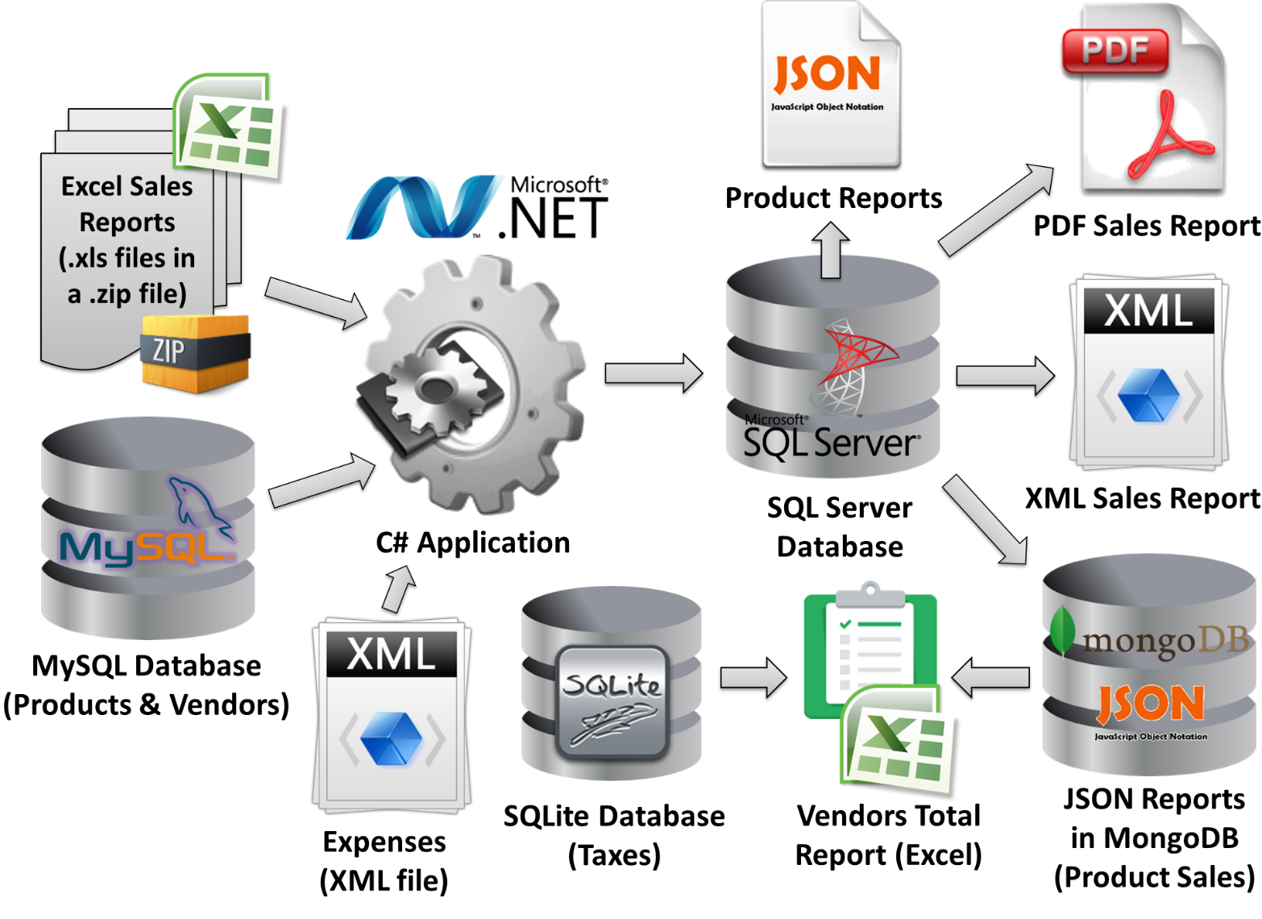

## Problem #1 – Load Excel Sales Reports from ZIP File

Suppose you have the **MySQL database “Supermarket”** holding information about the vendors and products and **a set of Excel files** (*.xls) holding information about the sales in the different super­markets.

Your task is to write a C# program to **load the Excel reports in** **MS SQL Server**. You may need to preliminary design a database schema to hold all data about the products (data from the MySQL database and data from the Excel files) or use the "code-first" approach to move the DB schema from MySQL to SQL Server. Your C# program should also move the products data from MySQL to SQL Server.

The Excel files are given inside a **ZIP archive** holding subfolders named as the dates of the report in format **dd-MMM-yyyy** (see the example reports archive Sample-Sales-Reports.zip).

Note that the ZIP file could contain few hundred dates (folders), each holding few hundreds Excel files, each holding thousands of products sold.

**Input**: MySQL database; ZIP file with Excel 2003 reports. **Output**: data loaded in the SQL Server database.

## Problem #2 – Generate PDF Aggregated Sales Reports

Your task is to **generate a PDF aggregated report** summarizing the sales from all supermarkets for all available dates from the SQL Server.

The **PDF report** should contain a table like the sample below:

|  |  |  |  |  |
| --- | --- | --- | --- | --- |
| **Aggregated Sales Report** | | | | |
| Date: 20-Jul-2013 | | | | |
| **Product** | **Quantity** | **Unit Price** | **Location** | **Sum** |
| Beer “Beck’s” | 40 liters | 1.20 | Supermarket “Kaspichan – Center” | 48.00 |
| Beer “Zagorka” | 37 liters | 1.00 | Supermarket “Bourgas – Plaza” | 37.00 |
| Chocolate “Milka” | 7 pieces | 2.85 | Supermarket “Bay Ivan” – Zmeyovo | 19.95 |
| Vodka “Targovishte” | 14 liters | 8.50 | Supermarket “Bourgas – Plaza” | 119.00 |
| Chocolate “Milka” | 12 pieces | 2.90 | Supermarket “Kaspichan – Center” | 34.80 |
| Beer “Zagorka” | 65 liters | 0.92 | Supermarket “Kaspichan – Center” | 59.80 |
| Vodka “Targovishte” | 4 liters | 7.80 | Supermarket “Bay Ivan” – Zmeyovo | 31.20 |
| … | … | … | … | … |
| Total sum for 20-Jul-2012: | | | | **349.75** |
| Date: 21-Jul-2013 | | | | |
| **Product** | **Quantity** | **Unit Price** | **Location** | **Sum** |
| Beer “Zagorka” | 11 liters | 1.00 | Supermarket “Bourgas – Plaza” | 11.00 |
| Beer “Zagorka” | 78 liters | 0.92 | Supermarket “Kaspichan – Center” | 71.76 |
| Beer “Zagorka” | 146 liters | 0.88 | Supermarket “Plovdiv – Stolipinovo” | 128.48 |
| Vodka “Targovishte” | 20 liters | 8.50 | Supermarket “Bourgas – Plaza” | 170.00 |
| Vodka “Targovishte” | 67 liters | 7.70 | Supermarket “Plovdiv – Stolipinovo” | 515.90 |
| Vodka “Targovishte” | 3 liters | 7.80 | Supermarket “Bay Ivan” – Zmeyovo | 23.40 |
| Beer “Beck’s” | 43 liters | 1.20 | Supermarket “Kaspichan – Center” | 51.60 |
| Beer “Beck’s” | 75 liters | 1.05 | Supermarket “Plovdiv – Stolipinovo” | 78.75 |
| Chocolate “Milka” | 9 pieces | 2.90 | Supermarket “Kaspichan – Center” | 26.10 |
| Chocolate “Milka” | 5 pieces | 2.85 | Supermarket “Bay Ivan” – Zmeyovo | 14.25 |
| … | … | … | … | … |
| Total sum for 21-Jul-2012: | | | | **1091.24** |
| Date: 22-Jul-2013 | | | | |
| **Product** | **Quantity** | **Unit Price** | **Location** | **Sum** |
| Beer “Zagorka” | 16.00 | 1.00 | Supermarket “Bourgas – Plaza” | 16.00 |
| Beer “Zagorka” | 90.00 | 0.92 | Supermarket “Kaspichan – Center” | 82.80 |
| Beer “Zagorka” | 230.00 | 0.88 | Supermarket “Plovdiv – Stolipinovo” | 202.40 |
| Vodka “Targovishte” | 24.00 | 8.50 | Supermarket “Bourgas – Plaza” | 204.00 |
| Vodka “Targovishte” | 12.00 | 7.70 | Supermarket “Plovdiv – Stolipinovo” | 92.40 |
| Beer “Beck’s” | 18.00 | 1.20 | Supermarket “Kaspichan – Center” | 21.60 |
| Beer “Beck’s” | 60.00 | 1.05 | Supermarket “Plovdiv – Stolipinovo” | 63.00 |
| Chocolate “Milka” | 14.00 | 2.90 | Supermarket “Kaspichan – Center” | 40.60 |
| … | … | … | … | … |
| Total sum for 21-Jul-2012: | | | | **722.80** |
| Grand total: | | | | **2163.79** |

A sample PDF report is also available: <Sample-Aggregated-Sales-Report.pdf>.

**Input**: SQL Server database. **Output**: PDF report.

## Problem #3 – Generate XML Sales Report by Vendors

Your task is to create a C# program to **generate aggregated sales report by dates in XML format** like the sample below:

|  |
| --- |
| **Sales-by-Vendors-report.xml** |
| <?xml version="1.0" encoding="utf-8">  <sales>  <sale vendor="Nestle Sofia Corp.">  <summary date="20-Jul-2013" total-sum="54.75" />  <summary date="21-Jul-2013" total-sum="40.35" />  <summary date="22-Jul-2013" total-sum="40.60" />  </sale>  <sale vendor="Targovishte Bottling Company Ltd.">  <summary date="20-Jul-2013" total-sum="150.20" />  <summary date="21-Jul-2013" total-sum="709.30" />  <summary date="22-Jul-2013" total-sum="249.40" />  </sale>  <sale vendor="Zagorka Corp.">  <summary date="20-Jul-2013" total-sum="144.80" />  <summary date="21-Jul-2013" total-sum="341.59" />  <summary date="22-Jul-2013" total-sum="385.80" />  </sale>  <sales> |

Save the report in a file named “**Sales-by-Vendors-report.xml**”.

**Input**: SQL Server database. **Output**: XML report.

## Problem #4 – Product Reports (JSON)

Your task is to write a program to create a **product report** for each product in **JSON format** and save all reports as JSON documents in **MongoDB** (you may add additional primary key). All product reports should look like the sample below and should be saved in the **MongoDB** database as well as in the file system (in a folder called “**Product-Reports**”, in files named “**XX.json**” where **XX** is the product ID).

Sample product report in JSON format:

|  |
| --- |
| **3.json** |
| {  "product-id" : 3,  "product-name" : "Beer “Beck’s”",  "vendor-name" : "Zagorka Corp.",  "total-quantity-sold" : 236,  "total-incomes" : 262.95,  } |
| **1.json** |
| {  "product-id" : 1,  "product-name" : "Beer “Zagorka”",  "vendor-name" : "Zagorka Corp.",  "total-quantity-sold" : 673,  "total-incomes" : 609.24,  } |
| **4.json** |
| {  "product-id" : 4,  "product-name" : "Chocolate “Milka”",  "vendor-name" : "Nestle Sofia Corp.",  "total-quantity-sold" : 47,  "total-incomes" : 135.70,  } |
| **2.json** |
| {  "product-id" : 2,  "product-name" : "Vodka “Targovishte”",  "vendor-name" : "Targovishte Bottling Company Ltd.",  "total-quantity-sold" : 144,  "total-incomes" : 1155.90,  } |

**Input**: SQL Server database. **Output**: a set of JSON files; JSON loaded in the MongoDB database.

## Problem #5 – Load Vendor Expenses from XML

You are given an **XML file** **Vendors-Expenses.xml** holding the expenses of all vendors by months in the following format:

|  |
| --- |
| **Vendors-Expenses.xml** |
| <?xml version="1.0" encoding="utf-8">  <expenses-by-month>  <vendor name="Nestle Sofia Corp.">  <expenses month="Jul-2013">30.00</expenses>  <expenses month="Aug-2013">40.00</expenses>  </vendor>  <vendor name="Targovishte Bottling Company Ltd.">  <expenses month="Jul-2013">200.00</expenses>  <expenses month="Aug-2013">180.00</expenses>  </vendor>  <vendor name="Zagorka Corp.">  <expenses month="Jul-2013">120.00</expenses>  <expenses month="Aug-2013">180.00</expenses>  </vendor>  <expenses-by-month> |

Your task is to **read the expenses** XML file, parse it and **save the expenses** in the **MongoDB** database and in the **SQL Server**. Please think how your database schema / document model will support expenses.

**Input**: XML file. **Output**: expenses loaded in the SQL Server; expenses loaded in the MongoDB.

## Problem #6 – Vendors Total Report (Excel)

You are given a **SQLite database** holding the **taxes** for each product in the following format:

|  |  |
| --- | --- |
| **Product Name** | **Tax** |
| Beer “Beck’s” | 20% |
| Beer “Zagorka” | 20% |
| Chocolate “Milka” | 18% |
| Vodka “Targovishte” | 25% |

Write a program to **read the MongoDB database** of product reports, **read the product taxes from SQLite** and generate a **single Excel 2007** file called “**Products-Total-Report.xlsx**” holding the following information **for the current month** (e.g. July 2013):

|  |  |  |  |  |
| --- | --- | --- | --- | --- |
| **Vendor** | **Incomes** | **Expenses** | **Taxes** | **Financial Result** |
| Nestle Sofia Corp. | 135.70 | 30 | 24.43 | **81.27** |
| Targovishte Bottling Company Ltd. | 1155.90 | 200 | 288.98 | **666.92** |
| Zagorka Corp. | 872.19 | 120 | 174.44 | **577.75** |

You are **not** allowed to connect to the SQL Server or MySQL databases to read information about the vendors / products / sales.

**Input**: SQLite database; MongoDB database. **Output**: Excel 2007 file (.xlsx).

## Additional Requirements

* Your main program logic should be a C# application (a set of modules, executed sequentially one after another).
* Use non-commercial library to read the ZIP file.
* For reading the Excel 2003 files (.xls) use ADO.NET (without ORM or third-party libraries).
* MySQL should be accessed through OpenAccess ORM.
* SQL Server should be accessed through Entity Framework.
* You are free to use "code first" or "database first" approach or both for the ORM frameworks.
* For the PDF export use a non-commercial third party framework.
* The XML files should be read / written through the standard .NET parsers (by your choice).
* For JSON serialization you a non-commercial library / framework of your choice.
* MongoDB should be accessed through the Official MongoDB C# Driver.
* The SQLite embedded database should be accesses though its Entity Framework provider.
* For creating the Excel 2007 files (.xlsx) use a third-party non-commercial library.