**My portfolio link:**

**Name: Tanzim Raha**

**Department of CIS**

**Daffodil International University**

I made my portfolio for myself and it’s help me introduce myself with other so faster.

**My portfolio Output : **



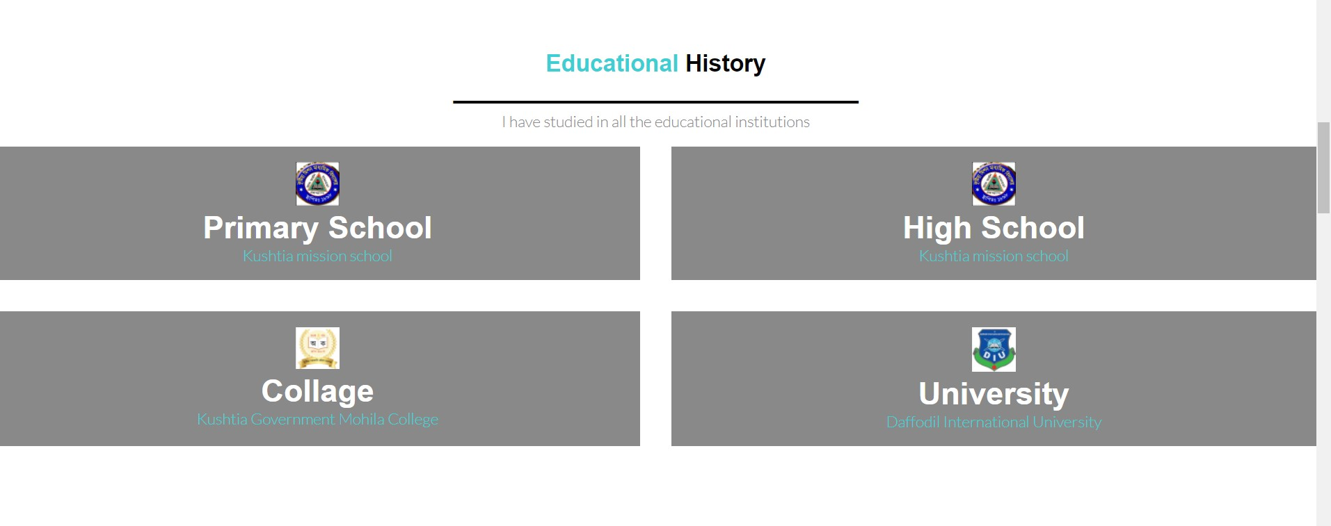

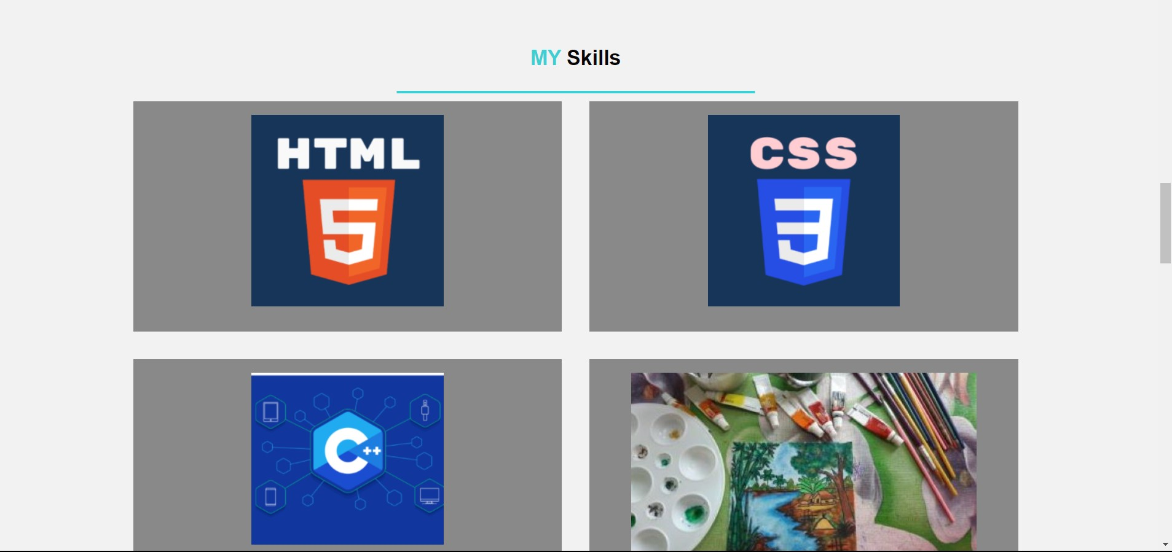

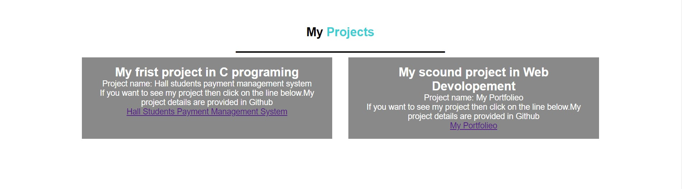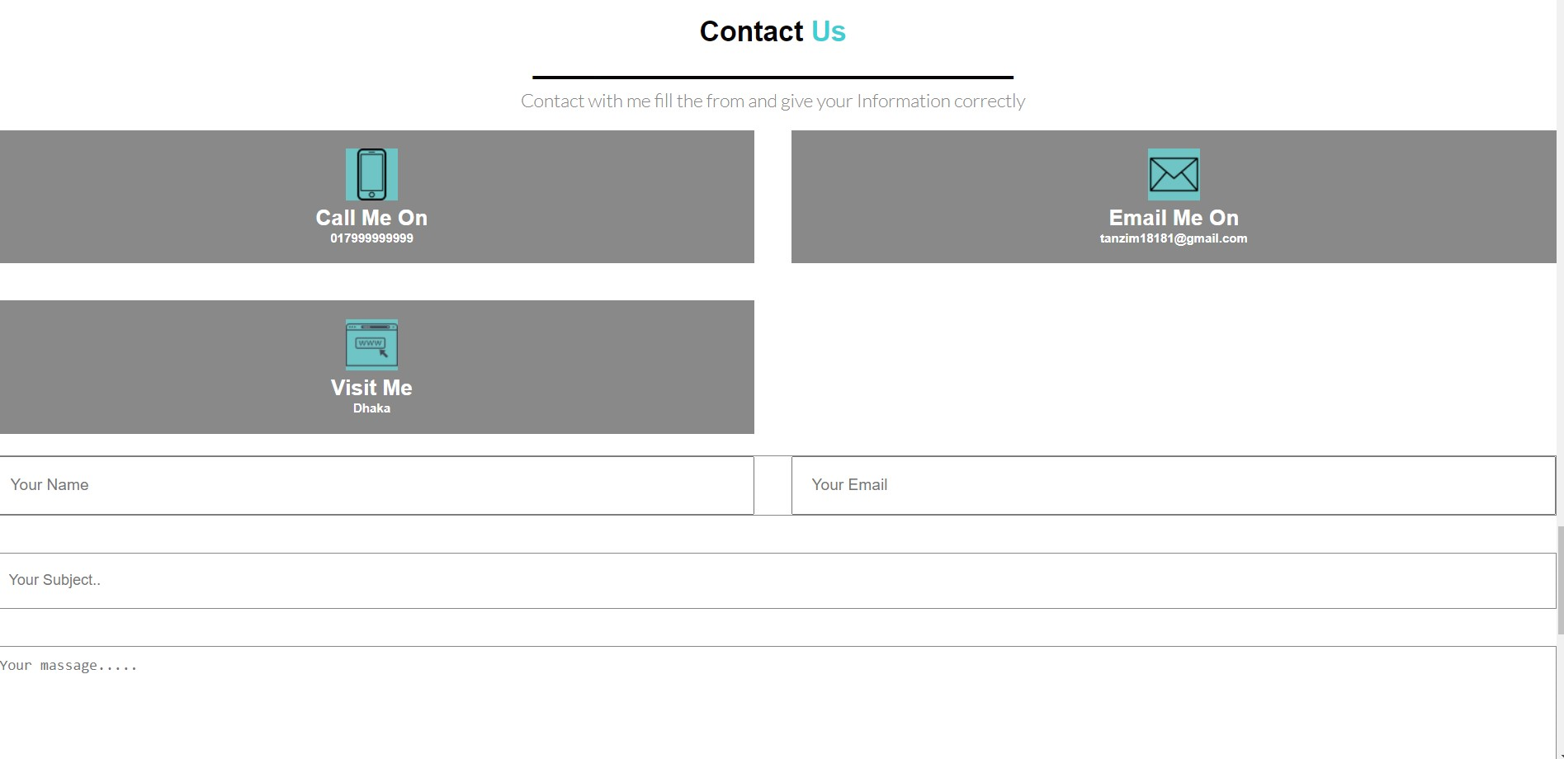

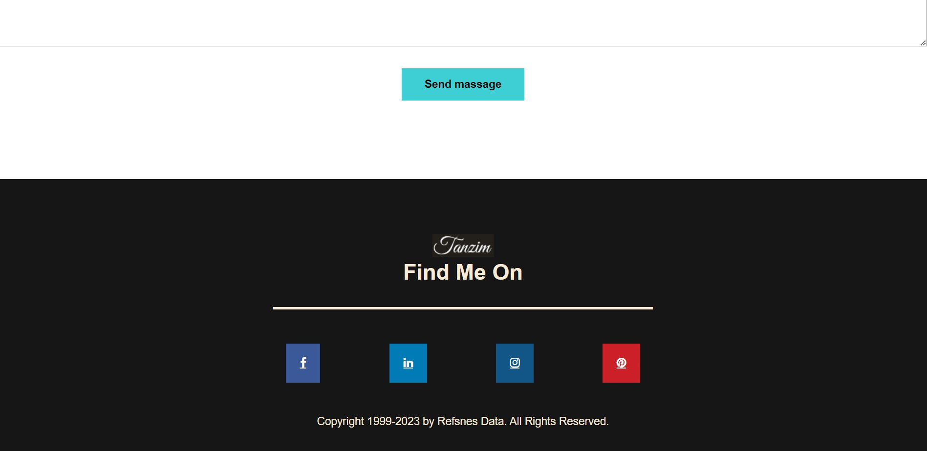

**My portfolio html code :**

<!DOCTYPE html>

<html lang="en">

<head>

<meta charset="UTF-8">

<meta name="viewport" content="width=device-width, initial-scale=1.0">

<meta name="viewport" content="width=device-width, initial-scale=1">

<title>Tanzim Raha </title>

<link rel="preconnect" href="https://fonts.googleapis.com">

<link rel="preconnect" href="https://fonts.gstatic.com" crossorigin>

<link href="https://fonts.googleapis.com/css2?family=Poppins:wght@400;600&display=swap" rel="stylesheet">

<link rel="preconnect" href="https://fonts.googleapis.com">

<link rel="preconnect" href="https://fonts.gstatic.com" crossorigin>

<link href="https://fonts.googleapis.com/css2?family=Lato:wght@300;700&display=swap" rel="stylesheet">

<link rel="stylesheet" href="https://cdnjs.cloudflare.com/ajax/libs/font-awesome/4.7.0/css/font-awesome.min.css">

<link rel="stylesheet" href="https://cdnjs.cloudflare.com/ajax/libs/font-awesome/4.7.0/css/font-awesome.min.css">

<link rel="stylesheet" href="https://cdnjs.cloudflare.com/ajax/libs/font-awesome/4.7.0/css/font-awesome.min.css">

<link rel="stylesheet" href="1stportfolio.CSS">

<link rel="stylesheet" href="utilitie.CSS">

</head>

<body>

<header id="home">

<div class="container ">

<nav id="main-nav" class="flex items-center justify-between">

<div class="left flex ">

<div class="branding">

<img src="2tanzim.png" alt="">

</div>

<div >

<a href="#home">Home Page</a>

<a href="#about">About Me</a>

<a href="#educational">Education</a>

<a href="#skills">Skills</a>

<a href="#project">Projects</a>

<a href="#contact">contact</a>

</div>

</div>

</nav>

<div class="hero flex items-center ">

<div class="left flex-1 flex justify-left">

<img src="tanzim2.png" alt="Tanzim">

</div>

<div class="right flex-1">

<h6>Tanzim Raha</h6>

<h1>I'm a student of <span>CIS</span></h1>

<h3 class="btn btn-3">Daffodil International University</h3>

<p class="btn" >I’m Tanzim Raha, from kushtia,khulna district .

My study field is on Computing and Information System in Daffodil International University.

I've knowledges over Web development and C programing language. I'm right now a larner in future

I want to build my career in an educational institute, employing and pertaining to utilize my technical skills and research knowledge.

I also want to make a career rather than just a job and to face the challenges in all aspects.</p>

<button class="btn btn-primary">Download CV</button>

</div>

</div>

</div>

</header>

<section id="about" class="about">

<div class="container flex items-center">

<div >

<img class="img" src="image1.jpg" alt="">

</div>

<div class="flex-1">

<h1>About <span>Me</span></h1>

<h1>__________________________________________________________________</h1>

<h3>Hello! I'm Tanzim Raha.</h3>

<p>I’m Tanzim Raha, from kushtia,khulna district .

My study field is on Computing and Information System in Daffodil International University.

I've knowledges over Web development and C programing language.

I'm right now a larner in future

i want to job in IT sector.</p>

</div>

<div class="social icon-bar">

<a href="https://www.facebook.com/tanzim.raha" class="fa fa-facebook"></a>

<a href="#" class="fa fa-linkedin"></a>

<a href="https://www.instagram.com/tan_180___/" class="fa fa-instagram"></a>

<a href="https://www.pinterest.com/tanzim18181/" class="fa fa-pinterest"></a>

</div>

</section>

<section id="educational" class="school">

<div class="contener">

<h1 class="section-headding"><span>Educational</span> History</h1>

<h1 class="section-headding">_______________________________</h1>

<P>I have studied in all the educational institutions </P>

</div>

<div id="card-wrapper">

<div class="card">

<a href="https://www.facebook.com/kushtia.mission.high.school/"><img src="mission.png" alt=""></a>

<h2>Primary School</h2>

<p>Kushtia mission school</p>

</div>

<div class="card">

<a href="https://www.facebook.com/kushtia.mission.high.school/"><img src="mission.png" alt=""></a>

<h2>High School</h2>

<p>Kushtia mission school</p>

</div>

<div class="card">

<a href="https://kmc.edu.bd/"><img src="mohila.png" alt=""></a>

<h2>Collage</h2>

<p>Kushtia Government Mohila College</p>

</div>

<div class="card">

<a href="https://daffodilvarsity.edu.bd/"><img src="daffodil.png" alt=""></a>

<h2>University</h2>

<p>Daffodil International University </p>

</div>

</div>

</section>

<section id="skills" class="work">

<div class="container">

<h1 class="section-headding"><span>MY </span> Skills</h1>

<h1 class="section-headding"><span>_______________________________</h1>

<div id="card-wrapper">

<div class="card">

<div class="overlay">

</div>

<img src="html.png" alt="">

</div>

<div class="card">

<div class="overlay">

</div>

<img src="css.png" alt="">

</div>

<div class="card">

<div class="overlay">

</div>

<img src="c.png" alt="">

</div>

<div class="card">

<div class="overlay">

</div>

<img src="art1.jpg" alt="">

</div>

<div class="card">

<div class="overlay">

</div>

<img src="art2.jpg" alt="">

</div>

<div class="card">

<div class="overlay">

</div>

<img src="art3.jpg" alt="">

</div>

</div>

</div>

</section>

</section>

<section id="project" class="projects">

<div class="container">

<h1 class="section-headding">My <span>Projects</span></h1>

<h1 class="section-headding">_______________________________</h1>

<div id="card-wrapper">

<div class="card">

<h1>My frist project in C programing<br></h1>

<span>Project name: Hall students payment management system<br> </span>

<span>If you want to see my project then click on the line below.My project details are provided in Github<br></span>

<a href="">Hall Students Payment Management System</a>

</div>

<div class="card">

<h1>My scound project in Web Devolopement<br></h1>

<span>Project name: My Portfolieo<br> </span>

<span>If you want to see my project then click on the line below.My project details are provided in Github<br></span>

<a href="">My Portfolieo</a>

</div>

</section>

</section>

<section id="contact" class="contact">

<div class="container">

<h1 class="section-headding">Contact<span> Us</span></h1>

<h1 class="section-headding">_______________________________</h1>

<p>Contact with me fill the from and give your Information correctly</p></div>

<div id="card-wrapper">

<div class="card">

<img src="phone.png">

<h3>Call Me On</h3>

<h6>017999999999</h6>

</div>

<div class="card">

<img src="gmail.png">

<h3>Email Me On</h3>

<h6>tanzim18181@gmail.com</h6>

</div>

<div class="card">

<img src="visit.png">

<h3>Visit Me</h3>

<h6>Dhaka </h6>

</div>

</div>

<from action="" class=" from">

<div class="input-wrap-1">

<input type="text" placeholder="Your Name">

<input type="email" placeholder="Your Email">

</div>

<div class="input-wrap-2">

<input type="text" placeholder="Your Subject..">

<textarea name="" id="" cols="30" rows="10" placeholder="Your massage....."></textarea>

</div>

<div class="btn-wrapper">

<button class="btn btn-primary">Send massage </button>

</div>

</from>

</div>

</section>

<footer>

<div class="container">

<img class="footer-logo" src="2tanzim.png" alt="">

<div class="copy">

<h1>Find Me On</h1>

<h1>_______________________________</h1>

</div>

<div id="footer-socials">

<a href="https://www.facebook.com/tanzim.raha" class="fa fa-facebook"></a>

<a href="#" class="fa fa-linkedin"></a>

<a href="https://www.instagram.com/tan_180___/" class="fa fa-instagram"></a>

<a href="https://www.pinterest.com/tanzim18181/" class="fa fa-pinterest"></a>

</div>

<div class="copy">

Copyright 1999-2023 by Refsnes Data. All Rights Reserved.

</div>

</div>

</footer>

</div>

</body>

</html>

**My portfolio Css code :**

@import 'utilite.CSS';

:root{

--primary:#3DCFD3;

--dark:#161616;

--pure:#FFFFFF;

--ternary:#898989;

--light:#F2F2F2;

--secondary:#070606;

}

body{

font-family: 'poppines', sans-serif ;

}

html{

scroll-behavior: smooth;

}

*{

padding: 0;

margin: 0;

box-sizing: border-box;

-webkit-font-smotthing:antialiased;

}

header{

background-color: var(--dark);

clip-path: polygon(0 0,100% 0,100% 100%,70% 90%,0 100%);

}

.container{

max-width: 1152px;

padding: 0 15 px;

margin: 0 auto;

}

header nav .left a{

color: var(--pure);

text-decoration: none;

margin-right: 2rem;

text-transform: uppercase;

transition:all .11s ease ;

}

header nav .left a:hover{

color:var(--primary);

}

header nav{

padding:2rem 0 ;

}

header nav .branding{

margin-right: 3rem;

}

.hero{

padding-right: 3rem 0;

}

.hero .left img {

width:300px;

}

.hero .right{

color:var(--pure);

}

.hero .right h6{

font-size:1.6rem;

color: var(--primary);

margin-top: 1rem;

}

.hero .right h1{

font-size:4rem ;

font-weight: 100;

margin-top: -2rem;

}

.hero .right h3{

margin-top: -2rem;

margin-bottom: 2rem;

}

.hero .right h1 span{

color: var(--primary);

}

.hero .right{

line-height:1.9 ;

margin-bottom:2rem ;

}

.hero .right{

margin-top: -5rem;

}

section{

padding:6rem 0;

}

section.about.img{

height: 450px;

}

section.about h1{

margin-bottom: 1rem;

font-size: 1.6rem;

font-weight:400 ;

}

section.about h1 span{

color: var(--primary);

}

section.about h3{

font-size: 1rem;

margin-bottom: 1rem;

font-weight: 400;

}

section.about p{

font-family: 'Lato', sans-serif;

color: var(--ternary);

line-height: 1.9;

}

.about .social a.fa {

padding: 20px;

font-size: 30px;

width: 50px;

text-align: center;

text-decoration: none;

margin: 5px 2px;

}

.about .social a.fa:hover {

opacity: 0.7;

}

.about .social a .fa-facebook {

background: #3B5998;

color: white;

}

.about .social a .fa-linkedin {

background: #007bb5;

color: white;

}

.about .social a .fa-instagram {

background: #125688;

color: white;

}

.about .social a .fa-pinterest {

background: #cb2027;

color: white;

}

section.about{

border-block-width: 5px;

border-block-end-style: solid;

border-block-color: var(black);

inline-size: 100%;

}

.section-headding{

color: var(--secondary);

text-align: center;

margin-bottom: 1rem;

line-height: 0.5;

}

.section-headding span{

color: var(--primary);

}

.section-headding + p{

color: var(--ternary);

font-family: 'Lato', sans-serif ;

margin-bottom:1rem;

text-align: center;

}

#card-wrapper{

display: grid;

grid-template-columns:repeat(2,1fr) ;

grid-column-gap: 2rem;

grid-row-gap:2rem;

}

#card-wrapper .card{

background: var(--ternary);

padding:1rem 1rem;

color: #FFFFFF;

position: relative;

text-align: center;

}

#card-wrapper img{

background:rgb(111, 197, 197);

}

#card-wrapper.card img{

position:absolute;

top: -5.5rem;

transform: translatex(-50%);

}

#card-wrapper .card h2{

font-weight: bold;

font-size: 2rem;

}

#card-wrapper .card p{

color: var(--primary);

font-family: 'Lato', sans-serif ;

}

#card-wrapper.card:hover{

background: var(--pure);

}

section.freelancer{

text-align: center;

background: linear-gradient(rgba(0,0,0,0.7),rgba(0,0,0,0.7)),url("camera.jpeg");

background-repeat: none;

color: var(--pure);

clip-path: polygon(0 0,100% 0,100% 100%,60% 80%,0 100%);

padding-bottom: 8rem;

}

section.freelancer h1{

font-size: 2rem;

margin-bottom: 0.5rem;

}

section.freelancer h1{

margin-bottom:2rem ;

font-family:'Lato', sans-serif;

}

section.work{

background: var(--light);

}

section.work #card-wrapper{

display: grid;

grid-template-columns:repeat(3 1fr) ;

}

section.work #card-wrapper .card{

position: relative;

height: 300px;

}

section.work #card-wrapper .card .overlay{

position: absolute;

top: 0;

left: 0;

width: 100%;

height: 100%;

background: rgba( 61,207,211, 0.9);

justify-content: center;

align-items: center;

flex-direction: column;

color: var(--ternary);

opacity: 0;

transition: all 0.5s ease;

}

section.work #card-wrapper .card:hover .overlay{

opacity: 1;

}

section.work #card-wrapper .card .overlay{

color: var(--secondary);

text-decoration: none;

}

section.work #card-wrapper .card .overlay img{

height: 100%;

width:100% ;

}

section.contact .input-wrap-1{

display: grid;

grid-template-columns: repeat(2, 1fr);

grid-gap:2rem;

margin-bottom: 2rem;

border: 1px solid var(--ternary);

font-size: 0.8rem;

}

section.contact .input-wrap-2{

display: flex;

flex-direction: column;

}

section.contact .input-wrap-2 input{

margin-bottom: 2rem;

border: 1px solid var(--ternary);

font-size: 0.8rem;

}

section.contact .input-wrap-2 textarea{

padding: 0.5rem;

border: 1px solid var(--ternary);

font-size: 0.8rem;

}

section.contact input{

padding: 1rem ;

}

section.contact input:focus section.contact .input-wrap-2 textarea{

outline: none ;

}

section.contact .btn-wrapper{

text-align: center;

margin-top: 2rem;

}

.from{

padding: 3rem;

}

footer{

color: antiquewhite;

background: var(--dark);

text-align: center;

padding: 5rem 0;

}

footer.footer-logo{

margin-bottom: 5rem;

}

footer #footer-socials a{

margin: 3rem;

padding: 2%;

}

.fa-facebook {

background: #3B5998;

color: white;

}

.fa-linkedin {

background: #007bb5;

color: white;

}

.fa-instagram {

background: #125688;

color: white;

}

.fa-pinterest {

background: #cb2027;

color: white;

}