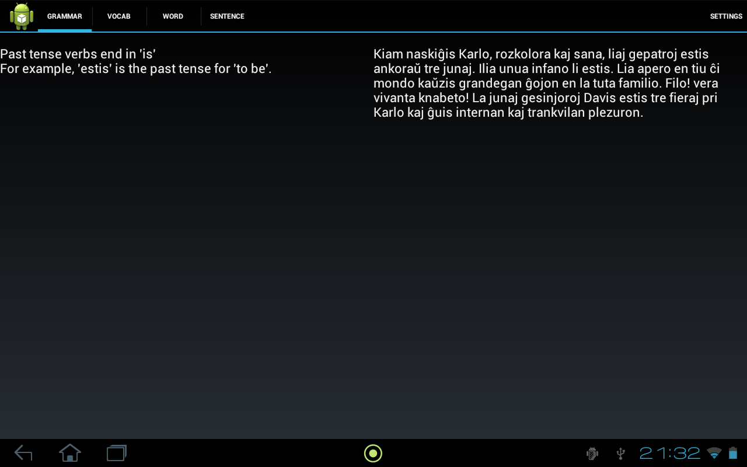
Ryan Smith
David Cronkite

Graded Reader

Going along with what we had already decided, we still wish to have 4 basic views in the app, that we think are most useful in allowing a student of a language to begin reading in this new language. The goal of the app is that through reading, the user can grow accustomed to their language in more than just a purely academic and theoretical viewpoint. Our target audience is primarily those who have already begun studying a language in a traditional manner, and need something to help them bridge the gap from beginner to intermediate.

The default view when someone opens the program, after having selected what text they would like to read, is a two-paned view with the chapter of the text they are currently reading on the right, and the grammatical contents of the lesson corresponding to this chapter on the left.This view allows the reader to learn the necessary grammatical constructs before beginning. This content is prepared by the lesson preparer.
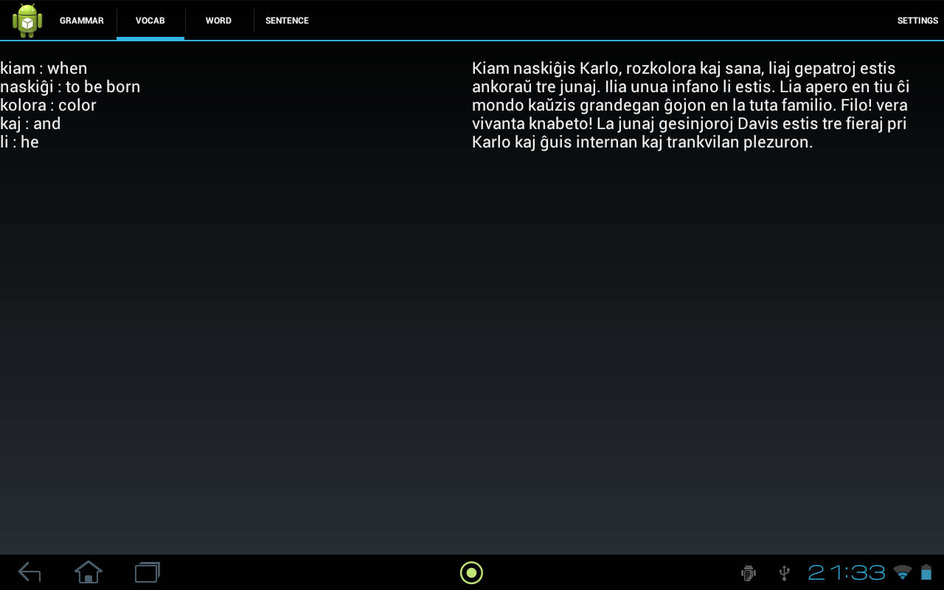

The next view a reader would access is the "vocab" tab. This view is a list of the most important words, as selected by the content preparer. A well designed lesson plan would have the majority of the new words in a text presented in this view, and the reader should expect that the majority of their time reading will be spent with this tab open.

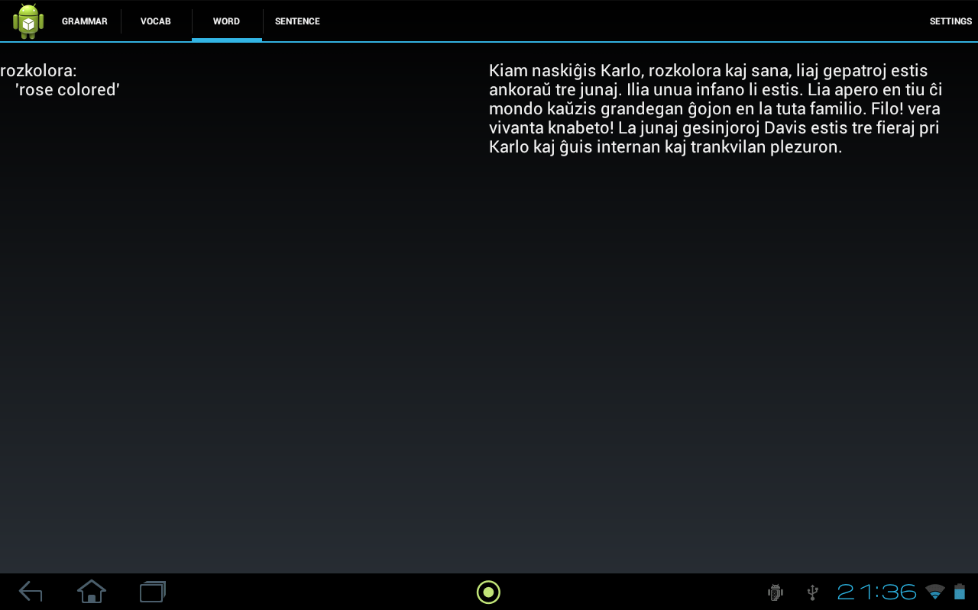
The other two tabs exist to help the reader for when they have forgotten words, or just simply can't understand the meaning of the words once put together. They are the "word" and "sentence" tabs. The word tab will give the translation of the selected word, as given by the preparer of the content. Our hope is that desktop program that helps the preparer select the definitions, alternatively we might have it set up to query an on-line dictionary for meanings and return the results. The sentence tab is similar to the word tab, except rather than showing the definition of a word, it will show the translation of the selected sentence. Currently, we haven't programmed the functionality of being able to select sentences or words as this is still a mock-up.
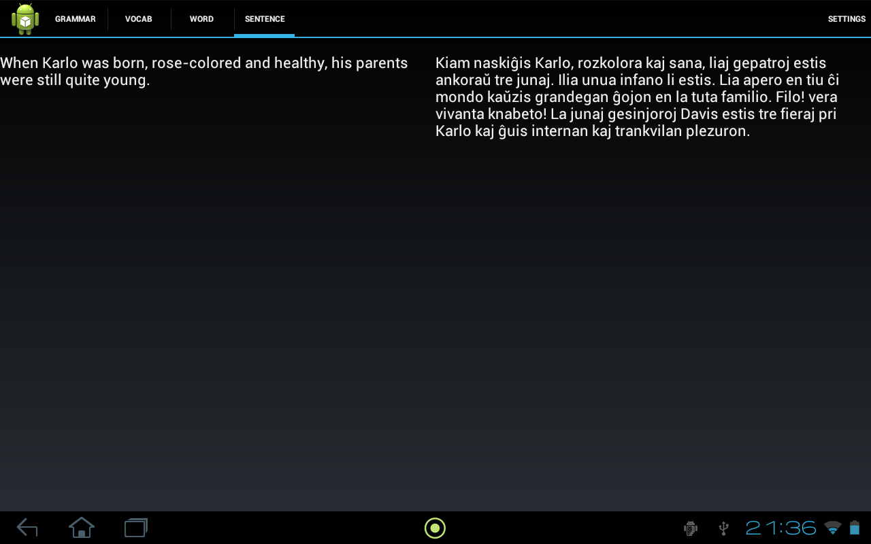
The content that we will be having our program read in will be from an XML filefile. An example XML is included in the e-mail named "karlo.xml", though it currently the word and sentence level translations are left blank, as are the grammatical lessons and vocab list.

From the SDK, we are using the action bar to create our tabs, and using fragments to set our views. We are currently thinking about using either intents or event calls / listeners to set up the selecting of the text for the word and sentence level translations, but are not quite sure yet how exactly this is going to be implemented. The text we are preparing as an example text is a free text in Esperanto, named Karlo and was written by Edmond Privat. The version we are using is from Project Gutenberg. The linguistic data we're adding for the language learner is coming primarily from Ryan's knowledge of Esperanto, with help from a few Esperanto dictionaries (such as the on-line one at lernu.com).

All screenshots are from the app running on Ryan's tablet. The UI is functional, but the content is currently static.

