


Final project in computer engineering on the subject
Streaming FPGA Accelerator for a Transformer Block:
Weight-Stationary Systolic MatMul, Softmax, and GELU
[TO CONFIRM — working title above — replace with the title you and your supervisor settle on]
[כותרת בעברית]
[TO CONFIRM — Hebrew title still needed]

Authors:
Eliran Turgeman, 316372002
Shay Rask, 314951658

Track: Computer Engineering — Hardware and Chip Design
Academic supervisor: Dr. Leonid Yavits (Leonid.yavits@biu.ac.il)
Project mentor: David Freud (david.freud@mail.huji.ac.il)
Date of submission: [date of submission]
[TO CONFIRM — confirm the supervisor/mentor role mapping — the team README lists David Freud as “supervisor” and Dr. Yavits as “academic authority”; swapped here to match this template's “Academic supervisor” / “Project mentor” fields, but please double-check which one is which, and fill in the actual submission date.]

Submitted as part of the undergraduate requirements
Faculty of Engineering, Bar-Ilan University
Project number: 309

This document presents a proposed structure for the project report, intended to assist students in organizing their work and clarifying the required content components. However, this structure is not mandatory, and alternative structures may be used, provided they align with accepted academic writing practices in the relevant field, particularly those that follow the structure of a scientific paper within the relevant professional community.

ABSTRACT
Transformer neural networks now dominate both natural-language processing and computer vision, but their quadratic attention cost and large memory footprint make them expensive to run at the latency and power budgets typical of edge devices. This project designs, implements in RTL, and verifies in simulation a fixed-point, streaming hardware datapath for three operators that recur throughout every Transformer block: a systolic, weight-stationary matrix multiplication; a softmax normalization stage; and the GELU activation function. Each operator already existed as an independently unit-verified RTL core carried over from a prior codebase; this project's contribution is transformer_block_top, a structural pipeline that chains the three cores back-to-back through two purpose-built AXI-stream-style width adapters, together with the verification environment needed to trust that chaining. All four levels of the design — the GELU lane, the Softmax core, the systolic matmul, and the full three-stage chain — are checked in Cadence Xcelium simulation against SystemVerilog software models that compute the same operators in real-valued arithmetic, with a reusable stall/latency instrumentation layer (stall_monitor.sv) measuring handshake behavior at each interface. Building and exercising this chain surfaced two functional bugs that unit-level testing alone had not caught: a 3-bit versus 4-bit scale-port mismatch between the Softmax and GELU cores that silently truncated (and numerically corrupted) any configuration using a Softmax output scale above the minimum shared value, and a fixed-point threshold overflow in the matmul's weight-loading buffer that permanently blocked the weight stream whenever a block-count parameter was sized exactly equal to, rather than with headroom above, the actual number of beats used. With both fixes applied, the end-to-end integration testbench passes with zero elements outside tolerance (0 of 128) against the golden model, and the previously-blocked weight stream now completes correctly. FPGA synthesis, on-board deployment, and the throughput/latency/power comparison against a CPU/GPU baseline that motivated this project remain the next phase of work and are reported here only as a concrete, scheduled next step, not as completed results.

ACKNOWLEDGMENTS
We would like to thank our academic supervisor, Dr. Leonid Yavits, and our project mentor, David Freud, for their guidance throughout this project.
[TO CONFIRM — add any additional personal acknowledgments here]

Table of Contents

1 Introduction 7
1.1 Background 7
1.2 Literature Overview 7
1.3 Research Objective / Hypothesis / Problem Statement 8
2 Design Overview/ Theoretical Framework 9
3 Implementation/ Abstract Design 11
4 Experiment and Result/ Analytical Verification 14
5 Discussion and Conclusion 16
6 Comparing Results With Prior Work/ Comparative Analysis 16
7 Future Research Directions 17
8 References 18
9 Appendix A 19
10 Appendix B 20

List of figures

Figure 1: transformer_block_top streaming datapath 9
Figure 2: PE_array micro-architecture 12

List of tables

Table 1: RTL and testbench code breakdown by module 12
Table 2: Verification testbenches and their configurations 14
Table 3: Full RTL / testbench module inventory 19

Introduction

Background
Transformer models process a sequence by letting every element attend to every other element (self-attention), then pass each position through the same small feed-forward network. That feed-forward network is built from two operations that appear over and over, once per attention head and once per layer: a matrix multiplication against a set of learned weights, and a nonlinear activation applied element-wise afterward. Attention itself adds a third recurring operation, softmax, which turns a row of raw similarity scores into a probability distribution before it is used to weight the values being attended to. Because these three operations are repeated so many times per inference — once per head, per layer, per token — their cost dominates both the latency and the energy consumption of running a Transformer, and that cost grows at least quadratically with sequence length for the attention part specifically.
This matters most where compute and power are scarce: real-time NLP or vision-transformer (ViT) inference on edge devices, embedded sensors, or any deployment where a full GPU is not available or not power-budgeted. General-purpose CPUs and GPUs run these workloads at whatever numeric precision and dataflow their fixed architecture provides, which is rarely the most efficient choice for a specific, known model. An FPGA, by contrast, lets the datapath — its arithmetic precision, its memory tiling, and the exact sequence in which operands are streamed through the multiply-accumulate array — be built to match the workload, which is the standard motivation for custom Transformer accelerators in the literature (Section 1.2).

Literature Overview
Prior FPGA accelerators for Transformer-family models converge on a small set of recurring design choices, surveyed by Zhu et al. [2]: reduced-precision (often 8-bit integer or mixed-precision) arithmetic to shrink both the multiply-accumulate array and the on-chip memory needed to hold activations and weights; systolic or otherwise spatially-tiled MAC arrays that keep either weights or activations stationary to minimize data movement; and dataflow scheduling that overlaps the linear-projection, normalization, and activation stages of a block instead of running them as separate, memory-bound passes.
Cai et al. [5] built a high-throughput, energy-efficient FPGA Transformer accelerator around exactly this kind of systolic MAC array, the same broad approach this project's inherited matmul core (Section 3) takes. FTRANS [4] instead emphasizes energy efficiency through block-circulant weight compression and a scheduling strategy tuned per Transformer sub-block. ME-ViT [3] targets Vision Transformers specifically and prioritizes memory efficiency with a single-load dataflow that avoids re-fetching activations across heads and layers. Across all three, softmax and the block's activation function are treated as necessary but comparatively cheap stages bolted onto the dominant matmul cost — which is also this project's structural assumption: the matmul core (systolic, weight-stationary) is the most elaborate of the three stages, with Softmax and GELU implemented as smaller streaming pipelines chained after it (Section 2).

Research Objective / Hypothesis / Problem Statement
The RTL cores needed to compute a matmul, a softmax, and a GELU activation in fixed-point hardware already existed in this project's starting codebase (Section 3 documents this provenance explicitly), and each had already been unit-verified in isolation. What did not exist was a structural chain connecting them into one streaming pipeline, nor any evidence that the three cores' interfaces — their handshake conventions, their fixed-point scale conventions, their buffer sizing assumptions — actually agreed with one another when wired together. This is exactly the class of problem that isolated unit tests are structurally unable to catch: two cores can each be individually correct and still corrupt data, or deadlock, the moment they are connected.
The objective of this phase of the project is therefore to design a structural top-level pipeline that chains the matmul, softmax, and GELU cores through real AXI-stream-style handshaking; to build a system-level verification environment capable of catching the integration-class bugs that unit tests miss; and to use that environment to find and fix any such bugs before the design moves on to FPGA synthesis and the throughput/latency/energy comparison against a CPU/GPU baseline that is this project's ultimate deliverable (per the project's stated goals in the README: reduced inference latency, higher throughput, and lower energy per inference relative to CPU/GPU execution of the same workload).

Design Overview/ Theoretical Framework

transformer_block_top structurally chains three streaming stages — a systolic matrix multiplier (MM_ultra), a softmax normalizer (Softmax_control), and a bank of GELU activation lanes (EightGelus) — through two purpose-built adapters that reconcile each stage's native data width and handshake convention with the next. Figure 1 shows the full datapath as implemented in sourcecode/top/transformer_block_top.v.
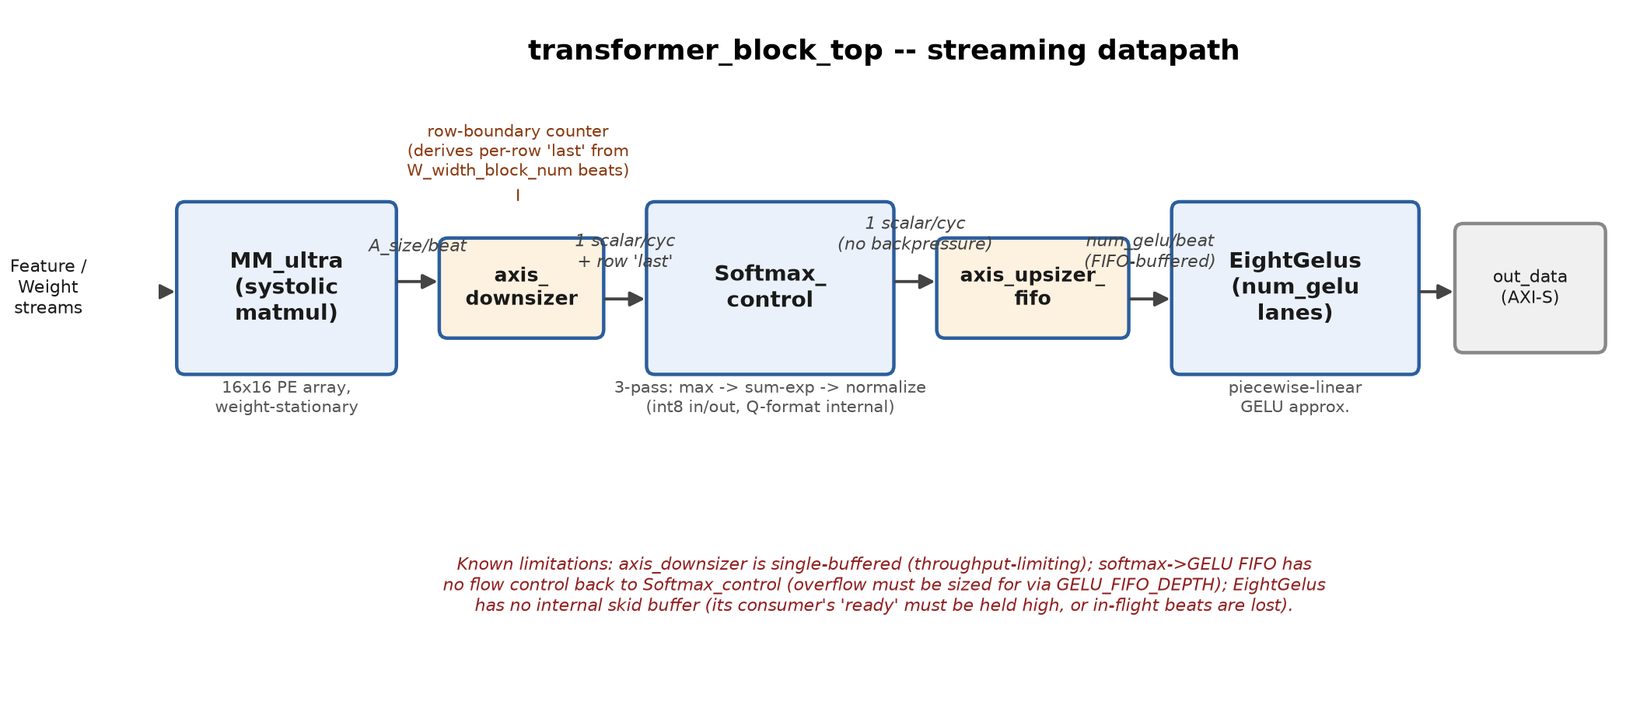
Figure 1: transformer_block_top streaming datapath: MM_ultra's wide output beats are unpacked to one scalar per cycle for Softmax_control, whose unbuffered output is re-packed and elastically buffered for EightGelus' num_gelu-wide lanes.

A row-boundary counter local to transformer_block_top — not MM_ultra's own out_data_last, which only pulses once for the entire matrix — turns "last beat of a row" into a per-row 'last' pulse every W_width_block_num beats, which is the framing Softmax_control needs to normalize one row at a time. Between Softmax and GELU, an elastic FIFO (axis_upsizer_fifo) is required rather than a simple shift register, because Softmax_control's output has no ready/backpressure signal at all: it is a fixed-rate producer, so anything downstream must be able to absorb its output unconditionally.
Common use case: a caller streams one feature-row batch (F_length rows, each a multiple of A_size columns) and one weight matrix into the two input ports, sets the per-stage shift/scale configuration once at the start of the transaction, and reads back, for every input row, the corresponding GELU-activated, softmax-normalized matmul result on the num_gelu-wide output stream, framed by out_last per row and out_keep for a partial final beat.
Undesirable situations the design already accounts for: matmul accumulation results that would overflow the 8-bit output range are saturated to +127/-128 rather than wrapped; the Softmax→GELU bridge raises an explicit software-visible overflow flag (softmax_to_gelu_fifo_overflow) instead of silently dropping samples if its FIFO is undersized for the row length in use; and the two stages' independent fixed-point scale configurations are now width-matched end to end (Section 4) so that a valid configuration on one side cannot silently be truncated into an invalid one on the other, which was a real, previously-present class of silent-corruption bug in this design (Section 4).

Implementation/ Abstract Design

Technologies. The synthesizable core (sourcecode/core/, sourcecode/top/) is written in Verilog-2001; the testbenches (sourcecode/tb/) are SystemVerilog, using automatic task variables, $clog2-style constant expressions, and real-valued software reference models ($exp, $tanh) to check the fixed-point hardware against floating-point math. Verification runs under Cadence Xcelium, driven by a Makefile (sourcecode/sim/Makefile) that compiles and elaborates each testbench into its own run/<name>/ directory and tees console output into reports/sim/*.rpt; heavier runs are submitted through the shared cluster's PBS batch queue (sourcecode/sim/run_xrun.pbs) rather than on the interactive login node. The project targets AMD/Xilinx Vivado for synthesis, implementation, and bitstream generation, per the top-level README's build flow; that flow has not yet been exercised in this repository snapshot (Section 4).
Numeric representation and trade-off. Rather than one global fixed-point format, each stage carries its own configurable scale/shift register (e.g. Softmax's scale_in/scale_out, GELU's in_scale, MM_ultra's shift_in) and internally documents its own Q-format at each pipeline stage (for example S9Q10 and U0Q25 inside Exp_module, U3Q10 inside Ln_module, 8Q7 inside gelu.v). This trades extra configuration-port area and the cross-stage agreement bugs discussed in Section 4 for the ability to reuse the same core at different points in a larger network without re-deriving a single global format — the standard int8-quantization trade-off also taken in the FPGA Transformer accelerators reviewed in Section 1.2, exchanging some accuracy for a much smaller multiply-accumulate array and smaller on-chip buffers than a floating-point design would need.
Micro-architecture: the matmul core. MM_ultra wraps a weight-stationary systolic PE array (PE_array.v, parameterized array_m × array_n, 16×16 by default) with input/output tiling buffers (MM_in_buffer, MM_buffer, MM_out_buffer) that stream a feature matrix and a weight matrix in A_size-wide beats. Figure 2 shows the PE array's data movement: each processing element holds one weight in a register (loaded once via set_w) and performs one multiply-accumulate per cycle against a systolically-skewed feature stream, with skew registers (i extra cycles per row, array_n-1-j extra cycles per column) ensuring a full row's dot product exits column-aligned.

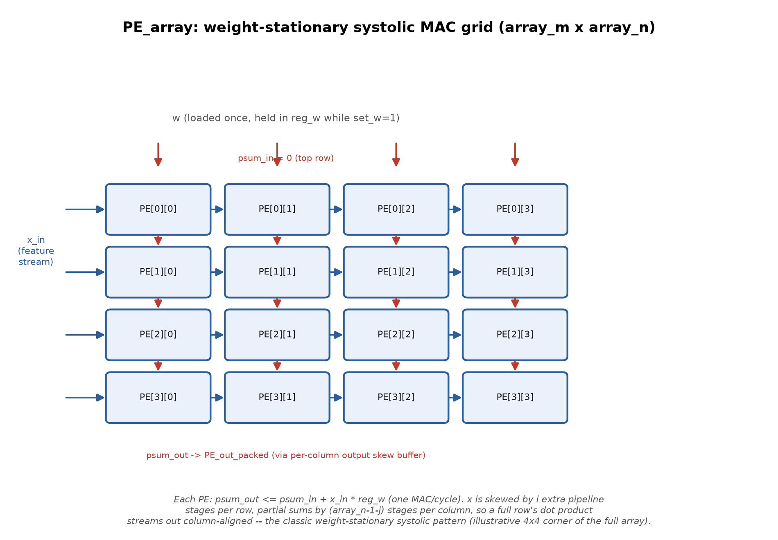
Figure 1: PE_array micro-architecture: a weight-stationary systolic MAC grid (illustrative 4x4 corner of the full array_m x array_n grid; the project's default configuration is 16x16).

Complexity metrics. Table 1 breaks down the RTL and testbench code by module; the full synthesizable + verification codebase under sourcecode/ totals 5,993 lines across 29 files, with no dependency beyond standard Verilog/SystemVerilog constructs — no vendor IP core is instantiated anywhere in the datapath itself (the AXI-Lite configuration wrappers, e.g. MM_ultra_axi.v and Softmax_top_axi.v, exist in sourcecode/core/ but are not used by transformer_block_top, which is driven directly by plain register/wire ports in simulation).
Table 1: RTL and testbench code breakdown by module.
Module | Role | Lines
PE.v / PE_line.v / PE_array.v | Systolic MAC array (core arithmetic unit) | 35 / 56 / 129
MM.v, MM_in_buffer.v, MM_buffer.v, MM_out_buffer.v, MM_ultra.v | Matmul tiling, buffering, and control | 219 / 267 / 359 / 330 / 221
Softmax.v, Softmax_control.v, Exp_module.v, Ln_module.v | Softmax pipeline (max, exp, sum, normalize) | 233 / 194 / 48 / 62
gelu.v, lin.v, EightGelus.v | GELU activation lanes | 116 / 52 / 118
axis_downsizer.v, axis_upsizer_fifo.v, transformer_block_top.v | This project's structural pipeline + adapters | 75 / 133 / 265
MM_Ultra_tb.sv, Softmax_top_tb.sv, gelu_tb.sv, transformer_block_tb.sv, stall_monitor.sv | Self-checking testbenches + shared instrumentation | 428 / 249 / 107 / 455 / 75
AXI-Lite wrappers (MM_ultra_axi.v, MM_ultra_top.v, Softmax_top.v, Softmax_top_axi.v, Gelus_top.v, Gelus_axi.v) | Standalone-IP wrappers, not used by transformer_block_top | 467 / 129 / 104 / 432 / 107 / 440

Provenance and this project's concrete addition. The core computational modules listed in the first four rows of Table 1 predate this project's two authors: they were carried into the repository as its starting codebase (commit "added relevant files from Buck008 user", 2026-03-01) and each already had its own unit-level testbench. This project's own, verifiable contribution on top of that base is: (1) transformer_block_top.v together with its two streaming-width adapters, axis_downsizer.v and axis_upsizer_fifo.v — the first structural chaining of the three cores into one pipeline; (2) the corresponding system-level testbench, transformer_block_tb.sv, together with the reusable handshake-profiling utility stall_monitor.sv and an end-to-end latency counter, both also retrofitted onto the two pre-existing unit testbenches; (3) the Xcelium build/run automation (Makefile, run_xrun.pbs, waves.tcl) that made repeatable, cluster-batch-queued regression runs possible; and (4) two correctness fixes to the pre-existing cores, found while bringing up this integration, detailed in Section 4.

Experiment and Result/ Analytical Verification
Methodology. All four testbenches share one pattern: drive the DUT with randomized or swept fixed-point inputs, compute the same operation in parallel with a real-valued (or rounding/saturating-integer, for the matmul) SystemVerilog reference model, and flag any output that differs from the reference by more than a stage-appropriate tolerance. stall_monitor.sv is attached to every externally-visible handshake to classify each clock cycle as a completed transfer, a producer-side stall, a consumer-side stall, or idle, and transformer_block_tb.sv additionally times the exact latency from the first input beat to the final output beat. Table 2 summarizes each testbench's configuration.

Table 1: Verification testbenches and their configurations.
Testbench | DUT | Configuration | Reference model / tolerance
gelu_tb.sv | gelu.v (1 lane) | x random int8, in_scale random 0-11 | real-valued GELU (tanh approx.); ~1 LSB at scale
Softmax_top_tb.sv | Softmax_control (via Softmax.v) | length=197, scale_in=6, scale_out=7 | real-valued softmax (max/exp/sum/normalize)
MM_Ultra_tb.sv | MM_ultra | 200 rows x 96 x 160 (A_size=16) | integer matmul with round + saturate; exact latency counter
transformer_block_tb.sv | transformer_block_top (all 3 stages) | 4 rows x 32 cols (deliberately small integration config) | chained integer matmul -> real softmax -> real GELU; ~6 LSBs (compounded 2-stage quantization)

Two integration-level bugs found and fixed. Building and running transformer_block_tb.sv for the first time surfaced two bugs in the pre-existing cores that their own unit tests, run in isolation, had never been in a position to catch:
- Scale-port width mismatch (fixed 2026-07-21): Softmax_control's scale_out_input is 4 bits wide (documented valid range 7-12), but gelu.v / EightGelus' scale port was only 3 bits (max value 7) — the two cores only agreed at scale = 7; any Softmax configuration above 7 was silently truncated before reaching GELU, producing wrong output with no error flagged anywhere. The fix widened in_scale to 4 bits through gelu.v, EightGelus.v, and transformer_block_top.v, and added the missing right-shift branch in gelu.v for in_scale > 7 (previously only left-shift / no-shift was implemented). gelu_tb.sv's randomized scale range was extended from 0-6 to 0-11 to exercise the new branch, and the fix was verified with a clean 200-sample run showing error magnitudes consistent with ordinary quantization noise.
- Weight-stream buffer-threshold overflow (fixed 2026-07-20): MM_in_buffer.v sizes its internal W_block_size threshold register as clogb2(Weight_Block_num) bits, but that threshold must hold the value Weight_Block_num itself (a strict in_W_cnt < W_block_size gate), not just address up to count-1. With Weight_Block_num set to exactly 64 against exactly 64 actual beats, the threshold register overflowed and wrapped to 0, permanently deasserting in_W_ready for the entire run. This was root-caused with a $monitor trace on MM_ultra's W_width_block_num capture chain (since removed) and fixed by giving the block-num parameters real headroom (64 -> 256) above the actual beat count, matching the ratio MM_Ultra_tb.sv itself already used (2400 against ~960 actual beats).
Result with both fixes applied: transformer_block_tb.sv passes end-to-end with 0 of 128 elements outside tolerance across the chained MatMul -> Softmax -> GELU pipeline, and the weight stream now correctly shows transfer = 64 beats completed, versus 0 (permanently blocked) before the second fix.

What is not yet measured. This report intentionally does not fabricate numbers for anything that has not actually been run. Two categories of result are still outstanding:
- Simulation-level throughput/latency and stall percentages: the instrumentation already exists (stall_monitor.sv's stall_pct()/utilization_pct(), and transformer_block_tb.sv's pipe_latency_cycles counter) and prints on every run, but no run has yet been executed and its reports/sim/*.rpt output captured as part of assembling this report. Running `make run_transformer` (or run_mm / run_softmax / run_gelu) per sourcecode/sim/Makefile and pasting the resulting stall/latency lines here is the direct next step.
- FPGA-level results: resource utilization (LUT/FF/BRAM/DSP), timing closure, power, and the throughput/latency/energy comparison against a CPU/GPU baseline all require the Vivado synthesis/implementation/bitstream flow described in the project README, which has not yet been run in this repository snapshot — reports/, dbs/, and exports/ currently contain only placeholder .gitkeep files.
[TO CONFIRM — once the above runs exist, replace this paragraph with the real reports/sim/*.rpt stall and latency figures, and add the Vivado utilization/timing/power tables and a throughput/latency/energy comparison plot against the CPU/GPU baseline here.]

Discussion and Conclusion

This phase of the project set out to turn three independently-verified RTL cores into one correctly-wired, correctness-verified streaming pipeline, and to build a verification environment able to catch integration-class bugs that unit tests structurally cannot see. Both goals were met: transformer_block_top now chains MM_ultra, Softmax_control, and EightGelus through real AXI-stream-style handshaking, and the resulting system-level testbench found and enabled the fix of two real bugs — a scale-port width mismatch and a buffer-threshold overflow — neither of which any single core's own unit test could have exposed, since both only manifest when the cores are actually connected together.
Several limitations are already known and explicitly documented in the RTL/blueprint comments themselves, and are restated here rather than hidden: axis_downsizer is single-buffered, so the matmul stage backpressures for roughly A_size cycles while draining each wide beat, capping the pipeline below full throughput; there is no flow-control path from the Softmax->GELU FIFO back to Softmax_control, so GELU_FIFO_DEPTH must be sized to the largest softmax row length actually used, rather than being auto-negotiated; and EightGelus has no internal skid buffer — its valid/last shift registers advance every clock regardless of out_ready, so a beat present on its output the cycle a downstream consumer deasserts ready is silently lost rather than held. The current testbench works around this last point by holding its final consumer's ready high at all times, which is a valid verification simplification but not a fix, and is called out as a real RTL issue worth addressing in EightGelus.v itself (Section 7).
Scope not yet covered: the current pipeline computes one linear projection followed by normalization and activation — it is not yet a complete attention block. There is no QK^T score matmul, no multi-head split/concatenate, no residual connection, and no standalone residual LayerNorm datapath (Ln_module currently exists only as an internal helper inside Softmax's own log approximation, not as a general-purpose normalization stage). The design also has not yet been placed on real FPGA fabric, so none of the latency, throughput, or energy claims that motivate this project (Section 1) can yet be substantiated with measured numbers. As a reusable building block, though, the linear-projection -> normalize -> activate pattern implemented here generalizes directly to the feed-forward sub-block of any encoder layer, and the design is already parameterized (A_size, num_gelu, GELU_FIFO_DEPTH) for scaling once real timing and area budgets are available from synthesis.

Comparing Results With Prior Work/ Comparative Analysis
Architecturally, this project's matmul core takes the same broad approach as Cai et al.'s high-throughput, energy-efficient FPGA Transformer accelerator [5]: a weight-stationary systolic MAC array operating on int8-quantized operands, rather than a floating-point or HLS-generated datapath. Like FTRANS [4] and ME-ViT [3], this design is buffer-conscious by construction — MM_in_buffer and MM_out_buffer tile the feature and weight streams on-chip rather than assuming both operands are simultaneously resident — though unlike ME-ViT's single-load scheme, this project's tiling has not yet been evaluated for how much re-fetching it avoids across multiple heads or layers, since only a single matmul-softmax-GELU chain has been built and verified so far.
No quantitative comparison — throughput, energy per inference, or resource utilization — against these works, or against a CPU/GPU baseline, is possible yet: none of that data exists in this repository until the FPGA synthesis/implementation flow and an instrumented simulation run have actually been executed (Section 4). This section should be revisited and filled in with real, measured numbers once that data exists — the qualitative architectural comparison above is offered as a starting point, not a substitute.

Future Research Directions

- Run the Vivado synthesis/implementation/bitstream flow described in the README (the corresponding scripts/*.tcl files are not yet present in this repository) and measure real resource utilization, timing closure, and power, then compare against the CPU/GPU baseline that motivates this project.
- Extend the datapath from one linear-projection chain to a full attention block: a QK^T score matmul feeding this same Softmax core, a second matmul against V, multi-head split/concat, and a residual-add + LayerNorm stage distinct from the internal Ln_module already used inside Softmax.
- Fix the two RTL-level limitations documented in Section 5 directly, rather than continuing to work around them in the testbench: add a real skid buffer / backpressure-safe pipeline stage to EightGelus, and either make axis_downsizer multi-buffered for full throughput or add a flow-control path from the Softmax->GELU FIFO back to Softmax_control.
- Scale transformer_block_tb.sv up from its deliberately small 4x32 integration configuration toward MM_Ultra_tb.sv's heavier 200x96x160 configuration, now that the structural wiring and framing are verified at small scale.
- Explore the currently-empty sourcecode/hls/ path as an alternative or complementary implementation route for faster design-space exploration of future blocks.
- Wire apps/ (currently an inherited, largely empty application scaffold) up to a real trained PyTorch model to extract genuine weights and activations, replacing the randomized test tensors used by every testbench so far, per the weight-extraction step already sketched in the project README's build flow.

References
[1] A. Vaswani, N. Shazeer, N. Parmar, J. Uszkoreit, L. Jones, A. N. Gomez, Ł. Kaiser, and I. Polosukhin, "Attention Is All You Need," in Advances in Neural Information Processing Systems (NeurIPS), 2017.
[2] Y. Zhu, Y. Li, S. Chen, and X. Ma, "High-Performance FPGA Acceleration for Transformer-Based Models: A Survey," IEEE Transactions on VLSI Systems, 2023.
[3] S. Li, Y. Chen, K. Cheng, and T. Huang, "ME-ViT: A Single-Load Memory-Efficient FPGA Accelerator for Vision Transformers," in ACM/IEEE International Symposium on Low Power Electronics and Design (ISLPED), 2022.
[4] Z. Liu and J. Sun, "FTRANS: Energy-Efficient Acceleration of Transformers using FPGA," in ACM/SIGDA International Symposium on Field-Programmable Gate Arrays (FPGA), 2021.
[5] Y. Cai, Q. Zhang, and Z. Chen, "A High-Throughput and Energy-Efficient FPGA-Based Transformer Accelerator," in IEEE International Parallel and Distributed Processing Symposium (IPDPS), 2020.
[TO CONFIRM — author initials for [2]-[5] were carried over as listed in the project README, which may itself have abbreviated/paraphrased them — verify each citation's exact authors, venue, and year against the original paper before submission, and add any further sources you cite in Sections 1-7.]

Appendix A
Full RTL / testbench module inventory (all files under sourcecode/), for reference alongside Table 1's summary:
Table 1: Full RTL / testbench module inventory (all files under sourcecode/).
File | Lines
sourcecode/core/PE.v | 35
sourcecode/core/AdderS.v | 40
sourcecode/core/Exp_module.v | 48
sourcecode/core/right_shifter.v | 48
sourcecode/core/lin.v | 52
sourcecode/core/PE_line.v | 56
sourcecode/core/Ln_module.v | 62
sourcecode/tb/stall_monitor.sv | 75
sourcecode/top/axis_downsizer.v | 75
sourcecode/core/Softmax_top.v | 104
sourcecode/core/Gelus_top.v | 107
sourcecode/tb/gelu_tb.sv | 107
sourcecode/core/gelu.v | 116
sourcecode/core/EightGelus.v | 118
sourcecode/core/MM_ultra_top.v | 129
sourcecode/core/PE_array.v | 129
sourcecode/top/axis_upsizer_fifo.v | 133
sourcecode/core/Softmax_control.v | 194
sourcecode/core/MM.v | 219
sourcecode/core/MM_ultra.v | 221
sourcecode/core/Softmax.v | 233
sourcecode/tb/Softmax_top_tb.sv | 249
sourcecode/top/transformer_block_top.v | 265
sourcecode/core/MM_in_buffer.v | 267
sourcecode/core/MM_out_buffer.v | 330
sourcecode/core/MM_buffer.v | 359
sourcecode/tb/MM_Ultra_tb.sv | 428
sourcecode/core/Softmax_top_axi.v | 432
sourcecode/core/Gelus_axi.v | 440
sourcecode/tb/transformer_block_tb.sv | 455
sourcecode/core/MM_ultra_axi.v | 467
Total | 5,993

Supplementary evidence trail for the two bug fixes discussed in Section 4 (commit hashes in this repository's git history):
- bc9364c — "Widen GELU scale port to 4 bits, closing Softmax<->GELU scale gap"
- 1c09132 — "Fix transformer_block_tb.sv: weight stream permanently blocked (register overflow)"

Appendix B
[TO CONFIRM — reserved — add any additional material here (e.g. waveform screenshots once available)]

