I chased Comb 23 (type K) in Keith’s post. This comb has an offset of 153.3545 Hz and a fundamental frequency of 0.0884Hz. It starts at 153.3545 Hz and goes up to its 11th harmonic, 154.3272 Hz.

I found the comb structure in two channels of ISI subsystem. Figure 1 shows the plot of channel H1:ISI-HAM6_BLND_GS13RZ_IN1_DQ. Figure 2 shows the plot of channel H1:ISI-HAM6_BLND_GS13Z_IN1_DQ. In the plots of both channels, we can see a comb structure stands out at the positions of harmonics.

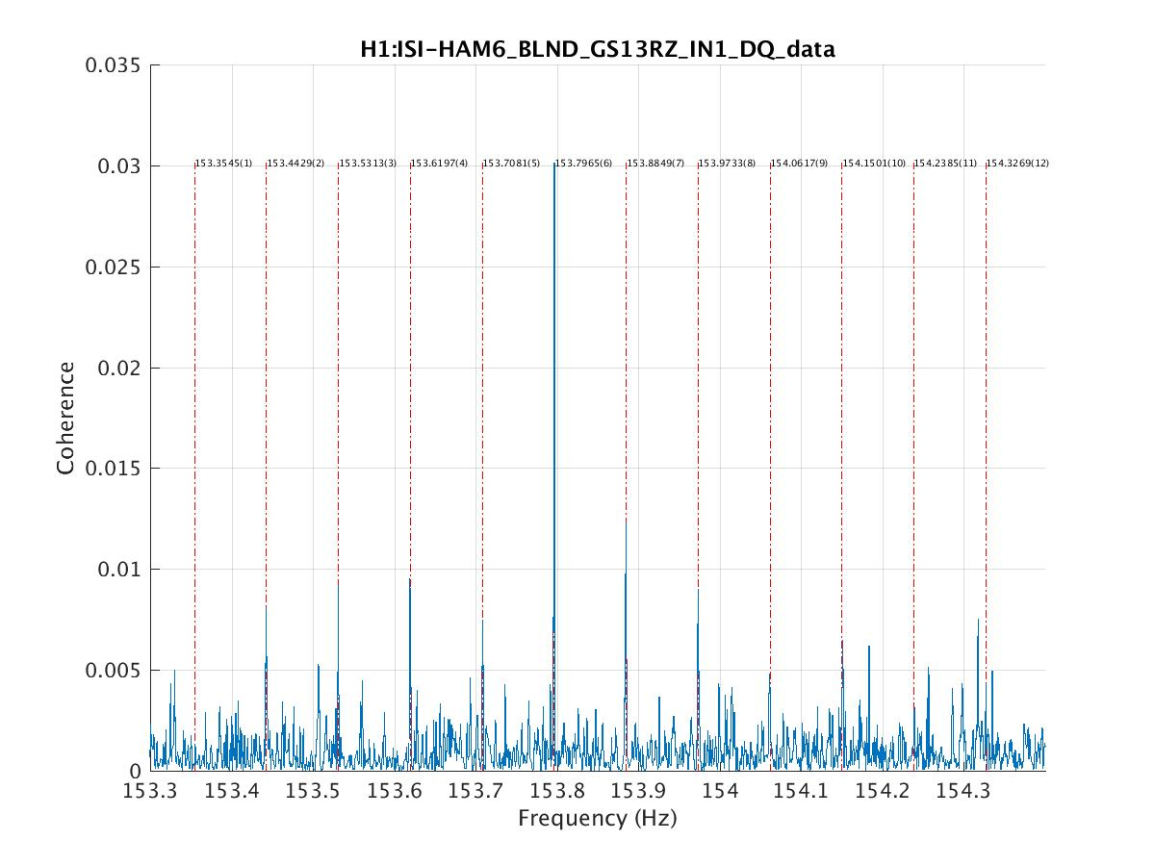

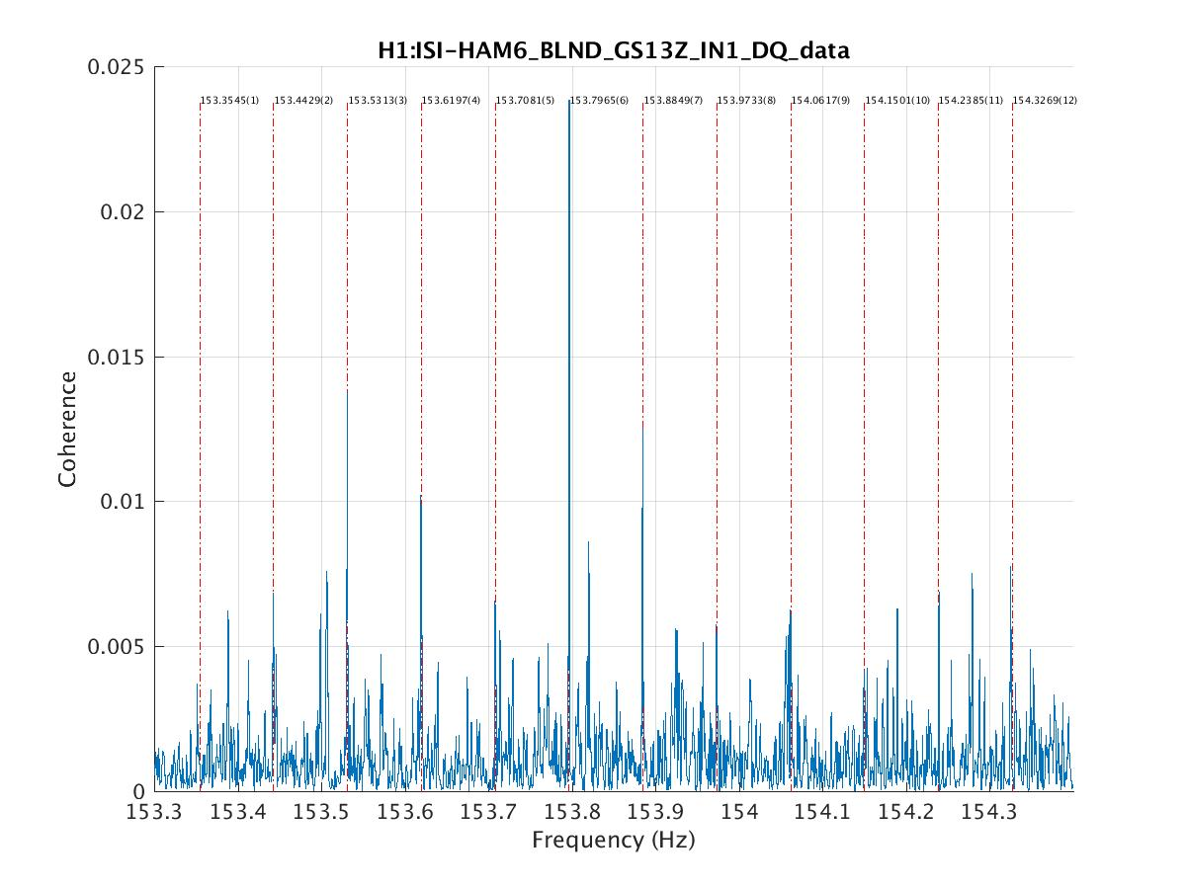

**Why these seismic isolation channels?**