**Coherence Analysis Result for the 56.8406Hz Comb**

According to [Keith's post](https://alog.ligo-wa.caltech.edu/aLOG/index.php?callRep=28364) on July 12,

“There is a ‘new’ 56.8406-Hz comb visible to its 11th harmonic at ~625.25 Hz, which in hindsight I can see was buried in the O1 spectrum...pervasive in ISI, SUS and PEM channels at the corner station and both end stations.”

I analyzed this observation with coherence tool and here are the results. The same structure is found to be significant in 35 channels in ER9, distributed in ISI, SUS, PEM and LSC subsystems. Among all the 35 channels, 22 of them does not have a range up to its 11th harmonic, 625.25 Hz. The channels are listed at the end.

Here are a few interesting observations:

* The 9th harmonic at 511.56Hz is the weakest in most channels, sometimes buried in noises.
* In some PEM channels, there are missing lines at low frequency (< 200 Hz) and high frequency (> 500 Hz).
* In PEM and ISI channels, there seems to be another comb structure with a frequency slightly larger than 56.8406Hz coexists. That one is usually most significant at its third harmonics.
* Generally, the structure is more clearly seen in LSC, SUS and ISI channels

**Sample plots from each subsystem:**

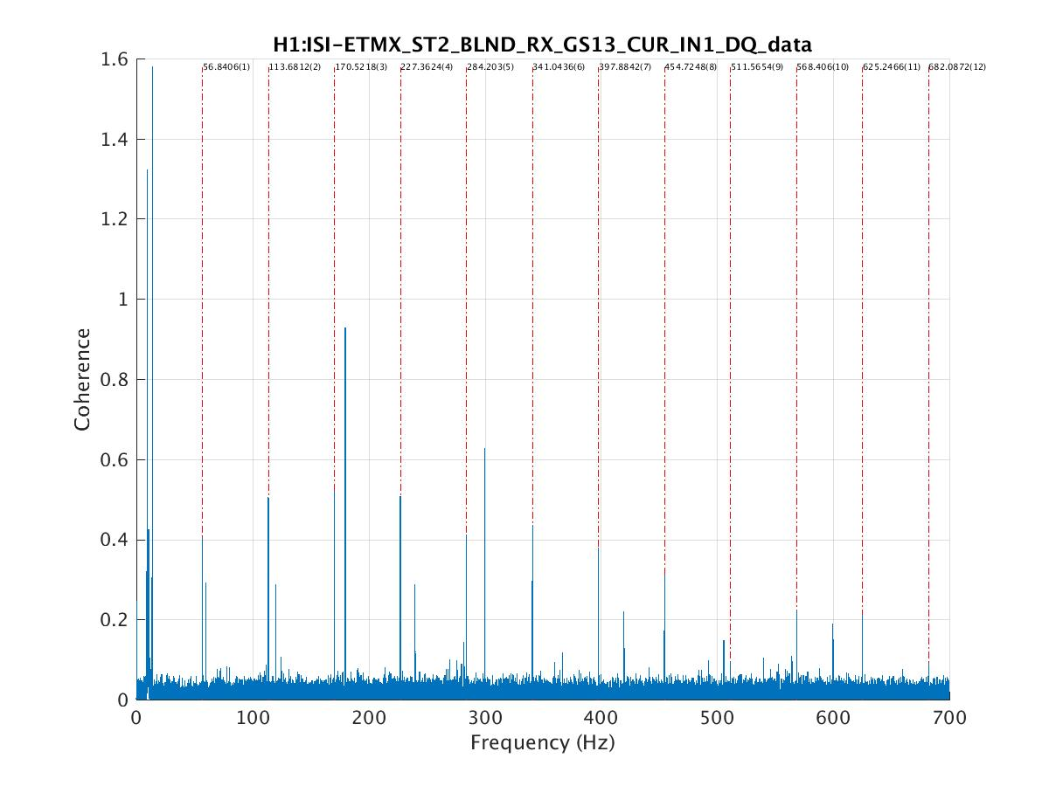

Here we can see the 56.8406Hz comb structure exists with its 9th harmonic weakest.

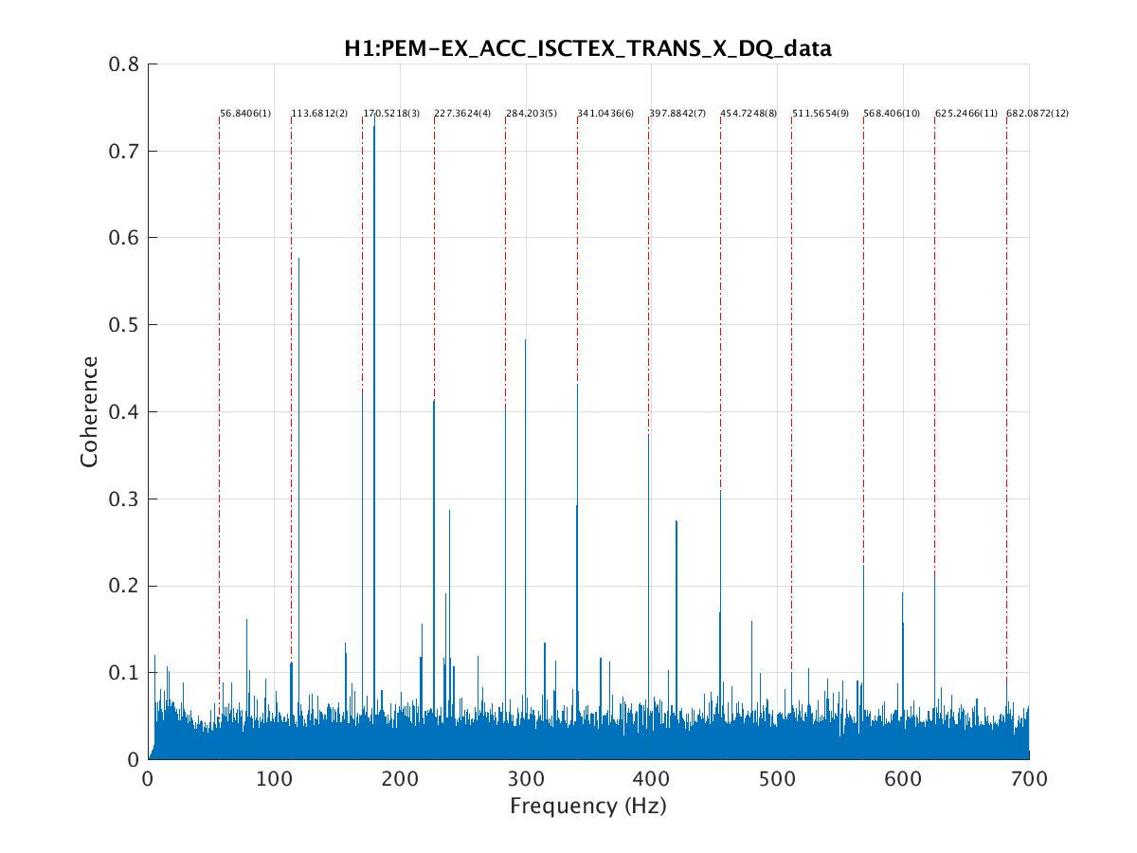

PEM channels have more noises and, as in ISI channels, the other comb structure coexists.

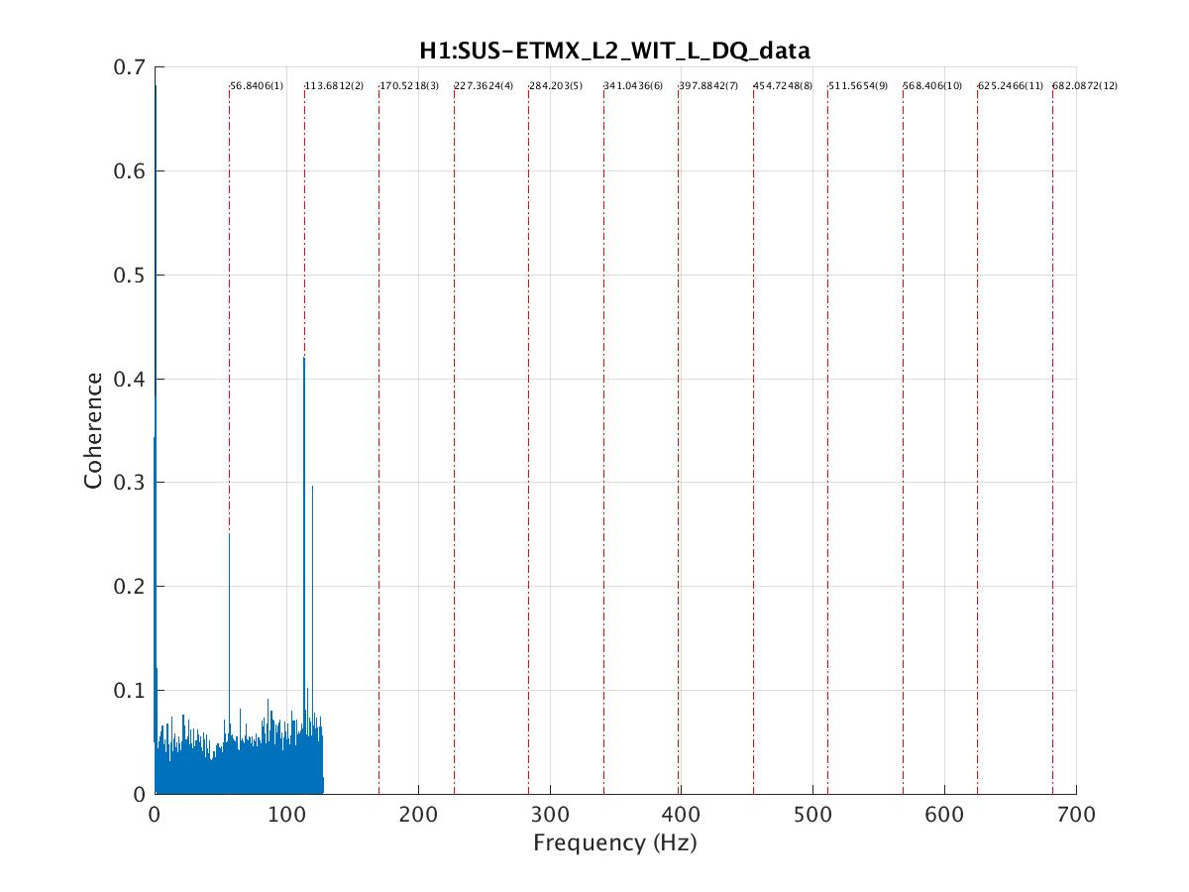

SUS channels do not have enough range up its 11th harmonic but we can see its first and second harmonic here.

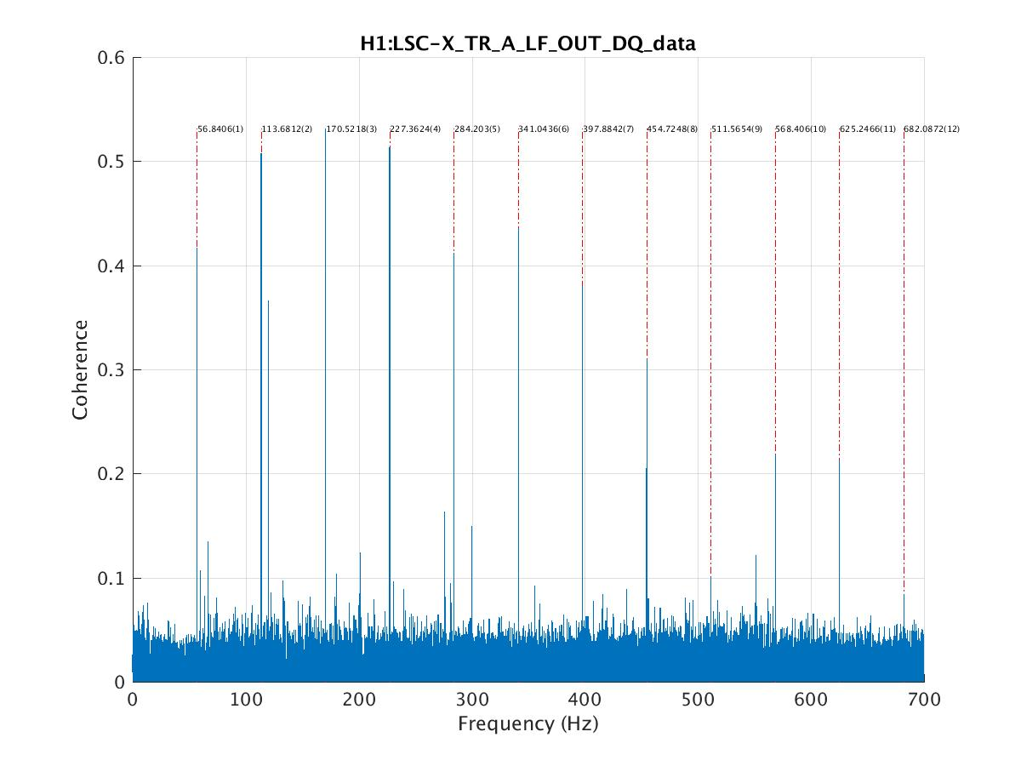

There is only one channel from LSC but the structure is very clear.

**Channels List:**

H1:ISI-ETMX_ST2_BLND_RX_GS13_CUR_IN1_DQ_data

H1:ISI-ETMX_ST2_BLND_RY_GS13_CUR_IN1_DQ_data

H1:ISI-ETMX_ST2_BLND_RZ_GS13_CUR_IN1_DQ_data

H1:ISI-ETMX_ST2_BLND_X_GS13_CUR_IN1_DQ_data

H1:ISI-ETMX_ST2_BLND_Y_GS13_CUR_IN1_DQ_data

H1:ISI-ETMX_ST2_BLND_Z_GS13_CUR_IN1_DQ_data

H1:LSC-X_TR_A_LF_OUT_DQ_data

H1:PEM-EX_ACC_BSC9_ETMX_Y_DQ_data

H1:PEM-EX_ACC_BSC9_ETMX_Z_DQ_data

H1:PEM-EX_ACC_ISCTEX_TRANS_X_DQ_data

H1:PEM-EX_ACC_VEA_FLOOR_Z_DQ_data

H1:PEM-EX_MIC_VEA_MINUSX_DQ_data

H1:PEM-EX_MIC_VEA_PLUSX_DQ_data

* Not Enough Range *

H1:ISI-ETMX_ST1_BLND_Y_T240_CUR_IN1_DQ_data

H1:ISI-ETMX_ST1_BLND_Z_T240_CUR_IN1_DQ_data

H1:ISI-GND_STS_ETMX_X_DQ_data

H1:ISI-GND_STS_ETMX_Y_DQ_data

H1:PEM-EX_MAINSMON_EBAY_1_DQ_data

H1:PEM-EX_MAINSMON_EBAY_2_DQ_data

H1:PEM-EX_MAINSMON_EBAY_3_DQ_data

H1:PEM-EX_SEIS_VEA_FLOOR_X_DQ_data

H1:PEM-EX_SEIS_VEA_FLOOR_Y_DQ_data

H1:SUS-ETMX_L1_WIT_Y_DQ_data

H1:SUS-ETMX_L2_WIT_L_DQ_data

H1:SUS-ETMX_L2_WIT_P_DQ_data

H1:SUS-ETMX_L2_WIT_Y_DQ_data

H1:SUS-ETMX_M0_DAMP_L_IN1_DQ_data

H1:SUS-ETMX_M0_DAMP_P_IN1_DQ_data

H1:SUS-ETMX_M0_DAMP_T_IN1_DQ_data

H1:SUS-ETMX_M0_DAMP_V_IN1_DQ_data

H1:SUS-ETMX_M0_DAMP_Y_IN1_DQ_data