Student Name: **Hongyao Tao (001067209)**

**INFO 6205**

**Program Structures & Algorithms**

**Spring 2021**

**Assignment No.3**

* **Implement height-weighted Quick Union with Path Compression**

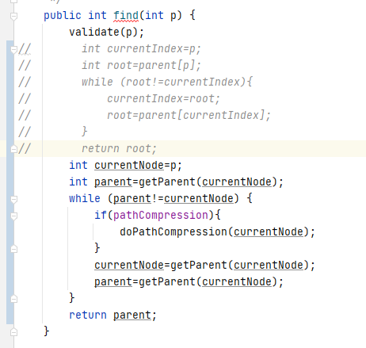

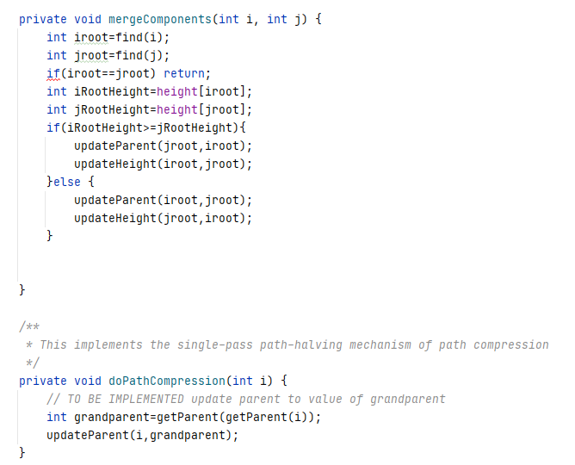

**Figure 1. The implement of UF_HWQUPC class**

* **The implement of main and count function**

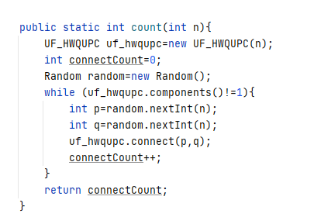

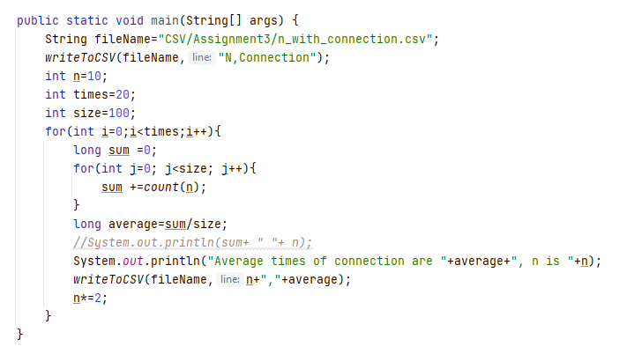

**Figure 2. The implement of count and main functions**

* **The Output**

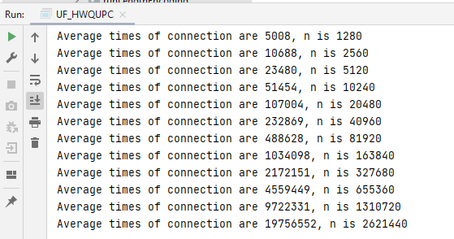

**Figure 3. The output result of main function**

* **Relationship Conclusion:**

**m = n^1.135**

* **Evidence to support the conclusion:**

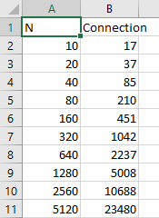 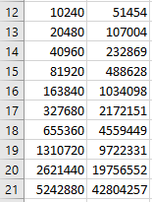

**Figure 4. The data of examination**

* **Graphical representation:**

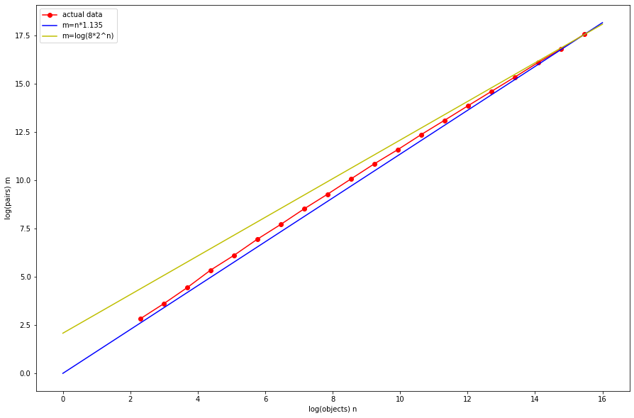

**Figure 5. The Connection/N grow logarithm graph**

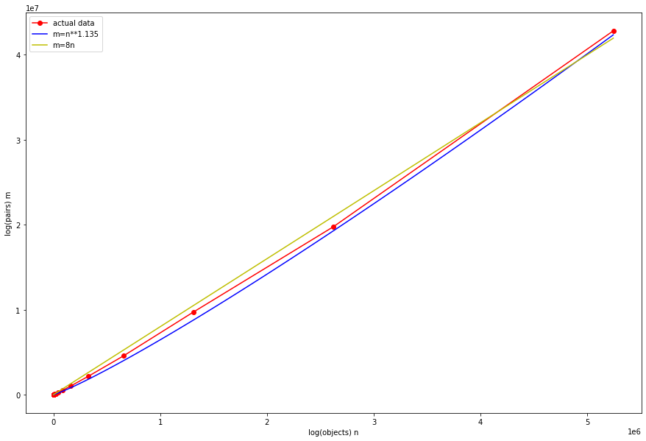

**Figure 6. The Connection/N line graph**

**Unit tests result:**

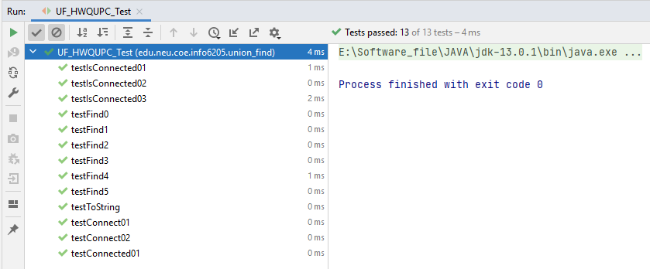

**Figure 7. The unit tests of UF_HWQUPC class**