Student Name: **Hongyao Tao (001067209)**

**INFO 6205**

**Program Structures & Algorithms**

**Spring 2021**

**Assignment No.4**

* **Implement depth-weighted Quick Union with 2 loop Path Compression**

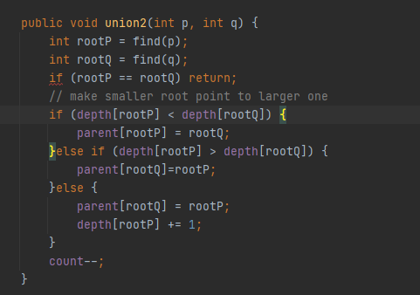

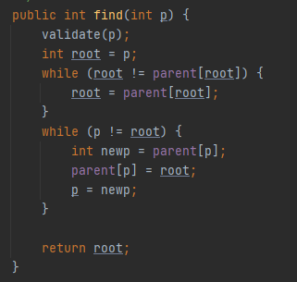

**Figure 1. The implement of WQUPC class**

* **Implement size-weighted Quick Union with 2 loop Path Compression**

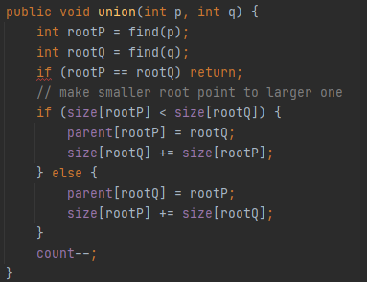



**Figure 2. The implement of WQUPC class**

* **Implement size-weighted Quick Union with 2 loop Path Compression**

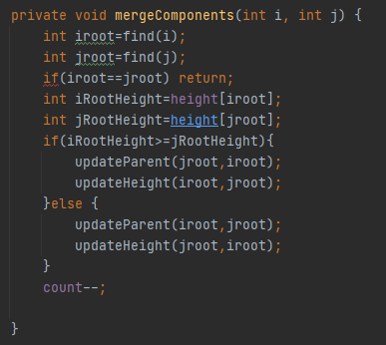

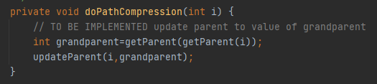

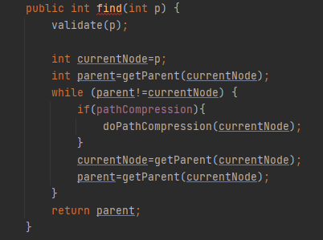

**Figure 3. The implement of UF_HWQUPC class**

* **Implement of benchmark**

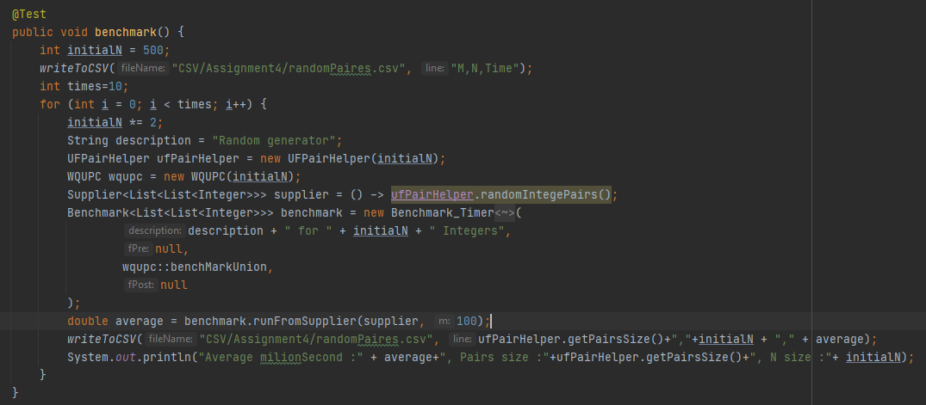

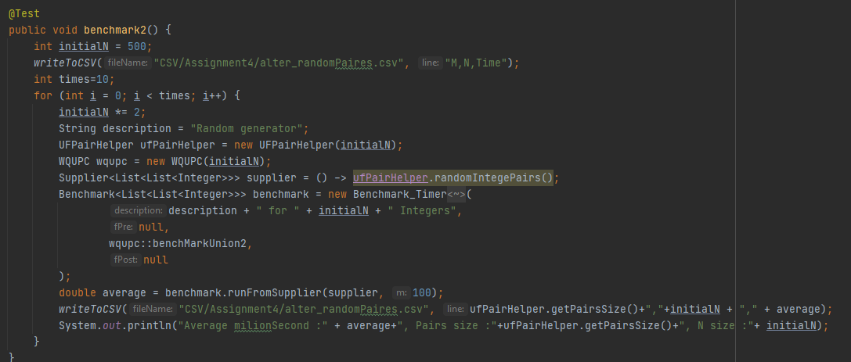

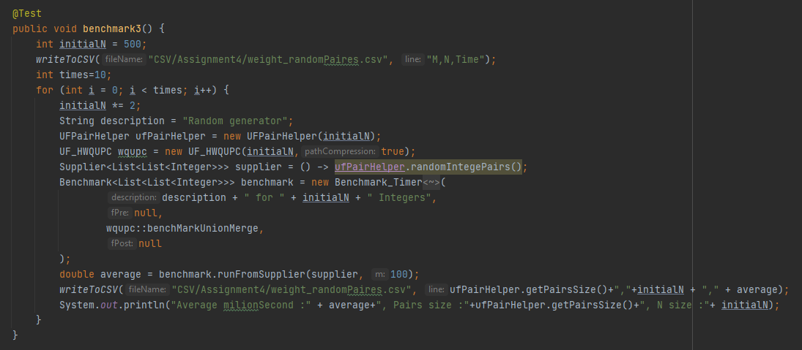

**Figure 4. The implement of BenchmarkUF class**

* **Unit test result**

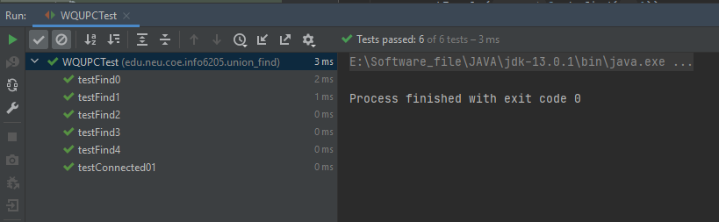

**Figure 5. The result of unit test of WQUPC class**

* **Comparison among different implementation**

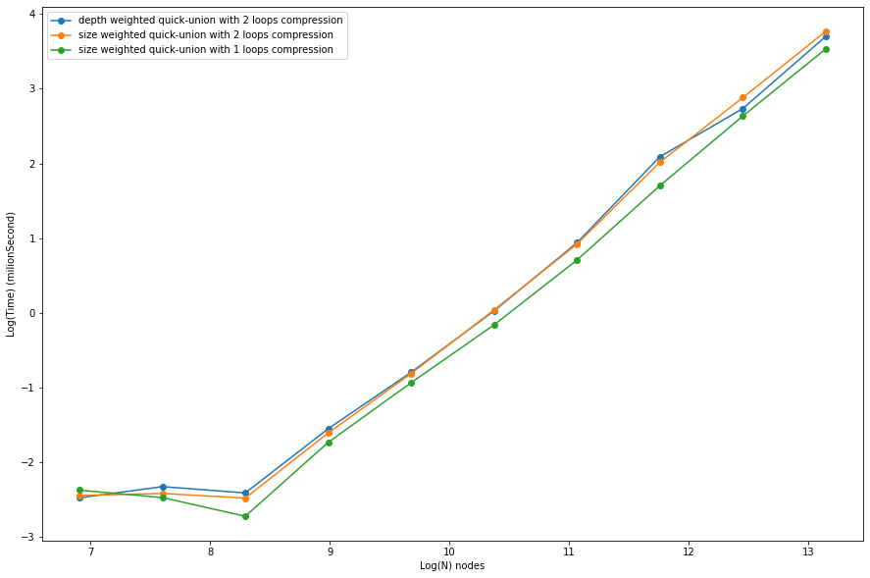

**Figure 5. The line graph of Time and N under different QU implements**

* **Evidence to support the conclusion:**

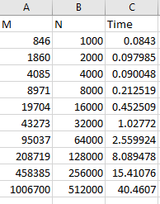 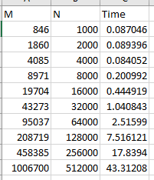 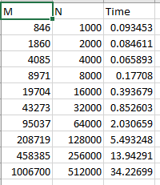

**Figure 4. The data of examination( Depth weighted quick-union with 2 loops compression, Size weighted quick-union with 2 loops compression and size weighted quick-union with 1 loops compression)**

* **Conclusion**

**According to Figure 5, the benchmark time of size weighted quick-union with 1 loop path compression algorithm always is below the orange line and blue line. It implies that the time complexity of the one-loop path compress algorithm is better than the time complex of two loops path compress algorithm. From the comparison between the orange line and blue line, the blue line almost same as the orange line, which demonstrates that using depth for weighted quick union is unnecessary since it has same time cost of using size.**