History of TechnologyFeature

Building the System/360 Mainframe Nearly Destroyed IBM

Instead, the S/360 proved to be the most successful product launch ever and changed the course of computing
James W. Cortada
05 Apr 2019
15 min read
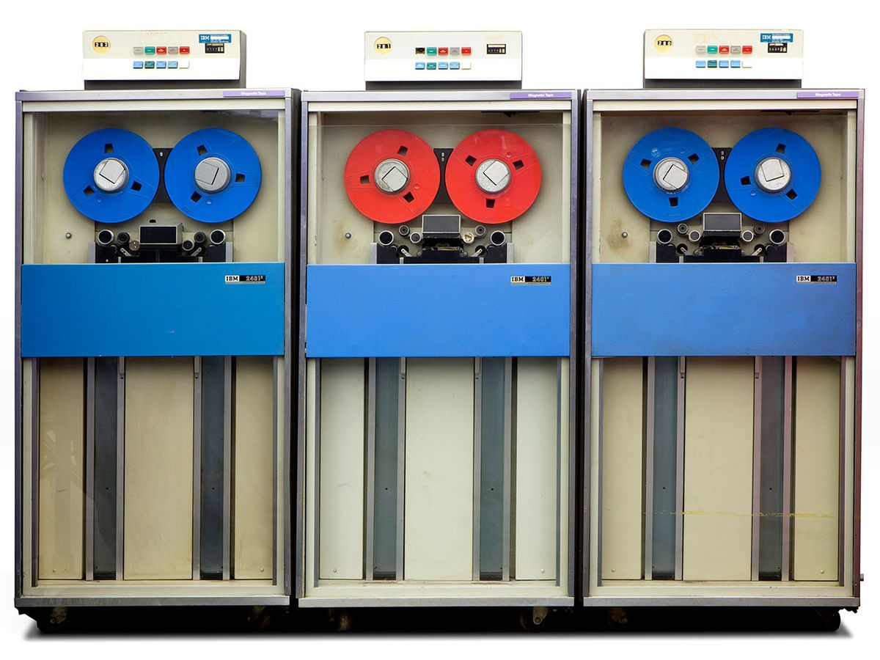
IBM spent US $5 billion to build the System/360, introduced in 1964. These 9-track magnetic tape drives were among the S/360’s 150-product line.
Photo: Mark Richards/Computer History Museum
Ashort list of the most transformative products of the past century and a half would include the lightbulb, Ford’s Model T—and the IBM System/360. This mainframe series forever changed the computer industry and revolutionized how businesses and governments worked, enhancing productivity and making countless new tasks possible.

In the years leading up to its 7 April 1964 launch, however, the 360 was one of the scariest dramas in American business. It took a nearly fanatical commitment at all levels of IBM to bring forth this remarkable collection of machines and software. While the technological innovations that went into the S/360 were important, how they were created and deployed bordered on disaster. The company experienced what science policy expert Keith Pavitt called “tribal warfare”: people clashing and collaborating in a rapidly growing company with unstable, and in some instances unknown, technologies, as uncertainty and ambiguity dogged all the protagonists.

Ultimately, IBM was big and diverse enough in talent, staffing, financing, and materiel to succeed. In an almost entrepreneurial fashion, it took advantage of emerging technologies, no matter where they were located within the enterprise. In hindsight, it seemed a sloppy and ill-advised endeavor, chaotic in execution and yet brilliantly successful. We live in an age that celebrates innovation, so examining cases of how innovation is done can only illuminate our understanding of the process.

By the end of the 1950s, computer users faced a seemingly intractable problem. Had it not been solved, it would have prevented computers from becoming widespread, and any thoughts of living in an Information Age would have been fiction.

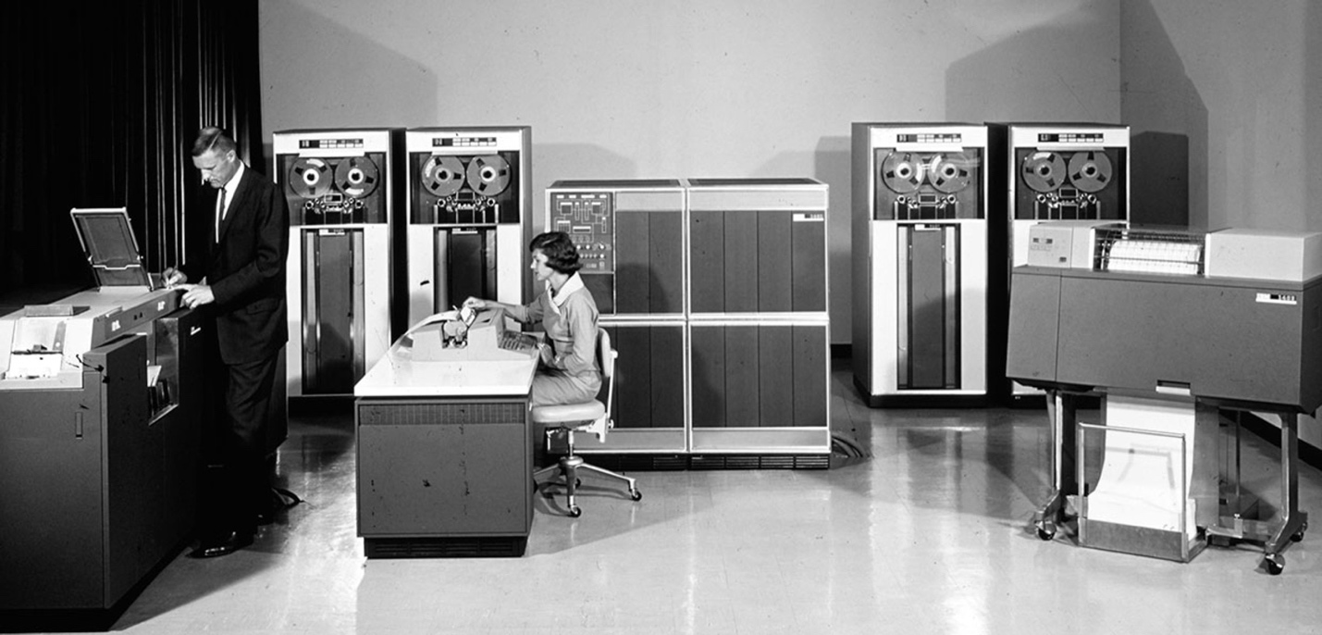
The S/360 was designed to replace IBM’s 1401 mainframe, which was popular but couldn’t be expanded or upgraded.Photo: IBM

Organizations were acquiring computers in great numbers, automating many of the old punch card operations and doing more with data processing. The popularity of the IBM 1401 illustrates the rapid adoption of computing. Over 12,000 of these systems were sold from their introduction in 1959 to 1971, when IBM retired the line.

With the 1401 so dominating the computer business, any problems with it were serious. One of them was that the 1401 was too small.

Users found these machines so useful that they kept piling more work on them, reaching the system’s capacity. They then had three options: move to a bigger IBM system, such as an IBM 7000, install a competitor’s system, or acquire more 1401s. None of these options was attractive. To change to a bigger system required rewriting software, since the old software would not work on a different type of machine. The cost of rewriting could easily exceed the financial benefits of moving to a bigger machine. Such a change also called for retraining staff or hiring new staff familiar with the new system. Adding more units of the same system was equally unattractive because each unit required duplicate staff, equipment, and maintenance of hardware and software. Customers wanted systems that were “upgradable” or “compatible,” such that as their needs grew, they could bring in larger machines but still run the same software and peripheral equipment. In the 1950s and early 1960s, it was a wish, and for vendors an aspiration.

IBM had worse problems than its customers did. The 1401s were proving so popular that engineers in Endicott, N.Y., which had developed the system, resisted attempts by their counterparts in Poughkeepsie to build larger computers, leading to growing rivalry between the two groups. As one engineer recalled, “So intense was it that sometimes it seemed to exceed the rivalry with external competitors.” Systems made by Poughkeepsie would not run programs written for the 1400 series. Customers wanting to move from the smaller 1400s to the larger Poughkeepsie machines put increasing pressure on IBM to provide compatibility. Senior management had to contend with the expenses of sustaining R&D for a half-dozen incompatible product lines and training IBMers to sell and maintain so many systems.

Consensus grew that IBM needed to get down to one system to simplify production, reduce the cost of R&D, and be more competitive against a growing array of rivals. If customers had to upgrade in the early 1960s, they could just as easily move to a competitor’s machine, since they would have to rewrite their software anyway.

The power of compatibility was demonstrated in the fall of 1960, when IBM introduced the more powerful 1410 to replace the 1401. Software and peripheral equipment for the 1401 worked with the newer machine. Customers and IBM sales loved that fact. Poughkeepsie’s engineers were close to completing work on a set of four computers known as the 8000s that were compatible with the 7000s.

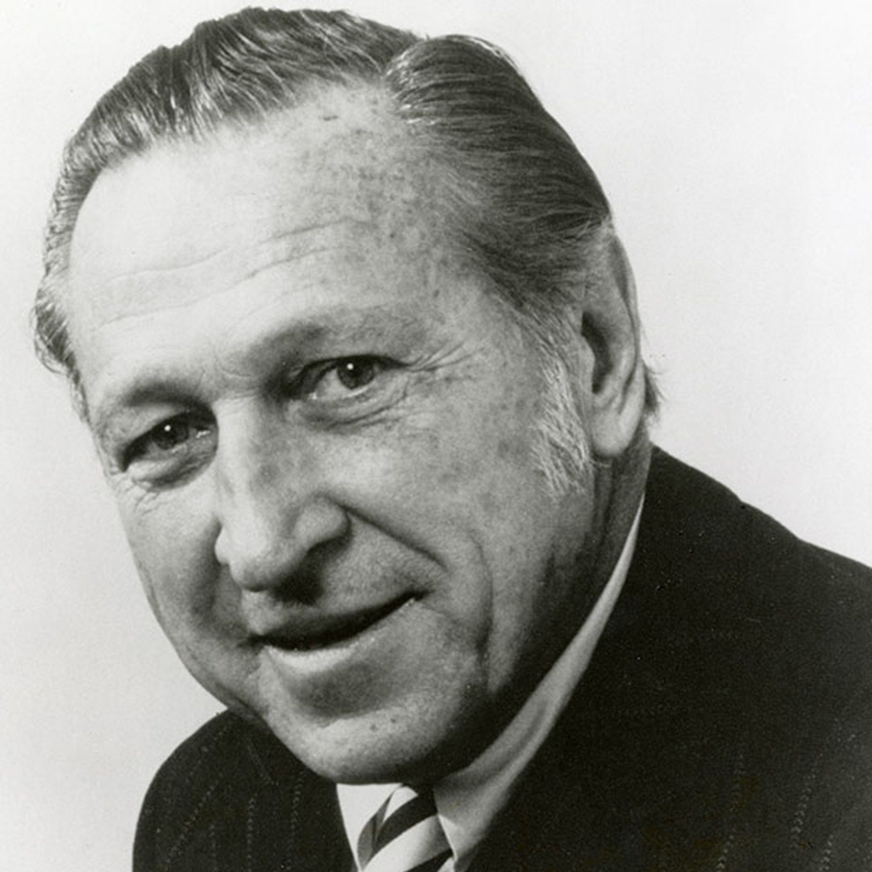To get the S/360 off the ground, T. Vincent Learson compelled engineering factions within IBM to cooperate.Photo: IBM

T. Vincent Learson—known as Vin or T.V.—was in charge of future product development as the vice president of manufacturing and development. A gifted problem solver, he knew he had to move quickly to break down the rivalry between Endicott and Poughkeepsie. IBM’s CEO at the time, Thomas J. Watson Jr., later described what happened: “He did it by applying a management technique called ‘abrasive interaction.’ This means forcing people to swap sides: taking the top engineer from the small-computer division and making him boss of the best development team in the large-computer division. A lot of people thought this made about as much sense as electing Khrushchev president.”

Learson replaced the Poughkeepsie manager in charge of the 8000 project with Bob O. Evans, who had served as the engineering manager for the 1401 and 1410. Evans favored compatibility across all future products. After 90 days in his new role, Evans recommended that work on the 8000s be stopped and that both sites begin working “to develop a total cohesive product line.” He also proposed a bold new base technology for all future systems, called Solid Logic Technology (SLT), to make IBM’s machines more competitive.

Frederick P. Brooks Jr., who led the design team for the 8000, fought back. Evans and Brooks were formidable opponents. The two engineers both had years of experience running engineering and product development activities at IBM, and they were articulate and highly respected by their staffs and senior management. Brooks was not as high ranking as Evans, so Learson brought in Jerrier A. Haddad, who had spent the previous two years in charge of the Advanced Engineering Development Division, to study the proposed approaches of Evans and Brooks. Haddad recommended going with Evans’s ideas, and Learson killed the 8000 project in May 1961.

Bob Evans immediately asked Brooks to develop the plan for a compatible family of computers. Brooks was flabbergasted, but he accepted, and with that the two engineering communities stopped feuding and began collaborating. There were still opponents in the company, but no matter—the trajectory toward a common system had been set.

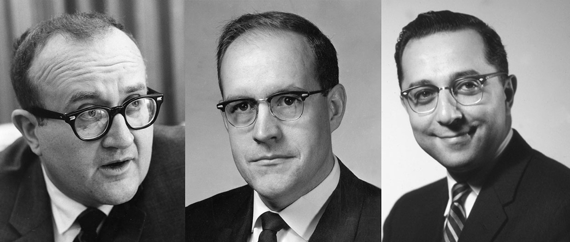
Bob O. Evans (left) recommended killing IBM’s larger 8000 mainframe in favor of a new line of compatible computers. Frederick P. Brooks Jr. (middle), who led the 8000’s design, objected, but Jerrier A. Haddad (right) sided with Evans. Evans then asked Brooks to work on the new line, which became the S/360.Photos: IBM

Learson also assigned John W. Haanstra, president of the General Products Division, which produced the 1400s, to chair an internal task force called SPREAD (for Systems Programming, Research, Engineering, and Development), with Evans as vice chair. Brooks later joined the task force. In December 1961, the group presented its technical recommendations.

Their report called for five compatible computers, labeled processors (defined as the computer, its memory, and channels to connect to peripheral equipment). The software and peripherals for one processor were to work with all other processors. The plan called for using standard hardware and software interfaces between computers and peripherals, such as between disk drives and tape drives connecting to computers, so that the peripherals did not have to be swapped out when a new processor was installed. The recommendations became the basis for the System/360.

Because so much would be new, the processors would not be compatible with IBM’s existing products. That was an enormously important point. Customers moving to the new IBM machines would have to rewrite existing software just once to get on the path of the new system.

Then, IBM got a lucky break. As one engineer wrote, “Almost miraculously [Evans’s] vision of the new product line was saved by a last-minute technical accomplishment. In mid-1963, engineers in the Poughkeepsie and Endicott laboratories had begun exploring the possibility of adding special microcode to the control stores of computers to improve their performance when simulating earlier IBM computers.” This function would allow 1401 software to run in the two smaller models of the proposed new system, only faster. Sales got on board, and its executives began pressuring R&D and manufacturing management for early introduction of the new processors.

Watson recognized what was at stake, as he recalled in his memoirs:

From the beginning we faced two risks, either of which was enough to keep us awake at night. First there was the task of coordinating the hardware and software design work for the new line. We had engineering teams all over America and Europe working simultaneously on six new processors and dozens of new peripherals…but in the end all of this hardware would have to plug together. The software was a bigger hurdle still. In order for System/360 to have a common personality, hundreds of programmers had to write millions of lines of computer code. Nobody had ever tackled that complex a programming job, and the engineers were under great pressure to get it done.

A second set of problems involved manufacturing the electronic components for the new systems. The electronics industry was starting to work on integrated circuits, and the new computers were going to be filled with these new components. To be independent, IBM had to make its own. It proved to be an expensive proposition.

Eventually, the corporate management committee, including Watson and the board of directors, sucked in a deep breath and approved the SPREAD recommendations. IBM was off to the races in the wildest ride of its history.

IBM could not hide what was going on. New employees flocked to Endicott, Poughkeepsie, and other labs and plants. Customers heard rumors, the computer press was speculating, and executives at GE, Honeywell, Sperry Univac, and elsewhere were trying to anticipate what IBM would do.

At IBM, nobody seemed satisfied with progress on the new system. Engineering, manufacturing, sales, and corporate staff were in many cases working 100-hour weeks. Engineers moved cots into their offices. When Watson stopped in to see how programming was going, an engineer yelled at him to get out so he could work. The chairman of IBM beat a hasty retreat.

On 7 April 1964, a train from New York City’s Grand Central Terminal shuttled reporters to Poughkeepsie, where IBM chairman Thomas J. Watson Jr. officially unveiled the System/360.Photos: IBM

It all became public at noon eastern time in the United States on 7 April 1964. Over 100,000 customers, reporters, and technologists met in 165 U.S. cities, while others gathered around the world over the next few days to hear the news. As Watson declared at a press conference in Poughkeepsie, it was “the most important product announcement in the company’s history.”

Among the System/360’s 44 peripherals was the 2311 disk storage drive. Each removable disk pack stored 7.25 megabytes.Photo: Mark Richards/Computer History Museum

On that day, IBM introduced a mind-boggling 150 new products: 6 computers; 44 peripherals, including tape drives, disk drives, printers, and control units; and a promise to provide the software necessary to make everything work together. The press packet was an inch thick, and manuals describing all the machines, components, software, and their installation and operation filled more than 50 linear feet.

The central feature of the System/360 was, of course, its compatibility. A growing data center could install a small 360 computer and later upgrade to a larger one without rewriting software or replacing peripheral equipment. Once familiar with the system, one did not have to learn a great deal more to handle an upgrade. The name 360 was chosen to suggest the idea of 360 degrees, covering everything.

In the first month following the S/360 announcement, customers worldwide ordered over 100,000 systems. To put that number in perspective, in that same year in the United Kingdom, all of Western Europe, the United States, and Japan, there were slightly more than 20,000 computers of any kind installed. The first deliveries of the smaller machines were promised for the third quarter of 1965, and deliveries of the larger ones in the first quarter of 1966. The delay between announcement and shipping date gave customers time to decide which models to acquire, get them approved and budgeted, plan on where to house them, train staff, complete software remediation, and so forth. With the April announcement, IBM bought itself two years to make good on its promises and knock competitors back on their heels.

From 7 April to when the company started delivering machines to customers, IBM entered the most dangerous, intense, and challenging era of its history. The company spent US $5 billion (about $40 billion today) to develop the System/360, which at the time was more than IBM made in a year, and it would eventually hire more than 70,000 new workers. Every IBMer believed that failure meant the death of IBM.

As Watson later recalled, “Not all of the equipment on display [on 7 April] was real; some units were just mockups made of wood. We explained that to our guests, so there was no deception. But it was a dangerous cutting of corners—not the way I think business ought to be done—and an uncomfortable reminder to me of how far we had to go before we could call the program a success.”

Watson assigned his brother, Arthur, to manage engineering and manufacturing going forward. Learson would run sales for the new system, “twisting the tails of our salesmen.” Tom Watson Jr. thought Learson had the more difficult task. The risk of customers converting to someone else’s machines rather than to the S/360 greatly concerned Watson.

IBM promised to begin delivering the first S/360 machines in the third quarter of 1965. Production problems emerged almost immediately.Photo: IBM

As the number of orders for the S/360 kept increasing, manufacturing was asked in 1965 to double production. One production manager said it could not be done and was replaced. Quality declined. Some of the electronic circuits within an SLT, for example, were not complete, so electrons could not go where they were supposed to. By the end of the year, the quality control department had impounded 25 percent of all SLT modules, bringing production to a halt.

With the S/360, IBM introduced its solid logic technology (SLT), a precursor to integrated circuits. Doubling the production of the S/360 in 1965 led to defects in a quarter of the SLT modules.Photo: IBM

After the problems were solved, manufacturing proceeded in 1966, resulting in 90 million SLT modules bring produced, compared to just 36 million the previous year. IBM opened a new plant in East Fishkill, just south of Poughkeepsie, which made more semiconductor devices than all other manufacturers worldwide combined. Production also expanded to new facilities in Burlington, Vt., and in Corbeil-Essonnes, France.

To resolve manufacturing problems with the ferrite-core memories, IBM set up a plant in Boulder, Colo., in 1965. But it took the craftsmanship of workers in Japan to get the production of memories up to the required amounts and quality.

The S/360’s ferrite-core memory also proved extremely tricky to manufacture. This plane contains 1,536 memory cores.Photo: Mark Richards/Computer History Museum

As manufacturing became a worldwide effort, new problems arose in coordinating activities and fabricating machines. Arthur Watson had some experience managing IBM’s small factories outside the United States but none with resolving engineering problems, let alone massive global problems in development and manufacturing. He was out of his league, and his brother challenged him to resolve the problems. Meanwhile, Learson and his sales teams wanted additional improvements to the product line. Relations between Learson and Arthur completely deteriorated. In October 1964, IBM announced significant delays in shipping products.

Tom removed Arthur from his job and turned over his responsibilities to Learson, who in turn brought in four engineering managers to punch through the problems. Nicknamed the “four horsemen,” they had full authority worldwide for getting the S/360 manufactured and delivered to customers. Their collection of problems, one of the managers noted later, was “an absolute nightmare,” “a gray blur of 24-hour days, seven days a week—never being home.” And yet, in five months, they had worked out enough of the problems to start meeting delivery dates. In January 1966, Learson became president of IBM.

Facing unacceptable production delays, Learson brought in (left to right) Henry E. Cooley, Clarence E. Frizzell, John W. Gibson, and John Haanstra, who sorted out manufacturing problems worldwide and got the S/360 back on track.Photos: IBM

Arthur was shunted into the role of vice chairman. His career was broken, and he retired in 1970. In his memoirs, Tom Watson Jr. admitted to being in a nearly continuous panic from 1964 to 1966 and deeply regretted his treatment of Arthur. “I felt nothing but shame and frustrations at the way I’d treated him…. As it was, we remade the computer industry with the System/360, and objectively it was the greatest triumph of my business career. But whenever I look back on it, I think about my brother I injured.”

Software problems also slowed production of the 360. The software development staff was described as being in “disarray” as early as 1963. The operating system, called OS/360, struggled to run more than one job at a time, which was essential to making the S/360 fast and productive. Other problems surfaced with telecommunications and with application programs. Programming support became another contentious issue.

Fred Brooks volunteered to help, and IBM added 1,000 people to the operating system project, costing the company more for software in one year than had been planned for the entire development of the S/360 system. But throwing more programmers at the project did not help. Based on the S/360 experience, Brooks would later expand on that theme in The Mythical Man-Month (Addison-Wesley, 1975), still one of the most widely read books on computing. The software would take years to complete, but in the end it worked well enough to keep the shipping delay to one month.

A System/360 arrives at Tokai Bank in Japan. Demand for computing grew enormously in the years following the S/360’s launch.Photo: IBM

Despite the costs and anxiety, in 1965—the year IBM had committed to shipping the first units to customers—it managed “by some miracle” (Watson’s words) to deliver hundreds of medium-size S/360s. Their quality did not always match the original design specifications. Shortages of parts, other parts that did not work, and software filled with bugs spread to many countries. Almost every initial customer encountered problems.

Branch offices were hiring systems engineers to help. SEs were college graduates, usually with technical degrees, who knew how to debug software and assisted the sales force in selling and supporting computers. The SEs heroically tackled S/360’s software problems, while field engineers, who installed equipment, fixed hardware problems. Salesmen calmed their customers, while branch managers worked to keep their staffs motivated and focused.

And despite the many problems, “customers were still ordering 360s faster than we could build them,” Watson recalled, forcing delivery dates out as much as three years. By the end of 1966, customers had taken delivery of nine models of the S/360, for a total of 7,700.

IBM’s competitors responded. Burroughs, GE, Honeywell, NCR, and Sperry Rand, operating largely in the United States, CII in France, and ICT (later ICI) in Great Britain introduced systems compatible with one another’s machines, but not compatible with IBM’s. A second, smaller group chose to manufacture machines that were compatible with IBM’s, including RCA and others in Europe and Japan, relying on RCA’s licenses.

NASA purchased a number of S/360s, including this one at Goddard Space Flight Center. Several others at mission control in Houston were used to monitor Apollo 11.Photo: IBM

Five years later, the worldwide inventory of installed IBM computers had grown to $24 billion, while that of competitors had reached $9 billion. In other words, IBM’s S/360 increased overall demand for computing so massively that it raised all boats. The industry’s annual growth in the second half of the 1960s was in double digits year over year, as many thousands of organizations expanded their use of computers. Demand for computing grew because of the technological innovations brought forth by IBM, but also because users were accumulating enough experience to understand a computer’s value in driving down costs and performing new functions.

IBM also grew, more than doubling from 127,000 employees worldwide in 1962 to 265,000 by the end of 1971. Revenue rose from $3.2 billion in 1964 to $8.2 billion in 1971.

The S/360 reinforced IBM’s domination of the global computer business. One executive, asked whether the company would ever take on another such project, replied, “Hell no, never again.”Photo: IBM

Because the S/360 was the heart of much computing by the end of the 1960s, its users constituted a world of their own. Thousands of programmers only knew how to use software that ran on S/360s. Additional thousands of data-processing personnel had worked only with IBM equipment, including keypunch machines, printers, tape drives, disk drives, and software, which in many instances took years to master. By the early 1970s the computing space was largely an IBM world on both sides of the Atlantic, in the emerging markets in Latin America, and in Japan.

Years later, when asked whether IBM would ever engage in such a massive project again, one executive barked out, “Hell no, never again.” Watson tilted toward a similar reaction. Commenting in 1966, he said, “At our size, we can’t go 100 percent with anything new again,” meaning anything that big. After the 360, Watson made it a policy “never to announce a new technology which will require us to devote more than 25 percent of our production to that technology.”

The generation that brought out the S/360 remained unique in the company, a special clan bonded ferociously to IBM. Careers had been made and broken, personal lives and marriages upended. IBMers did not know at the time how extensively their products would change the world, but we do.

This article is based on excerpts from IBM: The Rise and Fall and Reinvention of a Global Icon (MIT Press, 2019).
From Your Site Articles
- A Quadrillion Mainframes on Your Lap - IEEE Spectrum ›
- 100 Years Ago, IBM Was Born - IEEE Spectrum ›
- IBM’s Executive Terminal Was a War Room for Top Managers - IEEE Spectrum ›
silicon revolutionhardwaresoftwareibmcomputer historyibm system 360mainframe
James W. Cortada
is a senior research fellow at the University of Minnesota’s Charles Babbage Institute. See full bio →
Publish
Sort byNewestOldestPopular

EnergyNews

Grid Battery Stabilizes Scottish Power Supply
3 hours ago
4 min read

BiomedicalNews

Scientist Shine a Laser Through a Human Head
5 hours ago
5 min read

TransportationNews

Why BMW’s New EVs Are More Sustainable Than Ever
7 hours ago
3 min read

