QLora

Ideas
- Quantize weights
- then finetune with lora
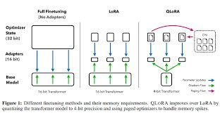

References
https://magazine.sebastianraschka.com/p/practical-tips-for-finetuning-llms
https://www.youtube.com/watch?v=C33SwN3Ynp4
Paper found here: https://arxiv.org/abs/2305.14314

Code
https://github.com/artidoro/qlora

