DOCX comments test — open this in Office 365 and tell me what you see at A, B, C and D.
A. This sentence has a typed comment, with a reply.
B. This sentence has a comment whose content is a HANDWRITING PICTURE.
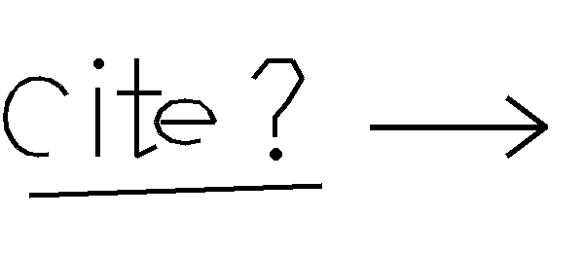
C. This paragraph has the same handwriting picture floating in the RIGHT MARGIN beside it (not a comment). Some more words so the paragraph runs to a second line on the page.
D. Tracked changes: this was inserted and .

