|  |  |  |  |  |  |  |  |  |  |  |  |  |  |  |  |  |  |
| --- | --- | --- | --- | --- | --- | --- | --- | --- | --- | --- | --- | --- | --- | --- | --- | --- | --- |
| **[Support Function]** |  | |  |  |  |  |  |  |  |  |  |  |  |  |  |  |  |
| Create/Update Story/Task/epic/competence area | | |  |  |  |  |  |  |  |  |  |  |  |  |  |  |  |
| Note: competence area is NOT suggested to use currently, JIRA Server team has concern about this. | |  |  |  |  |  |  |  |  |  |  |  |  |  |  |  |  |
|  |  | |  |  |  |  |  |  |  |  |  |  |  |  |  |  |  |
| **[How to use?]** |  | |  |  |  |  |  |  |  |  |  |  |  |  |  |  |  |
| 1. There are 4 types of data sheet: jira_story, jira_task, jira_epic, jira_competence_area. Just fill the data to the sheet you want to create/update. | | | |  |  |  |  |  |  |  |  |  |  |  |  |  |  |
| |  | | --- | |  | |  | |  |  |  |  |  |  |  |  |  |  |  |  |  |  |  |
|  |  | |  |  |  |  |  |  |  |  |  |  |  |  |  |  |  |
| **Sheet_name** | **Desc** | |  |  |  |  |  |  |  |  |  |  |  |  |  |  |  |
| jira_story | For create/update story | |  |  |  |  |  |  |  |  |  |  |  |  |  |  |  |
| jira_task | For create/update task | |  |  |  |  |  |  |  |  |  |  |  |  |  |  |  |
| jira_epic | For create/update epic | |  |  |  |  |  |  |  |  |  |  |  |  |  |  |  |
| jira_competence_area | For create/update competence area | |  |  |  |  |  |  |  |  |  |  |  |  |  |  |  |
|  |  | |  |  |  |  |  |  |  |  |  |  |  |  |  |  |  |
| There are some fields which you can update for each sheet, not all the fields can be updated. | |  |  |  |  |  |  |  |  |  |  |  |  |  |  |  |  |
| **Sheet_name** | **Editable Fields** | |  |  |  |  |  |  |  |  |  |  |  |  |  |  |  |
| jira_story | assignee, labels, description, story_point, estimation | |  |  |  |  |  |  |  |  |  |  |  |  |  |  |  |
| jira_task | assignee, labels, description, story_point, estimation | |  |  |  |  |  |  |  |  |  |  |  |  |  |  |  |
| jira_epic | epic_name, assignee, labels, description, start_fb, end_fb, story_point, estimation | |  |  |  |  |  |  |  |  |  |  |  |  |  |  |  |
| jira_competence_area | item_id, activity_type, assignee, labels, description, story_point, estimation | |  |  |  |  |  |  |  |  |  |  |  |  |  |  |  |

2. Fill your username and password and choose the issuetype you want to create in sheet "start_create_update"

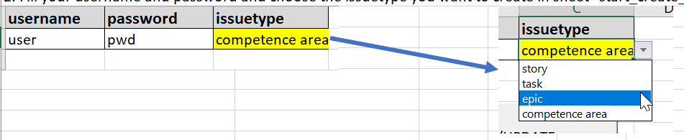

3. Click the button "START CREATE/UPDATE" in sheet "start_create_update"

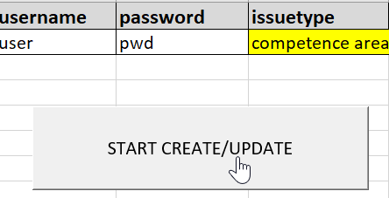

4. Wait until popup windows disappear, then everything is done!

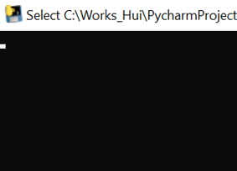

5. A new file will be created and will be named with “jira_timeslot” as below



In the file, you can check the new created issue’s key



**[How to get key of fields’ values]**

There are some fields need key not the value, so we need to find the key firstly before fill data

**project_key**

Step1, Click “Create” button

Step2, Choose the project you want to create, for example “CloudRAN CI (FCA_CLOUDRANCI)”, get the project_key = “FCA_CLOUDRANCI” and

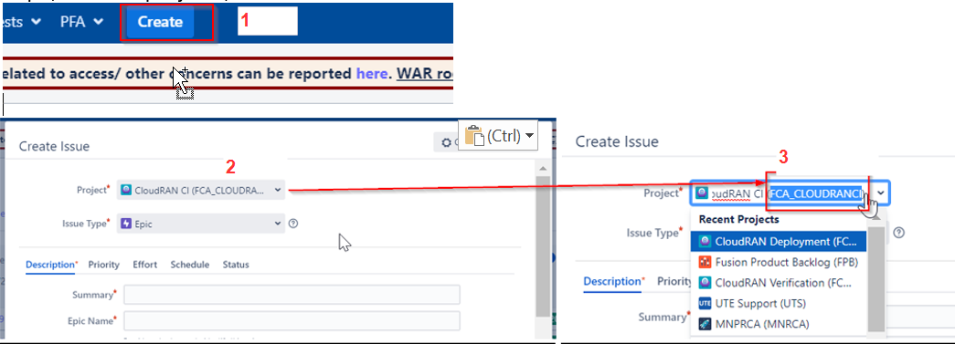

Step3: Fill project_key into excel

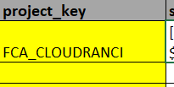

**epic_key**

Step1: Get the epic from webpage that you want to create story/task under it.

Step2: Get epic_key from the web link, for example, the below should be epic_key= “FCA_CLOUDRANCI-1797”

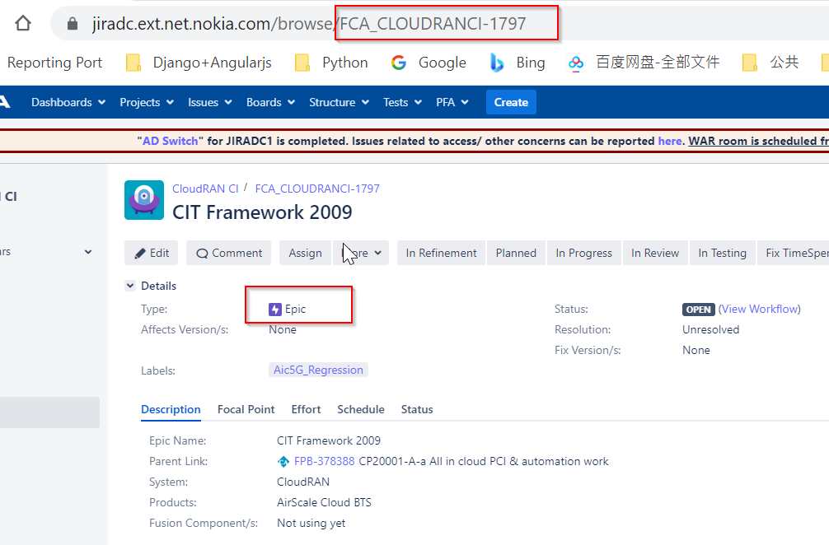

Step3: Fill the epic_key into jira_story/ jira_task sheet

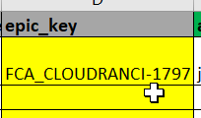

**team**

Step1: Find the “team” on story/task Jira issue page

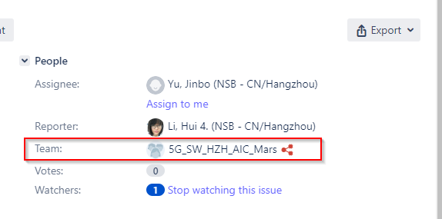

Step2: Click “Export” and choose “XML”

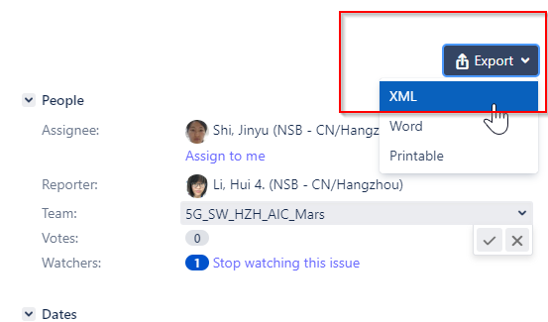

Step3: On the xml page, search keyword “team” and find below information, then get the team key is “2753”

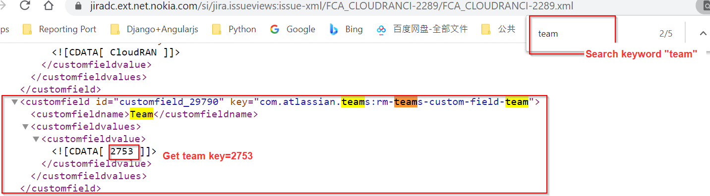

Step4: Fill team “2753” into excel

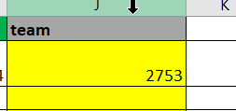

**CA_key**

Step1: Go to specific competence area which you want to create epic under it, for example, below CA_key is “FPB-378689”

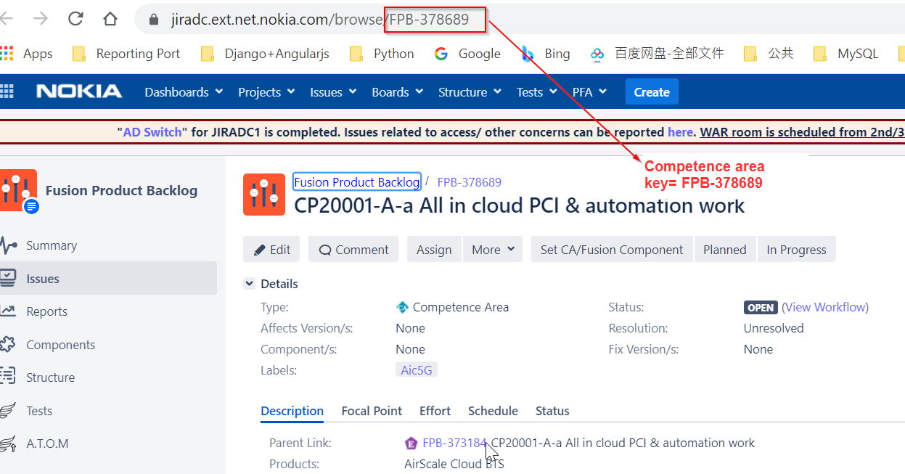

Step2: Fill CA_key = “FPB-378689” into sheet jira_epic

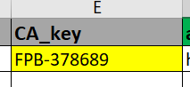

**EI_key**

Step1: Go to specific Entity Item which you want to create competence area under it, for example, below EI_key is “FPB-373184”

