Supplementary Information
Complementary spectroscopic probes in an autoregressive crystal language for powder structure solution
Draft compiled 25 August 2026 from frozen evaluation artifacts. Figures are result plots only. Grey in-figure footnotes were omitted to avoid overlap with bars, axes, and legends.

How to read the two metric families
The manuscript never collapses “structures found somewhere in the candidate list” with “spectroscopic Top-1 under a known lattice”. Throughout this file we keep three nested claims separate:
1. Any-rung recall, including the formula-conditioned reference: a ground-truth match appears in the top-k list of at least one information rung (PXRD, PXRD+ND, PXRD+XRF, PXRD+ND+XRF, or formula).
2. Spectroscopic recall, excluding formula: the same, but only rungs that a laboratory could record without already knowing the exact stoichiometry as a token prefix.
3. Spectroscopic known-lattice Top-1: PXRD + ND + XRF, lattice parameters provided, reranked rank = 1. This is the headline experimental claim for the collaborator set (3/10).
On every experimental hold-out in this work, the PXRD pattern is measured. Neutron diffraction and XRF are simulated from the deposited CIF at the training wavelength (Cu Kα, λ = 1.54184 Å) unless a sentence explicitly says otherwise. We do not claim paired experimental XRD + experimental ND.

Note S1. Matching protocol
Generated crystals are parsed from the crystal-language token string and compared with the ground-truth structure using pymatgen StructureMatcher (primitive cell; ltol = 0.3, stol = 0.5, angle_tol = 10°). The same matcher is used for the simulated test ladder, the MP-20 first-500 study, the public experimental PXRD hold-out, and the collaborator set. Each query generates N = 100 candidates (temperature 0.8). Reported Top-k values use spectrum-aware reranking, not raw sampling rank, unless a table says sampling.
Experimental PXRD jobs (public 337 and collaborator 10) disable synthetic noise injection (--noise-profile none) and use the deploy reranker: Gaussian peak matching with σ = 0.40° and a global 2θ shift of up to ±0.20°. Simulated-test jobs use the clean default peak width (σ = 0.25°) without a shift search. Default rerank weights are w_PXRD = 1.0, w_ND = 0.25, w_charge = 0.2, with an invalid-candidate penalty of −2.
Setting | Simulated test | Public / collaborator PXRD
N test crystals | 33,944 | 337 / 10
PXRD origin | CIF-simulated | Experimental (Q-aligned)
ND origin | CIF-simulated | CIF-simulated
XRF origin | CIF composition | CIF composition
Candidates / crystal | 100 | 100
Rerank σ / shift | 0.25° / 0° | 0.40° / ±0.20°
Model | tierA Stage-2 (clean spectra) | tierA Stage-2 noisy-exp

Table S1. Evaluation settings used in this Supplementary Information.

Note S2. Crystal language
The decoder emits a parseable crystal language rather than Cartesian coordinates in a diffusion frame. Version V2 replaces per-digit numeric tokens with bin tokens for coordinates, lattice lengths/angles, and space group, and moves continuous spectra out of the token stream into a 1D encoder. A complete target for 1T-TaS2 (collaborator hold-out, n_sites = 3) is:
<CRYSTAL_START> <FORMULA> S 2 Ta 1 <N_SITES> 3 <SPACE_GROUP> <SG164> <LATTICE> <L0068> <L0068> <L0123> <G180> <G180> <G240> <ATOM_SITES_START> <ATOM> S <C333> <C667> <C246> <ATOM> S <C667> <C333> <C754> <ATOM> Ta <C000> <C000> <C000> <ATOM_SITES_END> <CRYSTAL_END>
Conditioning prefixes are assembled from the same grammar: <ELEMENT_SET>, <XRF_START>…<XRF_END>, optional <XPS_VALENCE_START>…, and/or an explicit <FORMULA> block, plus raw PXRD and ND peak arrays. The formula-conditioned rung is an oracle reference, not a laboratory protocol.
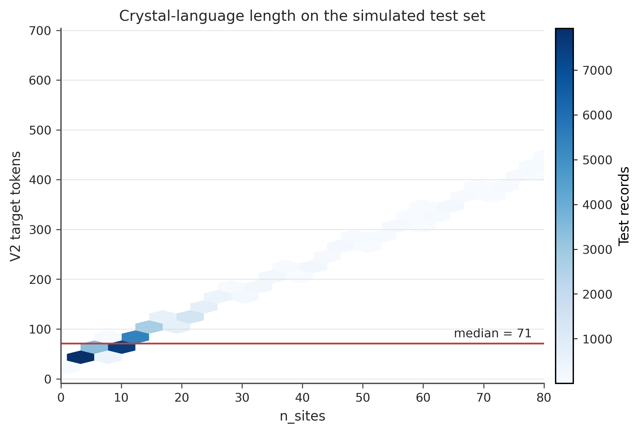
Figure S1. V2 target length versus n_sites on the full simulated test set (N = 33,944). The median target is 71 tokens (90th percentile 142; maximum 671). Spectra are not counted in this length.

Note S3. Why PXRD and ND are not interchangeable
X-ray atomic form factors grow with Z; neutron coherent scattering lengths do not. For a fixed CIF, the two powder patterns therefore reweight the same Bragg positions. Figure S2 shows two n_sites = 4 test crystals: several peaks that are weak in PXRD become strong in ND, which is the information the multimodal decoder is meant to use when XRF is absent or incomplete.
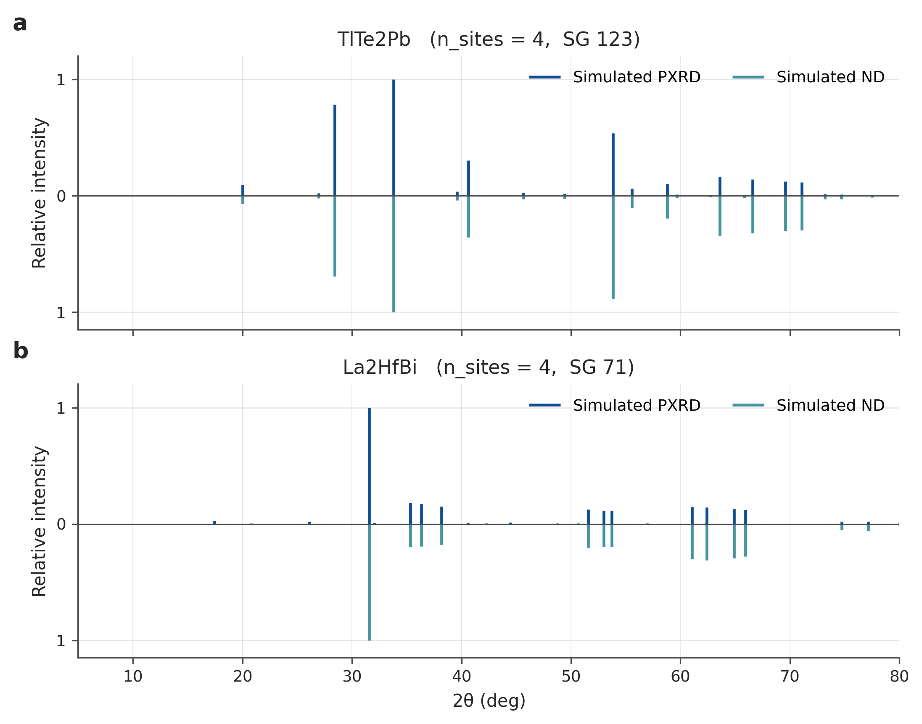
Figure S2. CIF-simulated PXRD (up) versus ND (down) for two simulated-test crystals. Intensities are separately normalised. The 2θ grid is 5–80°.
Reranking scores a candidate by a weighted sum of PXRD and ND peak-match terms plus a charge/XPS term when those prefixes are present. Figure S3 shows that, on the noisy-exp N = 500 pool, lattice-free Top-1 for PXRD+ND+XRF is maximised near the default w_ND = 0.25. Setting w_ND = 0 drops Top-1 from 74.6% to 73.0%; raising it to 1.0 does not help.
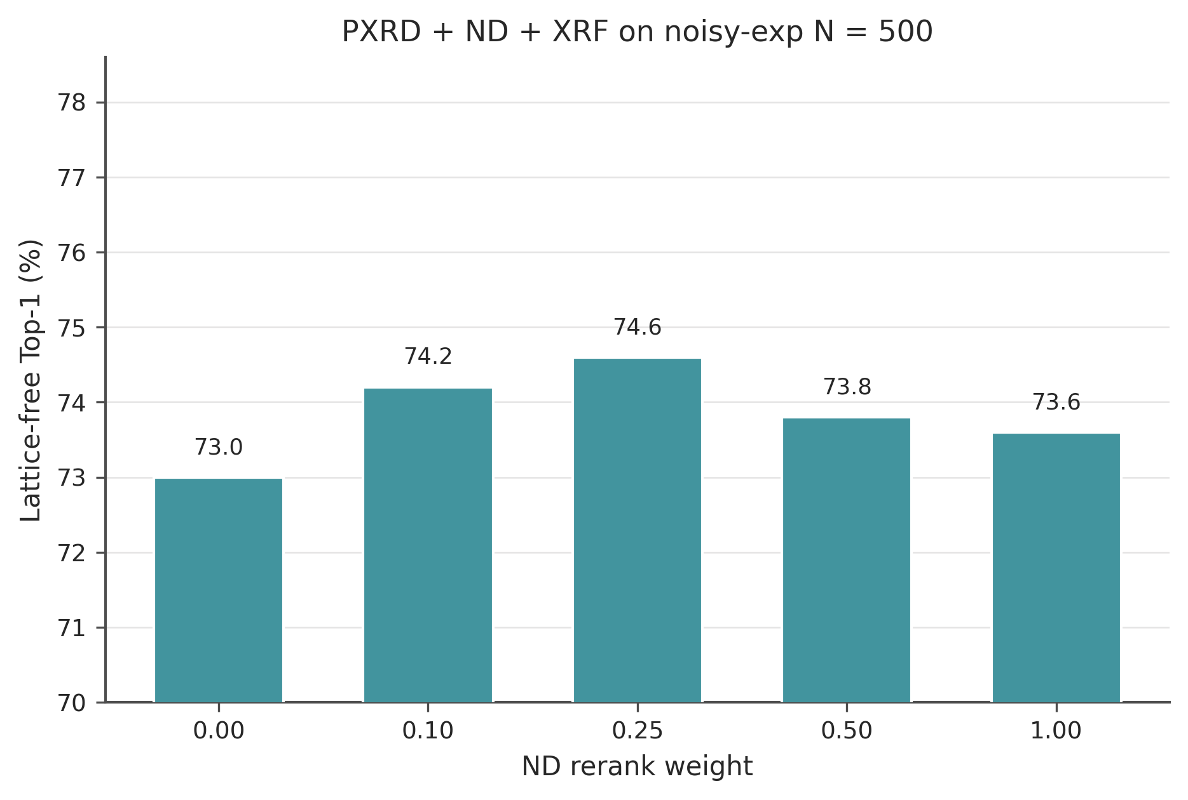
Figure S3. ND rerank-weight ablation on the noisy-exp N = 500 pool, PXRD + ND + XRF, lattice-free Top-1.

Note S4. Training corpus and leakage
Unified multimodal records total 10.21 million. A Tier-A quality filter retains 4.13 million; tight deduplication yields 3.52 million frozen records (train 3,456,202 / valid 34,039 / test 33,944). Alexandria, AFLOW, OQMD, WBM and Materials Project contribute 62.6%, 15.3%, 10.8%, 7.1% and 4.2% of the deduplicated corpus. Counts are shown as bars, not as a workflow diagram.
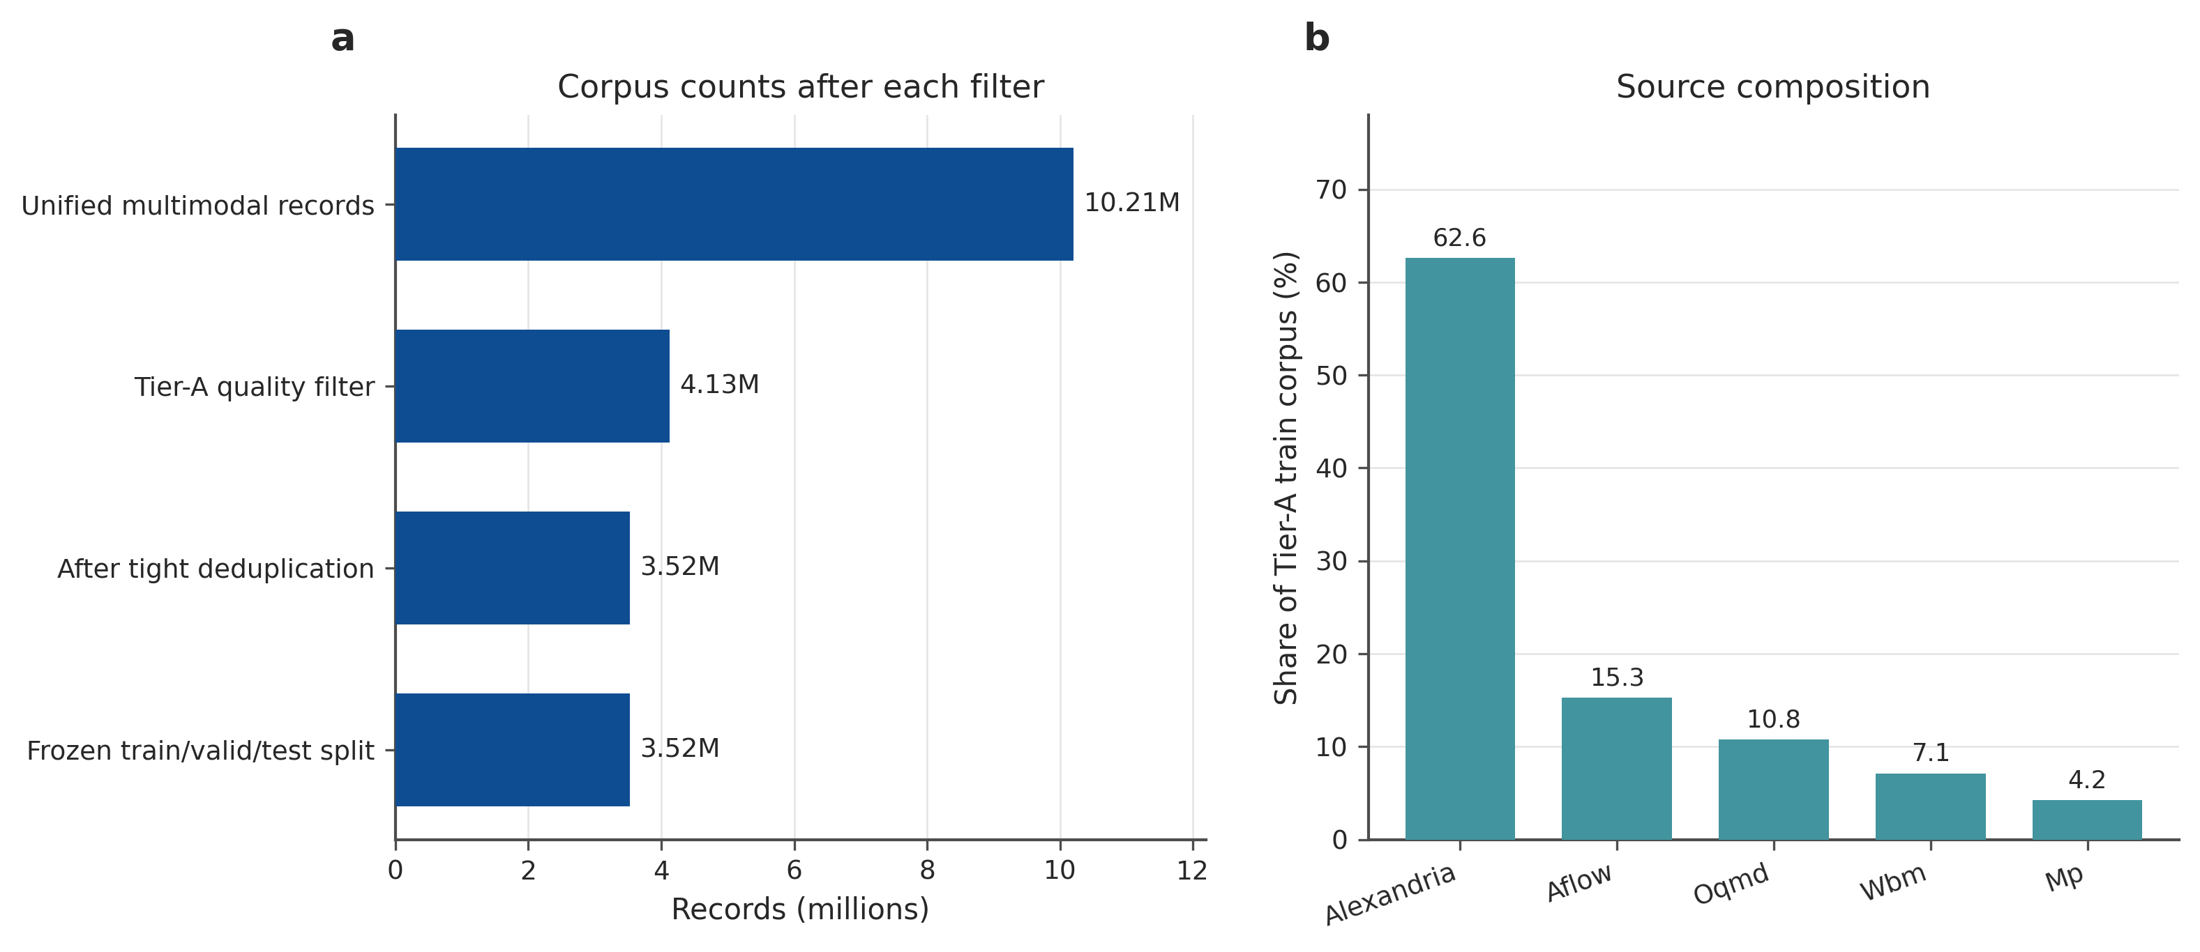
Figure S4. (a) Record counts after each corpus filter. (b) Source share of the Tier-A training corpus.
The MP-20 official test set (N = 9,046) was matched against the RealPXRD 6M pretraining train split. 6,399 test crystals (70.7%) have a near-duplicate in that train split (volume-per-atom relative tolerance 2%; StructureMatcher ltol = 0.2, stol = 0.3, angle_tol = 5°). This overlap is expected because MP-20 sits inside ICSD-derived corpora. MP-20 numbers in Note S5 must therefore be read as SFT on a leaked pretraining distribution unless a leakage-clean subset is quoted.
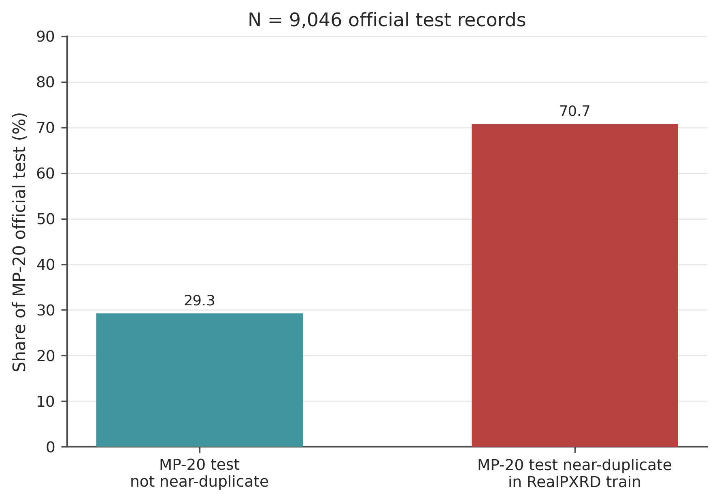
Figure S5. Share of the official MP-20 test set that is a near-duplicate of a RealPXRD pretraining crystal.

Note S5. MP-20 comparisons (protocol-aligned)
Literature MP-20 headlines are not interchangeable. PXRDGen’s often-quoted 82%/96% pair is known-lattice on a 8.93%-filtered “valid” subset. The full-set lattice-free PXRDGen numbers cited by Uni-3DAR are 68.68% @1 and 85.37% @20; the full-set known-lattice numbers are 75.32% @1 and 88.08% @20. XRDSol reports 82.3% with a known cell. Uni-3DAR reports 75.08% lattice-free on the full official test, trained from scratch on MP-20 only.
Our SFT model (RealPXRD pretrain + MP-20 SFT) is evaluated here on the first 500 crystals of the official MP-20 test, formula-conditioned, N = 100, reranked, same StructureMatcher as Table S1. Lattice-free Top-1 / Top-20 = 83.2% / 90.2%. Known-lattice Top-1 / Top-20 = 87.2% / 90.6%. These first-500 numbers are not a full 9,046-crystal official-test claim. A leakage-clean subset of the same 500 is lower (implementation log: lattice-free 79.4% @1 on the clean slice of this pool).
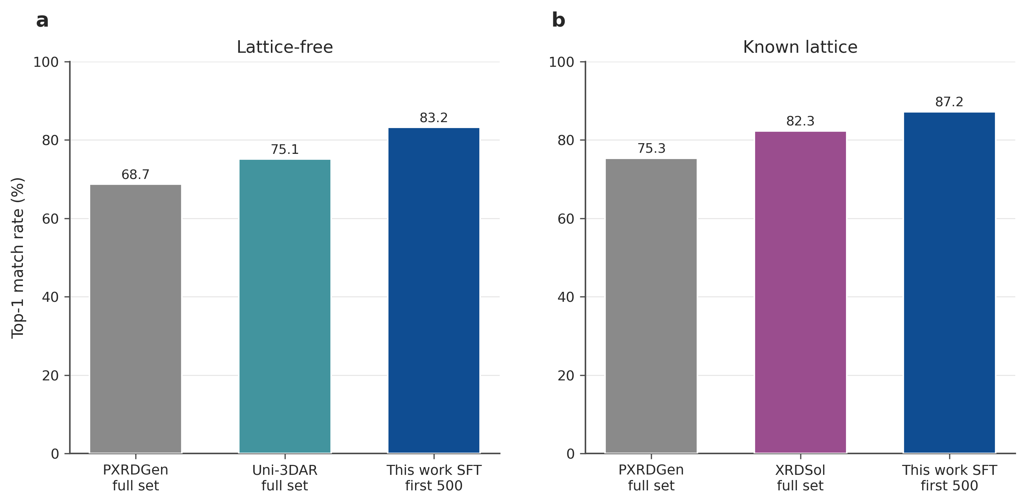
Figure S6. Protocol-aligned MP-20 Top-1. Literature bars are full official test; this work is first 500 after RealPXRD SFT. PXRDGen 82/96 is intentionally not plotted beside Uni-3DAR 75.08%.
Protocol | PXRDGen | Uni-3DAR | XRDSol | This work SFT (first 500)
Lattice-free @1 | 68.68% (full) | 75.08% (full) | — | 83.2%
Lattice-free @20 | 85.37% (full) | — | — | 90.2%
Known lattice @1 | 75.32% (full) | — | 82.3% (full) | 87.2%
Known lattice @20 | 88.08% (full) | — | — | 90.6%

Table S2. MP-20 comparison with protocol footnotes. Full official test N = 9,046.

Note S6. Runtime
We report wall-clock on NVIDIA GeForce RTX 4090 D, not FLOPs. Training logs for this codebase give ~0.34 s/step for the V2 language-model pretrain and ~1.24 s/step for Stage-B continuation. MP-20 SFT on this hardware finished in about 9 minutes per GPU in the implementation log.
For generation, Slurm job 3689 (public experimental PXRD ladder, N = 100 candidates per crystal) yields a median 19.0 s per structure (10th–90th percentile 13.1–23.5 s; 120 shards). That cost is what made the N = 33,944 simulated ladder and the N = 337 public hold-out feasible. We do not mix these 4090D numbers with FlowMM/DiffCSP/Uni-3DAR times from other papers on other GPUs.
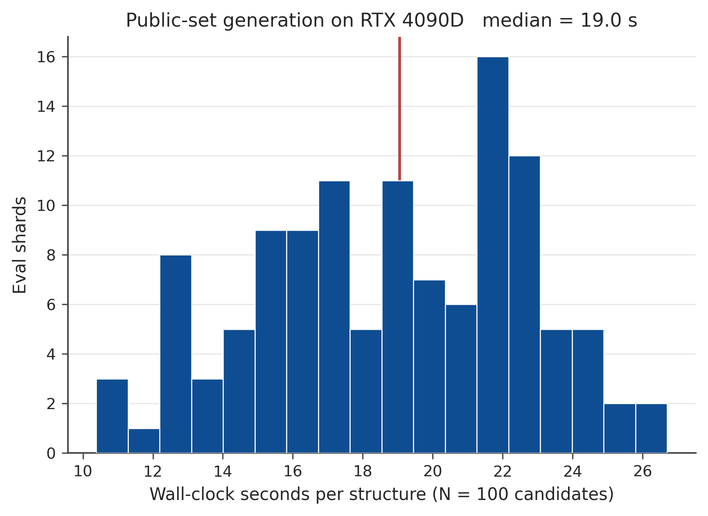
Figure S7. Wall-clock seconds per structure for N = 100 autoregressive samples on RTX 4090 D (public-set eval shards, job 3689).
Measurement | Hardware | Value
V2 pretrain | RTX 4090 D | ~0.34 s/step
Stage B continuation | RTX 4090 D | ~1.24 s/step
Generate N = 100 (median) | RTX 4090 D | 19.0 s / structure
Public 337 × 12 rungs | RTX 4090 D, job 3689 | Completed (array 0–119)

Table S3. Wall-clock measurements used in this SI. Training rates are from project logs.

Note S7. Full simulated ladder, including XPS
The main-text Figure 3 omits XPS because valence prefixes are nearly determined by composition and do not move Top-1. On the full simulated test (N = 33,944) the lattice-free Top-1 change from PXRD+ND+XRF to PXRD+ND+XRF+XPS is +0.03 percentage points; known-lattice is −0.06 points. ND without composition still roughly doubles PXRD-only Top-1 (3.8% → 7.8% lattice-free; 7.1% → 15.5% known lattice), but absolute rates remain low until XRF or formula is provided.
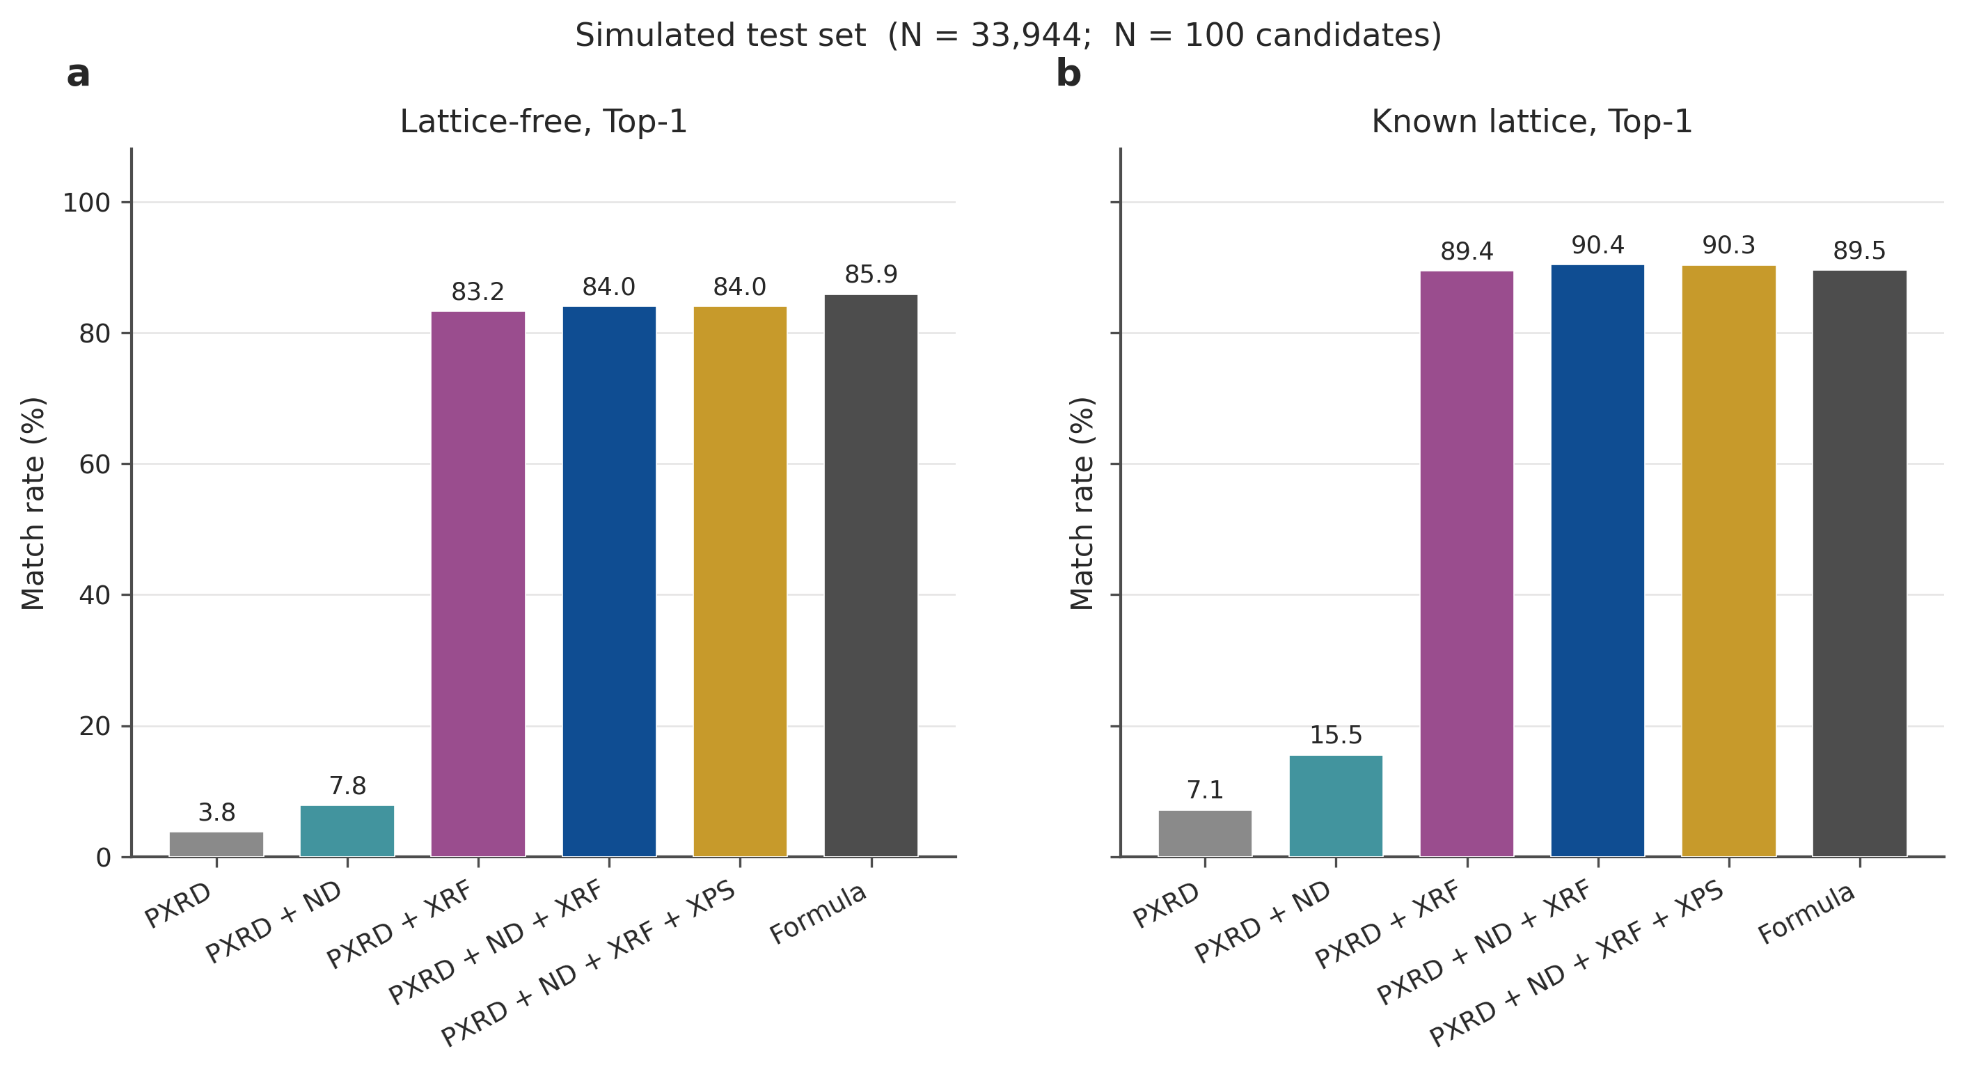
Figure S8. Full simulated-test Top-1 by information rung, including the XPS rung omitted from the main figure.
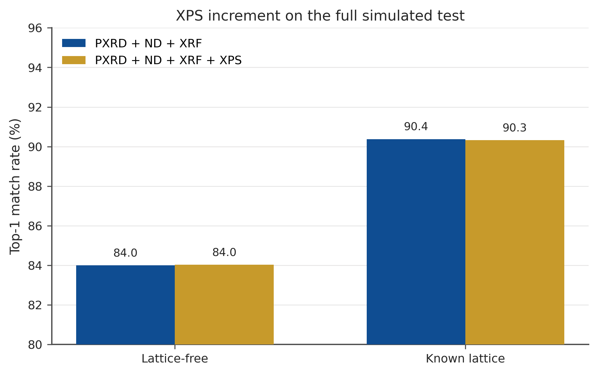
Figure S9. XPS increment on PXRD+ND+XRF. The two bars in each pair are visually indistinguishable, which is the negative result.
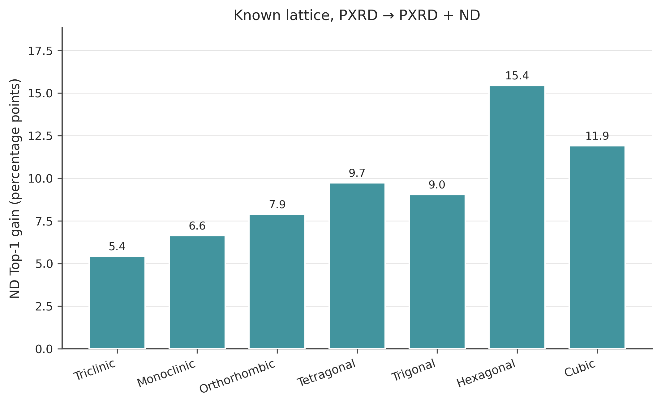
Figure S10. Known-lattice ND Top-1 gain (PXRD → PXRD+ND) by crystal system on the 10k-subset statistics used for main-text Figure 4.
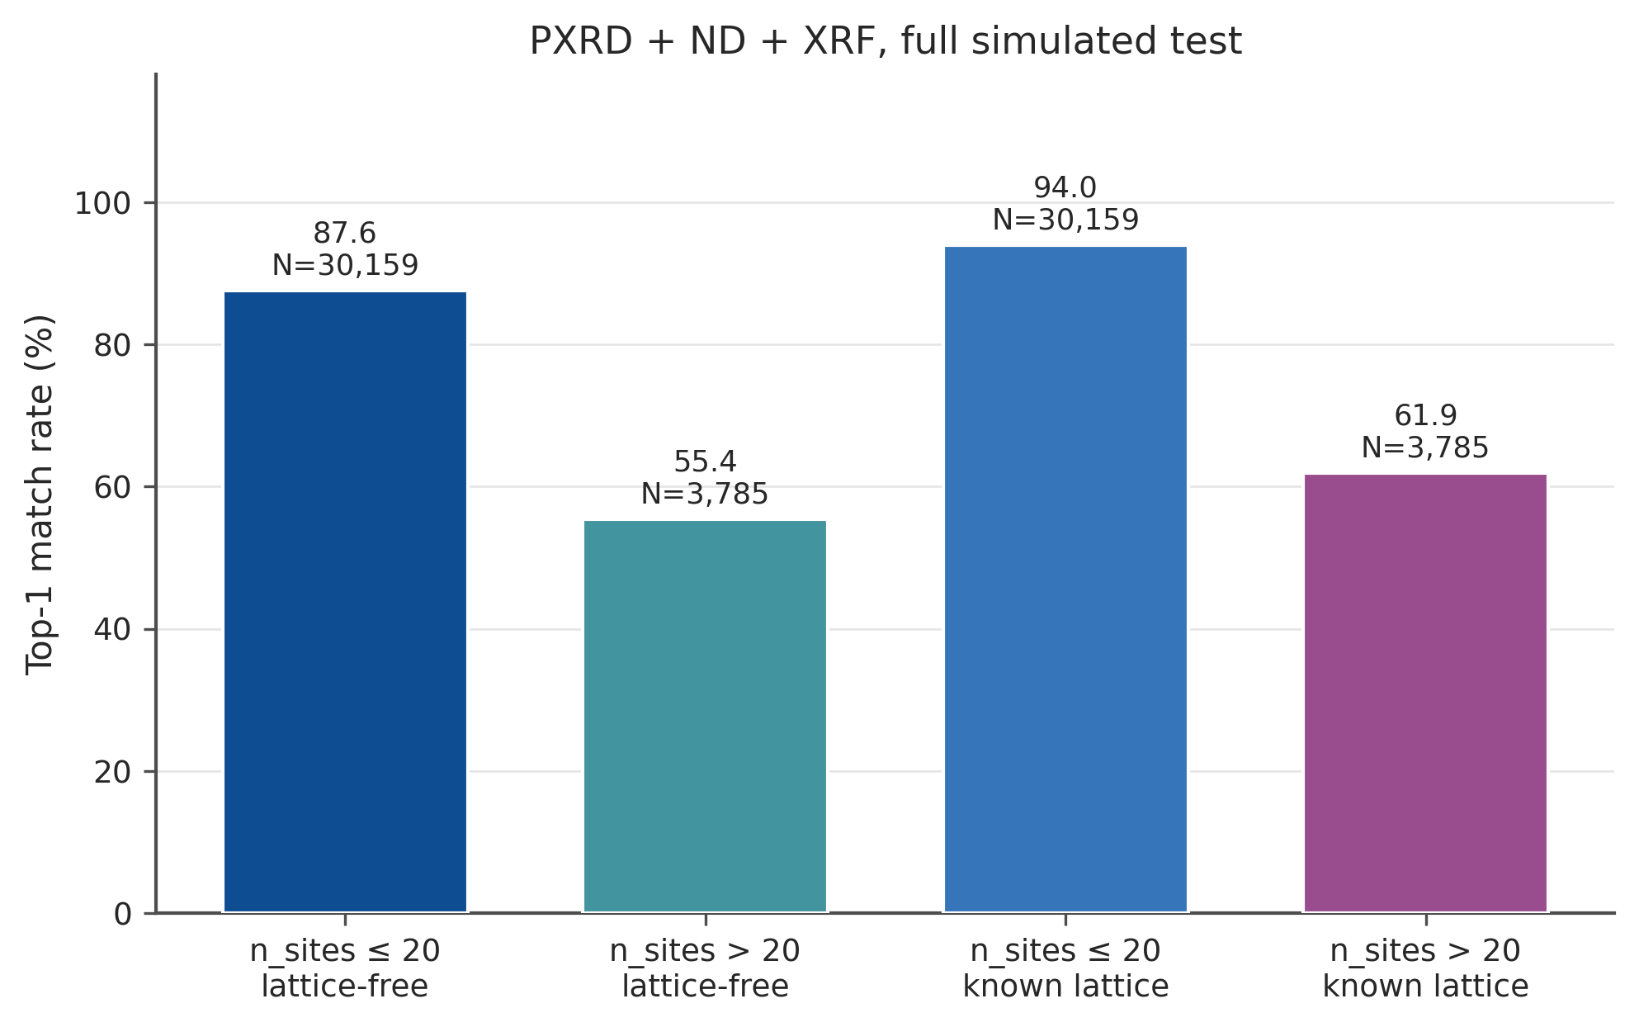
Figure S11. PXRD+ND+XRF Top-1 on the full simulated test, split at n_sites = 20. Large cells remain the failure mode even with a known lattice (61.9% vs 94.0%).
Condition | Comp. % | Top-1 | Top-10 | Top-20 | Top-50
PXRD | 24.8 | 3.8 | 11.8 | 15.2 | 20.3
PXRD + ND | 31.6 | 7.8 | 17.9 | 21.5 | 26.6
PXRD + XRF | 98.9 | 83.2 | 90.2 | 91.4 | 92.3
PXRD + ND + XRF | 98.9 | 84.0 | 90.4 | 91.5 | 92.3
PXRD + ND + XRF + XPS | 98.9 | 84.0 | 90.5 | 91.5 | 92.4
Formula | 100.0 | 85.9 | 92.1 | 93.0 | 93.7

Table S4. Simulated test, lattice-free, reranked (N = 33,944).
Condition | Comp. % | Top-1 | Top-10 | Top-20 | Top-50
PXRD | 32.1 | 7.1 | 20.6 | 24.7 | 28.7
PXRD + ND | 39.4 | 15.5 | 30.0 | 33.2 | 35.9
PXRD + XRF | 99.8 | 89.4 | 93.1 | 93.7 | 94.1
PXRD + ND + XRF | 99.8 | 90.4 | 93.2 | 93.6 | 94.0
PXRD + ND + XRF + XPS | 99.8 | 90.3 | 93.2 | 93.6 | 94.1
Formula | 100.0 | 89.5 | 93.3 | 93.9 | 94.3

Table S5. Simulated test, known lattice, reranked (N = 33,944).

Note S8. Synthetic noise is not experiment
Training a noise-aware decoder recovers much of the drop caused by synthetic PXRD corruptions on a held-out N = 500 pool, especially once the lattice is known (PXRD+ND+XRF Top-1: 96.4% clean → 92.2% noisy-exp). Lattice-free is hit harder (91.4% → 75.4%). The public and collaborator experimental sets in Notes S9–S10 are far below these synthetic-noise numbers, which is the point of reporting them in that order: synthetic robustness is necessary, not sufficient.
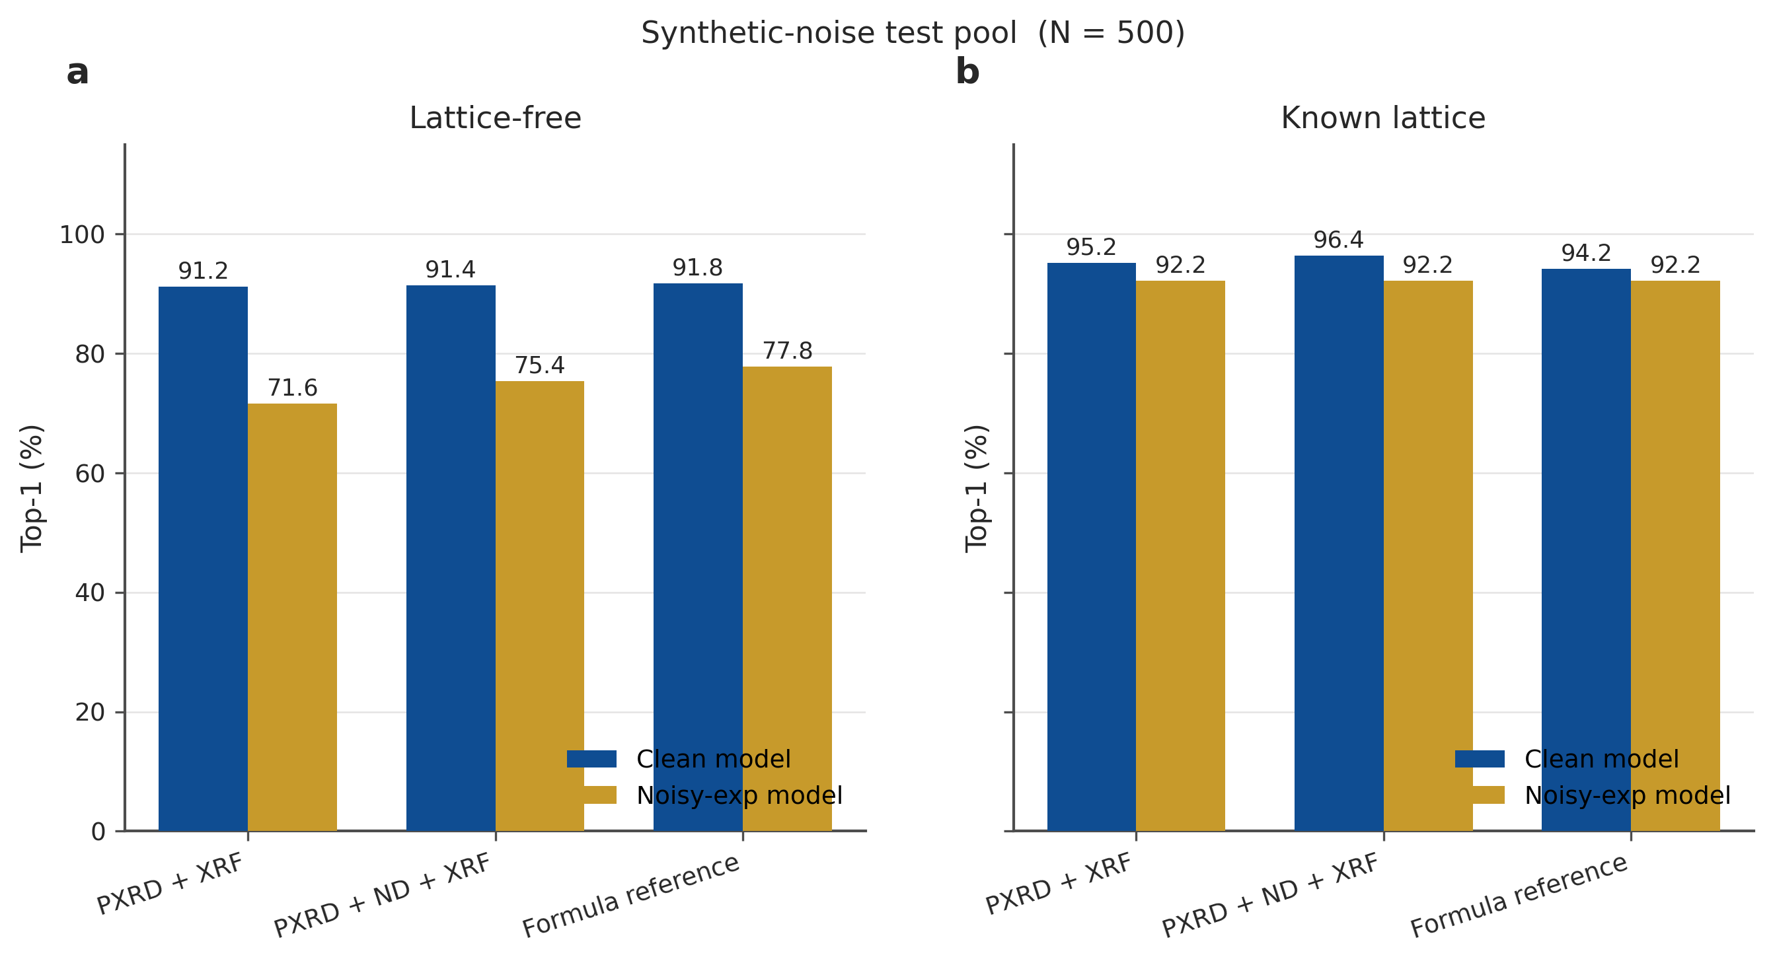
Figure S12. Clean versus noisy-exp models on the synthetic-noise N = 500 pool (high-information rungs).
Lattice | Condition | Clean T1 | Noisy-exp T1 | Δ T1
Free | PXRD + XRF | 91.2 | 71.6 | −19.6
Free | PXRD + ND + XRF | 91.4 | 75.4 | −16.0
Free | Formula | 91.8 | 77.8 | −14.0
Known | PXRD + XRF | 95.2 | 92.2 | −3.0
Known | PXRD + ND + XRF | 96.4 | 92.2 | −4.2
Known | Formula | 94.2 | 92.2 | −2.0

Table S6. Synthetic-noise N = 500, reranked Top-1 (%).

Note S9. Public experimental PXRD hold-out (N = 337)
Protocol public_exp_pxrd_v1 was frozen before evaluation. Sources are COD observed powder (pdCIF/HKL, never calculated intensities) and opXRD subsets that ship atomic coordinates (CNRS and HKUST-A; Zenodo 10.5281/zenodo.14254270, CC-BY-4.0). ICDD/PDF-5+, CSD powder, ICSD powder, RRUFF and HTEM-DB are excluded because they do not provide a same-specimen atomic ground truth for CSP scoring.
Of 1591 attempted records, 727 parsed, 565 passed the cosine ≥ 0.40 QC, and 337 unique (reduced formula + space group) crystals remain (COD 56, opXRD 281). Filters: n_sites 2–80, ≥8 PXRD bins, occupancy not collapsed, tokenizer-legal elements, observed intensities only. This set is never used for training, and it is not passed through the collaborator keep-10 selection.
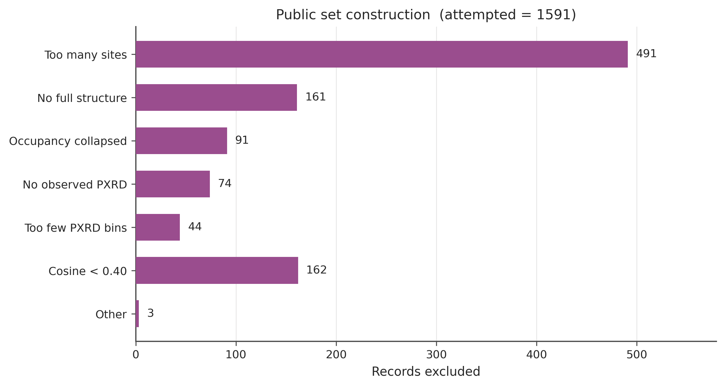
Figure S13. Exclusion counts for the public hold-out. This is a result bar chart of filter outcomes, not a construction flowchart.
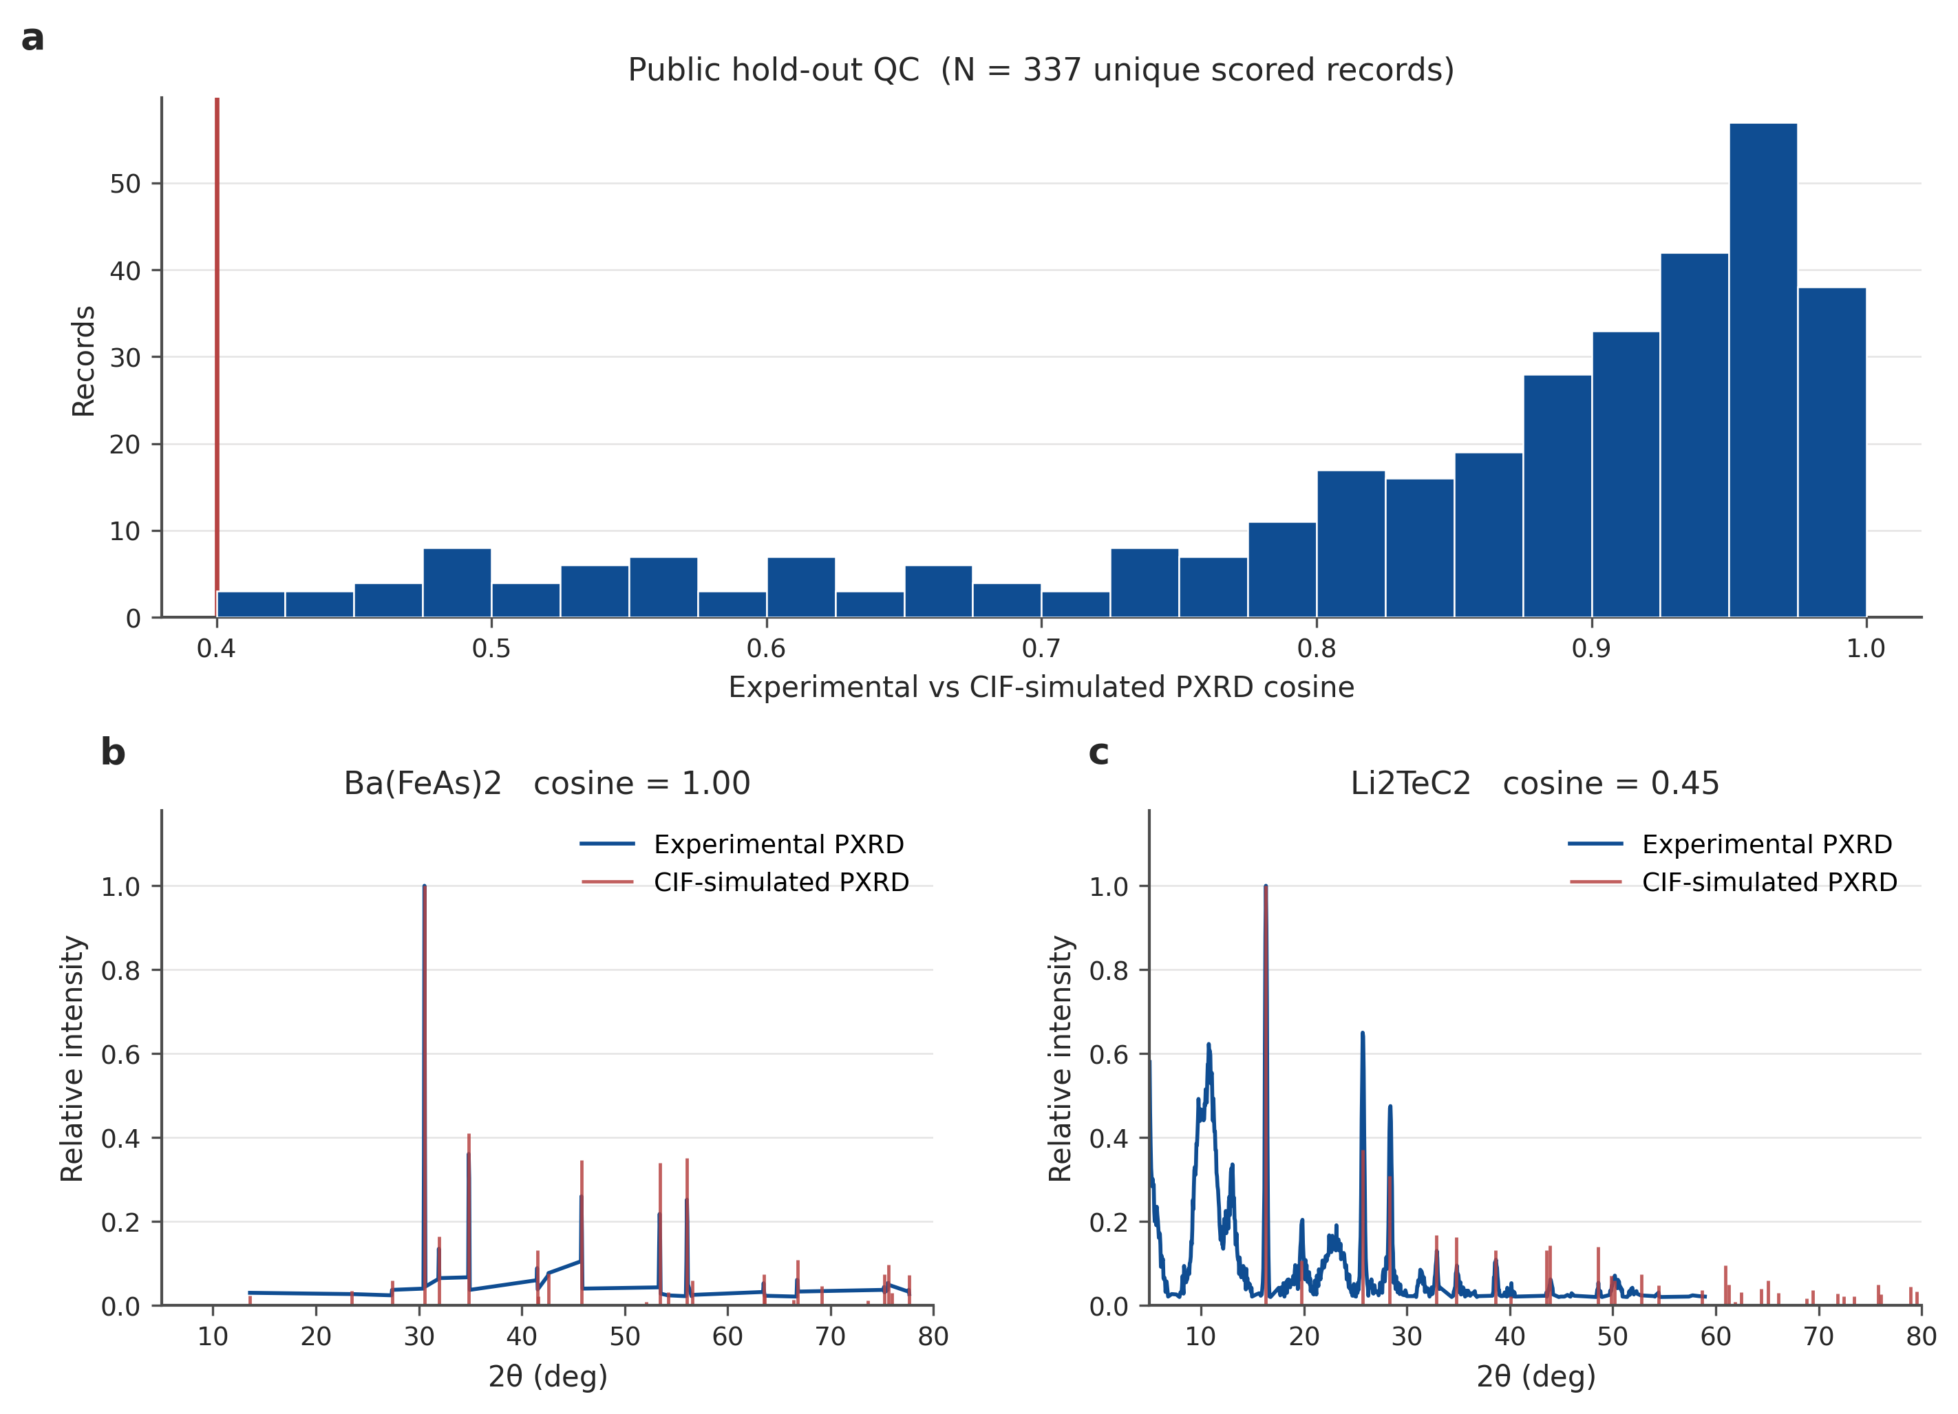
Figure S14. (a) Experimental vs CIF-simulated PXRD cosine on the 337 unique scored records (threshold 0.40). (b) High-cosine example. (c) Record near the acceptance floor.
On the noisy-exp model with the Table S1 experimental reranker, PXRD alone and PXRD+ND (no composition) give 0/337 Top-1 in both lattice settings. Adding XRF lifts known-lattice Top-1 to 7.1%; ND on top of that reaches 8.6% (29/337). Formula reference is 9.2%. Lattice-free spectroscopic Top-1 is 2.7% (PXRD+ND+XRF). XPS does not help. These rates are the experimental-PXRD story: complementary probes still climb the ladder, but simulated-test percentages do not transfer.
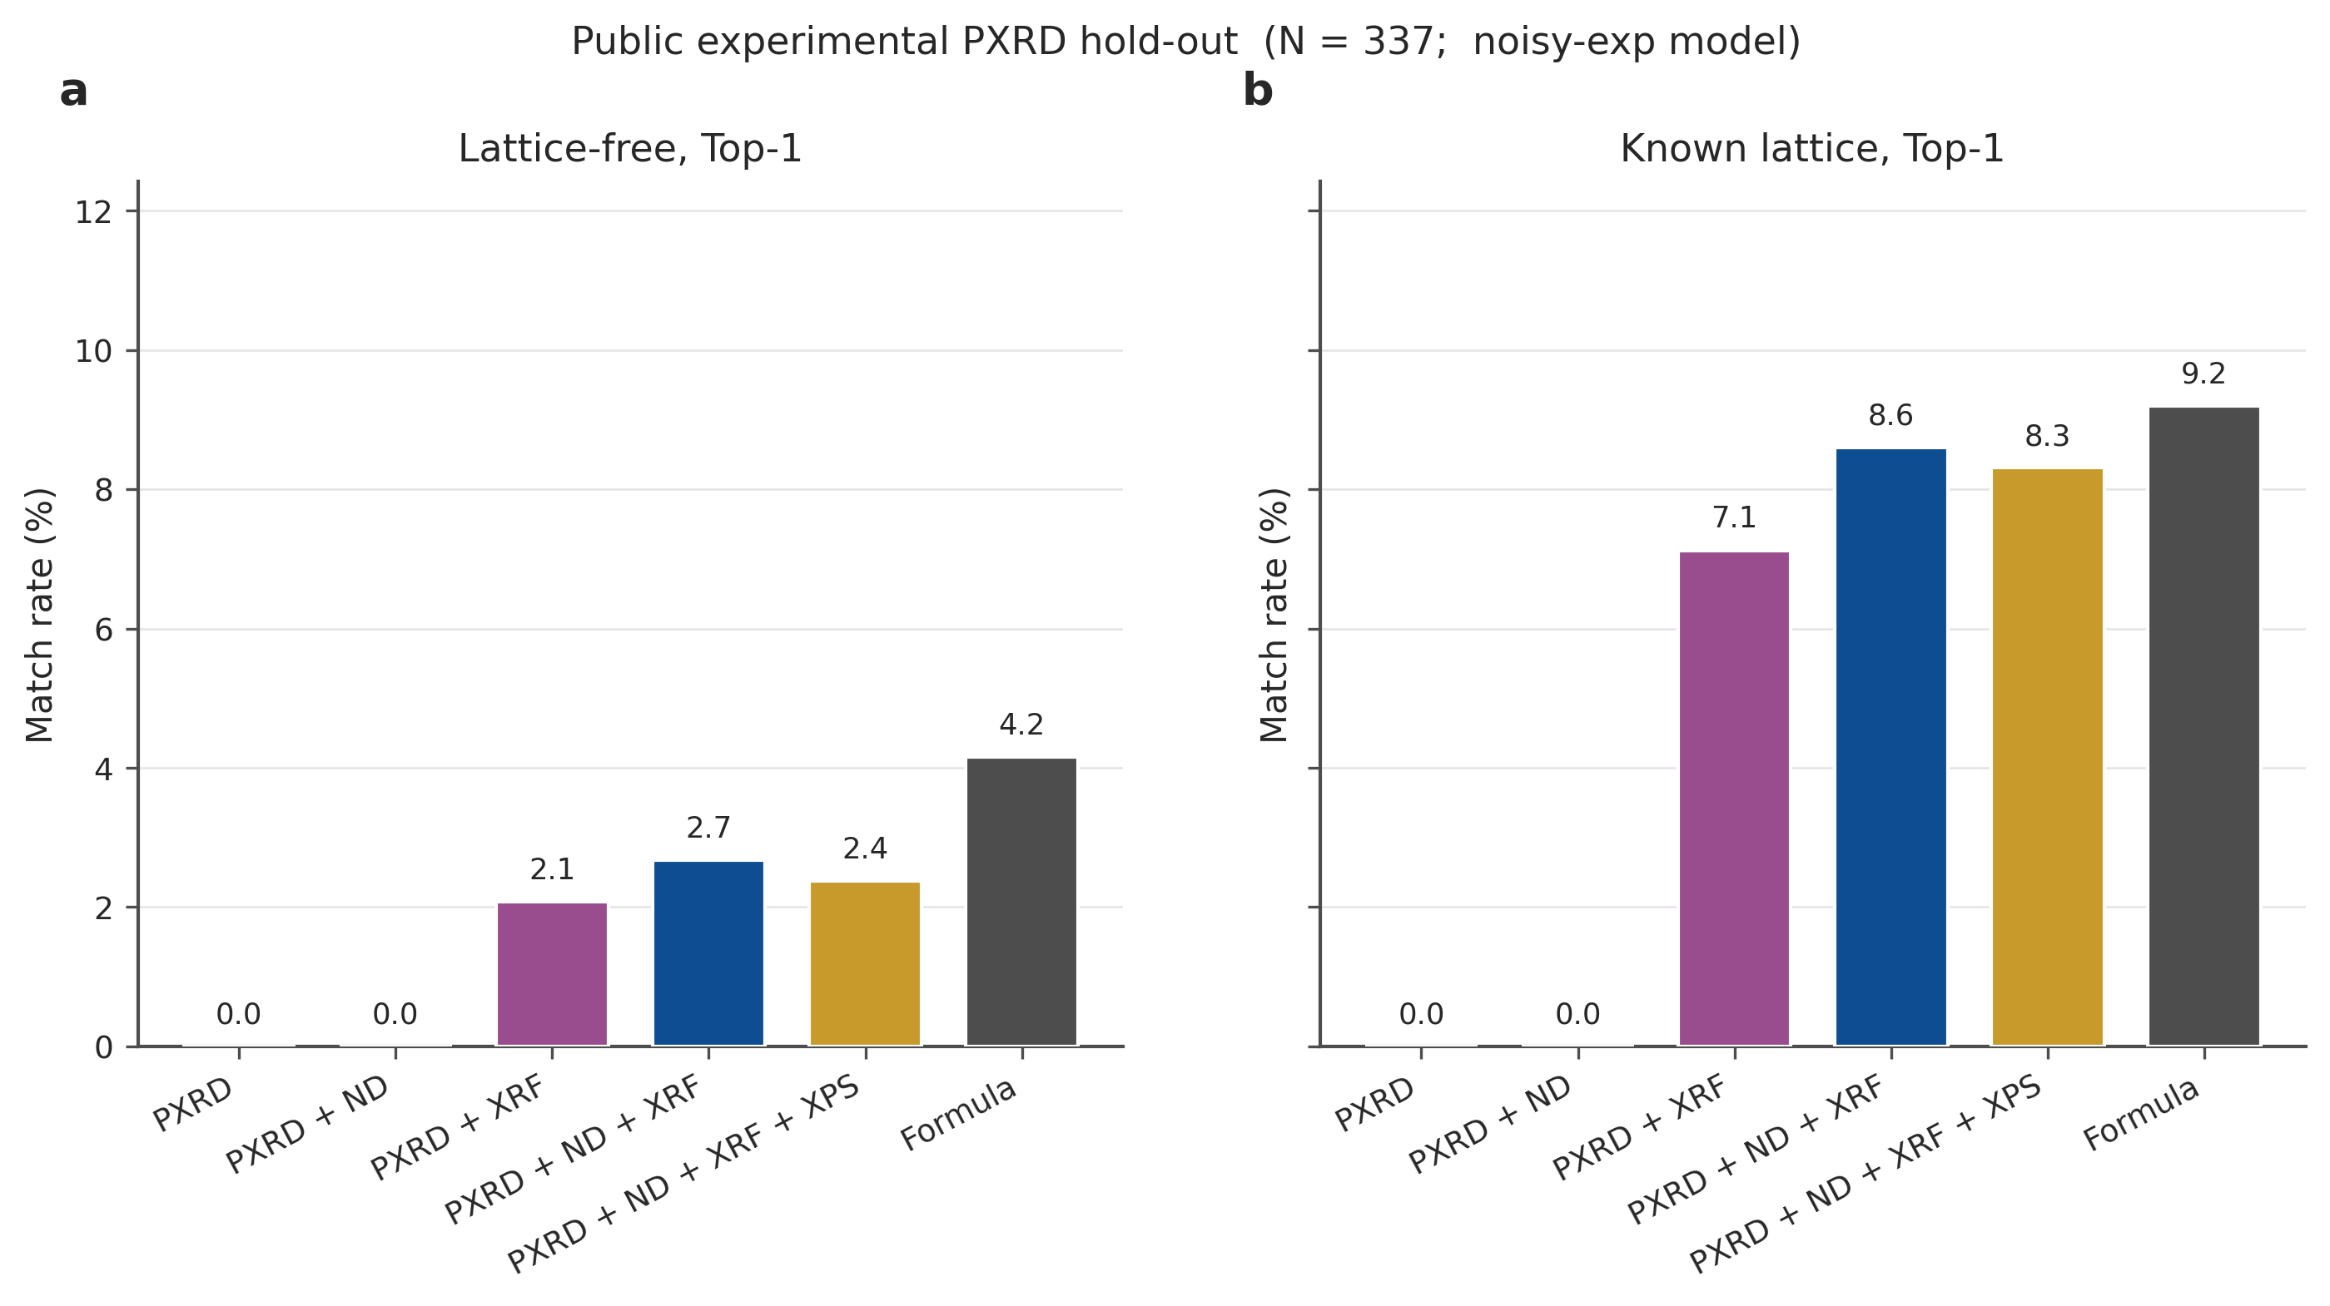
Figure S15. Public experimental PXRD hold-out, noisy-exp model, reranked Top-1 (N = 337).
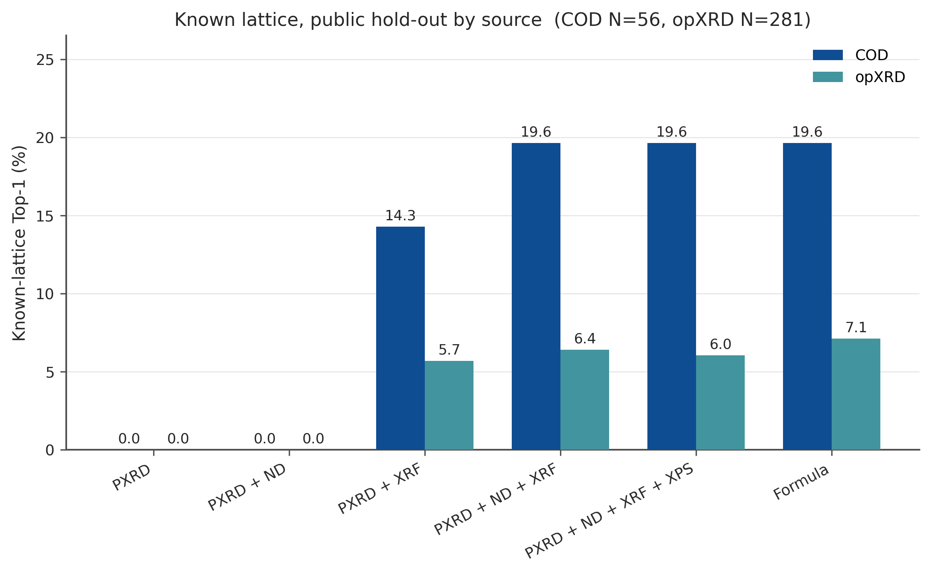
Figure S16. Known-lattice Top-1 split by source. COD N = 56, opXRD N = 281. The COD slice is easier; it is also smaller and biased toward structures whose authors deposited observed powder with a CIF.
Condition | Comp. % | Top-1 | Top-10 | Top-20 | Top-50
PXRD | 0.0 | 0.0 | 0.0 | 0.0 | 0.0
PXRD + ND | 0.0 | 0.0 | 0.0 | 0.0 | 0.0
PXRD + XRF | 17.8 | 2.1 | 2.7 | 3.6 | 3.6
PXRD + ND + XRF | 19.9 | 2.7 | 3.3 | 3.3 | 3.9
PXRD + ND + XRF + XPS | 19.3 | 2.4 | 3.3 | 3.3 | 3.9
Formula | 100.0 | 4.2 | 6.8 | 7.7 | 8.0

Table S7. Public hold-out, lattice-free, reranked (N = 337).
Condition | Comp. % | Top-1 | Top-10 | Top-20 | Top-50
PXRD | 0.0 | 0.0 | 0.0 | 0.0 | 0.0
PXRD + ND | 0.3 | 0.0 | 0.0 | 0.0 | 0.0
PXRD + XRF | 37.1 | 7.1 | 8.9 | 9.8 | 9.8
PXRD + ND + XRF | 41.2 | 8.6 | 9.8 | 9.8 | 9.8
PXRD + ND + XRF + XPS | 41.8 | 8.3 | 9.8 | 10.1 | 10.7
Formula | 100.0 | 9.2 | 11.3 | 12.5 | 13.1

Table S8. Public hold-out, known lattice, reranked (N = 337).
Condition | COD Top-1 (N=56) | opXRD Top-1 (N=281)
PXRD | 0.0 | 0.0
PXRD + ND | 0.0 | 0.0
PXRD + XRF | 14.3 | 5.7
PXRD + ND + XRF | 19.6 | 6.4
PXRD + ND + XRF + XPS | 19.6 | 6.0
Formula | 19.6 | 7.1

Table S9. Public hold-out known-lattice Top-1 (%) by source.

Note S10. Collaborator experimental PXRD (keep-10)
The collaborator pool is a separate, non-public experimental PXRD set. After occupancy and data-quality screens the keep-10 list is: 1T-TaS2, 2M-WS2, BiOCl, Li2CO3, Li2SO4, LiCoO2, Na3PS4, NaCoO2, Nb3Cl8, SiS2. ND and XRF are CIF-simulated. The noisy-exp model is the one reported in the main text.
Any-rung Top-50 including formula: 7/10 (1T-TaS2, BiOCl, Nb3Cl8, LiCoO2, NaCoO2, Na3PS4, SiS2). Spectroscopic Top-50, no formula: 4/10 (BiOCl, LiCoO2, NaCoO2, SiS2). Spectroscopic known-lattice Top-1 (PXRD+ND+XRF): 3/10 (LiCoO2, NaCoO2, BiOCl). LiCoO2 is the emblematic unlock: PXRD-only misses; PXRD+ND becomes Top-1 once the lattice is known; XRF also solves it. These three numbers are not interchangeable.
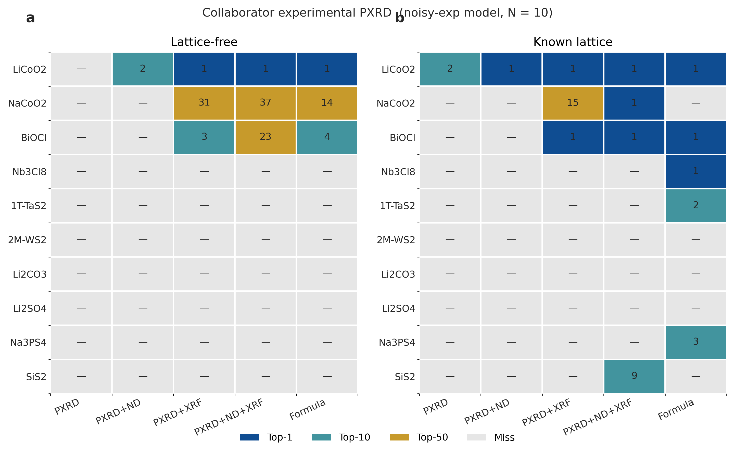
Figure S17. Per-sample reranked rank on the collaborator keep-10 set (noisy-exp model). Numbers are the best rank when the match is inside Top-50; a dash is a miss. Main-text 3/10 is the known-lattice PXRD+ND+XRF Top-1 column (LiCoO2, NaCoO2, BiOCl).
Crystal | PXRD | PXRD+ND | PXRD+XRF | PXRD+ND+XRF | Formula
LiCoO2 | 2 | 1 | 1 | 1 | 1
NaCoO2 | — | — | 15 | 1 | —
BiOCl | — | — | 1 | 1 | 1
Nb3Cl8 | — | — | — | — | 1
1T-TaS2 | — | — | — | — | 2
2M-WS2 | — | — | — | — | —
Li2CO3 | — | — | — | — | —
Li2SO4 | — | — | — | — | —
Na3PS4 | — | — | — | — | 3
SiS2 | — | — | — | 9 | —

Table S10. Collaborator keep-10, noisy-exp model, known lattice. Entries are reranked ranks when the match is in Top-50. Spectroscopic known-lattice Top-1 is the PXRD+ND+XRF column with rank 1 (3/10).

Note S11. Limits that belong in the SI, not the title
XPS, as currently encoded, is not a complementary probe in this model (Figures S8–S9). Large cells (n_sites > 20) remain a steep drop (Figure S11). Experimental PXRD, even with simulated ND and XRF, is an order of magnitude harder than the simulated test (Tables S4 vs S7–S8). The public 337 set is still single-phase, occupancy-simple, and cosine-filtered; it is not a Rietveld championship on multiphase industrial powders. RRUFF, ICDD and composition-only opXRD slices were inspected and left out of the scored set because they cannot support a CIF-level match. Crystal-language speed is a lemma that made the ladders possible (Figure S7), not a second title claim. Open-ended generation / materials design is an outlook until it has its own quantitative table.

Data and code pointers
Simulated ladder: crystal_language/eval_results/ladder_tierA_s2_full_neutron/ladder_test_table.json. Public hold-out protocol: data_prep/outputs/public_exp_pxrd/protocol.json. Public eval: crystal_language/eval_results/ladder_public_exp_pxrd_noisy/. Collaborator ranks: paper_figures/fig7_experimental_pxrd/data/per_sample_ranks.csv. Figure source data for this file: paper_figures/si_supplementary/data/.

