Database Project Report Template
Due Date: [Week 5-8.]
Project ID & Title: University Research & Lab Asset Tracker

Project Identity
- Team Name: G1
- Team Members:
- Phạm Văn An (n22dcat002@student.ptithcm.edu.vn)
- Lâm Minh Chiến (n24dece057@student.ptithcm.edu.vn)
- Đỗ Vương Bảo Anh (n24dece054@student.ptithcm.edu.vn)
- Project Title : University Research & Lab Asset Tracker

B. Report structure

Introduction & Project Scope

1.1 System Objective

1.1.1 Problem Statement
Universities operate multiple research labs serving faculty and students, using high-value equipment and chemicals while also receiving funding from multiple research grants provided by different funding organizations. Currently, the management of lab assets, chemical inventory, and lab access rights is often carried out manually using paper records and separate spreadsheets, leading to the following problems:
- It is difficult to control who is accessing hazardous chemicals or restricted areas, creating occupational safety risks.
- Equipment and chemicals are not associated with a specific lab or grant, making them difficult to trace during audits.
- There is no mandatory constraint ensuring that only personnel with appropriate safety certifications are allowed to access hazardous materials.
- There is insufficient data linkage among personnel (faculty/students), research grants, and the laboratory assets they use.
The objective of the project is to design and build a relational database named "University Research & Lab Asset Tracker" for the centralized management of: (1) research grants, (2) laboratory equipment, (3) chemical inventory, and (4) access logs for faculty and students entering or leaving laboratories. The most important integrity constraint is that only personnel with valid, unexpired certifications may access materials or areas with the corresponding hazard level. This constraint will be enforced at the database layer through an SQL Trigger.

1.1.2 Scope
- In scope: management of departments, personnel (faculty/students), safety certifications, laboratories, equipment, chemicals, research grants, and access logs.
- Out of scope: the university's full financial accounting system, academic administration (course registration), and the complete HR system for university employees.

1.1.3 Functional Requirements
- FR1: The system allows an Administrator (Admin) to register new laboratory equipment and assign the equipment to a specific laboratory.
- FR2: The system allows Faculty members to create and manage research grant records, including the funding organization name, grant amount, and project duration.
- FR3: The system records every personnel access event at a laboratory, including the timestamp and access type (entry/exit).
- FR4: The system must validate a personnel member's safety certification before allowing access to chemicals or laboratories classified as hazardous. This rule is enforced by an SQL Trigger, not only at the application layer.
- FR5: The system tracks chemical inventory, including stock quantity, storage location, and hazard classification (hazard class).
- FR6: The system allows multiple personnel members (faculty/students) to be assigned to a grant with specific roles (PI, Co-PI, Research Assistant).
- FR7: The system supports report queries, including lists of unauthorized access attempts, equipment by laboratory, and chemicals with related certifications that are nearing expiration.

1.1.4 Non-Functional Requirements
- NFR1 (Security): Certification data and personnel identification information must be subject to strict access control; encryption at rest is recommended for sensitive fields.
- NFR2 (Performance): Access-log lookup queries used for auditing must return results in under 200 ms with up to 100,000 records.
- NFR3 (Availability): The system should be available 24/7 because laboratories may be accessed outside normal working hours.
- NFR4 (Data Integrity): The rule that "only personnel with valid certifications may access hazardous materials" must be enforced at the database layer (trigger/constraint) and must not depend entirely on the application layer.

1.2. Business Rules

1.2.1 Personnel & Certification
- BR1: Each Personnel has a unique person_id. A Personnel may be specialized as either Faculty or Student. The specialization is disjoint and partial; therefore, a Personnel member may belong to neither subtype.
- BR2: Each Faculty member belongs to exactly one Department; a Department may have many Faculty members.
- BR3: Each Student may have at most one Faculty member as an advisor; a Faculty member may advise many Students.
- BR4: A Personnel member may be issued zero or more Certifications; a Certification may be issued to many Personnel members (an N:N relationship through PERSON_CERTIFICATION), and each issuance has its own issue_date and expiry_date.
- BR5: A Certification is valid only when the current date falls within [issue_date, expiry_date]; expired certifications are not considered valid when determining access permission.

1.2.2 Laboratories, Equipment & Chemicals
- BR6: Each Equipment item belongs to exactly one Lab; a Lab may contain zero or more Equipment items.
- BR7: Each Chemical is stored in exactly one Lab; a Lab may store zero or more Chemicals.
- BR8: Each Lab and each Chemical has a hazard_level/hazard_class. If hazard_level != 'None', only Personnel with a valid Certification at the corresponding hazard level or a higher level may access it (this constraint is enforced by an SQL Trigger BEFORE INSERT on ACCESS_LOG).

1.2.3 Research Grants
- BR9: Each Research Grant has exactly one Principal Investigator (PI), and the PI must be a Faculty member (not a Student).
- BR10: A Faculty member may be the PI of multiple Grants.
- BR11: A Grant may have many participating Personnel members with different roles (PI, Co-PI, Research Assistant) through the GRANT_MEMBER associative table; a Personnel member may participate in multiple Grants.
- BR12: The Grant amount must be > 0, and end_date must be later than start_date.

1.2.4 Access Log
- BR13: Each Access Log record must reference an existing valid Personnel member and Lab; it may optionally reference a specific Equipment item and/or Chemical if the event relates to that item or substance.
- BR14: Each access event has an access_type of 'Entry' or 'Exit' and an authorized_flag automatically determined by the trigger based on the Personnel member's valid Certification relative to the hazard_level of the related Lab/Chemical.
- BR15: The system does NOT allow an Access Log record to be inserted (INSERT) with authorized_flag = TRUE if the Personnel member does not have the corresponding valid Certification. This is the central DB Challenge of the project and will be implemented using an SQL Trigger in Phase 3.

Database Design

2.1 Conceptual Model

2.1.1 Comprehensive ER/EER Diagram
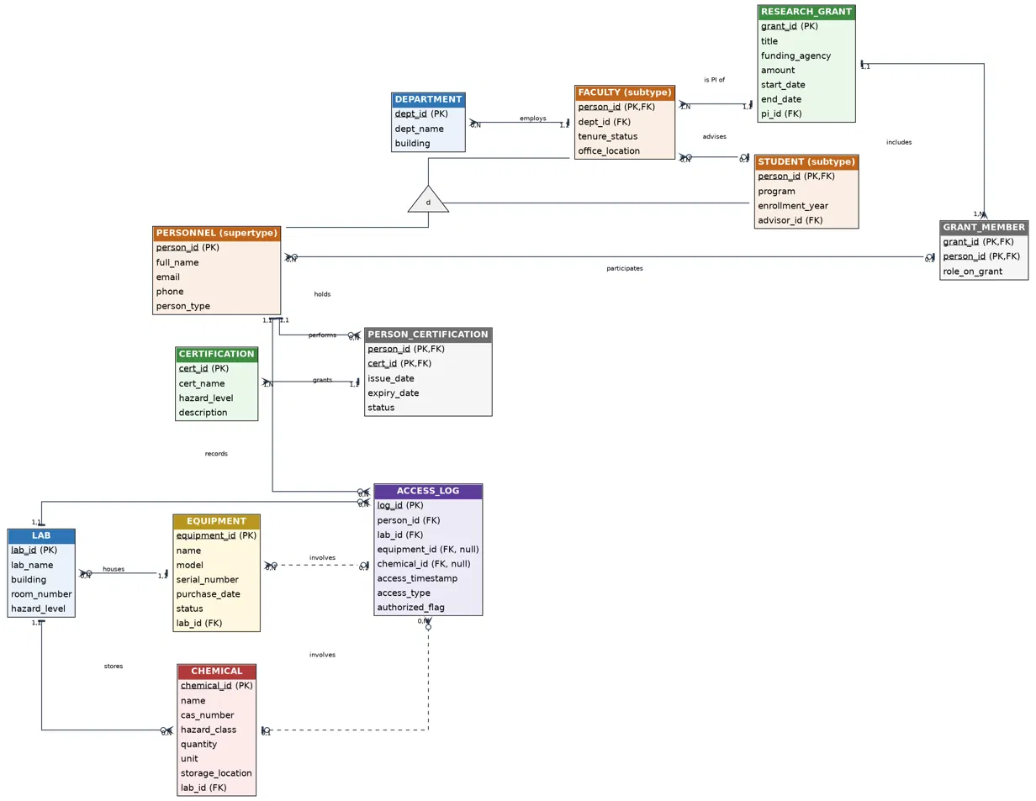

2.1.2 Entity Overview
The table below summarizes the main entities, their primary keys, and their purposes. Full details of data types and constraints will be presented in the Data Dictionary in Phase 2 (Logical Design).
Entity | Primary Key (PK) | Purpose
DEPARTMENT | dept_id | Department/unit responsible for managing faculty members.
PERSONNEL | person_id | Common supertype for all personnel (faculty, students, etc.).
FACULTY | person_id (FK) | Subtype: faculty member; may serve as a grant PI and advise students.
STUDENT | person_id (FK) | Subtype: student; may have a Faculty member as an advisor.
CERTIFICATION | cert_id | Safety certification type / authorized hazard-access level.
PERSON_CERTIFICATION | person_id, cert_id | N:N associative table recording certifications issued to each person and their validity.
LAB | lab_id | Laboratory with its own hazard level.
EQUIPMENT | equipment_id | Equipment assigned to a specific Lab.
CHEMICAL | chemical_id | Chemical stored in a Lab, with a hazard_class.
RESEARCH_GRANT | grant_id | Research grant with one PI (Faculty).
GRANT_MEMBER | grant_id, person_id | N:N associative table between a Grant and participating Personnel, including roles.
ACCESS_LOG | log_id | Lab entry/exit log with optional Equipment/Chemical references and an authorized_flag determined by a trigger.

2.1.3 Relationship Summary
Relationship | Cardinality (min,max) | Related Business Rule
DEPARTMENT - FACULTY | 1,1 - 0,N | BR2
FACULTY - STUDENT (advises) | 0,1 - 0,N | BR3
PERSONNEL - PERSON_CERTIFICATION - CERTIFICATION | 1,1 -(0,N)-(1,N)- 1,1 | BR4, BR5
LAB - EQUIPMENT | 1,1 - 0,N | BR6
LAB - CHEMICAL | 1,1 - 0,N | BR7
FACULTY - RESEARCH_GRANT (is PI of) | 1,1 - 1,N | BR9, BR10
RESEARCH_GRANT - GRANT_MEMBER - PERSONNEL | 1,1 -(1,N)-(0,N)- 0,1 | BR11
PERSONNEL - ACCESS_LOG | 1,1 - 0,N | BR13
LAB - ACCESS_LOG | 1,1 - 0,N | BR13
EQUIPMENT - ACCESS_LOG (optional) | 0,1 - 0,N | BR13
CHEMICAL - ACCESS_LOG (optional) | 0,1 - 0,N | BR13
PERSONNEL -(d)- FACULTY / STUDENT | EER disjoint, partial specialization | BR1

2.1.4 Design Assumptions
- A Personnel member cannot be both Faculty and Student at the same time (disjoint specialization).
- A Grant has only one PI at a time; if the PI changes, pi_id is updated (the PI change history is not stored in Phase 1).
- Each Access Log record is associated with at most one Equipment item OR one Chemical (neither is mandatory), supporting detailed traceability in accordance with BR13.
- The hazard level (hazard_level/hazard_class) uses a consistent categorical scale across Lab, Chemical, and Certification (for example: None, Low, Medium, High) so that the trigger in Phase 3 can compare them directly.

2.2 Logical Schema Mapping
Mapping Rules Applied:
Rule 1 — Strong Entity: Each strong entity maps to a separate relation table. The entity's key becomes the table's PK.
Rule 2 — Single-valued Attributes: Each single-valued attribute becomes a column in the table.
Rule 3 — Binary 1:N Relationship: The PK of the '1' side is added to the 'N' side table as a FK. Example: EQUIPMENT.lab_id → LAB.lab_id.
Rule 4 — Binary N:N Relationship: A new association table is created with FKs from both sides. The composite PK consists of those FKs. Applied to PERSON_CERTIFICATION and GRANT_MEMBER.
Rule 5 — EER Specialization (Method 8A): For DISJOINT PARTIAL specialization (PERSONNEL → FACULTY/STUDENT): retain the supertype table PERSONNEL and create separate subtype tables FACULTY and STUDENT. Each subtype's PK is a FK referencing PERSONNEL with ON DELETE CASCADE. Chosen because: (a) avoids excessive NULL values, (b) supports partial specialization (personnel in neither subtype remain valid), (c) enables efficient subtype-specific queries.
Rule 6 — Optional FK (Nullable): Optional relationships are represented by nullable FKs. Example: ACCESS_LOG.equipment_id and ACCESS_LOG.chemical_id may be NULL when the event is not linked to a specific item.
Full Relational Schema (Text Notation):
DEPARTMENT (dept_id [PK], dept_name, building)
PERSONNEL (person_id [PK], full_name, email, phone, person_type)
FACULTY (person_id [PK, FK*→PERSONNEL], dept_id [FK*→DEPARTMENT, null], tenure_status, office_location)
STUDENT (person_id [PK, FK*→PERSONNEL], program, enrollment_year, advisor_id [FK*→FACULTY, null])
CERTIFICATION (cert_id [PK], cert_name, hazard_level, description)
PERSON_CERTIFICATION (person_id [PK, FK*→PERSONNEL], cert_id [PK, FK*→CERTIFICATION], issue_date, expiry_date, status)
LAB (lab_id [PK], lab_name, building, room_number, hazard_level)
EQUIPMENT (equipment_id [PK], name, model, serial_number, purchase_date, status, lab_id [FK*→LAB])
CHEMICAL (chemical_id [PK], name, cas_number, hazard_class, quantity, unit, storage_location, lab_id [FK*→LAB])
RESEARCH_GRANT (grant_id [PK], title, funding_agency, amount, start_date, end_date, pi_id [FK*→FACULTY])
GRANT_MEMBER (grant_id [PK, FK*→RESEARCH_GRANT], person_id [PK, FK*→PERSONNEL], role_on_grant)
ACCESS_LOG (log_id [PK, AUTO_INCREMENT], person_id [FK*→PERSONNEL], lab_id [FK*→LAB], equipment_id [FK*→EQUIPMENT, null], chemical_id [FK*→CHEMICAL, null], access_timestamp, access_type, authorized_flag)
Foreign Key Summary:
Child Table | FK Column | References (Parent) | ON DELETE | Business Rule
FACULTY | dept_id | DEPARTMENT(dept_id) | SET NULL | BR2
FACULTY | person_id | PERSONNEL(person_id) | CASCADE | BR1
STUDENT | person_id | PERSONNEL(person_id) | CASCADE | BR1
STUDENT | advisor_id | FACULTY(person_id) | SET NULL | BR3
PERSON_CERTIFICATION | person_id | PERSONNEL(person_id) | CASCADE | BR4
PERSON_CERTIFICATION | cert_id | CERTIFICATION(cert_id) | RESTRICT | BR4
EQUIPMENT | lab_id | LAB(lab_id) | RESTRICT | BR6
CHEMICAL | lab_id | LAB(lab_id) | RESTRICT | BR7
RESEARCH_GRANT | pi_id | FACULTY(person_id) | RESTRICT | BR9
GRANT_MEMBER | grant_id | RESEARCH_GRANT(grant_id) | CASCADE | BR11
GRANT_MEMBER | person_id | PERSONNEL(person_id) | CASCADE | BR11
ACCESS_LOG | person_id | PERSONNEL(person_id) | RESTRICT | BR13
ACCESS_LOG | lab_id | LAB(lab_id) | RESTRICT | BR13
ACCESS_LOG | equipment_id | EQUIPMENT(equipment_id) | SET NULL | BR13
ACCESS_LOG | chemical_id | CHEMICAL(chemical_id) | SET NULL | BR13

2.3 Normalization Verification
Normalization eliminates data redundancy and ensures integrity. We verify each relation from 1NF through BCNF using Functional Dependency (FD) analysis.
- 1NF: All attributes are atomic (no repeating groups, no multi-valued attributes).
- 2NF: Achieves 1NF AND no partial dependency: every non-key attribute depends on the WHOLE PK (only relevant for composite PKs).
- 3NF: Achieves 2NF AND no transitive dependency: for every FD X → Y, X must be a superkey or Y must be a prime attribute.
- BCNF: Stricter than 3NF: for every FD X → Y, X must be a superkey. Eliminates all redundancy based on FDs.

Table: DEPARTMENT
Primary Key / Candidate Keys | PK: dept_id  Candidate Keys: dept_id
Functional Dependencies (FDs) | dept_id -> dept_name, building
Normalization Proof | 1NF: All attributes atomic. 2NF: Single-attr PK, no partial deps. 3NF: No transitive deps. BCNF: Only determinant is dept_id (superkey). Conclusion: Achieves BCNF.
Conclusion | DEPARTMENT achieves BCNF.
Table: PERSONNEL
Primary Key / Candidate Keys | PK: person_id  Candidate Keys: person_id, email
Functional Dependencies (FDs) | person_id -> full_name, email, phone, person_type  email -> person_id, full_name, phone, person_type
Normalization Proof | 1NF: All attributes atomic. 2NF: Single-attr PK. 3NF: No transitive deps. BCNF: Both determinants (person_id, email) are candidate keys = superkeys. Conclusion: Achieves BCNF.
Conclusion | PERSONNEL achieves BCNF.
Table: FACULTY
Primary Key / Candidate Keys | PK: person_id  Candidate Keys: person_id
Functional Dependencies (FDs) | person_id -> dept_id, tenure_status, office_location
Normalization Proof | 1NF: Atomic. 2NF: Single-attr PK. 3NF & BCNF: dept_id is FK, does not cause transitive dependency in FACULTY table as department name is not stored here. Conclusion: Achieves BCNF.
Conclusion | FACULTY achieves BCNF.
Table: STUDENT
Primary Key / Candidate Keys | PK: person_id  Candidate Keys: person_id
Functional Dependencies (FDs) | person_id -> program, enrollment_year, advisor_id
Normalization Proof | 1NF: Atomic. 2NF: Single-attr PK. 3NF & BCNF: advisor_id is FK, does not cause transitive dependency. Conclusion: Achieves BCNF.
Conclusion | STUDENT achieves BCNF.
Table: CERTIFICATION
Primary Key / Candidate Keys | PK: cert_id  Candidate Keys: cert_id, cert_name
Functional Dependencies (FDs) | cert_id -> cert_name, hazard_level, description  cert_name -> cert_id, hazard_level, description
Normalization Proof | 1NF: Atomic. 2NF: Single-attr PK. 3NF & BCNF: Both determinants (cert_id, cert_name) are candidate keys. Conclusion: Achieves BCNF.
Conclusion | CERTIFICATION achieves BCNF.
Table: PERSON_CERTIFICATION
Primary Key / Candidate Keys | PK: (person_id, cert_id)  Candidate Keys: (person_id, cert_id)
Functional Dependencies (FDs) | (person_id, cert_id) -> issue_date, expiry_date, status
Normalization Proof | 1NF: Atomic. 2NF: Single person_id or cert_id does not determine issue_date / expiry_date - no partial dependency. 3NF & BCNF: Only one FD, left side is composite PK (superkey). Conclusion: Achieves BCNF.
Conclusion | PERSON_CERTIFICATION achieves BCNF.
Table: LAB
Primary Key / Candidate Keys | PK: lab_id  Candidate Keys: lab_id, lab_name, (building, room_number)
Functional Dependencies (FDs) | lab_id -> lab_name, building, room_number, hazard_level  (building, room_number) -> lab_id, lab_name, hazard_level
Normalization Proof | 1NF: Atomic. 2NF: Single-attr PK. 3NF & BCNF: Every determinant is a candidate key (superkey). Conclusion: Achieves BCNF.
Conclusion | LAB achieves BCNF.
Table: EQUIPMENT
Primary Key / Candidate Keys | PK: equipment_id  Candidate Keys: equipment_id, serial_number (khi NOT NULL)
Functional Dependencies (FDs) | equipment_id -> name, model, serial_number, purchase_date, status, lab_id
Normalization Proof | 1NF: Atomic. 2NF: Single-attr PK. 3NF & BCNF: No transitive dependency. lab_id is FK but lab name/details are not stored here. Conclusion: Achieves BCNF.
Conclusion | EQUIPMENT achieves BCNF.
Table: CHEMICAL
Primary Key / Candidate Keys | PK: chemical_id  Candidate Keys: chemical_id, cas_number (khi NOT NULL)
Functional Dependencies (FDs) | chemical_id -> name, cas_number, hazard_class, quantity, unit, storage_location, lab_id
Normalization Proof | 1NF: Atomic. 2NF: Single-attr PK. 3NF & BCNF: No transitive dependency. lab_id is FK. Conclusion: Achieves BCNF.
Conclusion | CHEMICAL achieves BCNF.
Table: RESEARCH_GRANT
Primary Key / Candidate Keys | PK: grant_id  Candidate Keys: grant_id
Functional Dependencies (FDs) | grant_id -> title, funding_agency, amount, start_date, end_date, pi_id
Normalization Proof | 1NF: Atomic. 2NF: Single-attr PK. 3NF & BCNF: pi_id is FK, PI name is not stored here. No transitive dependency. Conclusion: Achieves BCNF.
Conclusion | RESEARCH_GRANT achieves BCNF.
Table: GRANT_MEMBER
Primary Key / Candidate Keys | PK: (grant_id, person_id)  Candidate Keys: (grant_id, person_id)
Functional Dependencies (FDs) | (grant_id, person_id) -> role_on_grant
Normalization Proof | 1NF: Atomic. 2NF: Single grant_id or single person_id does not determine role_on_grant - no partial dependency. 3NF & BCNF: Only one FD, left side is composite PK. Conclusion: Achieves BCNF.
Conclusion | GRANT_MEMBER achieves BCNF.
Table: ACCESS_LOG
Primary Key / Candidate Keys | PK: log_id  Candidate Keys: log_id
Functional Dependencies (FDs) | log_id -> person_id, lab_id, equipment_id, chemical_id, access_timestamp, access_type, authorized_flag
Normalization Proof | 1NF: Atomic. 2NF: Single-attr PK (AUTO_INCREMENT). 3NF & BCNF: authorized_flag is determined by trigger based on business logic, not an FD in schema. No transitive dependency. Conclusion: Achieves BCNF.
Conclusion | ACCESS_LOG achieves BCNF.
Normalization Summary:
Table | 1NF | 2NF | 3NF | BCNF | PK Type
DEPARTMENT | Pass | Pass | Pass | Pass | Single
PERSONNEL | Pass | Pass | Pass | Pass | Single
FACULTY | Pass | Pass | Pass | Pass | Single
STUDENT | Pass | Pass | Pass | Pass | Single
CERTIFICATION | Pass | Pass | Pass | Pass | Single
PERSON_CERTIFICATION | Pass | Pass | Pass | Pass | Composite
LAB | Pass | Pass | Pass | Pass | Single
EQUIPMENT | Pass | Pass | Pass | Pass | Single
CHEMICAL | Pass | Pass | Pass | Pass | Single
RESEARCH_GRANT | Pass | Pass | Pass | Pass | Single
GRANT_MEMBER | Pass | Pass | Pass | Pass | Composite
ACCESS_LOG | Pass | Pass | Pass | Pass | Single (AUTO_INCREMENT)

