A Feature-Level Examination of User Sentiment Toward Gamification Mechanics in Duolingo
Muqiao Tao
mt5201@nyu.edu

1. Introduction and Background
Gamification—defined as the integration of game-like elements such as points, streaks, rewards, and leaderboards into non-game contexts (Deterding et al., 2011)—has become a prominent strategy in digital learning environments. Research consistently shows that gamified systems can enhance motivation, engagement, and persistence (Hamari et al., 2014; Sailer & Homner, 2020). However, most studies conceptualize gamification as a single, unified treatment, evaluating whether “adding gamification” improves learning outcomes. Such an approach overlooks the fact that individual mechanics embed different psychological affordances: points may encourage extrinsic effort, quests may structure mastery-oriented goals, leaderboards may trigger social comparison, and “life” or “energy” systems may induce loss aversion or frustration. A feature-level perspective is therefore necessary to understand which specific mechanics help or hinder learning, and to provide actionable insights for stakeholders who must tune or redesign individual features.
A second limitation in the existing literature concerns methodology. Gamification studies overwhelmingly rely on controlled experiments, classroom interventions, or short-term field studies, where researchers manipulate one or more game elements and measure effects on performance or self-reported motivation (Seaborn & Fels, 2015). While valuable, these designs often involve small samples, limited ecological validity, and short time horizons. In contrast, social media data—unprompted, large-scale discourse produced by real users—remains largely unused in gamification research, despite its potential to reveal authentic responses to gamified systems as they evolve in the wild. Incorporating such data can complement experimental studies by highlighting patterns of frustration, delight, controversy, or feature-specific reception that may not emerge in controlled settings.
Duolingo provides an ideal case for advancing this feature-level, data-intensive approach. As the world’s largest gamified learning platform, Duolingo deploys a diverse and highly engineered ecosystem of mechanics—including XP, streaks, hearts/energy, leaderboards, quests, and recently, non-language modes such as Chess—that elicit extensive commentary across Reddit, TikTok, X/Twitter, and app-store reviews. These mechanics are frequently tested, modified, and debated, producing a rich, naturally occurring corpus of user sentiment. Moreover, Duolingo serves as a cultural exemplar of gamified education: shifts in its design often influence broader public perceptions of what gamification should achieve. By analyzing cross-platform user sentiment at the feature level, this study addresses gaps in the literature and demonstrates how individual mechanics differentially shape attitudes toward the learning experience. This approach complements traditional experimental methods and provides practical guidance for designers seeking to refine or evaluate specific components of gamified systems.

2. METHODS

2.1 Data Collection

Platforms
User-generated comments were collected from four platforms that represent distinct patterns of Duolingo engagement: (1) Google Play (app reviews from Android users), (2) Apple App Store (reviews from iOS users), (3) Reddit (r/duolingo, r/duolingomemes), and (4) Twitter/X.
Google play and App stores capture post-update reactions from everyday app users, Reddit provides discourse from highly engaged learners and humor-oriented communities, and Twitter supplies real-time emotional responses. Using multiple platforms reduces platform-specific bias and approximates the true population of Duolingo commentary.

Raw Comment Collection and Temporal Coverage
Comments were collected for each platform across the widest time span permitted by their respective APIs or scraping interfaces. The available windows differed substantially by platform: Google Play: 2025-10-26 to 2025-12-06, Apple App Store: 2025-11-30 to 2025-12-05, Reddit (r/duolingo): 2025-11-29 to 2025-12-07, Reddit (r/duolingomemes): 2025-06-26 to 2025-12-07, Twitter/X: 2025-09-03 to 2025-12-05
Because the obtainable data naturally concentrate in late 2025—the period in which Duolingo’s modern version (featuring the Energy system and the introduction of Chess mode) was widely deployed—the analysis effectively focuses on user sentiment toward this most recent iteration of the platform.
This temporal structure motivates the need for a consistent shared window for computing cross-platform activity ratios, introduced in the next section.

Shared Time Window for Platform Ratio Estimation
Because historical availability varied by platform, only the window 2025-11-30 to 2025-12-05 was fully observed across all sources. Platform activity in this shared window their corresponding proportions shown in Fig 1:
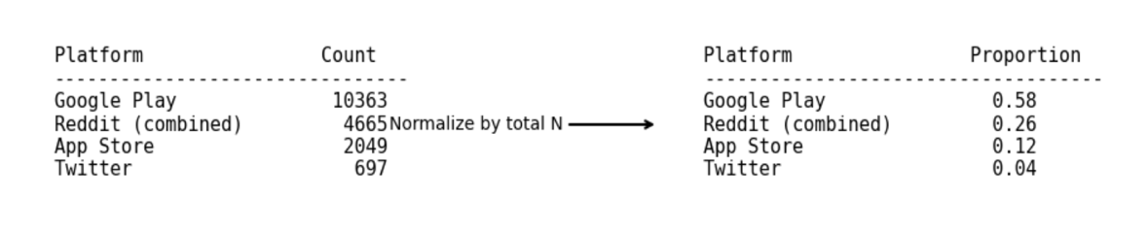Fig1
This shared window provides the only unbiased cross-platform comparison. Although short, platform proportions tend to be stable, making this acceptable for weighting.

Filtering to Gamification-Related Comments
After platform ratios were determined, raw comments were filtered to include only comments referencing gamification features, using a comprehensive keyword dictionary (Section 3.2).
Filtering is performed before sampling to ensure that: (1) sampling reflects the distribution of gamification-related discourse (2) rarer features are not underrepresented (3) irrelevant comments do not dominate the sample

Sampling
From the filtered dataset, N = 3,000 comments were drawn in proportion to platform weights: 1,740 Google Play & 780 Reddit & 360 App Store & 120 Twitter
This preserves representativeness of the multi-platform user population.

2.2 Gamification Feature Identification

Keyword Dictionaries
Gamification features were identified using curated keyword dictionaries covering eight major categories used in Duolingo’s most modern version:
- Streak: “streak,” “streak freeze,” …
- Hearts: “hearts,” “lives,” …
- Energy: “energy,” “energy refill,” …
- XP System: “xp,” “level up,” …
- Leaderboards: “league,” “rank,” …
- Chess: “chess,” …
- Quests: “quest,” “daily quest,” “friend quest,” “milestone,” …
- Rewards: “gems,” “coins,” “treasure chest,” …
The Energy system, introduced in 2025 as the planned replacement for Hearts, gives learners 25 daily Energy units that decrease with each answer (1–2 units) and can be replenished through streaks of correct responses. Unlike Hearts, Energy cannot be turned off even by paid subscribers, and its restrictive, consumption-based design generated substantial user discussion during testing.
Duolingo Chess, one of the platform’s newest non-language courses (after Math and Music), teaches beginner players chess fundamentals through theory lessons, best-move puzzles, and match simulations, with the goal of helping learners reach an Elo of roughly 1500. Its novelty and unexpected addition to the app prompted notable user reactions.

Keyword Validity Checks
To ensure accurate feature identification: (1) Regex boundaries prevented substring contamination (e.g., “xp” in “expensive,” “quest” in “request). (2) Manually reviewed exceptions addressed metaphorical uses (e.g., “heart” as emotion).
This minimizes false-positive feature detections.

Feature Engineering: feat_energy_vs_heart
Many comments are found to be negative towards the transition from heart system to energy system. A binary variable feat_energy_vs_heart was created to capture comments explicitly comparing the Energy system to Hearts (e.g., “Energy is worse than Hearts,” “Bring back Hearts”). Such comments typically express negative sentiment about the transition, not negative sentiment toward feature itself. This prevents the regression from mistakenly interpreting comparison-driven negativity as dissatisfaction with both features.

2.3 Sentiment Labeling

Manual Gold Standard: 597 Labels
The dataset includes 597 manually annotated comments (Fig 2):
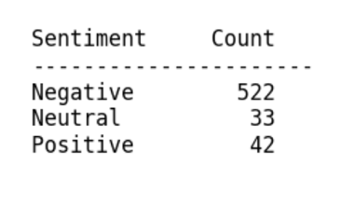Fig 2

LLM-Assisted Labeling (50-row batching)
ChatGPT was applied in 50-row batches, which empirically produced human-like sentiment reasoning. Large-batch attempts were tested but inconsistent.

Mislabel Evaluation Against Manual Labels
Comparison yielded the following confusion counts (Fig 3):
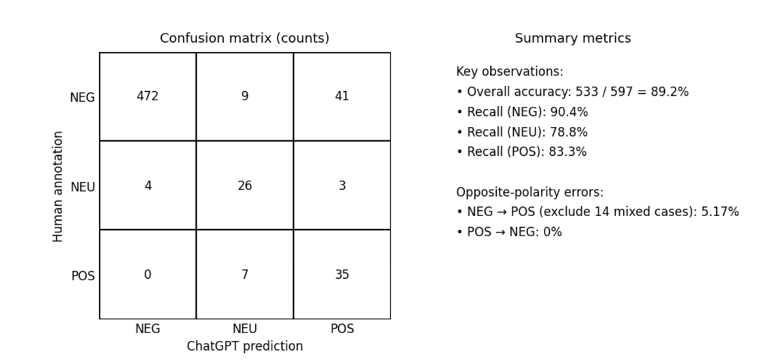Fig 3
The model never flips positive to negative, and true polarity reversals are extremely rare. Most disagreements reflect softening (NEG → NEU & mixed cases which mix positive and negative feelings around half vs half), which affects only the intercept, not slopes.
Because logistic regression is robust to low-level symmetric noise, and catastrophic polarity reversals are almost nonexistent, this labeling method is validated for analytical use.
Neutral labels were removed for binary modeling.

Final Analytical Dataset Construction
The final dataset (N = 1,788) includes: binary sentiment label, eight feature indicators, feat_energy_vs_heart, platform controls, time controls and text-length control
Platform Controls: Platform controls adjust for systematic differences in tone and writing style across platforms. Reddit tends to be more expressive or humorous; app store reviews tend to be shorter and more polarized. Controlling for these baselines ensures that coefficients measure feature sentiment, not platform behavior.
Comment-Length Control: Comment length is a known confounder in sentiment analysis: longer comments tend to include explanations, complaints, or nuance, and are disproportionately negative. Including comment length as a continuous control variable removes bias arising from verbosity differences across platforms or features.
Time Control: Time controls are standard in empirical research to absorb temporal sentiment shocks (e.g., Energy rollout). Although the dataset spans only several months, including time controls increases internal validity with minimal modeling cost.

3. ANALYSIS

3.1 Logistic Regression Model
A logistic regression was fitted with positive sentiment as the dependent variable (Fig4).
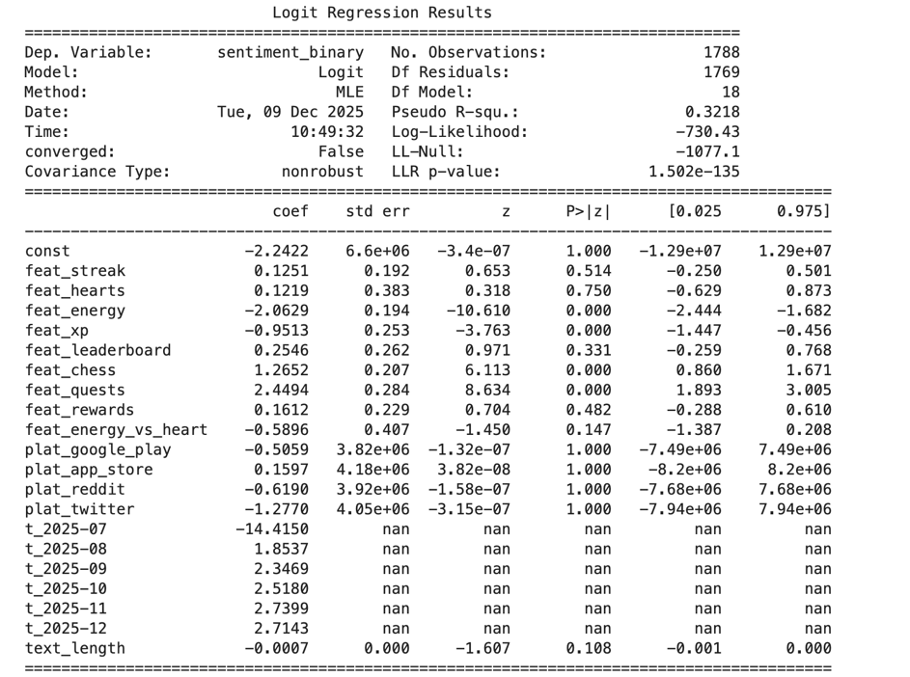Fig 4
The model achieved a pseudo-R² of 0.3218, indicating substantial explanatory power given the inherent noise of user-generated text.

3.2 Key Findings
(1) Quests Are Strongly Associated with Positive Sentiment (β = +2.449, p < 0.001)
(2) Chess Mode Generates Strong Positive Reception (β = +1.265, p < 0.001)
(3) The Energy System Is Strongly Disliked (β = −2.063, p < 0.001)
(4) XP-Related Comments Are Associated with Negative Sentiment (β = −0.951, p < 0.001)

Impact of Label Noise on Model Validity
Using the empirically observed 5.17% opposite-polarity mislabel rate, standard error propagation suggests approximately 10% coefficient shrinkage without sign changes. Because: (1) energy, xp, chess, and quests have large coefficients, (2) none of the positive comments were ever misclassified as negative, and (3) negative comments were rarely misclassified as positive,
all four major findings remain statistically and substantively robust.
Neutral mislabeling primarily affects the intercept rather than feature slopes, and therefore does not alter substantive conclusions.

3.4 Deeper Analysis of the Four Major Feature-Level Findings
(1) Energy: The sentiment patterns found in this study are further contextualized by comparing external commentary. According to Jay Peter's article, Duolingo's design aims to prevent cognitive overload, promote spaced repetition, and encourage better learning practices by framing energy as an education tool (Peter, 2025). In contrast, Sam Liberty's article represents the opposing viewpoints and describes the same mechanism as a monetization-driven, restrictive restriction that disrupts the learning process and is similar to predatory mobile-game strategies (Liberty, 2025). According to our analysis, actual user sentiment is more in line with external criticisms that highlight frustration and limitations than with the positive framing provided by designers and supportive commentators.
(2) Chess Mode: A similar pattern emerges in public discourse on Duolingo Chess, where one presents Duolingo Chess as an accessible, inviting medium with ease of use and motivational design elements (Greenberg, 2025), the other argues that Duolingo Chess offers minimal instructional depth beyond the beginner stage, citing the absence of analytical tools and limited puzzle variety (Rosales, 2025). Overall, the user-generated sentiment indicates that Duolingo’s new chess feature has effectively attracted and motivated the early-stage learners.
(3) XP system: The regression results indicates that XP references reliably predict more negative emotional responses. User comments suggest two dominant sources of dissatisfaction. First, many users report that XP introduces pressure that distorts the underlying learning goal. For example, one user noted that they “force [themselves] through new lessons without revising just to get XP and maintain [their] rank.” Second, users raised concerns about technical inconsistency, such as receiving “3x XP but not getting it the next day,” which further erodes trust in the system.
(4) Quests: In contrast, quests exhibit the strongest positive association with user sentiment among all features analyzed. Qualitative evidence from user comments explains this effect: quests are consistently described as motivating, enjoyable, and conducive to sustained engagement. Users highlight that “friend quests (and leaderboards) keep it interesting” and that daily quests provide “a great way to set yourself challenges.” Rather than imposing pressure, quests supply structure and purpose, offering attainable goals that support, which stands in contrast to the XP system, which many users describe as engendering obligation rather than motivation. The divergence between the two features may align with psychological distinctions between extrinsic pressure and goal-oriented challenge.

4. Conclusion
This study provides a feature-level analysis of user sentiment toward gamification mechanics in Duolingo, using large-scale social media data across multiple platforms. Unlike prior research that evaluates gamification as a unified construct, this approach demonstrates that individual mechanics elicit distinct and sometimes opposing emotional responses. Quests and the Chess mode generate strongly positive sentiment, suggesting that optional, goal-oriented, and mastery-supportive mechanics enhance user motivation. In contrast, the Energy system and XP mechanics are associated with significant negative sentiment, reflecting perceptions of restriction, pressure, and technical inconsistency. These findings highlight a mismatch between designers’ intentions and users’ lived experiences, particularly for mechanics that limit learning autonomy or appear tied to monetization.
Methodologically, the study shows the value of social media data for examining real-world reactions to gamified systems, complementing traditional experimental and classroom-based research. Practically, the results suggest that stakeholders should prioritize mechanics that support challenge, autonomy, and continuity of learning, while re-evaluating mechanics that impose constraints or disrupt learning flow. More broadly, the feature-level perspective used here offers a model for evaluating complex gamified ecosystems and underscores the importance of aligning design intentions with user experience.

References
Deterding, S., Dixon, D., Khaled, R., & Nacke, L. (2011). From game design elements to gamefulness: Defining gamification. CHI.
https://dl.acm.org/doi/10.1145/1979742.1979575
Hamari, J., Koivisto, J., & Sarsa, H. (2014). Does gamification work?—A literature review. HICSS.
https://ieeexplore.ieee.org/document/6758978
Sailer, M., & Homner, L. (2020). The gamification of learning: A meta-analysis. Educational Psychology Review.
https://link.springer.com/article/10.1007/s10648-019-09498-w
Seaborn, K., & Fels, D. (2015). Gamification in theory and action: A survey. International Journal of Human–Computer Studies.
https://www.sciencedirect.com/science/article/pii/S1071581914001160
Peters, J. (2025). Duolingo is Replacing Hearts with Energy. The Verge.
https://www.theverge.com/news/665315/duolingo-hearts-energy-system
Liberty, S. (2025). How Duolingo’s New Energy System is Failing its Users. Medium.
Greenberg, J. (2025). I Can’t Stop Playing Duolingo Chess. Wired.
https://www.wired.com/story/duolingo-chess/
Rosales, D. (2025). Duolingo’s Chess Course is Useless for Non-Beginners: My Honest Review.
https://davidwilliamrosales.com/2025/08/18/duolingo-chess-review/

