**Student Information**

**Management System**

A

Project Proposal Presented to

Isabela State University- Echague Campus at

College of Computing Studies Information and Communication Technology

**Submitted by:**

Aspiras, Carlo John

Calderon, Kathleen May

Dela Cruz, Jedidiah Andrei

Gutierrez, Ara

Ramirez, Ian Cedric

Valdez, Carl Xavier

**Submitted to:**

**PROFESSOR DARIOS ALADO**

**Table of Contents**

|  |  |
| --- | --- |
|  | **Page Number** |
| **Title page** | **1** |
| **Table of contents** | **2-3** |
| **CHAPTER I** | **4-7** |
| **Introduction** | **4** |
| * 1. **Project Context** | **4** |
| **1.2 Project Highlights** | **5** |
| **1.3 Objectives of the Project** | **5** |
| **1.3.1 Test the following System’s Functionality** | **5** |
| **1.3.2 Test the compatibility of the system using the Operating System:** | **5** |
| **1.3.3 Evaluate the system using Software Product Quality (ISO 25010) as perceived by user’s acceptability with respect to:** | **5-6** |
| **1.5 Scope and Limitation** | **6-7** |
| **Definition of Terms** | **7** |
| **CHAPTER II** | **8-11** |
| **Review Of Related Literature** | **8** |
| **2.1 Related Literature** | **8-9** |
| **Related Studies** | **9-10** |
| **Synthesis** | **10-11** |
| **CHAPTER III** | **12-13** |
| **Technical Background** | **12** |
| **3.1 Technicalities of the Project** | **12-13** |
| **3.2 Details of the Technology to be Used** | **13** |
| **CHAPTER IV** | **14-40** |
| **Methodology** | **14** |
| **Phases** | **14** |
| **Analysis and Quick Design** | **14** |
| **Build Prototypes** | **14-15** |
| **Testing** | **15** |
| **Implementation** | **15** |
| **4.1. Environment** | **15** |
| **4.1.1. Locale of the Study** | **15** |
| **4.1.2 Population of the Study** | **15** |
| **1.3 Organizational Chart** | **16** |
| **4.2 Requirement Specification** | **16** |
| **4.2.1 Operational Feasibility** | **16** |
| **4.2.1.1 Fishbone Diagram** | **16** |
| **4.2.2 Functional Decomposition Diagram** | **17** |
| **4.2.3 Technical Feasibility** | **18** |
| **4.2.4 Gant Chart** | **18** |
| **4.3 Requirements Modeling** | **19** |
| **4.3.1 Input Process Output Diagram** | **19** |
| **4.3.2 Control** | **20** |
| **4.4 Data and Process Modeling** | **20** |
| **4.4.1 Context Diagram** | **20** |
| **4.4.2 Data Flow Diagram** | **21** |
| **4.5 Analysis** | **22** |
| **4.5.1 Cost Benefit Analysis** | **22** |
| **4.5.2Risk Assessment Analysis** | **22-23** |
| **4.6 Design** | **24** |
| **4.6.1 Wireframes** | **24-29** |
| **4.7 Data Design** | **30** |
| **4.7.1 Entity Relationship Diagram** | **30** |
| **4.7.2 Data Dictionary** | **31-35** |
| **4.7.3 System Architecture** | **35** |
| **4.8 Development** | **36** |
| **4.8.1 Hardware Specification** | **36** |
| **4.8.2 Software Specification** | **36** |
| **4.8.3 Program Specification** | **37** |
| **4.8.4 Programming Environment** | **37-38** |
| **4.8.5 Development Diagram** | **38** |
| **4.8.6 Testing** | **38** |
| **Compatibility Testing** | **38** |
| **4.9 System Architecture** | **39** |
| **4.9.1 Network Model** | **39** |
| **4.9.2 Star Topology** | **39** |
| **4.10 Evaluation** | **39-40** |

**CHAPTER 1**

**INTRODUCTION**

* 1. **Project Context**

The Network-Based Application for a specific College Course of Isabela State University Echague Campus is a project intended for Bachelor of Science in Computer Science. The project focuses on the Gathering, Reviewing, Archiving, and Updating data for the target of the project to cater the different transactions of the Department. These transactions are comprising of gathering of student basic data, subjects enrolled, student’s activities like awards, webinars/ conference, contest and student’s past researches.

Bachelor of Science in Computer Science, Program Chair experience the following problems in the current system is it was a Network-based system; No Network-Based System of the freshman of the course; Difficult of accessing in real-time activity of the students. Also, the Application will act as newsfeed for the changes for an accurate information to students whom have difficulty in contacting their professor/s. The Program Chair uses the Network-Based System for the repository of the student’s subject and the future researches that a student has taken; for announcing schedules of enrolment or change to their subject Messenger App is used; late announcement due to poor internet connections are one major problem she encounters.

In order to solve the current problems Bachelor of Science in Computer Science Course, the proponent will design and develop Network-Based Application to monitor and inform students and professors in the College Course. Using the system, the data will be analyzed automatically by the system in a tabular format. The data are now organized and records of the different rates are stored in the Database of the system.

* 1. **Project Highlights**
* Manage Profile
* Subjects Enrolled for the Student and Professor Involved
* Manage Student’s Research Repository (Title and Abstract only)
* Manage Student’s Subjects
* Manage Student Activities
* Awards
* Webinars/ Conferences
* Competition/Contest

**1.3 Objectives of the Project**

This project aims to design and develop a Bachelor of Science in Computer Science Network-Based Application specifically the proponent aims to:

**1.3.1 Test the following System’s Functionality;**

* Profile of Students of Bachelor of Science in Computer Science.
* Report using a tabular and graphical presentation of data.
* Manage Students Profiles and Activities
* Manage Students Subjects
* Manage Students Researches

**1.3.2 Test the compatibility of the system using the Operating System:**

* Computer/Laptop
* Windows 8,10,11

**1.3.3 Evaluate the system using Software Product Quality (ISO 25010) as perceived by user’s acceptability with respect to:**

* Functionality
* Usability
* Reliability

**1.5 Scope and Limitations of the Project**

The system will have three types of user, the first user is the administrator which is the Program Chair he/she oversees the whole system. The Administrator manages the user account of the would-be-users, where administrator can add, edit, delete and view user accounts as administrator. Followed by the president and vice president of every section, which is the sub-administrator. And last type of user are the students. The system is capable to Manage Students’ Records such as the following, first is the student manage profile in which the system is capable to collect the basic information of the student’s including the name, address, contacts, and scholarship grant, device. It also includes the subjects enrolled for every students and professors involved. The system is capable to Manage Student Activities wherein the system is capable to track the different contested activities, who are the following students are willing to join and update the award that given to the students. It also include the update of the different webinars that related to the course. And under the Manage Student Research Repository, the system is capable to store and retrieve student’s researches base by the titles and the abstracts. The other set of users of the system is the class president and vice president account wherein the user is capable to manage student information of their section. Wherein the president can update student’s information, update student’s activities. And the third user are the students that can view and recommend some alteration on their data or information.

The System will be developed using Adobe XD as the interface prototyping of the user to the system. The System will be developed using PHP, HTML and CSS as the interface of the user to the system. The database of the system is MySQL server as the repository of data. It is a network-based system that will used two layer of architecture application layer and data layer.

The System is a Network-Based System. It means that is accessible using a Kiosk, personal computers.

**Definition of Terms**

**Adobe XD** is a powerful and easy-to-use vector-based experience design platform that gives teams the tools they need to craft the world’s best experiences collaboratively.

**Application layer** is an abstraction layer that specifies the shared protocols and interface methods used by hosts in a communications network.

**Database** is an organized collection of structured information, or data, typically stored electronically in a computer system. A database is usually controlled by a database management system (DBMS).

**Data layer** is the layer for collecting and managing the data that gets produced.

**Network-Based Application** is any application running on one host providing communication to another application running on a different host.

**Repository** is a central pace in which an aggregation of data is kept and maintained in an organized way, usually in computer storage.

**CHAPTER II**

**REVIEW OF RELATED LITERATURE**

**2.1 Related Literature**

The Program Chair of Bachelor of Science in Computer Science is in charge of keeping and storing basic information of the students, previous researches, and awards given to students from competition attended, and certificates from seminars or webinars attended by students. These information of the students are important to the future references. The information generated by the system such as name, address, contacts, researches, awards, competition and conferences are the information needed to develop a Network-Based Application.

According to techopedia, Web Based Application is any program that is accessed over a network connection using HTTP, rather than existing within a device’s memory. Web-based applications often run inside a web browser. However, web-based Applications also may be client-based, where a small part of the program is downloaded to a user’s desktop, but processing is done over the internet on an external server.

<https://www.techopedia.com/definition/26002/web-based-application>

Kamau, 2021, stated that Network Applications enable people or even computers to communicate within a network. These applications use a client-server architecture, where the client and server are two computers connected to the network. The server is programmed to provide some service to the client. The client is just a desktop, laptop or portable device like a smartphone. The server can be any of these, but in most cases, it is a computer in a data center running some specialized software. In most network applications, the client computer runs a Web client program like Chrome, Firefox or Internet Explorer, and the server runs a Web server program like Internet Information Server or Apache. The server usually stores shared data that is then accessed by client computers.

<https://turbofuture.com/computers/Network-Application>

Network application is any application running on one host providing communication to another application running on a different host. Network applications allows network operators to easily manage and monitor network traffic as well as analyse data that can be used to improve network systems. Network Application are created for a variety of purpose. They can have advanced analytics that enable real-time decision making for networks or be created to support operations of complex networking environments with discovery, monitoring and troubleshooting.

<https://www.cengn.ca/services/commercialization-services/cengn-project-areas/network-applications/>

**Related Studies**

The system is anchored on the studies of Cantos M.C.G, et.al 2017 about Mobile Web-Based Student Integrated Information System is now a facility which universities and colleges use to manage the records of their students. The convenience of accessing the educational resources online makes the programs ideal for working professionals and students alike. The system was developed to help the students check their academic result every end of the semester, make self-enlistment that would assist the students to manage their academic status that can be viewed in their mobile phone.

In today’s fast-paced and technology-driven community, quality education with essential systems being used is a necessity. Hence, Manuel S. Enverga University Foundation, Lucena City, Philippines has already an existing online student information portal in which students can only view their grades that can be accessed only through intranet. With this, the researchers looked into the workability of developing a mobile web-based student integrated information system that would give students an easy and speedy access through internet technology and use of mobile phones to a range of handy and important information about their school activities, program curriculum, enlistment and grades.

. In education, ICT has the ability to make change possible that at some point or another may touch teaching methodologies and strategies and the student‘s approaches to learning as well. And through ICT, information, ideas and experiences from an array of diverse people, societies and beliefs can be accessed so easily and rapidly. As stressed by Danner and Pessu, education is the paramount key area for ICT; and it helps improve students ‘learning by using modern ICTs in the form of wireless networks, internet, search engines, databases and websites

And also the system is anchored on the studies of Comendador, B.E. and Vera, M.C.S 2016 about A Web-based Student Support Services System Integrating Short Message Service Application Programming Interface is a two-way communication between students, faculty and other stakeholders. It aims to keep in contact with students and deliver significant information arising from the University using the system’s SMS facility offering auto-reply feature.

And the system is also anchored on the studies of Aljraiwi, S.S., 2016, about the web application-based learning environment to promote teaching and learning activities in the classroom, it helps teachers facilitate learners’ contribution in the process of learning and improving their motivation and performance. It provides teachers and learners with an effective support in managing and guiding the educational activities inside and outside the classroom.

**Synthesis**

College Program Chair is the one who interact with the student before it was proceed to the higher up. They are the one who collects the important data. And as a Program Chair, they have a lot of things to do. So to lessen their work, they ask the class president and vice president to do some of the simple task. Recording of the important documents of the students is important to be done systematically for better and efficiency service. The Studies above shows the help of Network Based Application to many institution on gathering some data of the students especially storing it for the future use.

Network Based Application will be a means to help the professor to store and manage the data. It will be helpful to monitor the student and it can be efficient to the professors to use the past data and information about the students. The System will be helpful for the Program Chair, the president and Vice President and the students for the checking and updating the information.

**Chapter III**

**TECHNICAL BACKGROUND**

This chapter describes the technicalities of the project, details of technology to be used, and how the project work.

**3.1 Technicalities of the Project**

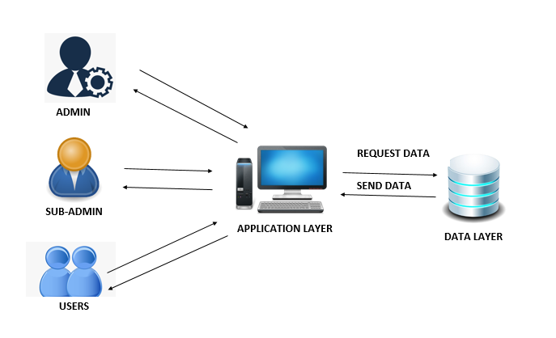

***Figure 1. Project Framework***

Figure 1 show the Project Framework of the System

**3.2 Details of the Technology to be used**

**Visual Studio Code-** is a code editor with support for development operations like debugging, task running, and version control. Use it to code in any programming language, without switching editors. Visual Studio Code has support for many languages, including Python, Java, C++, JavaScript, and more. It aims to provide just the tools a developer for a quick-build-debug cycle and leave more complex workflows fuller featured IDEs, such as Visual Studio IDE.

**MySQL –** is free and open source software under the terms of the GNU (General Public License, and is also available under a variety of propriety licenses. MySQL was owned and sponsored by the Swedish company MySQL AB, which was bought by Sun Microsystem (now Oracle Corporation). In 2010, when Oracle acquired Sun, Widenius forked the open-source MySQL Project to create MariaDB.

**Adobe XD –** is a powerful and easy-to-use vector-based experience design platform that gives teams the tools they need to craft the world’s best experiences collaboratively. Adobe XD helps to craft prototypes that look and feel like the real thing, so you can communicate your design vision and maintain alignment across your team efficiently.

**Adobe Photoshop-** is software that is extremely used for raster image editing, graphic design and digital art. It makes use of layering to allow for depth and flexibility in the design and editing process, as well as provide powerful editing tools, that when combined, are capable of just about anything.

**Adobe Illustrator-** is the industry standard design app that lets you capture your creative vision with shapes, color, effects, and topography. It is used to create a variety of digital and printed images, including cartoons, charts, diagrams, graphs, logos, and illustrations. Illustrator allows a user to import a photograph and use it as a guide to trace an object in the photograph.

**Gitkraken-** it is a powerful and elegant multiplatform graphical interface for Git developed by Axosoft, as an alternative to command line. In a simple way, we can keep a complete track of our repositories, see branches, tags, and create new, all the history of our work, commits and so on.

**XAMPP-** is an abbreviation for cross-platform, Apache, MySQL, PHP and Perl, and it allows you to build WordPress site offline, on a local web server on your computer. This simple and lightweight solution works on Windows, Linux, and Mac- hence the “cross-platform’ part.

**3.3 How the Project will Work**

The system uses Local Area Network where different users are connected with each other. The network is consisted of a server handled by the Administrator which is the Program Chair. The President or Vice president used another workstation where the application system can be accessed.

The system was designed using Visual Studio Code as the front end of the system and MySQL as the back end of the system.

**Chapter IV**

**METHODOLOGY**

This chapter the researchers will discuss the application to be used who will be the user and respondent, where is the system deployment and start the following functionalities of the system by using Diagrams, Data process, Network Model, Network topology, Analysis, Development and Design Fishbone Diagram.

The researchers used the Rapid Application Development (RAD). A type of software development methodology that uses minimal planning in favour of rapid prototyping.

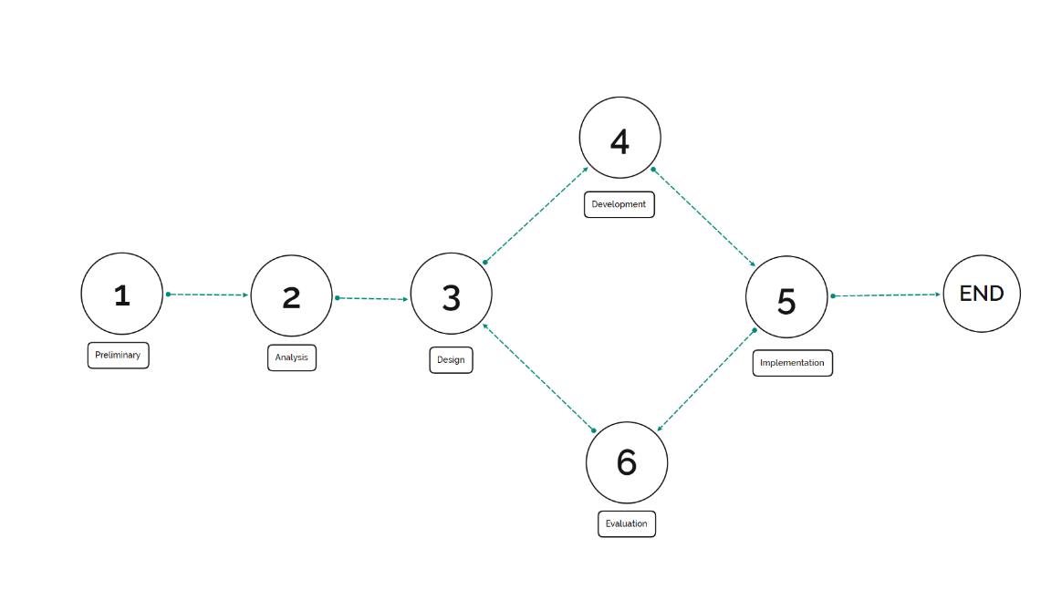

**Figure 1 shows the Rapid Application Development**

**Phases**

**Analysis and Quick Design**

* Conduct series of Interview to the Program Chair via Google Meet
* Gather information from the program chair
* Identify Functionality of the proposed system
* Construct blueprint of the system

**Build Prototypes**

* Build the prototype using Adobe XD based on the identified functionality
* Present the initial phase of the interface to the respondents
* Integrate suggestions and revisions in the prototype
* The process is repeated for refinement

**Testing**

* Pilot testing the system in the office of the Program Chair
* Test the different functionality of the system
* Record Feedback from the Program Chair
* Integrate the Feedback to the System
* Final test the system

**Implementation**

* User training
* Network Configuration
* Database population
* System Turnover

**4.1. Environment**

**4.1.1. Locale of the Study**

The researchers will be conducted the study at Isabela State University Echague Campus, San Fabian, Echague, Isabela. According to the Program Chair of the Bachelor of Science in Computer Science the current population BSCS student is

**4.1.2 Population of the Study**

The respondents of the study are consisted of the following: BSCS Program Chair, BSCS Presidents and Vice Presidents in the Isabela State University Echague Campus.

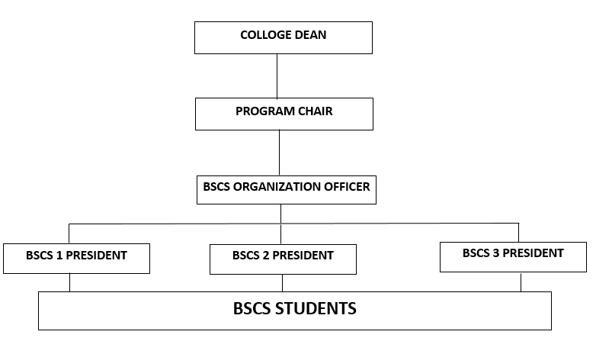**4.1.3 Organizational Chart**

*Figure 2. Organizational Chart*

Figure 2 shows the organizational chart of the system. The program chair manage the BSCS program, she collect data from the student and compiles the data.

**4.2 Requirement Specification**

**4.2.1 Operational Feasibility**

**4.2.1.1 Fishbone Diagram**

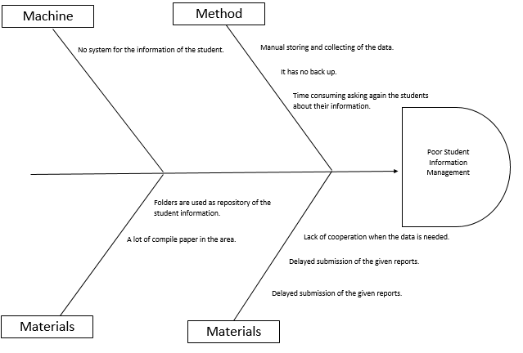

*Figure 4. Fishbone Diagram*

Figure 4 shows the Fishbone diagram that identifies the causes of the problems.

**4.2.2 Functional Decomposition Diagram**

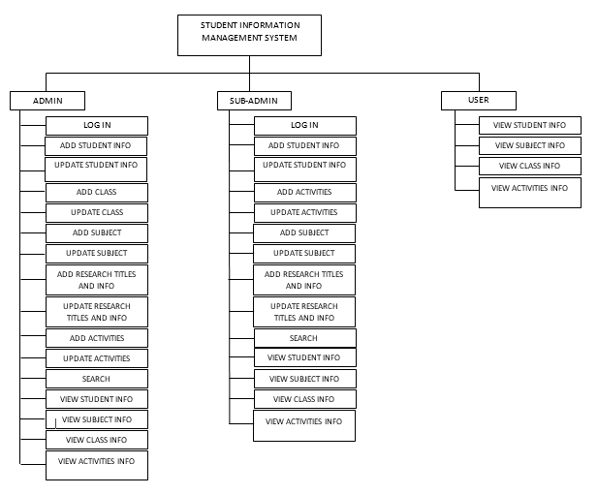

*Figure 4. Functional Decomposition Diagram*

Figure 4 shows the Functional Decomposition Diagram of the proposed system. The diagram shows the three (3) users of the system. The Admin or the Program Chair can login and manage Student info, Research, Subjects and Activities. The Sub-Admin can also login and manage student info, subject and research. The user can browse the previous research, their subjects, activities, and the class.

**4.2.3 Technical Feasibility**

**4.2.4 Gant Chart**

The Gantt chart below serves as the guide for the proponents in doing the project and to determine the activities involved meet the project deadline.

|  |  |  |  |  |  |  |  |  |  |  |  |  |  |  |  |  |  |  |
| --- | --- | --- | --- | --- | --- | --- | --- | --- | --- | --- | --- | --- | --- | --- | --- | --- | --- | --- |
|  | W1 | W2 | W3 | W4 | W5 | W6 | W7 | W8 | W9 | W10 | W 11 | W 12 | W 13 | W 14 | W  15 | W 16 | W  17 | W  18 |
| A.  Preliminary |  |  |  |  |  |  |  |  |  |  |  |  |  |  |  |  |  |  |
| B.  Analysis |  |  |  |  |  |  |  |  |  |  |  |  |  |  |  |  |  |  |
| C.  Design |  |  |  |  |  |  |  |  |  |  |  |  |  |  |  |  |  |  |
| D. Development |  |  |  |  |  |  |  |  |  |  |  |  |  |  |  |  |  |  |
| E. Implementation |  |  |  |  |  |  |  |  |  |  |  |  |  |  |  |  |  |  |
| F. Evaluation |  |  |  |  |  |  |  |  |  |  |  |  |  |  |  |  |  |  |

***Table 1.*** *Gantt chart*

The table shows the deliverables and the duration of the system, the deliverables contain the following: Preliminary, Analysis, Design, Development, Implementation, and Evaluation.

**4.3 Requirements Modeling**

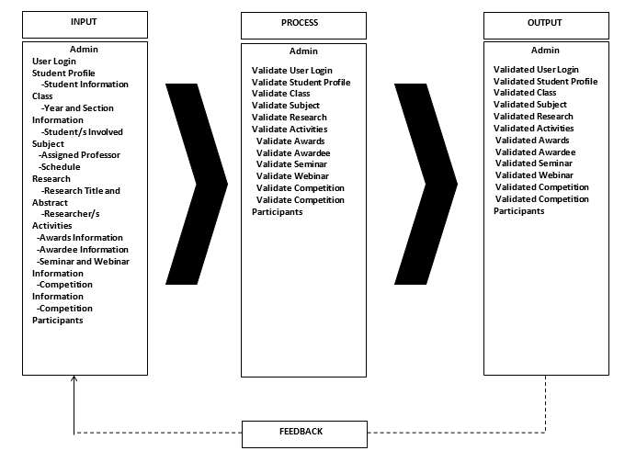**4.3.1 Input Process Output Diagram**

*Figure 5. Input-Process-Output Model*

Figure 5 shows the Input-Process-Output Diagram. The Input Box contains information about the data that will be inputted by the administrator of the system. The Process Box contains information to be validate by the system to produce an output. The Output Box contains the validated information for the administrator.

**4.3.2 Control**

Security control is important requirement of the user or client in order to protect the system from illegal access. The system provides security to ensure that the admin, sub-admin and the user can use the system.

**4.4 Data and Process Modeling**

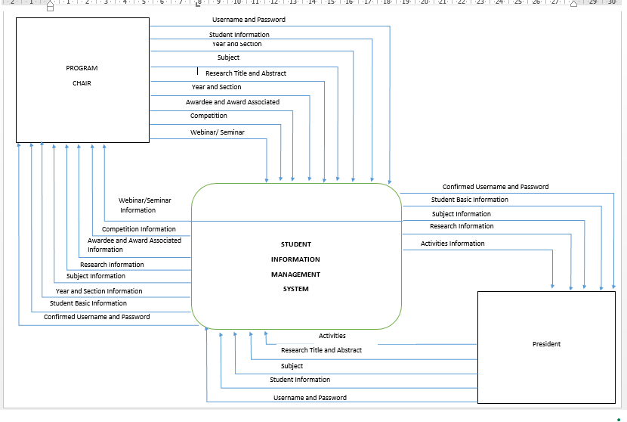**4.4.1 Context Diagram**

*Figure 6.Context Diagram*

The figure 6 Context Data Flow diagram showing the admin or the Program chair and its functionality in the system.

**4.4.2 Data Flow Diagram**

The researchers used Data Flow Diagram to identify the flow of the system

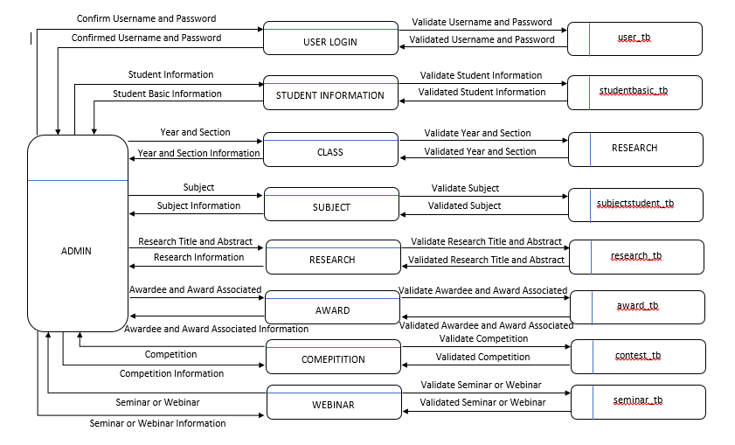

*Figure 7. Zero Diagram of the Admin*

The figure 7 shows the Zero Diagram of the admin depicting the different functionality represented by the process box. All functionality are stored in their corresponding tables in the database.

**4.5 Analysis**

**4.5.1 Cost Benefit Analysis**

**Table 2. Cost Benefit Analysis**

|  |  |
| --- | --- |
| **Hardware (based on the hardware assumed)** | **Amount** |
| Intel Pentium / AMD A8 (Dual/Quad Core) | 3,000 |
| H110m / A320 Mobo | 2,000 |
| 4gb DDR3 RAM 1333mhz | 500 |
| Toshiba 500GB SATA 3 | 1,600 |
| Mid Tower Case | 400 |
| AOC 18.5 LED Monitor | 2,000 |
| AVR 500watts | 200 |
| Limeide Mouse and Keyboard Set | 300 |
| **Total Hardware Cost** | 10,000 |
|  |  |
| Software (based on the hardware assumed) |  |
| Windows 10 | Free |
| XAMPP | Free |
| Browser | Free |

**Table 3. Development Cost**

|  |  |
| --- | --- |
| **Development Cost** |  |
| Electricity | 5,000 |
| No. of Development | 2 |

The table above shows all the expenses under the development of the system.

**4.5.2Risk Assessment Analysis**

**Table 4.** Risk Assessment Analysis

|  |  |  |  |  |  |  |  |  |  |  |  |  |
| --- | --- | --- | --- | --- | --- | --- | --- | --- | --- | --- | --- | --- |
| **Risk** | |  |  | **Value** | **Mitigation** |  |  | **Value** | **Contingency** | **Probability** |  |  |
| People | | | | | | | | | | | | |
| 1. Project team may not be knowledgeable enough. | Team may not know some things with regards t developing the project | 1 | L | 20 | Develop skill through researching, watching, tutorial and downloading available materials on the web | 2 | L | 40 | Improve skill through researching, watching, tutorial, and downloading available materials on the web. | 1 | IN | 20 |
| System | | | | | | | | | | | | |
| 1.System Malfunction | System may not work properly | 2 | L | 40 | Consistent checking of the system condition | 2 | L | 40 | Back-up files regularly.  Monitor device performances | 3 | M | 60 |
| 1.System Malfunction | System may not work properly | 2 | L | 40 | Consistent checking of the system condition | 2 | L | 40 | Back-up files regularly.  Monitor device performances | 3 | M | 60 |
| 2. Database | Corrupted Database | 3 | M | 60 | Consistent checking of the system condition | 2 | L | 40 | Back-up files regularly.  Monitor device performances | 2 | L | 40 |
| Customer | | | | | | | | | | | | |
| 1.Cooperating Agency changes requirements | The agency may add or eliminate some requirements | 2 | L | 40 | Adjust requirements according to customers need. | 2 | L | 40 | Eliminate some requirements | 1 | IN | 20 |

Table 5 shows the Risk Analysis of the system. The proponent been anticipating risk coming for the development and implementation to prevent or lessen future problems. The proponents anticipated risk that would probably come along the way. Strategies were formulated.

**4.6 Design**

**4.6.1 Wireframes**

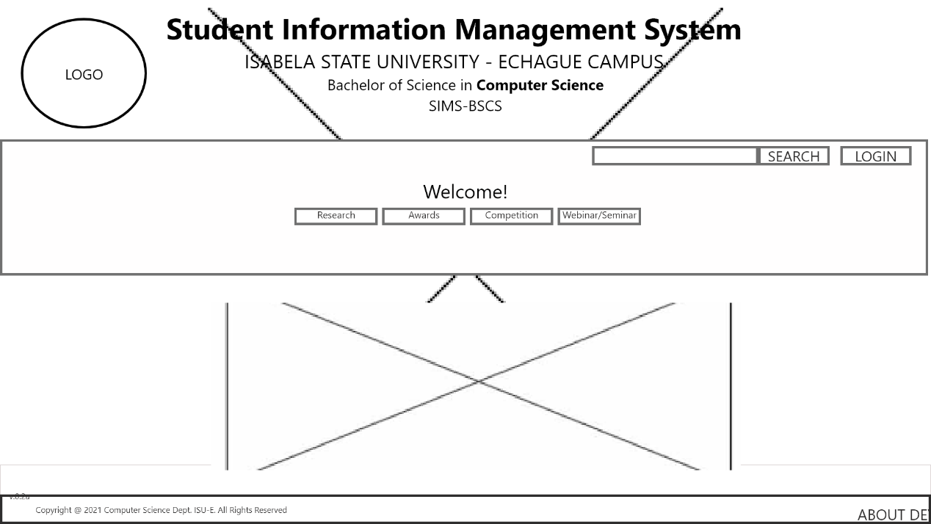**4.6.1.1 Administrators side**

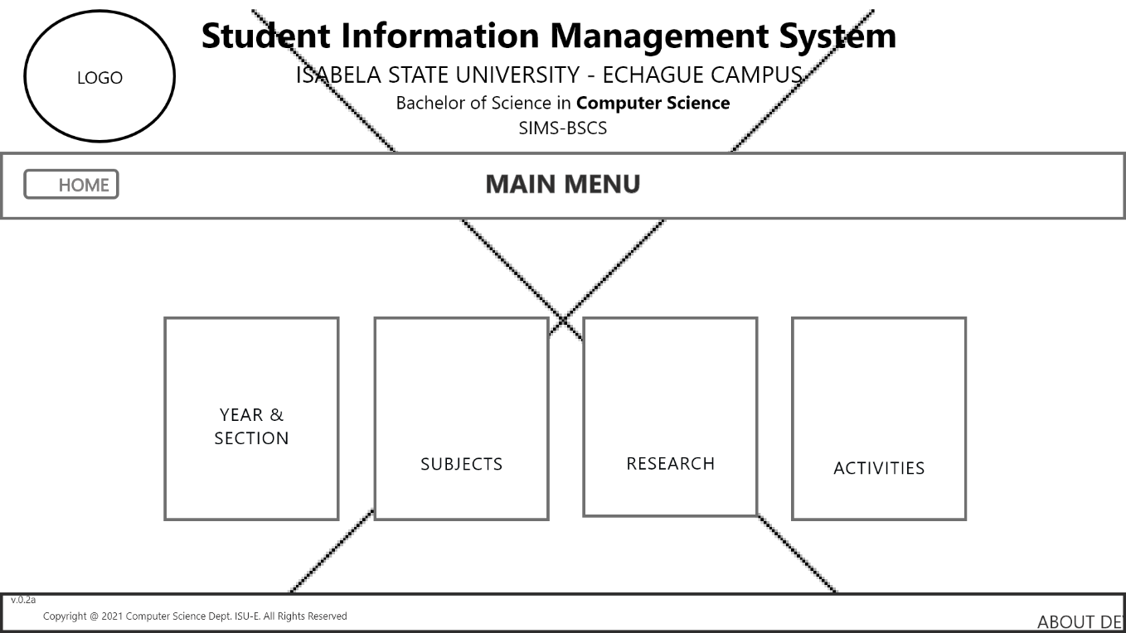

*Figure 8. Home Page*

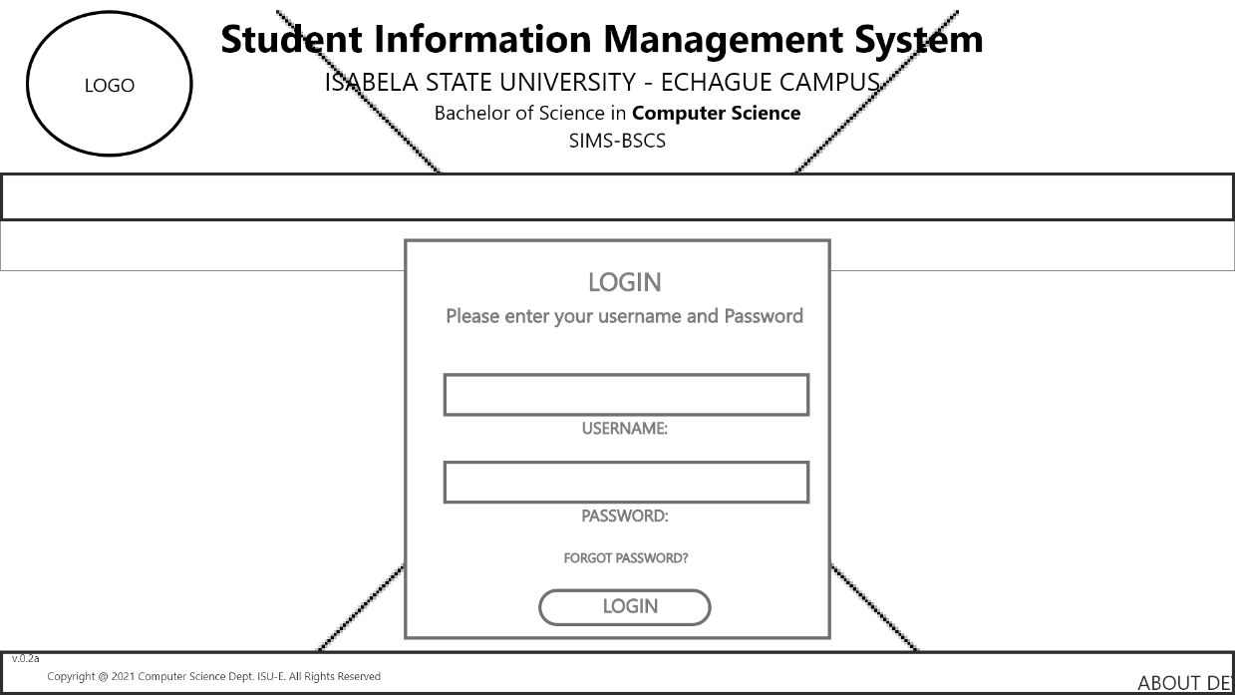 The figure 8 shows the Home page of the Administrator, she can access the Student info, manage subjects, manage research repository and manage student activities.

*Figure 9. Login Interface*

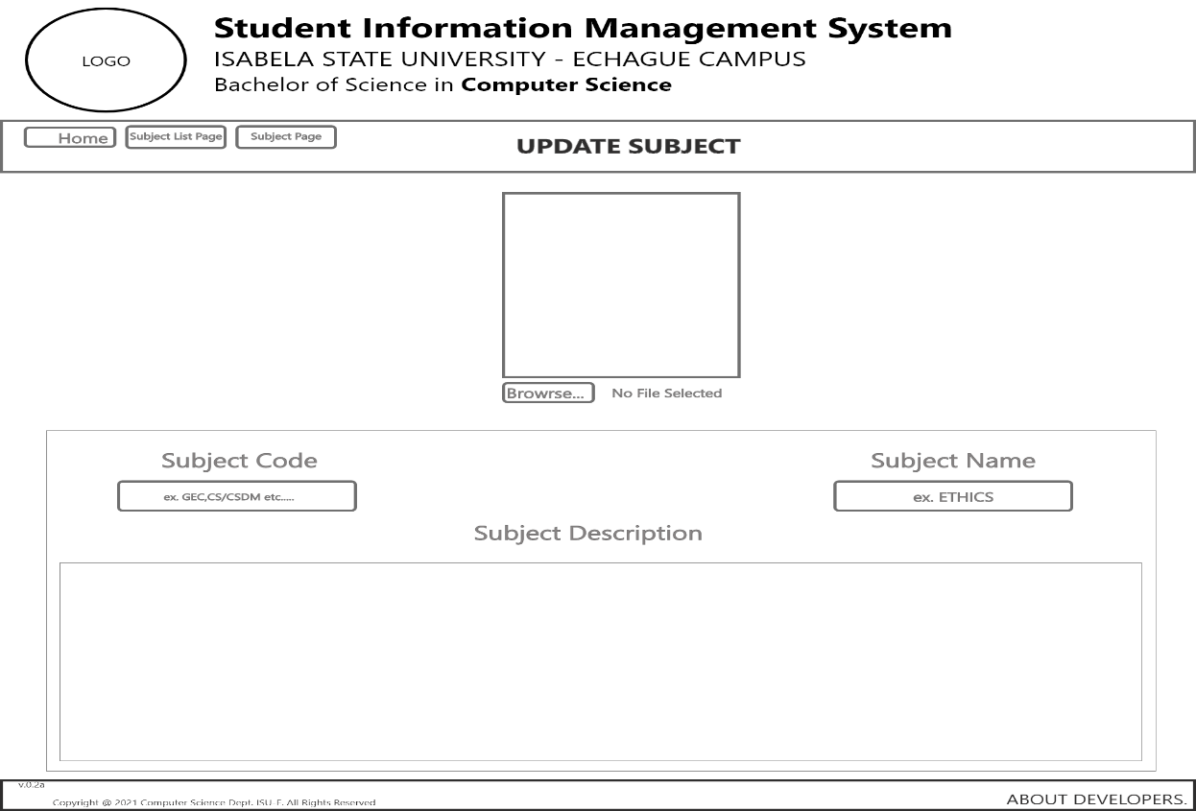 The figure 9 above shows the login interface of the system. The user will input their username and password. The system will identify if the user is administrator, sub-administrator. If the user is a student, the system will identify the specific.

*Figure 10. Manage Subject*

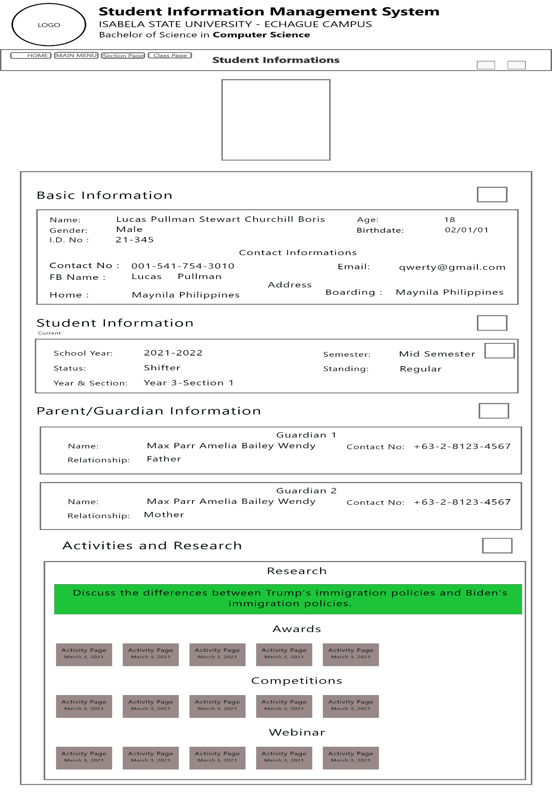The figure 10 shows where the administrator will manage the subject of the students. The administrator can to add subject, update subject and delete subject.

*Figure 11. Manage Student Information*

The figure 11 shows where the Administrator will manage student information. The administrator can add student information, update student information, and delete student information.

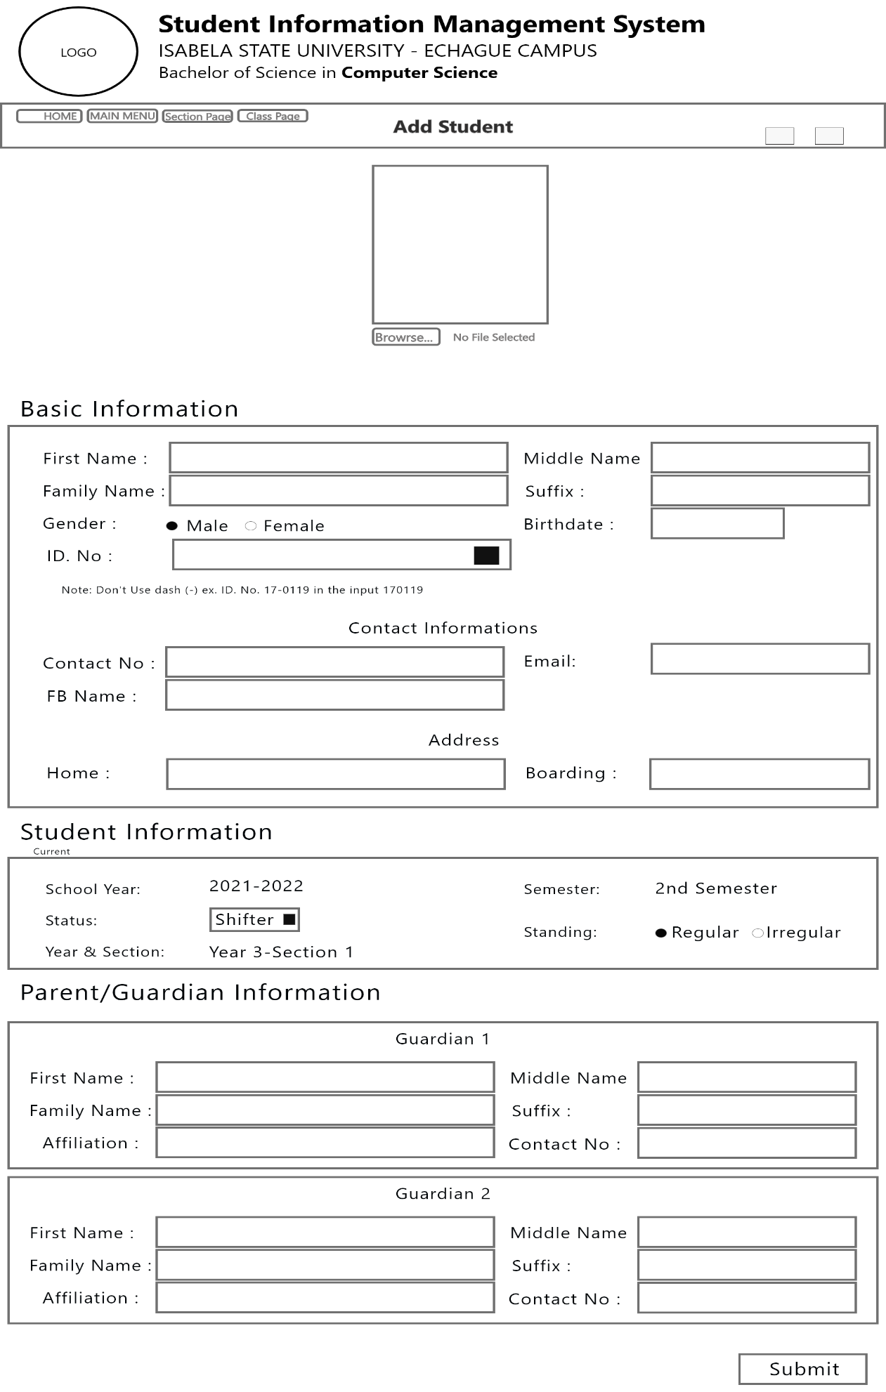

*Figure 12. Add Student Form*

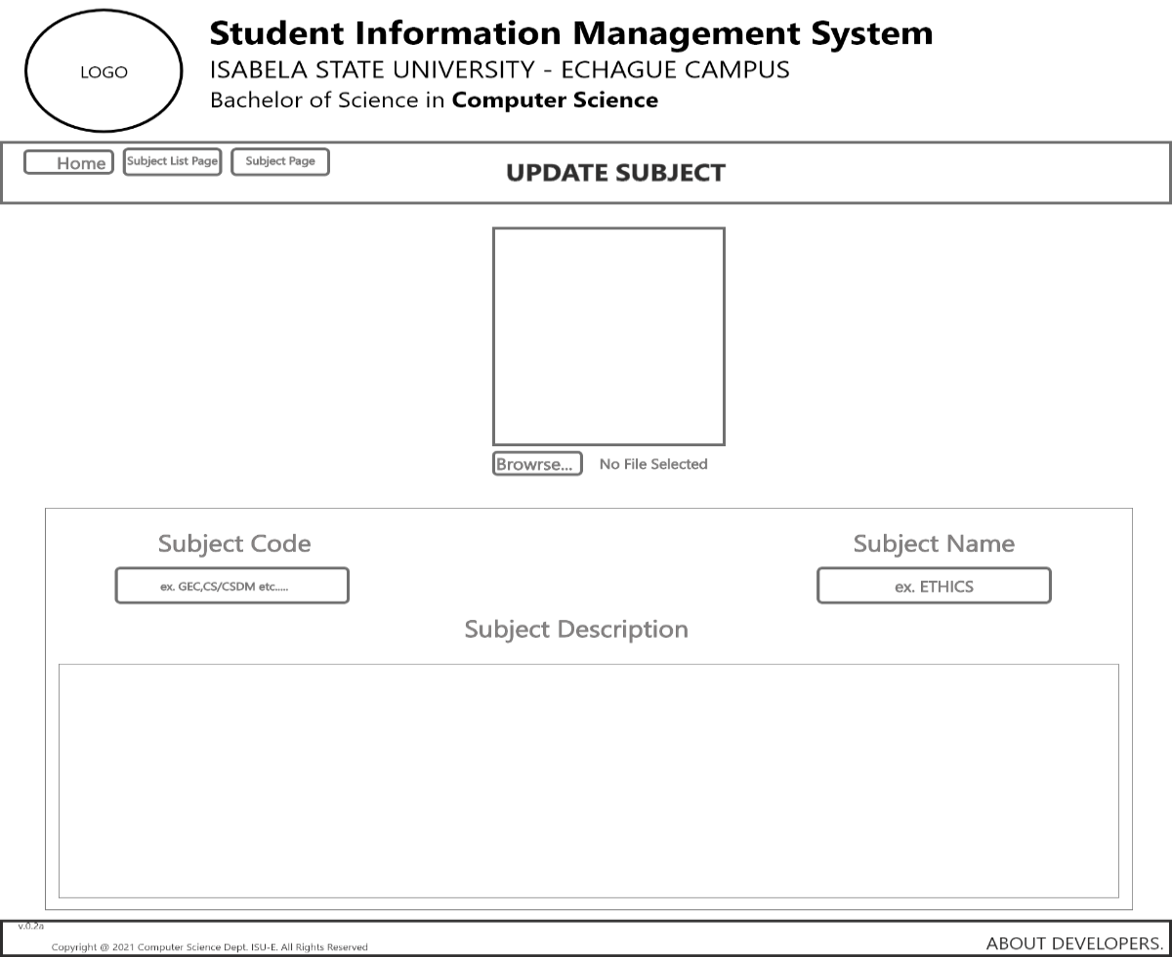The figure 12 shows the Add Student form wherein the administrator can add the student information that shift course in the BSCS.

*Figure 13. Update Subject Form*

The figure 13 shows the Update subject form where the admin can add subject available in the current semester.

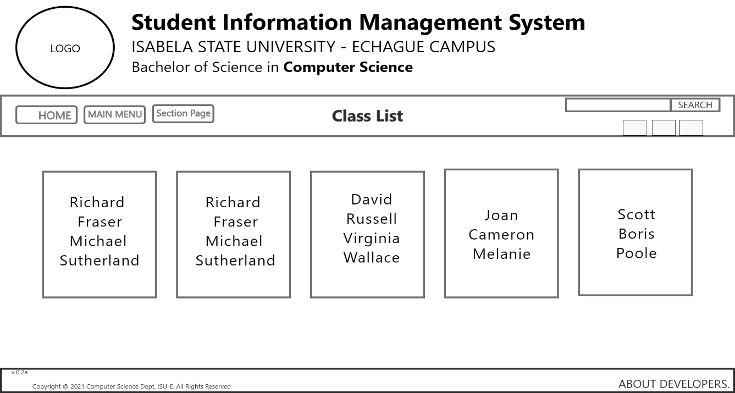

*Figure 14.Class List*

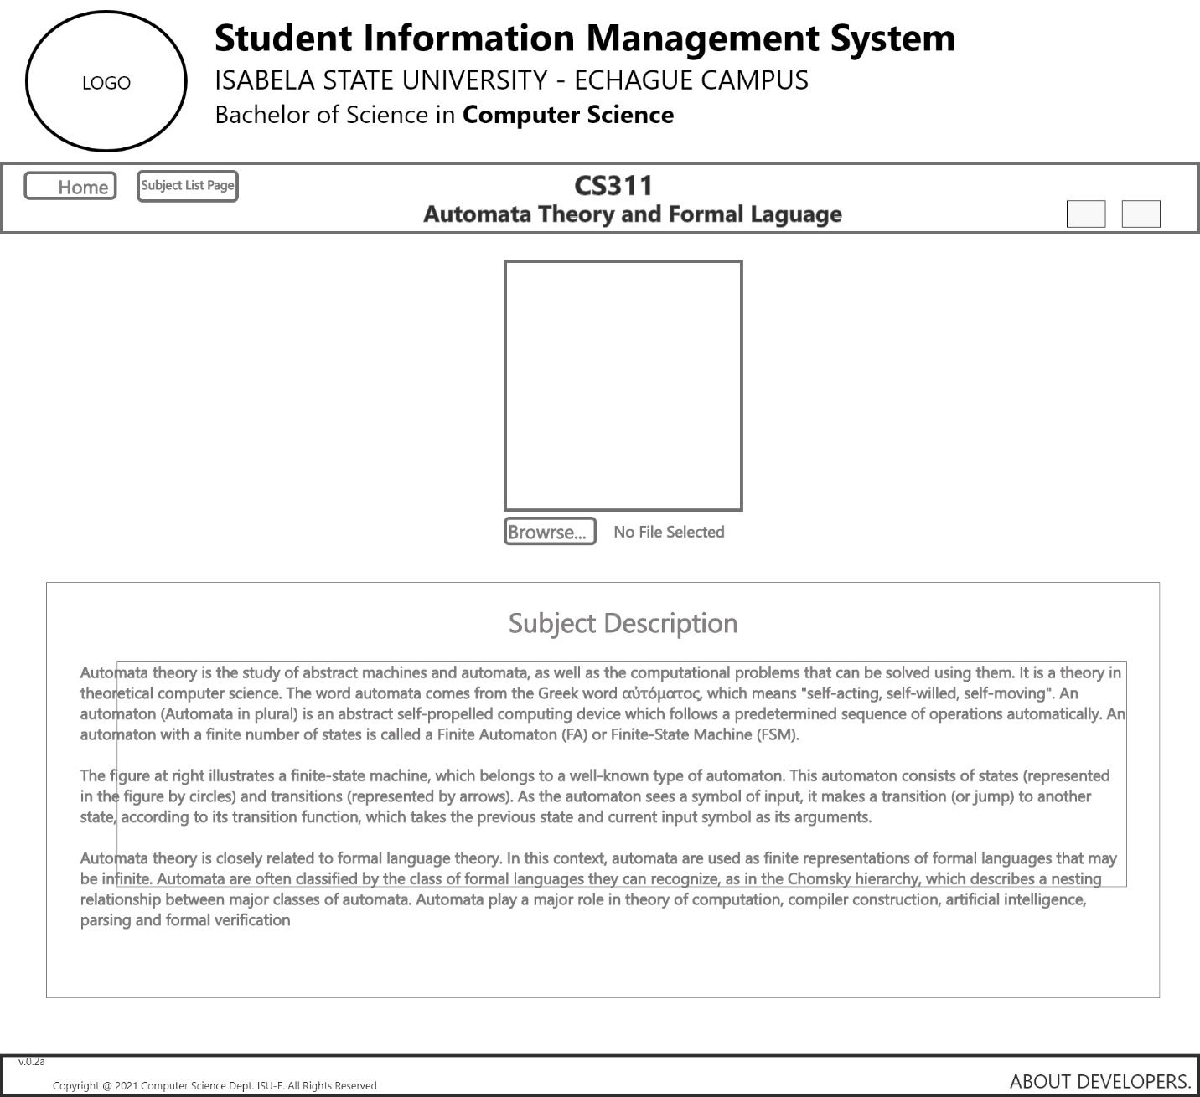The figure 14 show the list of the students in one class.

*Figure 15. Manage Subject*

Figure 15 shows where the administrator will manage the subjects of the student.

**4.7 Data Design**

**4.7.1 Entity Relationship Diagram**

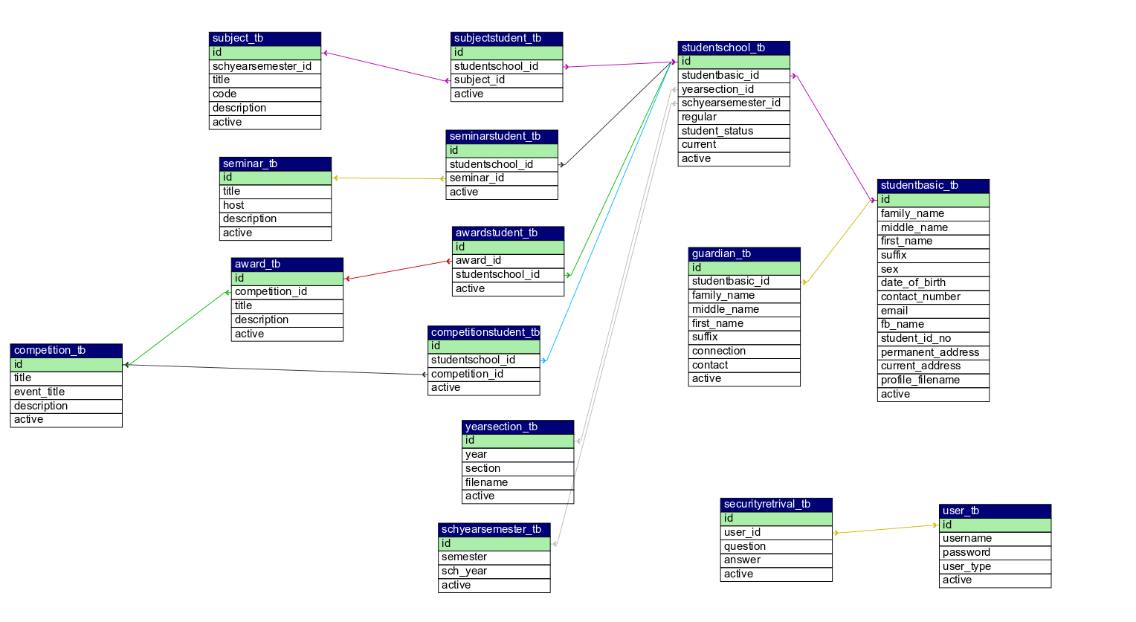

*Figure 16. Entity Relationship Diagram*

Figure 16 shows Entity Relationship Diagram (ERD). ERD provides to represent the structure of data.

**4.7.2 Data Dictionary**

Table 5. tbl_User

|  |  |  |  |  |  |
| --- | --- | --- | --- | --- | --- |
| Field Name | Data type | Length | FK | PK | Description |
| Id | Int | 11 | No | Yes | ID of the user |
| Username | Varchar | 255 | No | No | Username of the user |
| Password | Varchar | 255 | No | No | Password of the user |
| User_type | Int | 11 | No | No | User type |

Table 6. tbl_securityretival

|  |  |  |  |  |  |
| --- | --- | --- | --- | --- | --- |
| Field Name | Data type | Length | FK | PK | Description |
| Id | Int | 11 | No | Yes | ID information |
| User_id | Int | 11 | Yes | No | User ID information |
| Question | Varchar | 255 | No | No | Question |
| answer | Varchar | 255 | No | No | Answer |

Table 7. tbl_subjectsstudent

|  |  |  |  |  |  |
| --- | --- | --- | --- | --- | --- |
| Field Name | Data type | Length | FK | PK | Description |
| Id | Int | 11 | No | Yes | ID information |
| Studentschool_id | Int | 11 | Yes | No | Student school ID information |
| Subject_id | Int | 11 | No | No | Username of the user |

Table 8. tbl_subject

|  |  |  |  |  |  |
| --- | --- | --- | --- | --- | --- |
| Field Name | Data type | Length | FK | PK | Description |
| Id | Int | 11 | Yes | No | ID information |
| Schyearsemester_id | 1nt | 11 | No | No | School Year and Semester ID |
| Title | Varchar | 255 | No | No | Title of the subject |
| Code | Varchar | 255 | No | No | Code of the subject |
| Description | Text |  | No | No | Description of the subject |

Table 9. tbl_studentbasic

|  |  |  |  |  |  |
| --- | --- | --- | --- | --- | --- |
| Field Name | Data type | Length | FK | PK | Description |
| ID | Int | 11 | No | Yes | ID information |
| Family_name | Varchar | 255 | No | No | Family name of the student |
| Middle_name | Varchar | 255 | No | No | Middle name of the student |
| First_name | Varchar | 255 | No | No | First name of the student |
| Suffix | Varchar | 255 | No | No | Suffix of the student |
| Sex | Binary | 1 | No | No | Sex of the student |
| Date_of_birth | Date |  | No | No | Date of birth of the student |
| Contact_number | Int | 11 | No | No | Contact number of the student |
| Fb_name | Varchar | 255 | No | No | Facebook name of the student |
| Email | Varchar | 255 | No | No | Email of the student |
| Student_id_no | Varchar | 255 | No | No | Student ID number of the student |
| Permanent_address | Varchar | 255 | No | No | Permanent address of the student |
| Current_address | Varchar | 255 | No | No | Current address of the student |
| Profile_filename | Varchar | 255 | No | No | Profile Filename |

Table 10. tbl_studentschool

|  |  |  |  |  |  |
| --- | --- | --- | --- | --- | --- |
| Field Name | Data type | Length | FK | PK | Description |
| ID | Int | 11 | No | Yes | ID information |
| Studentbasic_ID | Int | 11 | Yes | No | Student ID information |
| Yearsection_ID | Int | 11 | No | No | Year section ID information |
| regular | Binary | 1 | No | No | Regular information |
| Student_status | Varchar | 255 | No | No | Student status information |

Table 11. tbl_guardian

|  |  |  |  |  |  |
| --- | --- | --- | --- | --- | --- |
| Field Name | Data type | Length | FK | PK | Description |
| ID | Int | 11 | No | Yes | ID information |
| Studentbasic_id | Int | 11 | Yes | No | Student basic id information |
| Family_name | Varchar | 255 | No | No | Family name of the guardian |
| Middle_name | Varchar | 255 | No | No | Middle name of the guardian |
| First_name | Varchar | 255 | No | No | First name of the guardian |
| Suffix | Varchar | 255 | No | No | Suffix of the guardian |
| Connection | Varchar | 255 | No | No | Connection of the guardian to the student |
| Contact | Varchar | 255 | No | No | Contact of the guardian |

Table 12. tbl_yearsection

|  |  |  |  |  |  |
| --- | --- | --- | --- | --- | --- |
| Field Name | Data type | Length | FK | PK | Description |
| ID | Int | 11 | Yes | No | ID information |
| Year | Int | 11 | No | No | Year |
| Section | Int | 11 | No | No | Section |
| Filename | Varchar | 255 | No | No | File name |

Table 13. tbl_schyearsemester

|  |  |  |  |  |  |
| --- | --- | --- | --- | --- | --- |
| Field Name | Data type | Length | FK | PK | Description |
| ID | Int | 11 | Yes | No | ID information |
| Semester | Varchar | 255 | No | No | Semester |
| Sch_year | Varchar | 255 | No | No | School Year |

Table 14. tbl_seminar

|  |  |  |  |  |  |
| --- | --- | --- | --- | --- | --- |
| Field Name | Data type | Length | FK | PK | Description |
| ID | Int | 11 | Yes | No | ID information |
| Title | Varchar | 255 | No | No | Title of the seminar |
| Host | Varchar | 255 | No | No | Host of the seminar |
| Description | Varchar | 255 | No | No | Description of the seminar |

Table 15. tbl_seminarstudent

|  |  |  |  |  |  |
| --- | --- | --- | --- | --- | --- |
| Field Name | Data type | Length | FK | PK | Description |
| ID | Int | 11 | No | Yes | ID information |
| Studentschool_id | Int | 11 | Yes | No | Student School Id information |
| Seminar_id | Int | 11 | Yes | No | Seminar Id information |

Table 16. tbl_competition

|  |  |  |  |  |  |
| --- | --- | --- | --- | --- | --- |
| Field Name | Data type | Length | FK | PK | Description |
| ID | Int | 11 | No | Yes | ID information |
| Title | Varchar | 255 | No | No | Title of the competition |
| Event_title | Int | 11 | No | No | Event title |
| Description | Varchar | 255 | No | No | Description of the competition |

Table 17. tbl_competitionstudent

|  |  |  |  |  |  |
| --- | --- | --- | --- | --- | --- |
| Field Name | Data type | Length | FK | PK | Description |
| ID | Int | 11 | No | Yes | ID information |
| Studentschool_id | Int | 11 | Yes | No | Student School ID information |
| Competition_id | Int | 11 | Yes | No | Competition ID information |

Table 17 tbl_award

|  |  |  |  |  |  |
| --- | --- | --- | --- | --- | --- |
| Field Name | Data type | Length | FK | PK | Description |
| ID | Int | 11 | No | Yes | ID information |
| Competition_id | Int | 11 | Yes | No | Competition ID information |
| Title | Varchar | 255 | No | No | Title of the award |
| description | Varchar | 255 | No | No | Description of the award |

Table 18. tbl_awardstudent

|  |  |  |  |  |  |
| --- | --- | --- | --- | --- | --- |
| Field Name | Data type | Length | FK | PK | Description |
| ID | Int | 11 | No | Yes | ID information |
| Award_ID | Int | 11 | Yes | No | Award ID information |
| Studentschool_ID | Int | 11 | Yes | No | Student school ID information |

Table 19. tbl_researcher

|  |  |  |  |  |  |
| --- | --- | --- | --- | --- | --- |
| Field Name | Data type | Length | FK | PK | Description |
| ID | Int | 10 | No | Yes | ID |
| research_ID | Int | 50 | Yes | No | Research ID information |
| Student_ID | Int | 50 | Yes | No | Student ID information |

Table 20. tbl_research

|  |  |  |  |  |  |
| --- | --- | --- | --- | --- | --- |
| Field Name | Data type | Length | FK | PK | Description |
| ID | Int | 11 | No | Yes | ID |
| Title | Varchar | 255 | No | No | Title of the Research |
| Publish_date | Varchar | 255 | No | No | Publish date of the research |
| Abstract_fileaname | Varchar | 255 | No | No | Abstract filename |

**4.7.3 System Architecture**

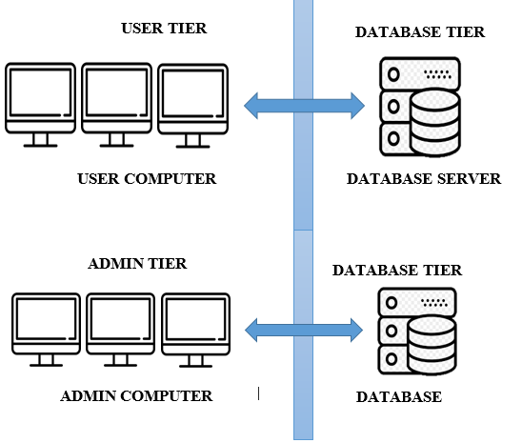

*Figure 17. System Architecture*

Figure 17 shows the system Architecture of the system.

**4.8 Development**

**4.8.1 Hardware Specification**

Table 22. Hardware Specification

|  |  |
| --- | --- |
| Hardware | Specification |
| Processor | Intel i7 |
| RAM | 16 GB |
| Hard Drive | Hard Disk: 1 Terabyte |

The table above shows the hardware specification of the administrators used in this system.

**4.8.2 Software Specification**

The following are the software’s used in the development and implementation of the system:

* **XAMPP-** it used to manage database locally and local web-server of the application during the duration of the development.
* **MySQL Server-** it is used for creating and managing the database and connects them to the software.
* **Visual Studio Code-** it is used VS code for developing the interface of the system.
* **Adobe XD-** it used for creating prototypes looks the real thing.
* **Adobe Photoshop-** it is used for lay outing background design of the interface.
* **Adobe Illustrator**-it is used for creating charts, diagram, illustrations, and graphs.

**4.8.3 Program Specification**

**Program Chair**

User Login

Student Profile

-Student Information

Class

-Year and Section Information

-Student/s Involved

Subject

-Assigned Professor

-Schedule

Research

-Research Title and Abstract

-Researcher/s

Activities

-Awards Information

-Awardee Information

-Seminar and Webinar Information

-Competition Information

-Competition Participant

**4.8.4 Programming Environment**

The following tools are used in the development of the project:

* **Front End**

Front end is where the user interact with the system. The proponents used Visual Studio Code, HTML and CSS for the front end. Visual Studio Code is a code editor with support for development operations. Cascading Style Sheet (CSS) used for styling web pages.

* **Back End**

The researchers used MySQL database server and PHP for the back end of the system. PHP scripting language, is widely-used open source general-purpose scripting language that is especially suited for web development. PHP was used by the proponents for the functionalities of the system.

**4.8.5 Development Diagram**

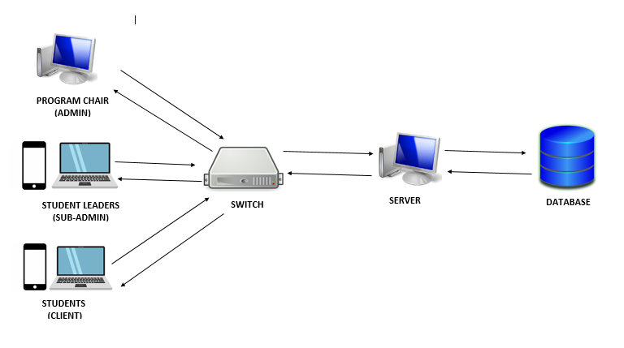

*Figure 18. Deployment Diagram*

Figure 18 represents the deployment Diagram of the proposed system. The user can access the system by accessing the kiosk. The data that the admin inputted will be store on the database server via localhost. The data that the sub-admin inputted will be store via localhost. The administrator which is the Program Chair, can monitor inputs of the sub-admin, and also manages the system personally.

**4.8.6 Testing**

**Compatibility Testing**

The developer used this type of testing to determine how compatible the system interface into the different operating system such as Windows 8, Windows 10 and Windows 11.

**4.9 System Architecture**

**4.9.1 Network Model**

**4.9.2 Star Topology**

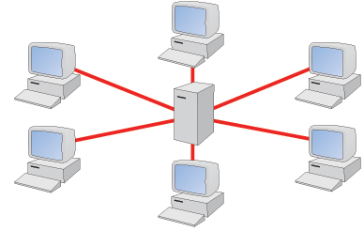

**SERVER**

**COMPUTER**

**COMPUTER**

**COMPUTER**

**COMPUTER**

**HUB**

**COMPUTER**

*Figure 19. Star Topology*

In this configuration, every devices connects to a central network device, like hub, switch or computer. The central network device acts as a server and the peripheral devices acts as clients.

**4.10 Evaluation**

The researchers will use the Software Quality Standard (ISO 25010) in evaluating the system as perceived by users’ acceptability with respect to: Functionality, Usability and Reliability.

The system will be evaluated by the IT expert and the users of the system in the Municipality of Echague. The researchers used Likert Scale to determine, evaluate and to give feedback to the system. According to Likert 1932 formula and interpreting the result is shown below. This has been used to determine whether the respondents rated “Strong Agree (SA)”, ”Agree (A)”, “Undecided (U)”, “Disagree (DA)”, and “Strongly Disagree (SD)”.

Table 20. Likert Scale

|  |  |  |
| --- | --- | --- |
| **Scale** | **Rating** | **Qualitative Rating** |
| 5 | 4.21- 5.0 | Strongly Agree |
| 4 | 3.41- 4.20 | Agree |
| 3 | 2.61- 3.40 | Undecided |
| 2 | 1.81- 2.60 | Disagree |
| 1 | 1.00- 1.80 | Strongly Disagree |