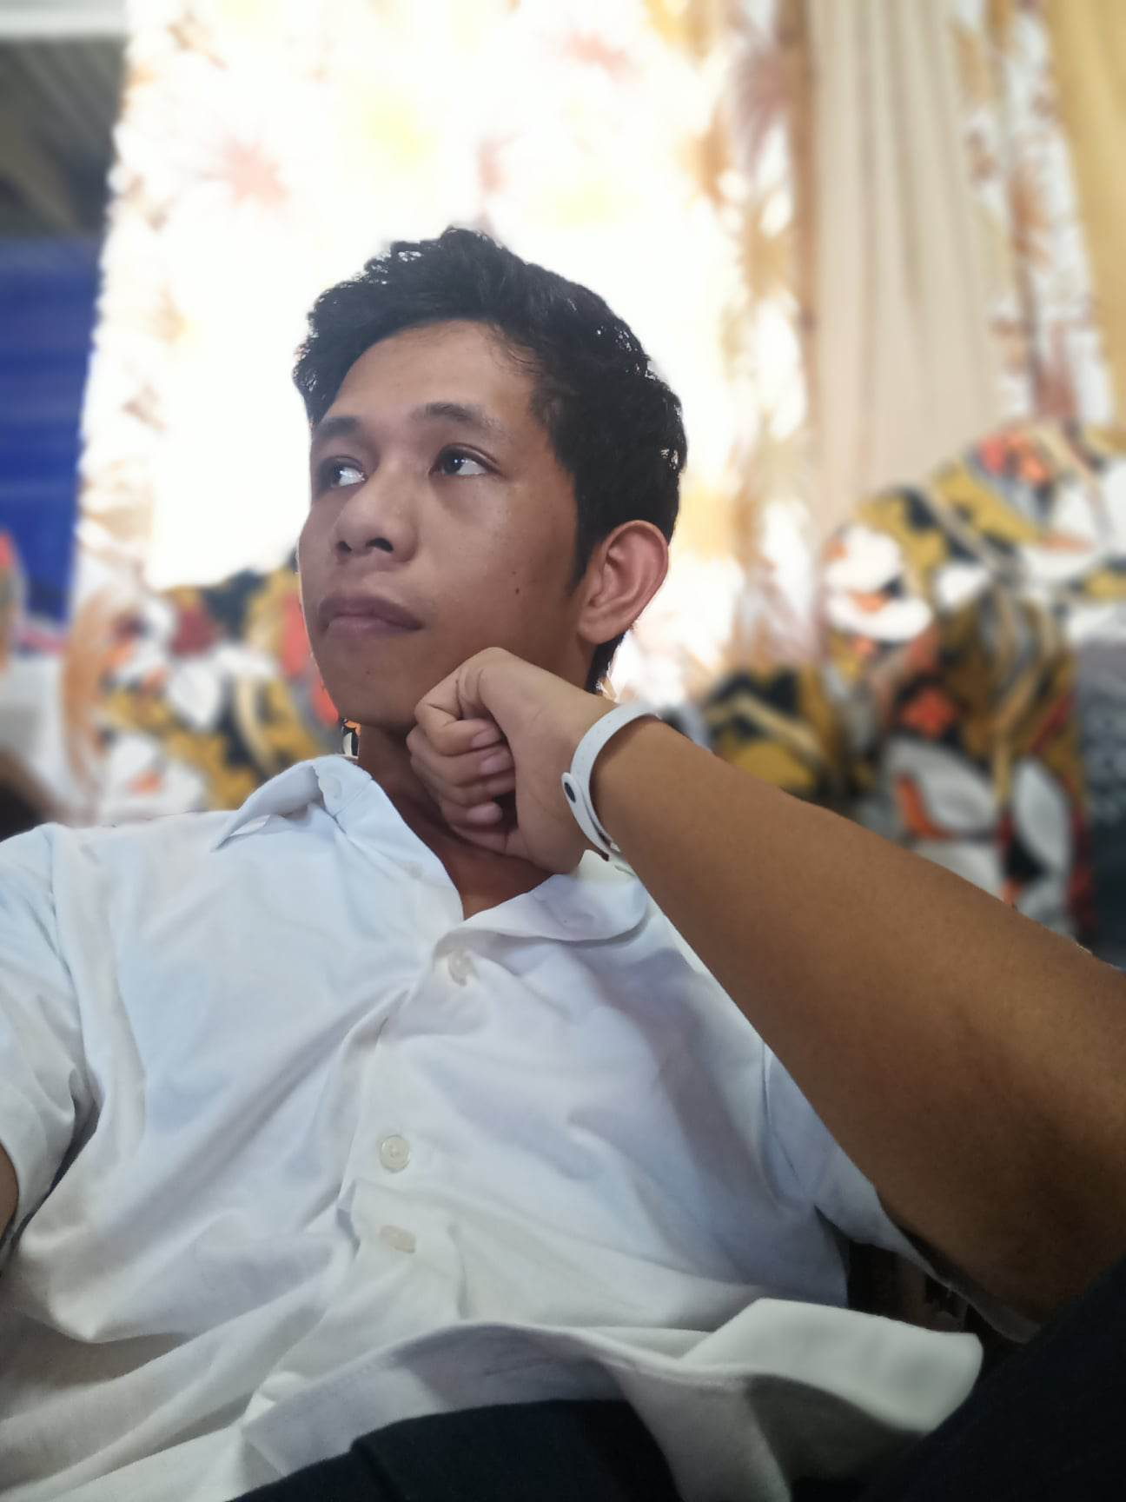

Programmer of the Year (2022)

Leadership Awards (2022)

Academic Excellence Award (2022)

Young Extensionist Award (2022)

**COLLEGE**

**ACHIEVEMENTS**

“ Dedicated programmer and willing to widen my knowledge for advancement of my chosen career. I want to find a challenging area in your company which will help me grow and provide a better outcome for my future projects with you “

**2019 - PRESENT**

**PSITE Programming Contest: Group**

5th Placer

Online Base – PSITE Region 12

**May 5, 2021**

**PSITE Programming Contest: Individual**

7th Placer

Online Base – PSITE Region 12

**May 5, 2021**

**Ramirez**

**Ian Cedric**

**Oct. 17, 2017**

**Division Science & Technology Fair: Robotics**

1st Placer

Alicia National High School

**Sept. 22, 2017**

**Area III Science Investigatory Project Fair: Robotics**

1st Placer

San Guillermo Vocational and Industrial High School

**Impact Hackathon: Smart City – Cauayan City**

Participant

F.L. Dy Memorial Hall

**WORK EXPERIENCE**

**Project Sparta Hackathon Cauayan City**

Participant

Online Base

**Nov. 1 1, 2022**



+639757749143

<https://www.facebook.com/ramirez.zyx.14/>

<https://github.com/taongnyebe>

<https://www.instagram.com/cold_014/>

**April 1, 2022**



*Continue…*

**Mechatronics and Robotics Society of the Philippines Isabela Chapter Student Council- Isabela State University (MRSPICSC)**

Isabela State University – Echague Campus

**WORK EXPERIENCE**

**2021 - PRESENT**

**2016 - 2018**

**Information, Communication and Resources Department Head**

United Methodist Church Youth Fellowship - Isabela South Ifugao East District – North East Luzon Annual Conference

**SEMINARS**

**Aug. 22, 2020**

**Getting Started with Angular**

NEU CCS – NEU Center of Data Research Online Media

**Aug. 14, 2020**

**3D Modeling & Realistic Art**

Animation and Game Expo 2020 – NEU Center of Data Research Online Media

**Dec. 13, 2020**

**18th Youth Congress on Information Technology**

Y4iT – UP System Information Technology Foundation

**Jan. 09, 2021**

**Introduction to C++ Programming Language**

Alison MOOC - Microsoft

**Jan. 13, 2021**

**C++ Programming using Advance Features**

Alison MOOC - Microsoft

**Jan. 13, 2021**

**Adobe Photoshop CS6 Essential Tools**

Alison MOOC – Advance Learning

**July 3, 2021**

**Application of Collaborative Filtering Algorithm Recommender System**

Mechatronics and Robotics Society of the Philippines Isabela Chapter

**Aug. 14 - 15, 2021**

**Pinoy Codes: Linangin ag Kakayahan sa Web Development**

Mechatronics and Robotics Society of the Philippines Isabela Chapter

*Continue…*

**Nov. 19, 2021**

**Web Application Security Testing Using Open-Source Tools**

College of Computing Studies, information and Communication Technology – Student Body Organmization

**SEMINARS**

**Jan. 24, 2022**

**Graphic Designing – Graphic Design in the E-Commerce Space**

Tech Me Up: Technifying the Bright Minds of Tomorrow – Google Developers Students Club

**Jan. 24, 2022**

**Animation – Drawn to Move: Inside of an Animator’s Mind**

Tech Me Up: Technifying the Bright Minds of Tomorrow – Google Developers Students Club

**Jan. 24, 2022**

**Video Editing – How to Catch Attention**

Tech Me Up: Technifying the Bright Minds of Tomorrow – Google Developers Students Club

**Jan. 25, 2022**

**UI/UX – Design Thinking: Human-Centered Design Process Behind the Best Apps and Websites**

Tech Me Up: Technifying the Bright Minds of Tomorrow – Google Developers Students Club

**Jan. 25, 2022**

**Web Development – Website vs Web Application: What’s the Difference**

Tech Me Up: Technifying the Bright Minds of Tomorrow – Google Developers Students Club

**Jan. 25, 2022**

**Mobile Development – How Mobile Apps are Helping Today’s Businesses**

Tech Me Up: Technifying the Bright Minds of Tomorrow – Google Developers Students Club

**Jan. 26, 2022**

**Data Science – Why data is the new oil?**

Tech Me Up: Technifying the Bright Minds of Tomorrow – Google Developers Students Club

**Jan. 26, 2022**

**Cloud Technology – Decoding Cloud in the 21st Century**

Tech Me Up: Technifying the Bright Minds of Tomorrow – Google Developers Students Club

**Jan. 26, 2022**

**AI/ML – The Future of AI/ML: Can Machines Truly Think?**

Tech Me Up: Technifying the Bright Minds of Tomorrow – Google Developers Students Club

**Feb. 19, 2022**

**PyStart(): Getting Started with Python**

Google Developers Students Club e-College

**ORGANIZATION**

**Mechatronics and Robotics Society of the Philippines Isabela Chapter Student Council- Isabela State University (MRSPICSC)**

**CHARACTER REFERENCES**

**SKILLS**

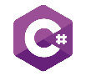

**Novice** - WPF



**Novice**



**Novice**



**Advance**



**Novice**



**Advance** - OOP



**Advance** – OOP – Database (SQL)



**Advance**



**Advance**



**Advance**



**Advance –** OOP - WPF



**Advance**



**Advance**



**Advance**



**Advance**

**Catleen Glo M. Feliciano,MIT**

*BSCS Program Chair*

*catleenglo.r.madayag@isu.ph*

+639357584628

**Christine Charmaine G. San Jose, DIT**

*CCSICT College Dean*

tinsanjose1112@gmail.com

+639175384845

**EDUCATION**

**2016 - 2018**

Salinungan National High-School (G11 – G12)

**2019 - Present**

Isabela State University – Echague Campus

Bachelor of Science in Computer Science: Major in Data Mining

Salinungan West, San Mateo, Isabela