Decision Tree:

Find best attribute:

Information gain :
- The entropy typically changes when we use a node in a decision tree to partition the training instances into smaller subsets
- Information gain is a measure of this change in entropy
- Definition: Suppose S is a set of instances, A is an attribute, Sv is the subset of S with A = v, and Values(A) is the set of all possible values of A , then
Gain(S, A) = Entropy(S) - . Entropy(Sv)
(recall | S| denotes the size of set S )

Neural Networks:

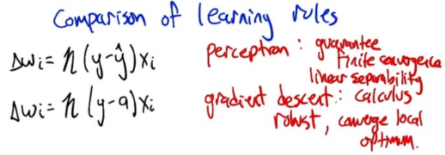
What are good initial weights in a neural network?

I have just heard, that it's a good idea to choose initial weights of a neural network from the range

where dd is the number of inputs to a given neuron. It is assumed, that the sets are normalized - mean 0, variance 1 (don't know if this matters).

Why is this a good idea?

Answers: 已省.

What are good initial weights in a neural network?

The Stack Exchange answer Franck posted is a good start and correctly states that 0-initialization is a common "rookie mistake" when initializing the weights.

Beyond this, the most common initializations are random initialization and Xavier initialization (what the Stack Exchange post refers to as a combination of fan-in and fan-out). Random initialization just samples each weight from a standard distribution (often a normal distribution) with low deviation. The low deviation allows you to bias the network towards the 'simple' 0 solution, without the bad repercussions of actually initializing the weights to 0.

Xavier initialization is often seen in convolutional neural networks. It is quite simple and not much different from random initialization, but it often turns out to work much better. This site gives a good explanation An Explanation of Xavier Initialization .

In addition to these two, recently, random orthogonal matrix initializations have been argued to be better than just any random initialization, especially in deep neural networks. I believe this paper is what initially proposed this initialization [1312.6120] Exact solutions to the nonlinear dynamics of learning in deep linear neural networks .

An Explanation of Xavier Initialization

Why’s Xavier initialization important?

In short, it helps signals reach deep into the network.

If the weights in a network start too small, then the signal shrinks as it passes through each layer until it’s too tiny to be useful.
If the weights in a network start too large, then the signal grows as it passes through each layer until it’s too massive to be useful.
Xavier initialization makes sure the weights are ‘just right’, keeping the signal in a reasonable range of values through many layers.

To go any further than this, you’re going to need a small amount of statistics - specifically you need to know about random distributions and their variance.

Okay, hit me with it. What’s Xavier initialization?

In Caffe, it’s initializing the weights in your network by drawing them from a distribution with zero mean and a specific variance,

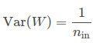

where WW is the initialization distribution for the neuron in question, and ninnin is the number of neurons feeding into it. The distribution used is typically Gaussian or uniform.

...

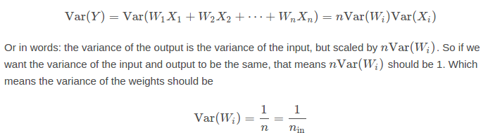

How to choose the number of hidden layers and nodes:

I realize this question has been answered, but I don't think the extant answer really engages the question beyond pointing to a link generally related to the question's subject matter. In particular, the link describes one technique for programmatic network configuration, but that is not a "[a] standard and accepted method" for network configuration.

By following a small set of clear rules, one can programmatically set a competent network architecture (i.e., the number and type of neuronal layers and the number of neurons comprising each layer). Following this schema this will give you a competent architecture but probably not an optimal one.

But once this network is initialized, you can iteratively tune the configuration during training using a number of ancillary algorithms; one family of these works by pruning nodes based on (small) values of the weight vector after a certain number of training epochs--in other words, eliminating unnecessary/redundant nodes (more on this below).

So every NN has three types of layers: input, hidden, and output.

Creating the NN architecture therefore means coming up with values for the number of layers of each type and the number of nodes in each of these layers.

The Input Layer

Simple--every NN has exactly one of them--no exceptions that I'm aware of.

With respect to the number of neurons comprising this layer, this parameter is completely and uniquely determined once you know the shape of your training data. Specifically, the number of neurons comprising that layer is equal to the number of features (columns) in your data. Some NN configurations add one additional node for a bias term.

The Output Layer

Like the Input layer, every NN has exactly one output layer. Determining its size (number of neurons) is simple; it is completely determined by the chosen model configuration.

Is your NN going running in Machine Mode or Regression Mode (the ML convention of using a term that is also used in statistics but assigning a different meaning to it is very confusing). Machine mode: returns a class label (e.g., "Premium Account"/"Basic Account"). Regression Mode returns a value (e.g., price).

If the NN is a regressor, then the output layer has a single node.

If the NN is a classifier, then it also has a single node unless softmax is used in which case the output layer has one node per class label in your model.

The Hidden Layers

So those few rules set the number of layers and size (neurons/layer) for both the input and output layers. That leaves the hidden layers.

How many hidden layers? Well if your data is linearly separable (which you often know by the time you begin coding a NN) then you don't need any hidden layers at all. Of course, you don't need an NN to resolve your data either, but it will still do the job.

Beyond that, as you probably know, there's a mountain of commentary on the question of hidden layer configuration in NNs (see the insanely thorough and insightful NN FAQ for an excellent summary of that commentary). One issue within this subject on which there is a consensus is the performance difference from adding additional hidden layers: the situations in which performance improves with a second (or third, etc.) hidden layer are very small. One hidden layer is sufficient for the large majority of problems.

So what about size of the hidden layer(s)--how many neurons? There are some empirically-derived rules-of-thumb, of these, the most commonly relied on is 'the optimal size of the hidden layer is usually between the size of the input and size of the output layers'. Jeff Heaton, author of Introduction to Neural Networks in Java offers a few more.

In sum, for most problems, one could probably get decent performance (even without a second optimization step) by setting the hidden layer configuration using just two rules: (i) number of hidden layers equals one; and (ii) the number of neurons in that layer is the mean of the neurons in the input and output layers.

Optimization of the Network Configuration
...

kNN

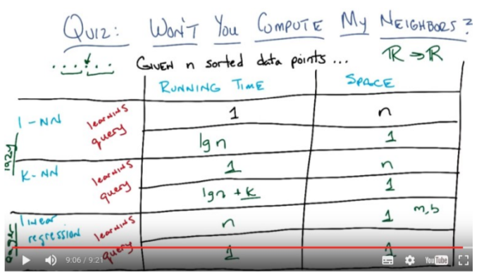
kNN如何選k:

至少有三個網頁都說選k = :

Choice of k is very critical – A small value of k means that noise will have a higher influence on the result. A large value make it computationally expensive and kinda defeats the basic philosophy behind KNN (that points that are near might have similar densities or classes ) .A simple approach to select k is set k = n^(1/2).

Choosing optimal K for KNN

I performed a 5-fold CV to select the optimal K for KNN. And it seems like the bigger K gets, the smaller the error...
...

If you carry on going, you will eventually end up with the CV error beginning to go up again. This is because the larger you make k, the more smoothing takes place, and eventually you will smooth so much that you will get a model that under-fits the data rather than over-fitting it (make k big enough and the output will be constant regardless of the attribute values). I'd extend the plot until the CV error starts to go noticably up again, just to be sure, and then pick the k that minimizes the CV error. The bigger you make k the smoother the decision boundary and the more simple the model, so if computational expense is not an issue, I would go for a larger value of k than a smaller one, if the difference in their CV errors is negligible.

If the CV error doesn't start to rise again, that probably means the attributes are not informative (at least for that distance metric) and giving constant outputs is the best that it can do.

kNN如何選distance (from ML note):

I think the real point to take there is, there are some good distance functions for our problem and there are some bad distance functions for our problem. And how you pick those is really fundamental assumption your making about the domain. That's why it's domain knowledge.

Boosting:

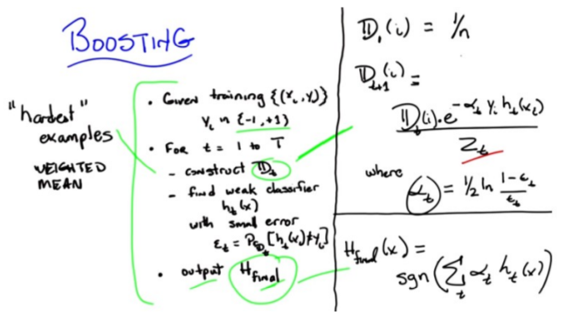
SVM:

(from ML note):

This kernel function is our representation, still, of similarity. Another way of thinking about that, by the way, is that this is the mechanism by which we inject domain knowledge into the support vector machine learning algorithm.

There is a specific technical requirement of a kernel function: Mercer Condition. For your intuition in the meantime, it basically means it acts like a distance, or it acts like a similarity. It's not an arbitrary thing that doesn't relate the various points together.

From online video:

SVM γ parameter:

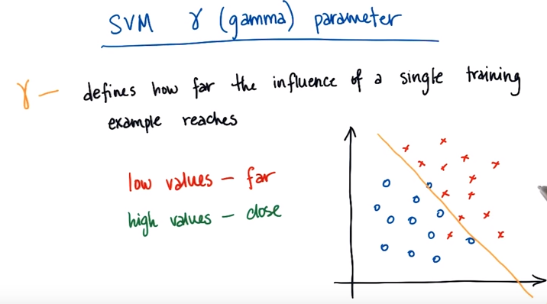
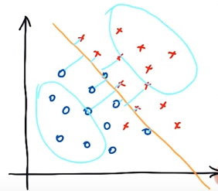
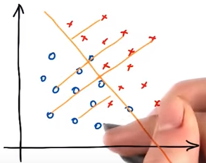

γ表示的就是support vector points到decision boundary的距離. γ越大, 表示這個距離越小. γ越小, 表示這個距離越大.

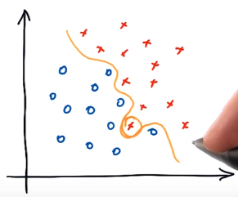

For high values of γ, you can end up with a fairly wiggly decision boundary.

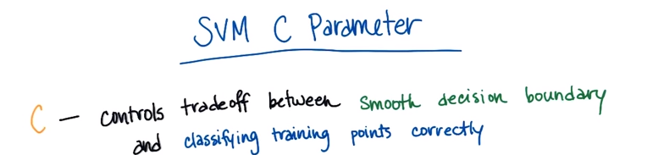
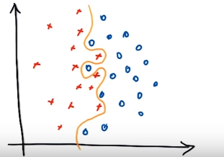
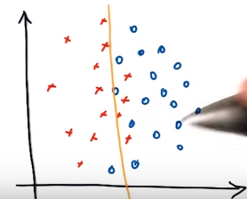

From another slides:

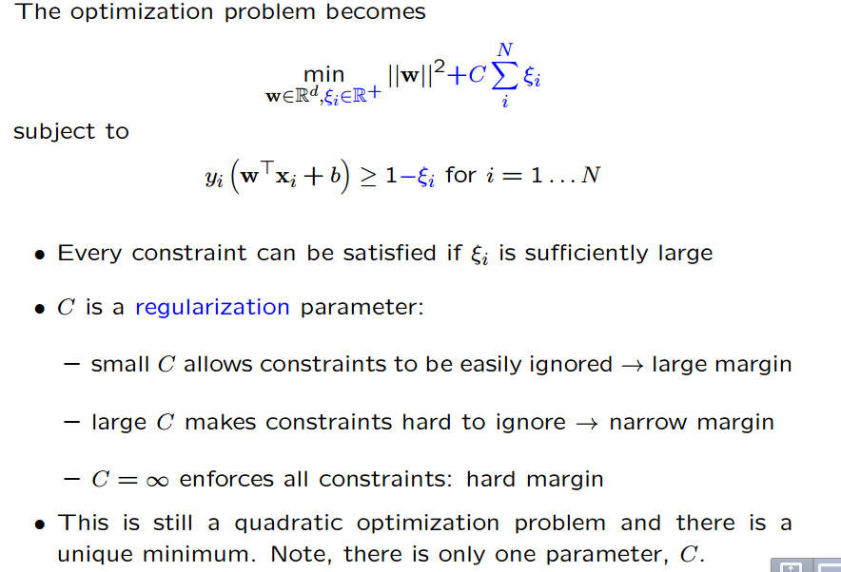

From another video:

If you had a really high C, you're saying I care a lot about getting every single point precisely correct. If on the other hand, we had a medium C, now we are talking about trading off the points that we correctly classify with how broad the margin is. And you can imagine we could have a very low C, so C that cares almost exclusively about maximizing margin, and that might actually care less about the close points and actually more about the sort of largest most difficult distant cluster of points

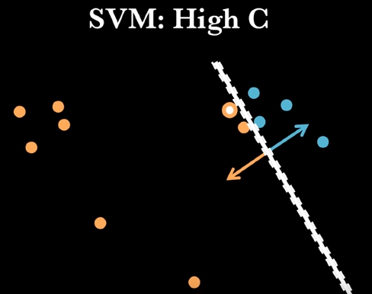
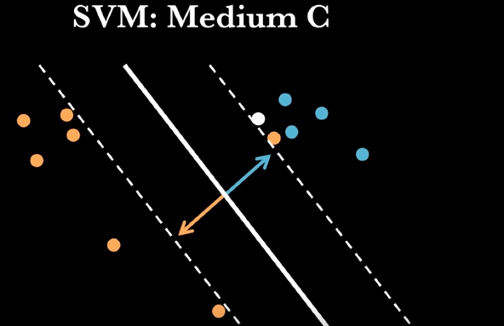
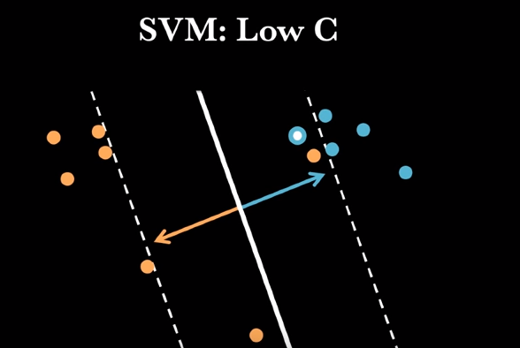

SVM如何選C和γ:
網上基本上都是用的這種grid-search:

Check out A practical guide to SVM Classification for some pointers, particularly page 5.

We recommend a "grid-search" on C and γ using cross-validation. Various pairs of (C,γ) values are tried and the one with the best cross-validation accuracy is picked. We found that trying exponentially growing sequences of C and γ is a practical method to identify good parameters (for example, C=2^−5,2^−3,…,2^15; γ=2^−15,2^−13,…,2^3).

Remember to normalize your data first and if you can, gather more data because from the looks of it, your problem might be heavily underdetermined.

SVM如何選kernel:

SVM-1.

A broad and practical answer:

Linear kernels are good for text and they are needed for performance if you have a lot of data.

RBF kernels are general purpose usually the first thing to try if you are not processing text.

Other kernels may be good in very specific situations but are rare in practice. You should find quickly if a special kernel is good if you have very specific data like graphs or strings.

SVM-2.

Always try the linear kernel first, simply because it's so much faster and can yield great results in many cases (specifically high dimensional problems).

If the linear kernel fails, in general your best bet is an RBF kernel. They are known to perform very well on a large variety of problems.

SVM-3 (good).

As others have pointed out, there’s no way to figure out which kernel would do the best for a particular problem. The only way to choose the best kernel is to actually try out all possible kernels, and choose the one that does the best empirically. However, we can still look at some differences between various kernel functions, to have some rules of thumb.

Let’s start by listing the kernel functions:

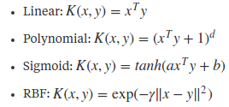

- Translation invariance: RBF kernel is the only kernel out of the above that is translation invariant, that is, K(x,y)=K(x+t,y+t), where t is any arbitrary vector. Intuitively, this property is useful — if you imagine all your data lying in some space, then the similarity between the points should not change if you shift the entire data, without changing the relative positions of the points.

- Inner product vs Euclidean distance: Related to the above point, RBF kernel is a function of the Euclidean distance between the points, whereas all other kernels are functions of inner product of the points. Again, it makes more intuitive sense to have Euclidean distance — points that are closer should be more similar. If two points are close to the origin, but on opposite sides, then the inner product based kernels assign the pair a low value, but Euclidean distance based kernels assign the pair a high value. It is, however, important to note that for some applications, inner product is sometimes the more preferred similarity metric, like in bag-of-words vectors, because you care more about the direction of the vectors (which words appear in both the document vectors) rather than the actual counts.

- Normalized: A kernel is said to be normalized if K(x,x)=1 for all x. This is true for only RBF kernel in the above list. Again, intuitively, you want this property to hold — if x and xx have a similarity of λ, then 2x and 2x should also have a similarity of λ. You can convert an arbitrary kernel K(x,y) to a normalized kernel K̃ (x,y) by defining

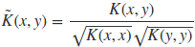

(Also, as a side note, RBF kernel is the normalized kernel for the exponential kernel, K(x,y)=exp(xTy).)

These properties tend to make RBF kernel better in general, for most problems. And because it does the best empirically, it tends to be most widely used. However, just to reiterate, depending on the nature of the problem, it is possible that one of the other kernels does better than RBF kernel.

SVM-4.

How does one pick a Greens function to solve a differential equation? It's the same problem

I guess you can guess..that is OK. But if you actually know something about your problem, try to take advantage of it.

Pick a Kernel that represents your prior knowledge about the problem.

[Picking a Kernel is (mostly) equivalent to picking a Regularizer (or Regularization Operator) and I will use them interchangeably]

If you are classifying images, you can try a RBF Kernel (即radial basis function, 即Gaussian) --because the RBF Kernel selects solutions that are smooth (this can be easily shown in frequency space...I started a blog to explain...bear with me as I proof it:
http://charlesmartin14.wordpress...
)

If you think your solutions are naturally sparse, then pick an L1-regularizer.

If you only have a small set of labels but lots of unlabeled data, then you might try a Manifold Regularizer (i.e. Transductive SVM), with or without a non-linear Kernel

If you have text, then don't apply RBF. That makes no mathematical sense.

If you data lives on a graph, you might want a Diffusion Kernel.

if you can't find a Kernel or Regularizer that represents your problem, then build the features yourself, and run a L1-SVM.

SVM-5.

Cross validate, Cross validate, Cross validate! Try several different Kernels, and evaluate their out-of-sample performance. Keep in mind that linear kernels usually compute much faster than radial or poly kernels.

Logistic Regression:

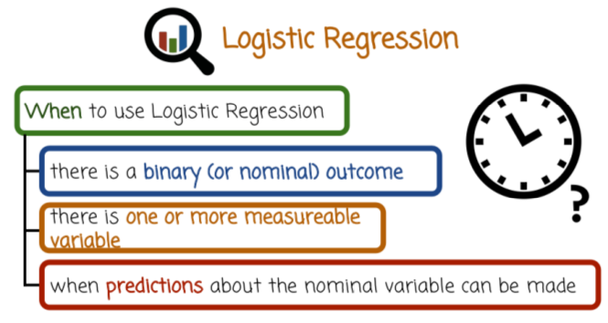

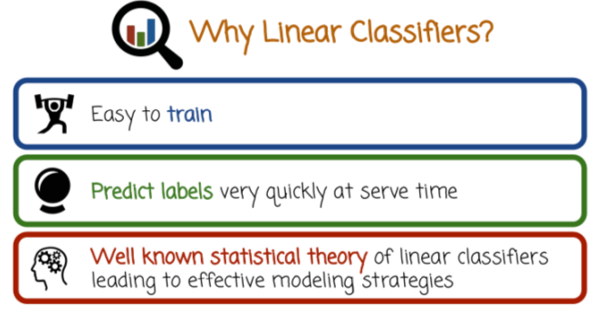
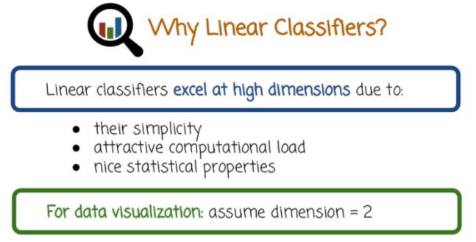

Logistic Regression如何選parameter:

Initialize θ random:

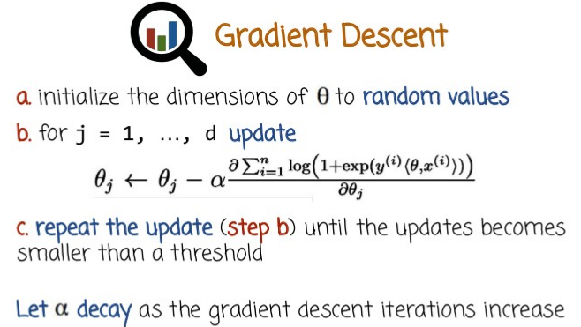
網上沒有找到關於如何初始化 θ的方法, 我的想法是, 有幾個原則:
- Initialize θ random, 如上圖
- Use domain knowledge, 例如課中的:
(level of radiation exposure, age, gender, BMI) = (2, 1, 0, 0.5), this specific classifier would basically assume that gender is not a good signal in determining cancer, because it has weight 0.BMI, age and radiation exposure are all important and their relative importance can be seen by the weights.
- 用較小的θ值, 因為課上講: Both of these penalty terms basically penalize high values of theta ( 注意在 ML 課中講了 , 對於 neural network, 很大的 weight 值容易導致 overfit, 這裡的 theta 應該差不多 ).
- 用合適的θ dimension, 因為 dimension太小會underfit, 太大會overfit.

SLC:

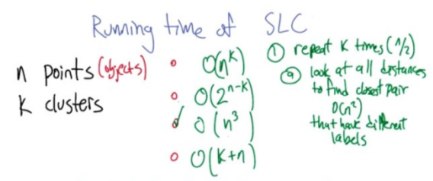

K-means:

K-means如何選center:

選center方法一: pick k centers at random (不好).

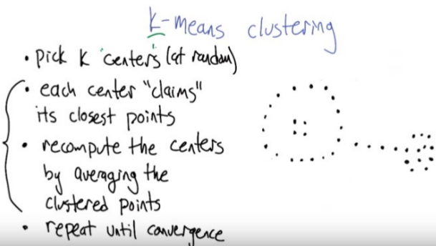
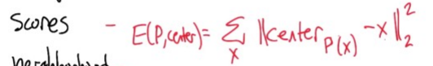

選center方法二: k-means++

An approach that yields more consistent results is K-means++. This approach acknowledges that there is probably a better choice of initial centroid locations than simple random assignment. Specifically, K-means tends to perform better when centroids are seeded in such a way that doesn't clump them together in space.

In short, the method is as follows:

1. Choose one of your data points at random as an initial centroid.
2. Calculate D(x), the distance between your initial centroid and all other data points, x.
3. Choose your next centroid from the remaining datapoints with probability proportional to D(x)^2.
4. Repeat until all centroids have been assigned.

Note: D(x) should be updated as more centroids are added. It should be set to be the distance between a data point and the nearest centroid.

You may also be interested to read this paper that proposes the method and describes its overall expected performance.

K-means如何選k:

How can we choose a "good" K for K-means clustering?
Some datasets have an "obvious" set of clusters that would be found by K-means clustering with the right choice of K. How can we, given a set of data, choose such a K?

ou can choose the number of clusters by visually inspecting your data points, but you will soon realize that there is a lot of ambiguity in this process for all except the simplest data sets. This is not always bad, because you are doing unsupervised learning and there's some inherent subjectivity in the labeling process. Here, having previous experience with that particular problem or something similar will help you choose the right value.

If you want some hint about the number of clusters that you should use, you can apply the Elbow method:

First of all, compute the sum of squared error (SSE) for some values of k (for example 2, 4, 6, 8, etc.). The SSE is defined as the sum of the squared distance between each member of the cluster and its centroid. Mathematically:

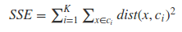

If you plot k against the SSE, you will see that the error decreases as k gets larger; this is because when the number of clusters increases, they should be smaller, so distortion is also smaller. The idea of the elbow method is to choose the k at which the SSE decreases abruptly. This produces an "elbow effect" in the graph, as you can see in the following picture:

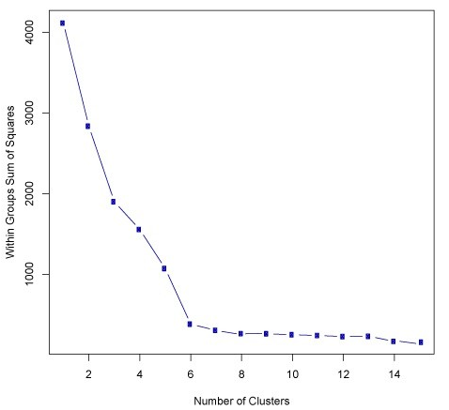

In this case, k=6k=6 is the value that the Elbow method has selected. Take into account that the Elbow method is an heuristic and, as such, it may or may not work well in your particular case. Sometimes, there are more than one elbow, or no elbow at all. In those situations you usually end up calculating the best k by evaluating how well k-means performs in the context of the particular clustering problem you are trying to solve.

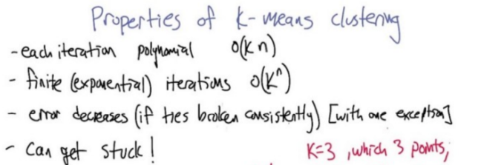

EM:

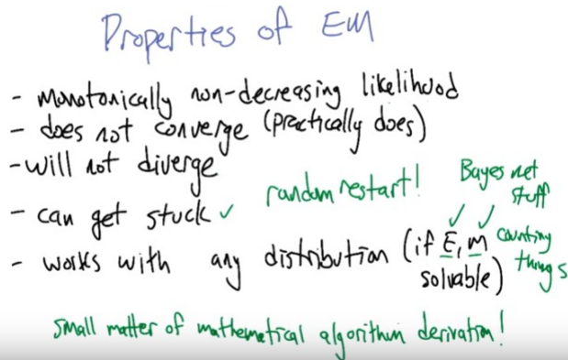

EM如何初始化:

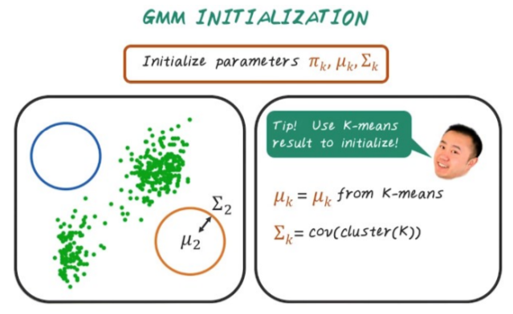
PCA (沒查到如何初始化 或 選參數):

