Lesson 3: Create New Activities and Navigate Apps with Intents

(5 intervals per day)
(From Lesson3, all the notes are exactly the subtitles)
(to compile: ./gradlew assembleDebug)
(This color is Blue 4)

Sunshine is now using real data thanks to the OpenWeatherMap API. And it's time for us to build out more of the UI. In this lesson you'll learn how to create activities, create the structure of your app, and learn how to navigate between screens. And that means learning more about activities, the intent framework and even learning how to use activities that come from other apps within your own.

Hey, Dan. want to see our weather app, so far, that we've been building? >> Pretty cool. But I want something more. >> Well, we're not done yet. We just started two lessons ago. Give us a break. But fair enough, there's still a bunch more work left to do. What do you think we should do next? >> Well for starters, let's make the list item do something when you click on it. >> Well, since you seem to be the expert on clicking on list items, why don't you do it? I'm going to go eat some jellybeans. >> I think Catherine was mocking me there. Speaking of mocks, let's go do some UI.

Sunshine looks something like this, but it doesn't show most of the fun information we have about the weather. We want to show a detailed view when the user clicks on a day within the list. Okay, that was a bit anticlimactic. It doesn't really do anything useful yet. But it will contain all sorts of great weathery details, things that weather nerds love such as barometric pressure and that navigators love such as wind speed and direction eventually, but baby steps.

From the mocks, we can see when a list item is clicked we should perform an action to open up the details page for the forecast. How do we implement the click listener behavior? Take a look at the ListView documentation. What method is used to wire up behavior on a list item when it is clicked?

The answer is setOnItemClickListener. We should register an OnItemClickListener with the list view via the setOnItemClickListener method. Then, when an item in the list view is clicked, the callback is invoked.

When the list item is clicked, use Android's Toast mechanism to display the weather forecast string. A Toast is a pop-up that displays a message for a few seconds before fading out. It's particularly useful for debugging, where it can be used as a way to indicate status visually without altering the app UI. We're going to put our list view (tao: already done before), set item click listener into forecast fragment inside of the on create view method (tao: see figure below). We'll just start typing listView.setOnItemClickListener and let the auto complete fill in the rest. Inside of this function, we're going to add click listener, which we can instantiate in place. So here's where we can call the code in Android to display the Toast. So, now that you know where to place the Toast code, take a look at the Toast documentation. Add a Toast when the list item is clicked that contains the weather information. Hint. You can get the forecast by getting an item from the forecast adapter, at the position given by the on item click listener.

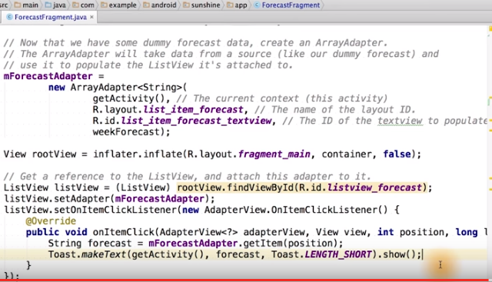
New Codes
Done already? Let me show you how it's done (tao: see figure above). As I said before, we get the forecast by calling getItem from the forecast adapter. And here's how we actually display the toast. Note that the context is actually available through getActivity in our fragment. However, it won't do anything unless we also show the toast. Displaying a toast is useful to see how an Android interaction works. But this method should really be used to start our detail activity. This is what we'll do next.

You're going to use Android Studio to create the detail activity from the blank activity with fragment template. The template asks for the hierarchical parent of detail activity, which defines the up button (tao: the sun) noted by the app icon, and a left pointing carrot here. But what does up mean? If you mapped out a hierarchy of all screens in the sunshine app, the root of the tree would be the MainActivity, and it's child would be the DetailActivity (tao: will create later). So, the app goes to the MainActivity. While the back button can achieve the same effect, it can also bring you back home or to another app, depending on your history of screens. Up will always navigate you within the same app to the parent, regardless of how you arrived at this screen. Create the detail activity now, and look at how the activity is declared in the Android manifest file.


We start by right-clicking on our package name to create the new activity from the Blank Activity with Fragment template (tao: in my Android Studio, there's no such option. So I chose Blank Activity, and the setup is as the figure below, note that I checked “Use a Fragment”). So for name, we use DetailActivity, and again, the hierarchical parent of this class is going to be our MainActivity. So as you can see, we now have a new DetailActivity along with the XML for activity_detail (tao: activity_detail.xml) and a fragment associated with that activity (tao: fragment_detail.xml). Great! You're done. But we still aren't launching our new activity.
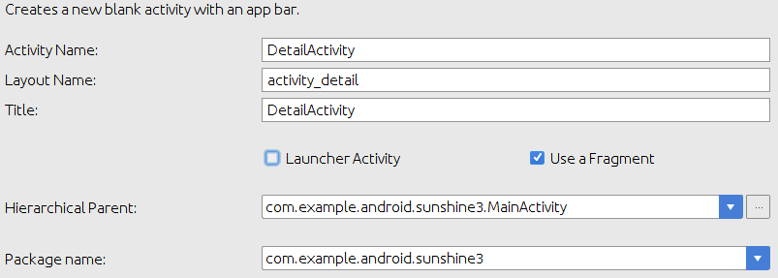

Match Our Code
As explained earlier, the new templates for Android Studio don’t exactly match the code seen in the videos. After generating your new DetailActivity you can do the following to remove the discrepancies:
- Copy over this code into DetailActivity.jav.
- Copy over this code into activity_detail.xml.
- Rename menu_detail.xml to just detail.xml. You’ll need to right-click on the menu_detail.xml file and select Refactor > Rename

Tao: DetailActivity.java in my Android Studio (can compile):

package com.example.android.sunshine3;
import android.os.Bundle;
import android.support.v4.app.Fragment;
import android.support.v7.app.AppCompatActivity;
import android.view.LayoutInflater;
import android.view.Menu;
import android.view.MenuItem;
import android.view.View;
import android.view.ViewGroup;
public class DetailActivity extends AppCompatActivity {
@Override
protected void onCreate(Bundle savedInstanceState) {
super.onCreate(savedInstanceState);
setContentView(R.layout.activity_detail);
if (savedInstanceState == null) {
getSupportFragmentManager().beginTransaction()
.add(R.id.container, new PlaceholderFragment())
.commit();
getSupportFragmentManager().beginTransaction().add(R.id.container, new PlaceholderFragment()).commit();
}
}
@Override
public boolean onCreateOptionsMenu(Menu menu) {
// Inflate the menu; this adds items to the action bar if it is present.
getMenuInflater().inflate(R.menu.detail, menu);
return true;
}
@Override
public boolean onOptionsItemSelected(MenuItem item) {
// Handle action bar item clicks here. The action bar will
// automatically handle clicks on the Home/Up button, so long
// as you specify a parent activity in AndroidManifest.xml.
int id = item.getItemId();
//noinspection SimplifiableIfStatement
if (id == R.id.action_settings) {
return true;
}
return super.onOptionsItemSelected(item);
}
/**
* A placeholder fragment containing a simple view.
*/
public static class PlaceholderFragment extends Fragment {
public PlaceholderFragment() {
}
@Override
public View onCreateView(LayoutInflater inflater, ViewGroup container,
Bundle savedInstanceState) {
View rootView = inflater.inflate(R.layout.fragment_detail, container, false);
return rootView;
}
}
}

Tao: activity_detail.xml in my Android Studio (can compile):

<FrameLayout xmlns:android="http://schemas.android.com/apk/res/android"
xmlns:tools="http://schemas.android.com/tools" android:id="@+id/container"
android:layout_width="match_parent" android:layout_height="match_parent"
tools:context="com.example.android.sunshine.app.DetailActivity" tools:ignore="MergeRootFrame" />

To move from one activity. In this case, the MainActivity in our sunshine app, to another, here the DetailActivity, we call StartActivity. But note that when using the StartActivity method, rather than specifying the class name of the activity to start directly, that class name is packaged explicitly within an intent. The basic premise is simple. Whenever you need your app components to communicate with each other, or the system, you use intents to identify the target destination. Starting activities within your app is the simplest example. [SOUND] With your intent explicitly indicating the target using the context and a class name of the activity. Intents that use the name of the component you're targeting directly, are known as explicit intents.

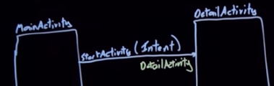

I like to think of intents as envelopes each one includes who, or in this case, which component you want it delivered to. And there's room for a small amount of data to be delivered, packaged as extras. Primitive tuples(元組, 數組) that will be available to the application component that ultimately receives and opens this intent. So an explicit intent, explicitly specifies the name of the recipient, as you can see on this envelope.
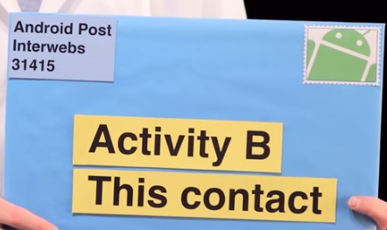

Implicit intents are a lot more interesting. Here, we don't specify the name of the class. We don't even know what it is. So, how do we indicate which activity to launch? Well, you know those stories you sometimes hear about letters with fake addresses like these that somehow still find their way to the intended recipient?


Well the intent resolution system on Android, works the same way. Finding an activity, capable of performing an action you specify on the associated data. So, rather than specifying the name of a class, you indicate an action you'd like an activity to perform, and on what data that action should be performed. Like this, where we want to address an activity that's capable of viewing a website. And because intents can cross through application boundaries, the activity that started, may not be part of your app. So, you can include functionality like this, browsing websites or making phone calls or choosing a contact from your address book.




All from within your app, without you having to implement any of it yourself. You don't even need to know about the app that will ultimately service your request. You can find details of some of the intents supported by native apps in Common Intents page of the Android developer site.

Thanks, Rado. Now that you understand what intents are in glorious metaphor, let's use them to do something useful. We'll replace the toast, with an intent to launch the detail activity. You'll need to pass in weather forecast data for the detail activity to display. For more information, see the intent extra constants defined in the intent class.
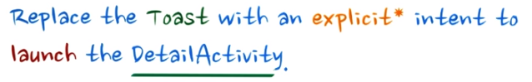
The solution is to lauch an explicit intent to the Detail Activity Class. We'll go to On Create View, where our On Item click listener is defined. To pass in the Weather Forecast information, we can use an intent extra, which is a key value pair in the Intent (tao: forcast is defined in the line above). We use the key name, Intent.EXTRA_TEXT, but we can use any string for the key. As long as we use the same key when reading the information out. Just as in the toast, we obtain the forecast data from the current list item, by calling get item on the adapter at the given position. Once we've added the intent, we just start the activity.
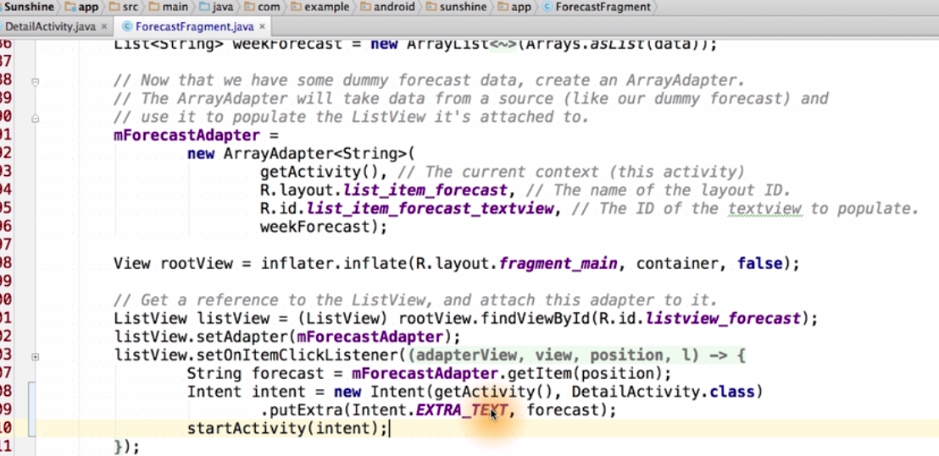

Once the Detail Activity is launched, it shows Hello World. Instead, we want to read the forecast data from the Intent, and display it. Make the appropriate changes in the app, so it matches the mocks. Then, verify the behavior by compiling and running the app.

In the fragment detailed layout, a text view is already defined. We have to assign it an ID so that within the detail fragment of detail activity we can use find view by ID to find the text view. To determine the forecast info that the text view should display. We can access the intent that the detail activity was launched by. We're going to use this inside of onCreateView. [SOUND] Since we added an intent extra with the forecast data there. We can read that intent extra back to display in the text view, as you can see we pulled the forecast string from the intent find our rootView and then set the text to that forecast string.
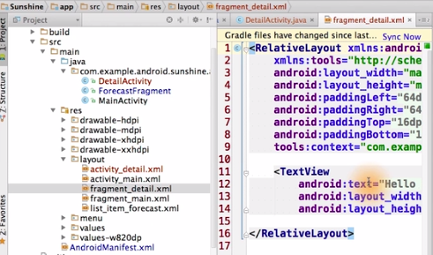

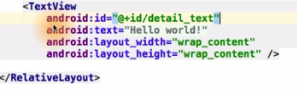

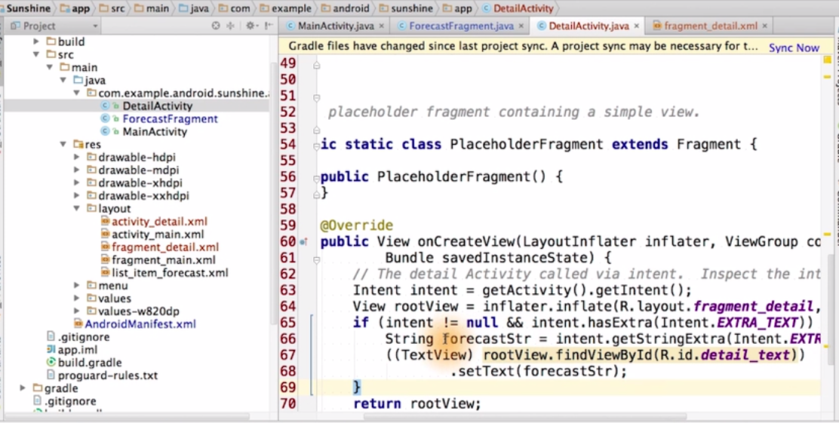
Woo Hoo. Clicking our list items works (tao: i.e., click on one item in the list view on the phone, like “Mon 6/23 – Sunny – 31/17”, then a new page displays, showing the same string: “Mon 6/23 – Sunny – 31/17” on the top and nothing else). >> Woo Hoo. [CLAP] >> Our app is awesome. >> Yeah. >> But clicking on the settings menu does nothing. Whomp whomp. #sadtrombone. >> Mm, don't do that again. Let me save you from Dan. And let's go build the settings now.

Let's go through the wire frames for the settings UI. Within the detail activity in the overflow menu, there's a settings menu item. When you tap on the setting's menu item, it opens up the settings activity. If you tap of location, it pops up a dialog, where you can enter in your postal code. Feel free to use your preferred method for inputting location, such as city name. Just verify that the data coming back from the server is for the location you expect. Note that there's no validation on this string input. If you're trying to make this app a production app, you would want some kind of air handling here. If you tap on pick your units, it opens up a dialogue where you can choose to display temperature within the app as wither metric or imperial units. This is basically just Celsius or Fahrenheit, and that is what this settings activity does.
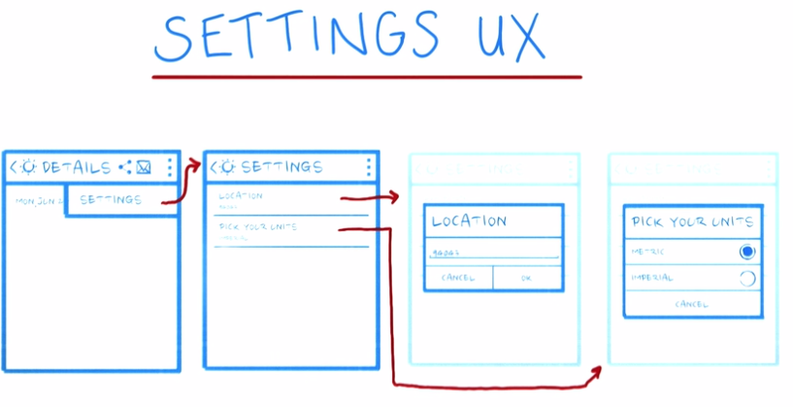
Remember that you don't want to make everything a setting. If you're discussing a feature with a teammate and you can't decide on something, don't compromise by just making it a user setting. There are instances where making a difficult product decision now will be better for the user, because then they won't have the burden of having to decide what the value of the setting should be. And remember, there's always an opportunity in an app update to add the setting later. If you add it to begin with, it's infinitely harder to take away the setting because some users might get angry with you. If you're having trouble deciding if something should be a setting or not, you can check out the setting section in the Android design guide, which is linked below. It contains a workflow diagram that could help you. Very few roads often lead to making something a setting.

Open up the Developer API Guide for Settings, if you want to follow along. If you've pondered it carefully and you've decided you really want this to be a setting, this is what you do next. Android provides a way to display a hierarchy of preferences, including headers, such as the ones shown here.

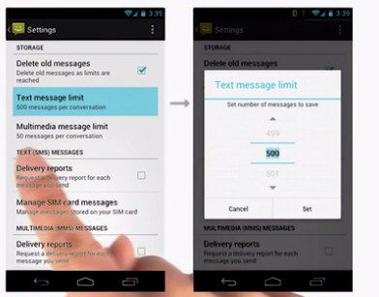

The value of the preference is called the preference summary, and that's seen here.
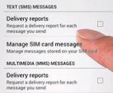

It looks almost like the subtitle text. The preference also provides UI. To allow users to modify that setting. You just need to supply the strings, but you don't have to implement the UI like the spinner here. Common preference types are the check box preference, list preference, edit text preference. We can see some examples in the settings app under developer options. Here's a bunch of preferences. This is an example of a check box preference.
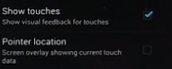

This is an example of a list preference where you have different radio button options here.
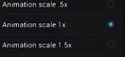

Once the user changes the setting, it gets saved in the default share preferences file. This stores a bunch of key value pairs of primitive data. An example integer preference could be how many days of e-mail history should be saved locally on the device. You could have a string stored integer preferences for what the currently selected account and device is. Then at any time you can fetch the value of this shared preferences, as long as you pass in the name of the key that you want. You can also use shared preferences outside the context of settings as well. This information is located in the developer API guide, for storage options, which is also linked below.
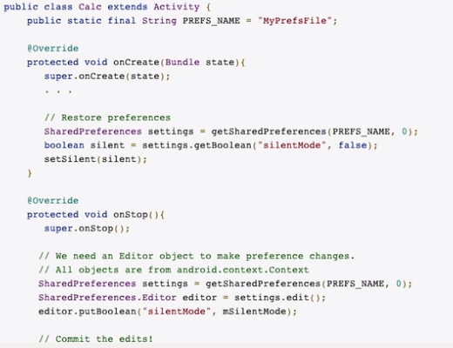
We'll take advantage of what the framework offers in order to build our SettingsActivity. Since we're supporting Gingerbread devices, we'll use a PreferenceActivity class. If you're targeting Honeycomber later, you'll want to use the PreferenceFragment class. Create a new SettingsActivity class from the gist provided below. Update the AndroidManifest to declare this new activity. You can see the way detail activity is declared as an example. If you see that APIs are deprecated, that's okay. That's a side effect of using PreferenceActivity, in order to target Gingerbread devices. When you create your app for your final project, you can use the wizard in Android Studio to create a new SettingsActivity. The code the wizard provides will make your app backward compatible, by using a combination of preference activity and PreferenceFragment. Our gist is meant to be a simplified version of that for learning purposes. So later, you'd be able to understand better what the wizard is doing. Check these items off when you're done.
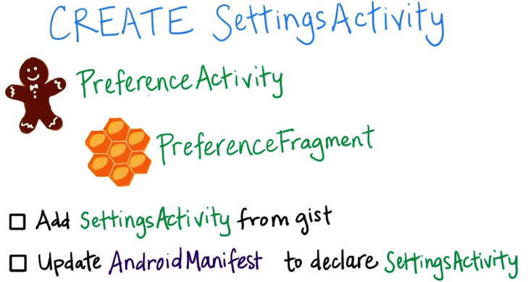

First, we create our settings activity, and this is the code that we got from the gist. Then, in the Android Manifest, we declare the settings activity. We give it an activity named Settings, which is declared in the Strings file. We also declare the main activity as the parent activity. That way, when you hit the up button in the settings activity, it will return back to the main activity.
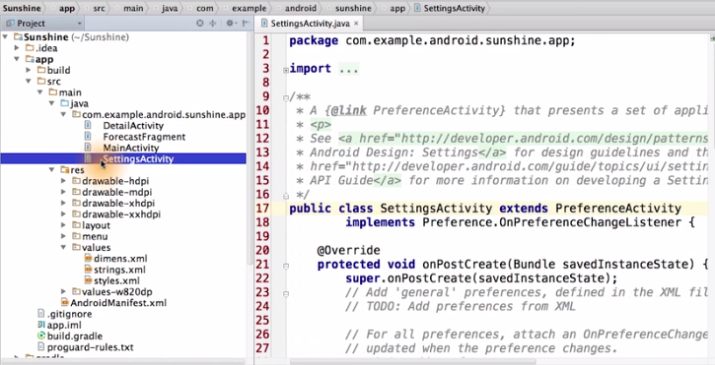

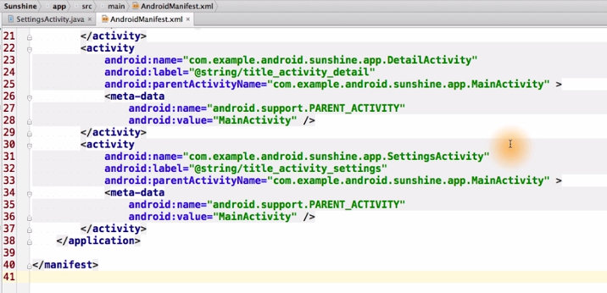
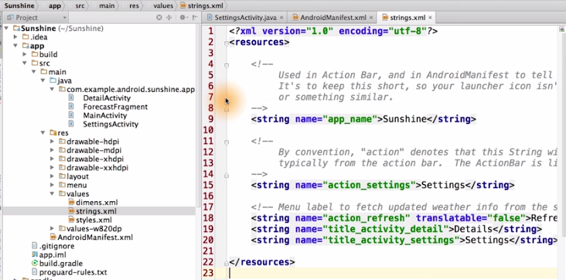

Stopped at and includes: subtile 20 (all codes added to my Android Studio and can compile)

