|  |  |  |  |  |  |  |  |  |  |  |  |  |  |  |  |  |  |  |  |  |  |  |  |  |  |  |
| --- | --- | --- | --- | --- | --- | --- | --- | --- | --- | --- | --- | --- | --- | --- | --- | --- | --- | --- | --- | --- | --- | --- | --- | --- | --- | --- |
| |  |  |  |  |  |  |  |  |  |  |  |  |  |  |  |  |  |  |  |  |  |  |  |  |  |  | | --- | --- | --- | --- | --- | --- | --- | --- | --- | --- | --- | --- | --- | --- | --- | --- | --- | --- | --- | --- | --- | --- | --- | --- | --- | --- | | |  |  | | --- | --- | | For office use only | | | T1 | ________________ | | T2 | ________________ | | T3 | ________________ | | T4 | ________________ | | |  | | --- | | Team Control Number **45596** | |  | | Problem Chosen **E** | | |  |  | | --- | --- | | For office use only | | | F1 | ________________ | | F2 | ________________ | | F3 | ________________ | | F4 | ________________ | |   **2016  MCM/ICM Summary Sheet** |

In a bid to assess whether a region has the ability to supply water to meet the demand, we establish an evaluation model of water-supplying ability based on Grey Model Theory. On the basis of previous research, we select 18 indicators from social, economic, environmental and technological aspects, all of which can affect a region’s water-supplying ability significantly. Considering relevancy among indicators, as well as their dynamic variation, we utilize Grey Relational Analysis to determine the weight of every indicator. Therefore, we define Carrying Capacity Sustainability (CCS), Carrying Capacity Pressure (CCP) and Carrying Capacity Index (CCI) to evaluate a region’s ability comprehensively.

We select Shandong, China as our target region in following research. After acquiring data of every indicator, we calculate the value of CCI of Shandong is 1.238 in 2004, which is classified to be overloaded. According to the score of every indicator, we give explanations for water scarcity from both economic and physical perspectives.

Afterward, based on Grey Prediction Model, we make prediction of Shandong’s water situation in the following 15 years. Tendency of CCI shows improvement of water-supplying ability, but the scores of some indicators show the situation of citizens’ water usage goes worse. We notice Population Size and other 6 indicators contributes most to water-supplying ability in this region. Taking them into account, we design intervention plan targeted at this region. Meanwhile, we also present the effects on surrounding areas, together with strengths and drawbacks of plan in a qualitative way.

With the help of Grey Prediction Model and Intervention Factor Model, we forecast water situation after the plan is carried out in the following years quantitatively. Comparison of original predicted value and intervened value illustrate that our plan accelerate the improving process of water-supplying ability, reflecting the effectivity and efficiency of our plan. However, we notice benefit of our plan decreases in the long run. This suggests we need to design new intervention plan years later.

**Contents**

I Introduction 2

**1.1** **Background** 2

**1.2** **Our Work** 2

II Assumptions 3

III Model 3

**3.1** **Overview of model** 3

**3.2** **Introduction to Grey System Theory** 4

**3.3** **Indicators selection** 5

**3.4** **Establishment of evaluation model** 6

3.4.1 Data standardization 6

3.4.2 Determination of weight of every indicator 6

3.4.3 Calculation of indexes 7

3.4.4 Classification of water-supplying ability 7

**3.5** **Establishment of prediction model** 8

3.5.1 Data generation 8

3.5.2 GM(1,1) model 8

IV Application 9

**4.1** **Judgment on water-supplying ability of Shandong province** 9

4.1.1 Three indexes of this region in 2004 9

4.1.2 Explanations for water scarcity of Shandong 11

**4.2** **Water situation in 15 years** 11

4.2.1 Prediction of indexes of the following years 11

4.2.2 Impacts of water situation on citizens 12

V Intervention plan 13

**5.1** **Indicators we intervene and our plan** 13

**5.2** **Qualitative analysis of plan** 14

**5.3** **Quantitative analysis of plan** 15

VI Sensitivity analysis 17

VII Advantages and disadvantages 18

VIII Reference 19

I. Introduction

* 1. **Background**

Water resource, known as one of matter bases of human's society, plays an extremely vital role during human society developing process. It is also one of the basic elements of economic development. As *The United Nations World Water Development Report 2015* (WWDR 2015) points out[1], water resources, and the essential services they provide, are among the keys to achieving poverty reduction, inclusive growth, public health, food security, lives of dignity for all and long-lasting harmony with earth’s essential ecosystems.

With the rapid development of industry all over the world and sharp increase of population, the demand of water resource rise gradually in general. On the other hand, severe water pollution greatly limits the amount of water available. In addition, poor management of this resource and the lack of infrastructure lead to even more pernicious effect on water resource availability in some parts of the world. Thus, some regions find it difficult to supply enough clean and fresh water to people. In other words, the relationship between supply and demand of water resources goes irreconcilable in some regions.

On account of various negative effects of water scarcity, quantities of measures are gradually taken, including inter-basin water transfer and planting more trees to reserve water. Sea water desalination technology of some countries beside the sea, and some new irrigation technologies (drip irrigation-ODF and sprinkling irrigation) adopted by some agricultural countries, have achieved quite good results. Thanks to these actions, water scarcity is still in the controllable range in short order.

* 1. **Our Work**

In order to assist ICM to solve world’s water problem, a mathematical model is needed to evaluate a region’s ability to provide clean water to meet the demand. So far several evaluation systems have been established and applied to assess usage of water in a region, most famous indexes among which are Water Scarcity Index (WSI) proposed by Falkenmark and Widstrand in 1992[2] and Water Footprint proposed by Hoekstra in 2002[3]. However, there is still no consensus about the indicators globally. Based on their studies, we take influence factors from social, economic, environmental and technological aspects into consideration, as is shown in Figure 1. Then we establish a new evaluation system. To be specific, we select 7 positive and 11 negative factors to water availability and determine how much these factors contribute to the positive and negative aspects based on Grey Relational Analysis (GRA), then we are able to get the values of Carrying Capacity Sustainability (CCS) and Carrying Capacity Pressure (CCP). Thus we can evaluate the water-supply ability according to the ratio of the two indexes, defined as Carrying Capacity Index (CCI).



**Figure 1 Four aspects of our evaluation system**

In our following work, we choose Shandong province, China as our target region, which is classified into heavily exploited areas in WSI 2004. On the basis of our data analysis, we give the explanations on water scarcity of this region.

Furthermore, we make a prediction with prediction model. Analyzing the result, we realize ability of providing water improves, but it is still overloaded. View of this situation, we put forward our intervention plan from several aspects, and we find our plan helps this region strengthen the ability to supply water to meet the demand based on forecast.

Last but not least, we make sensitivity analysis, and list advantages and disadvantages of our model.

II. Assumptions

* No major natural disasters and emergencies will occur during the years we make prediction of. That is to say, there exists no significant climatic and environmental differences among all years.
* Interference of policies and plans is stable, so the intervention factor of our intervention plans is a constant.

III. Model

* 1. **Overview of model**

Our model is established based on Grey Model Theory. On one hand, we structure a new evaluation system of water-supplying ability of a region, so we can judge whether it is able to provide enough water to meet the demand according to the score of indexes. This makes up the quantitative analysis part of our model. On the other hand, we build a prediction model of a region utilizing Grey Prediction Method. Therefore, we are able to figure out the trend of development of region’s water-supplying ability. This is the qualitative analysis part of our model. Taking all the results into consideration, we are able to draw the conclusion on how serious the water scarcity of a region is and what the trend in the future is. Hence, we may design some intervention plans to help this region improve gradually. This is the comprehensive analysis part of our model.

The flow chart of our model is shown below:



**Figure 2 The flow chart of GM analysis process**

* 1. **Introduction to Grey System Theory**

System containing both known information and unascertained information is defined as Grey System. Grey System Theory was put forward by Professor Deng Julong in 1982. It concentrates on problems[4] with limited amount of samples and information.

Grey System Theory provides a new analytical method, called Correlation Analysis Method, which is applied in the establishment of our evaluation system. Actually, Correlation Analysis Method is[5] the analysis of correlation coefficient. We firstly calculate the correlation coefficient of ideal plan consist of every single plan together with optimal indexes, then figure out the relevancy among them.

Grey System Theory also supplies a vital approach of prediction, Grey Prediction. Grey Prediction is making a forecast the according to Grey Model, which also can be utilized to predict the moment when unusual behavior will occur in one system. We use Grey Prediction to forecast water-supplying ability in 15 years of a region, and to simulate the effect of our intervention plan.

* 1. **Indicators selection**

Considering the particularity of water resource, we select indicators adhering the following principles[6]:

* Dynamic principle. During the analysis process, we will take the variation trend of the relationship between different indicators of different periods into consideration, together with complex correlation among them.
* Integrality principle. As is mentioned above, indicators we select need to cover different aspects that may influence water-supplying ability, including economy, society, environment and technology. Furthermore, we divide selected indicators into positive factors and negative factors, to reflect both aspects of the ability of a region.
* Reasonableness principle. We select indicators on the basis of former research done by experts, thus the system structure of index and acceptance or rejection of an indicator lie on scientific basis, which guarantee the reliability of results.
* Feasibility principle. Indicators which we have easy access to have a priority in our selection. Therefore, we can ensure the data is integrated.

Based on principles above, we select 15 indicators ultimately, listed as follows:

**Table 1 Indicators selected**

|  |  |
| --- | --- |
| Aspects considered | Indicators |
| Economic | Proportion of industrial water C1 |
| Agricultural water consumption per capita C2 |
| Emissions of industrial wastewater per unit of GDP C3 |
| GDP growth rate C4 |
| GDP per capita C5 |
| Effective irrigation area per capita C6 |
| Social | Total water consumption C7 |
| Population growth rate C8 |
| Domestic water consumption per capita C9 |
| Population size C10 |
| Urbanization rate C11 |
| Water storage C12 |
| Water resources per capita C13 |
| Environmental | Total water supply C14 |
| Forest coverage rate C15 |
| Groundwater quantity C16 |
| Surface water quantity C17 |
| Technological | R&D expenditure C18 |

* 1. **Establishment of evaluation model**
     1. Data standardization

Dimensions of data we obtain are different from each other, thus we need to standardize the data. As is mentioned above, we divide indicators into positive and negative ones, so we need to use different formula to standardize them respectively.

When an indicator contributes negatively, the formula is[7]:

 (1)

where is the standardized data of a single indicator; is actual value;  is reference value here we choose the minimum value of data among years.



When an indicator contributes positively, the formula is:

 (2)

where  is the standardized data of a single indicator;  is actual value;  is reference value, here we choose the maximum value of data among years.

* + 1. Determination of weight of every indicator

Based on Grey Model Theory, we need to select one indicator from negative indicators, and one from positive ones, which can rough reflect the ability of this region to provide clean water and the demand of clean water, as reference indicators. Taking various factors into consideration, we select total water consumption (C7) as negative reference indicator, and total water supply (C14) as positive reference indicator.

Let  be data array of reference indicator, and[8]



where  represents time. Assuming there are  arrays to be compared:



we define

 (3)

as correlation coefficient of array  to reference array , where  is resolution coefficient. Therefore, we are able to give the definition of relevancy  as

 (4)

Afterward, we can calculate the weight of every single indicator according to following formula:

 (5)

* + 1. Calculation of indexes

On the basis of standardized data of every indicator and the weight calculated, we are able to get negative score and positive score of the ability of providing water to meet the demand of a region. We define[9] negative score as Carrying Capacity Pressure (CCP) which reflect the ability of this region to provide water, and positive one as Carrying Capacity Sustainability (CCS), which reflects the level of demand of water. Calculation formulas are as follows:

 (6)

 (7)

Here we can find that, a larger value of CCP means the weaker ability of a region to supply enough water, while a lager value of CCS means this ability gets stronger.

* + 1. Classification of water-supplying ability

In order to reflect water-supplying ability directly, we define Carrying Capacity Index (CCI) as follows[9]:

 (8)

After referring to relative materials, we can get a table of classification to describe the degree of water-supplying ability qualitatively[10]:

**Table 2 Standard of classification in water-supplying ability**

|  |  |  |
| --- | --- | --- |
| **Basic Type** | **Subtype** |  |
| Overload (I) | Heavily (IA) |  |
| Moderately (IB) |  |
| Lightly (IC) |  |
| Criticality (II) |  |  |
| Lack-of-load (III) | Heavily (IIIA) |  |
| Moderately (IIIB) |  |
| Lightly (IIIC) |  |

* 1. **Establishment of prediction model**
     1. Data generation

There are two main ways to generate data: Accumulated Generating and Average Generating. Referring to existing materials[8], we are able to get the formula of Accumulated Generating:

 (9)

and the formula of Accumulated Generating:

 (10)

* + 1. GM(1,1) model[8]

The grey derivative of  is:



so we can define grey differential equation model as:



In other words

 (11)

where  is development factor,  is white background value and  is grey action.

Let time  in equation (11), we can get

 (12)

where , , . Via OLS, we can get

 (13)

If we consider time  as a continuous variable , then  can be written as . Meanwhile, let  correspond to  and  correspond to, we get white differential equation corresponding to grey one:

 (14)

VI. Application

We select Shandong province, China, which is classified as heavily overloaded area according WSI 2004, as our target region in our further research.

* 1. **Judgment on water-supplying ability of Shandong province**
     1. Three indexes of this region in 2004

In order to determine the weight of every indicator when evaluating its ability, we obtain origin data from[11] *Statistical Yearbook of Shandong Province* and[12] *Statistical Yearbook of China.* According to formula (1) and formula (2), the standardized data is listed as follows:

**Table 3 Standardized data of Shandong province**

(Negative indicators)

|  |  |  |  |  |  |  |  |  |  |  |  |
| --- | --- | --- | --- | --- | --- | --- | --- | --- | --- | --- | --- |
| **Year** | **C1** | **C2** | **C3** | **C4** | **C5** | **C6** | **C7** | **C8** | **C9** | **C10** | **C11** |
| **2004** | 0.99 | 0.92 | 1.00 | 0.39 | 1.00 | 0.94 | 0.97 | 1.00 | 1.00 | 0.94 | 1.00 |
| **2005** | 0.78 | 0.93 | 0.87 | 0.43 | 0.82 | 0.94 | 0.92 | 0.97 | 0.98 | 0.95 | 0.71 |
| **2006** | 0.75 | 1.00 | 0.78 | 0.50 | 0.70 | 0.94 | 0.99 | 0.92 | 0.98 | 0.96 | 0.70 |
| **2007** | 0.83 | 0.94 | 0.74 | 0.54 | 0.59 | 0.94 | 0.99 | 0.83 | 0.93 | 0.96 | 0.67 |
| **2008** | 0.85 | 0.92 | 0.66 | 0.48 | 0.50 | 0.94 | 0.99 | 0.85 | 0.89 | 0.97 | 0.67 |
| **2009** | 0.85 | 0.91 | 0.65 | 1.00 | 0.46 | 0.94 | 1.00 | 0.94 | 0.91 | 0.97 | 0.67 |
| **2010** | 0.91 | 0.89 | 0.63 | 0.62 | 0.40 | 0.94 | 1.00 | 0.90 | 0.90 | 0.99 | 0.64 |
| **2011** | 1.00 | 0.85 | 0.56 | 0.61 | 0.35 | 0.94 | 1.00 | 0.90 | 0.91 | 0.99 | 0.63 |
| **2012** | 0.95 | 0.88 | 0.55 | 0.93 | 0.32 | 0.93 | 0.98 | 0.82 | 0.92 | 1.00 | 0.62 |
| **2013** | 1.00 | 0.85 | 0.51 | 0.92 | 0.29 | 1.00 | 0.97 | 0.83 | 0.94 | 1.00 | 0.59 |

(Positive indicators)

|  |  |  |  |  |  |  |  |
| --- | --- | --- | --- | --- | --- | --- | --- |
| **Year** | **C12** | **C13** | **C14** | **C15** | **C16** | **C17** | **C18** |
| **2004** | 0.89 | 0.84 | 0.95 | 0.80 | 0.90 | 0.79 | 0.11 |
| **2005** | 0.94 | 1.00 | 0.98 | 0.80 | 1.00 | 1.00 | 0.16 |
| **2006** | 0.68 | 0.48 | 1.00 | 0.80 | 0.68 | 0.37 | 0.23 |
| **2007** | 0.90 | 0.92 | 0.97 | 0.87 | 0.93 | 0.95 | 0.29 |
| **2008** | 0.84 | 0.78 | 0.97 | 0.87 | 0.84 | 0.77 | 0.36 |
| **2009** | 0.67 | 0.67 | 0.97 | 0.87 | 0.84 | 0.59 | 0.43 |
| **2010** | 0.79 | 0.72 | 0.99 | 0.87 | 0.85 | 0.67 | 0.56 |
| **2011** | 1.00 | 0.80 | 0.99 | 1.00 | 0.92 | 0.80 | 0.71 |
| **2012** | 0.89 | 0.63 | 0.98 | 1.00 | 0.77 | 0.62 | 0.86 |
| **2013** | 0.76 | 0.67 | 0.97 | 1.00 | 0.81 | 0.65 | 1.00 |

On the basis of formula (3), (4) and (5), we ascertain the weight of every indicator, which is shown in Table 4. As is mentioned in Section 3.3.2, total water consumption (C7) and total water supply (C14) are selected to be reference indicator of negative and positive indicators respectively, so their weights are meaningless here.

**Table 4 Weight of every indicator**

(Negative indicators)

|  |  |  |  |  |  |  |  |  |  |  |
| --- | --- | --- | --- | --- | --- | --- | --- | --- | --- | --- |
| **Indicators** | **C1** | **C2** | **C3** | **C4** | **C5** | **C6** | **C8** | **C9** | **C10** | **C11** |
| **Weight** | 0.11 | 0.11 | 0.08 | 0.08 | 0.07 | 0.12 | 0.11 | 0.12 | 0.13 | 0.08 |

(Positive indicators)

|  |  |  |  |  |  |  |
| --- | --- | --- | --- | --- | --- | --- |
| **Indicators** | **C12** | **C13** | **C15** | **C16** | **C17** | **C18** |
| **Weight** | 0.18 | 0.16 | 0.18 | 0.18 | 0.16 | 0.13 |

Afterward, we calculate the score of every index, shown in Table 5:

**Table 5 Score of every indicator**

(Negative indicators)

|  |  |  |  |  |  |  |  |  |  |  |
| --- | --- | --- | --- | --- | --- | --- | --- | --- | --- | --- |
| **Indicators** | **C1** | **C2** | **C3** | **C4** | **C5** | **C6** | **C8** | **C9** | **C10** | **C11** |
| **Score** | 0.109 | 0.105 | 0.079 | 0.031 | 0.067 | 0.114 | 0.107 | 0.117 | 0.122 | 0.076 |

(Positive indicators)

|  |  |  |  |  |  |  |
| --- | --- | --- | --- | --- | --- | --- |
| **Indicators** | **C12** | **C13** | **C15** | **C16** | **C17** | **C18** |
| **Score** | 0.159 | 0.138 | 0.148 | 0.162 | 0.127 | 0.015 |

Therefore, we can calculate that, the value of three indexes of Shandong province in 2004 is: , and . Consulting Table 2, we draw the conclusion that the water capacity is lightly overloaded in Shandong, which means it’s quite hard for this region to provide enough water to meet the demand. This conclusion corresponds to the classification conducted by the UN, reflecting the rationality of the evaluation system.

* + 1. Explanations for water scarcity of Shandong

After carefully analyzing the score of every indicator, we conclude some reasons leading to water scarcity. We list them as follows:

* Physical scarcity:
  + Referring to relative material, we find that Shandong locates between 34°22’-38°23’N, 114°19’-112°43’E, which has monsoon climate of medium latitudes. This determine the surface water amount is limited. This is reflected by the score of indicator Surface Water Quantity (C17). Its score is only 0.127, which is last but one among all the positive indicators.
* Economic scarcity:
  + The score of R&D expenditure (C18) is at the top of bottom, much less than other positive indicators. This suggests that the technology of this region is so laggard that it has hindered the full usage of water resource severely.
  + The score of population size (C10) ranks number one among all negative indicators, which means the large number of population has an extremely bad effect on water usage. Data displays that the number of population is 91.8 million in 2004, increasing at the rate of around 6.01‰. Obviously, it’s a heavy burden to supply water to meet the demand.
  1. **Water situation in 15 years**
     1. Prediction of indexes of the following years

Utilizing the model established in Section 3.5, we may get the values of three indexes in the next following 15 years, which are shown in Figure 3 together with data of 2004-2013. The latest data we have access to is data of 2013, so we choose 2014 as the beginning of our prediction.

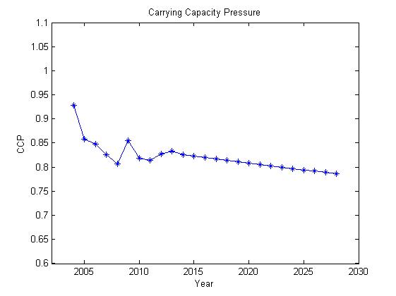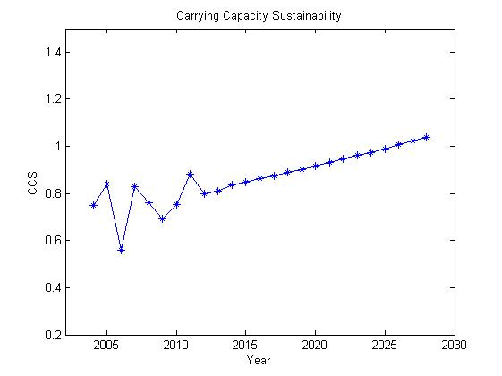

1. (b)

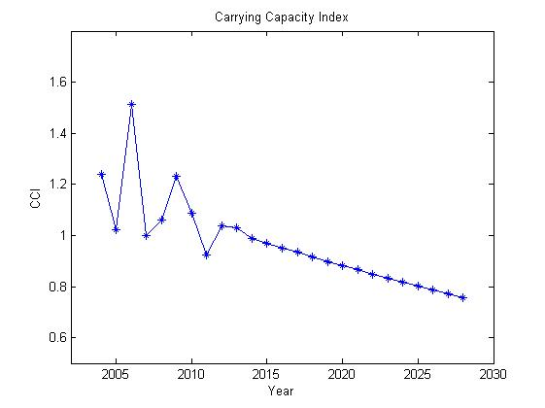

(c)

**Figure 3 The developing trend of (a) CCP, (b) CCS and (c) CCI**

Here we can find that the value of CCP has a tendency of steady decrease, while the value of CCS decreases more sharply, except for the data of 2006. After looking up to relative materials, we find a severe drought attacked Shandong province in 2006, which account for the abnormal value of CCS in 2006. The tendency of the two indexes suggests that in the following 15 years, the level of demand of water in this region decreases, so does the ability of this region to provide water.

CCI of this region decreases from 0.99 in 2014 to 0.76 in 2028, reflecting the ability of Shandong to provide enough water to meet the demand improves gradually. However, it is classified into lightly lack-of -load according to Table 2, which is still not optimistic enough.

* + 1. Impacts of water situation on citizens

In order to figure out how will water situation of following years impact lives of citizens in this region, we predict the situation of several significant indicators that related closely to lives of citizens. These indicators are Domestic water consumption per capita (C9), Water resources per capita (C13) and Forest coverage rate (C15). Similarly, we give Figure 4 to show their developing tendency.

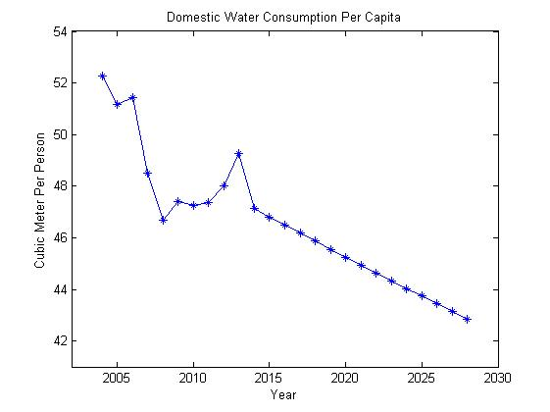

1. (b)

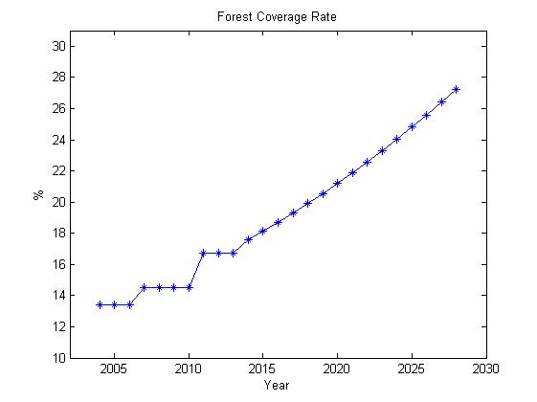

(c)

**Figure 4 The developing trend of (a) Domestic water consumption**

**per capita, (b) Water resources per capita and (c) Forest coverage rate**

From Figure 4 (a) and (b), we can clearly find that the Domestic water consumption per capita (C9) and Water resources per capita (C13) go down in the following years. This suggests that, although water scarcity is alleviated according to CCI tendency in Figure 2, it brings few benefits to water usage of citizens. Water resource available decreases gradually, which make it harder for the region to supply enough water to meet the citizens’ demand.

On the other hand, in a bid to prevent desertification of land, and water and soil loss, more trees are going to be planted, which will provide a better environment for their living.

V. Intervention plan

* 1. **Indicators we intervene and our plan**

According to the explanations of water scarcity in Section 4.1.2, we conclude that we need to focus both on enhancing the ability to supply water and restraining demand which is beyond a reasonable range. Based on the correlation calculated with formula (4) in evaluation model, we are able to figure out how every indicator is related to reference indicators (C7 and C14). We rank all the indicators according to their correlation, and show them in Figure 5.

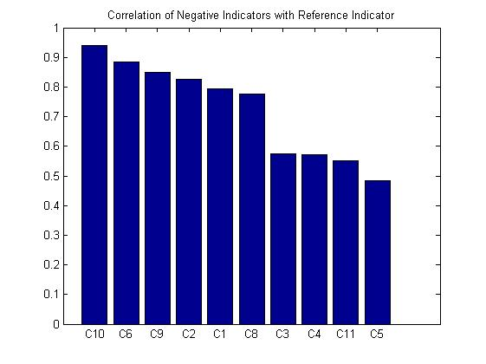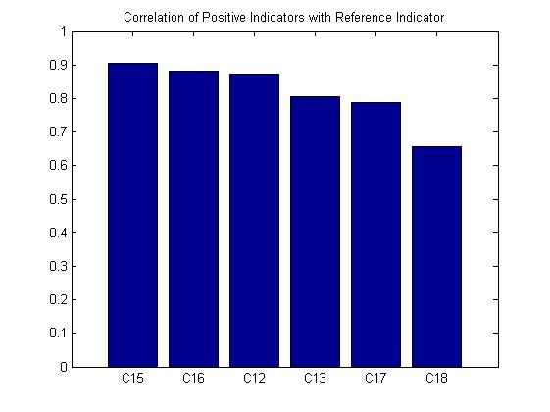

**Figure 5 Rank of indicators according to correlation with reference indicator**

Therefore, we find the indicators need most intervention are C1, C2, C9, and C10 among negative indicators, together with C12, C15 and C16 among positive indicators.

Now, we put forward our intervention plan as follows:

* Control the number of population scientifically. To be specific, we need to limit the size of population and improve the structure of population.
* Limit domestic, agricultural and industrial water consumption in a scientific way, including promoting technological development to increase utilization rate of water; applying new irrigation methods (e.g. drip irrigation-ODF and sprinkling irrigation); developing advanced waste water treatment system to make full use of waste water.
* Improve the ecological environment. We need to reserve vegetation and protect forests. Also, we need to focus on the ecological environment of rivers and seas, and strictly prohibit over-usage of groundwater.
* Pay more attention to infrastructure construction. For example, establish more large reservoirs to enhance the ability of the region to face extreme weather condition.
  1. **Qualitative analysis of plan**

We can sum the impacts on surrounding areas of our plan up, as follows:

* The population policy may accelerate the urbanization, while it may also lead to manpower shortage.
* Changes of economic and society will impact nearby areas positively via market effect.
* The environmental improvement will bring surrounding areas a more friendly ecological environment.

Therefore, we may conclude main strengths and drawbacks. Our intervention plan concentrates on indicators contributing much to water-supplying ability of a region, and it can help a region get biggest reward with limited investment in a relatively short time. However, our plan ignore indicators contributing less to the ability than significant ones, which also hinder the improvement of ability to some extent.

* 1. **Quantitative analysis of plan**

We introduce[13] intervention factor  to represent the effect of our intervention plan has on the prediction of some indicators. Here we define the relationship between our plan and the value of  is :

**Table 6 Relationship between**  **and plan**

|  |  |
| --- | --- |
|  | Character of plan |
| >0 | Supporting plan |
| =0 | No intervention plan |
| <0 | Restraining plan |

Therefore, the predicted value of them can be written as:

 (15)

Where  is the origin prediction value of an indicator,  is interfered value.

We are able to get the total intervention factor of CCP and CCS, according to the following formulas:

  (16)

Therefore, the interfered value of prediction of CCP and CCS can be written as:

 (17)

 (18)

where  is original prediction value,  is the interfered value of prediction; is original prediction value, is the interfered value of prediction.

Theoretically, the value of  varies between . However, it is obvious that the larger value of  means we will face more difficulty when carrying out the plan. Consulting relative materials[13], we have the relationship between  and the work difficulty level :

**Table 7 Relationship between  and the work difficulty level **

|  |  |  |  |  |  |
| --- | --- | --- | --- | --- | --- |
|  | 1 | 2 | 3 | 4 | 5 |
| (%) | 0.0-2.5 | 2.5-5 | 5-10 | 10-20 | >20 |

In Table 7, a larger value of  suggests more difficulty in carrying out the plan we put forward.

Taking work difficulty level  and the feasibility of our plan, together with how much every indicator contributes to water-supplying ability into consideration, we design intervention factor  of indicators. We list them in Table 8.

**Table 8 Intervention factor  of every indicator in our plan**

(Negative indicators)

|  |  |  |  |  |  |  |  |  |  |  |
| --- | --- | --- | --- | --- | --- | --- | --- | --- | --- | --- |
| **Indicators** | **C1** | **C2** | **C3** | **C4** | **C5** | **C6** | **C8** | **C9** | **C10** | **C11** |
| (%) | -7 | -8.5 | -7 | 0 | 0 | 0 | -4.5 | -8.5 | -4.5 | 0 |

(Positive indicators)

|  |  |  |  |  |  |  |
| --- | --- | --- | --- | --- | --- | --- |
| **Indicators** | **C12** | **C13** | **C15** | **C16** | **C17** | **C18** |
| (%) | 2.5 | 0 | 2 | 1.5 | 1.5 | 8.5 |

Based on formula (16), (17) and (18), we make a prediction about the trend of CCI in the future. In comparison, we make a 15-year prediction, and list them in Figure 6 together with original predicted data.

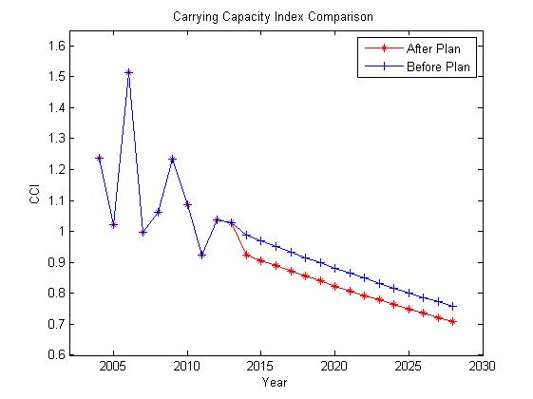

**Figure 6 Comparison of prediction before and after the plan is carried out**

Clearly, with the help of our intervention plan, the improvement process of water-supplying ability is accelerated apparently. By the end of the following 15 years, CCI decreases to 0.72, better than originally predicted value.

From another perspective, we draw define relative change rate as:



Therefore,  is able to reflect the relative benefit our intervention plan to this region. We give the value of  with variation of time in Figure 7:

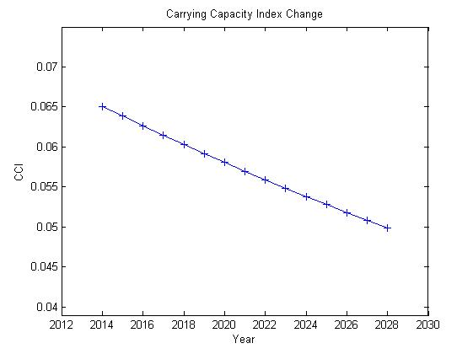

**Figure 7**  **with variation of time**

Here we can find, our plan brings a quite good benefit to water-supplying ability of this region in the early years, but relative benefit decreases gradually over years. We hold the belief that with the help of our plan, water-supplying ability is enhanced year by year, so that there is limited room for improvement a decade later. We need to design new intervention plan, concentrating on indicators we ignored in this intervention plan.

Therefore, we conclude that with assistance of timely and appropriate intervention plans of different times, this region is going to be less susceptible to water scarcity gradually. In other words, water will not be a critical issue in the future.

VI Sensitivity analysis

Based on Grey Theory Model, we can make sensitivity analysis[14] via taking a derivative of CCI with respect to time. From the establishment of model in this research, the solution to equation (14) is:



so the derivative is



We can illustrate how derivative changes with the variation of time in Figure 8. (Here we make an axis-shift, so that time starts from 1).

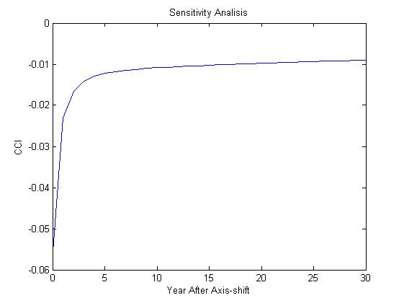

**Figure 8 Sensitivity analysis of model**

In Figure 7, when , the slope of the figure is nearly a constant. This suggests result of our model varies little with parameters changing. In other words, our model is rather stable.

VI I Advantages and disadvantages

* Advantages:
  + Consisting of relatively succinct indicators, our model is able to evaluate the ability of a region to supply water to meet the demand with creativity.
  + Based on Grey Model Theory, our model does also well in the situation where there is no abundant data.
  + Our model establish the index system from an interdisciplinary perspective, related to social, environmental and economic factors.
* Disadvantages:
  + We let intervention factor  be a constant in our intervention plan. This determines we can only predict the result of stable plans.
  + Events with a random nature are ignored by this model.

I I Reference

[1]The United Nations Educational,The United Nations World Water Development Report 2015:Scientific and Cultural Organization.Water for a sustainable world:UNESCO,2015.

[2]Malin Falkenmark,Carl Widstrand.Population and water resources:a delicate balance[J].Population Bulletin,1992,19.

[3]Chapagain A K,Hoekstra A Y. Water footprints of nations[C].Delft,the Netherlands:Value of Water Research Report Series:No.16.IHE,2004.

[4]Wen Lihua.Grey System Theory and Application[D].Harbin:Harbin Engineering University,2003.

[5]Guo Hong.Distinguishing coefficient of grey correlation,Fuzzy math,1985:Vol.5,No.2:55-58.

[6]Jia Rong,Xue Huifeng,Xie Jiancang,Jiang Xiaohui.Research on the Bearing Capacity of Regional Water Resources[J].Journal of Xi’an University of Technology, 1998:Vol.14,No.4.

[7]Li Changsheng,Deng Baozhong.A study on sustainable development indicators system of Longjiang country[J].Natural Science Journal of Harbin Normal University, 2007:Vol.23,No.5:104-105.

[8]Si Shoukui.Mathematical modeling algorithm and program[M].1.Naval Aeronautical Engineering Institute,2007:418-419;425-428.

[9]Feng Langang,Jiao Yanchen,Du Bijun.Capacity of water resources in hebei province based on AHP[J].Industry Technology Economy,2009:Vol.28,No.7:90-93.

[10]Sun Fuxing.Analysis and application of the water resources capacity[D].Nanking:Hohai University,2006.

[11]Liu Xinghui.Shandong Statistical Yearbook 2014[M].1.China Statistics Press, 2014.

[12]Sheng Laiyun.China Statistical Yearbook 2014[M].1. China Statistics Press, 2014.

[13]Li Zhihua,Wang Baizong,Wang Yuanzhi.Interference factor grey prediction method[J].Systerms Engineering-theory&Practice,1989:No.1:39-42.

[14]Li Xiaomei,Zhou Hui,Li Dongmei.Grey Model and Sensitivity Analysis of Summer Daily Peak Load and Effective Temperature[J].Power System Technology,2004:Vol.28,No.14:26.