**System Environment**

Structure of the System

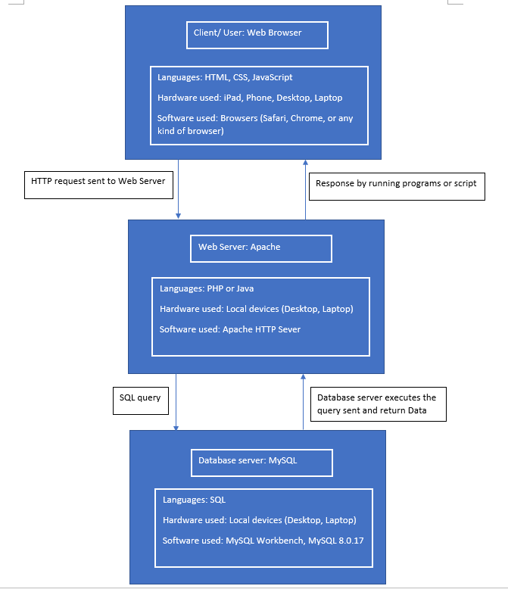

Hardware Used

* Desktop
* Laptop
* Phone
* Pad

Software Used

* Browsers
* MySQL Workbench
* Sublime Text
* Apache HTTP Sever
* Eclipse

RDBMS

* MySQL 8.0.17

Application Languages

* JavaScript
* HTML
* CSS
* Java
* PHP
* SQL