OPENSIGN PROJECT - Concept

This document describes functionality that the code signing server provides. Section one gives an overview of entities and their interaction with the server. Section two pictures use cases. Following two sections describe the user interface from the web portal as well as the client side application.

Abbreviations

SPC | Software Publishing Certificate (format: PKCS#7 [1])
CSR | Certificate Signing Request (format: PKCS#10[2])
OSS | Open Sign Server

1. Entities and Interaction

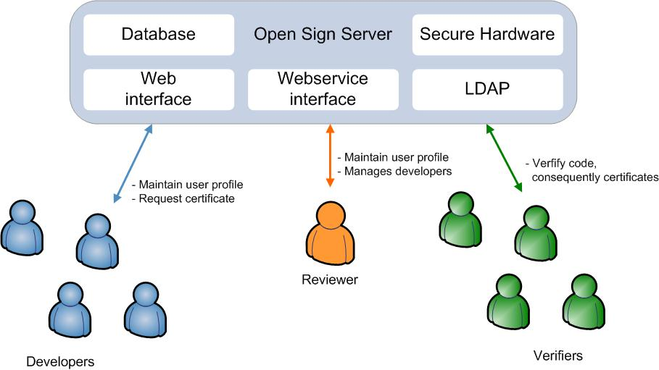

Open Sign Server: Trusted third party for code signing and verifying.
Users: Users are persons who are intending to sign code. For this reason they acquire code signing certificates from the OSS by using a client tool.
Reviewer: The Reviewer has to assure the trustworthiness of a small set of users.
Verifiers: Concerned users of signed code who want to assure the codes integrity and authenticity. To meet this they may use appropriate tools to challenge the OSS.

2. Use Cases

2.1 User Registration

Goal | User registered at the system, which involves having valid login-credentials and a public/private user profile
Actors | User
Preconditions | None
Basic Flow | - A user hits the “Register” button on the web interface  - User enters the required details  - User name  - Password  - Email address  - Real name  - Address  - Projects involved including links  - The system validates the format of the entered data and sends a notification email with an activation link  - User needs to click the link to activate the account
Alternative Paths | User terminates the procedure before step 4, which implies that no account is created.
Postconditions | User must be able to login with his chosen password and user name and modify his profile. Furthermore, a public profile showing:  - User name  - Projects involved  is accessible to all users.

2.2 REgistration for certificate Generation

Goal | User is able to generate a code signing certificate
Actors | User, Reviewer
Preconditions | User registered
Basic Flow | Here the OSS comes in three flavors:  - Users may generate certificates straight away (e.g. for an test-environment)  - Users need the approval of an Reviewer which they can choose (e.g. if the server is used within a company where the supervisor is known or by open-source projects where the project-initiator is also well known)  - User selects the desired Reviewer from a list  - The Reviewer is notified by email and decides whether to approve the request or not.  - User obtains a notification of the Reviewers choice  - Users need the approval of an Reviewer which they cannot choose (e.g OWASP – Summer of Code)  - User clicks on button “Request approver”  - An Administrator evaluates the request and my assign an Reviewer to the user  - User obtains a notification of the Administrators choice.
Alternative Paths | Reviewer or Administrator do not approve the request for generating a certificate
Postconditions | User is assigned with an Reviewer and is able to generate a certificate

2.2 certificate Generation

Goal | User has a certificate for code signing
Actors | User
Preconditions | - User registered for SPC generation  - Client application downloaded
Basic Flow | - User clicks button “Generate Certificate”  - The user is requested to input information which will be part of the certificate  - After submitting, the user has to enter his user name and password  - System verifies the password with the one set at server  - A asymmetric key is generated and stored, protected by the password, in the local key store.  - CSR is generated and signed by the public key  - CSR is forwarded to OSS  - Certificate is received  - Certificate is visualized and installed in local key store
Alternative Paths | - OSS determines that user has no Reviewer assigned. In this case an error message is sent as response instead of the certificate.
Postconditions | User has a certificate installed in local key store and online at his public profile

2.3 Code Signing

Goal | Signed code package
Actors | User
Preconditions | Code signing certificate installed in local key store
Basic Flow | - User clicks button “Sign code package”  - A dialog allows user to select the code package he wants to sign and, furthermore, the output directory and name  - Password is requested  - The password is used to decrypt the signing key  - The key is applied to sign the package
Alternative Paths | None
Postconditions | Signed code package

2.4 Code Verifying

Goal | Verification of code
Actors | Verifyer
Preconditions | - Client tool downloaded and installed  - Signed package downloaded
Basic Flow | - User clicks button “Verify code package”  - A dialog allows the user to select the code package he would like to verify  - Client extracts the certificate  - Certificate signature is validated by signer certificate, which is loaded on demand  - Certificate validity period is checked  - Signed code package is verified by use of the pervious validated certificate  - System declares the package as valid or not
Alternative Paths | The process stops if a step during validation does not meet the requested values
Postconditions | Information whether the code is declared as valid or not

2.5 Certificate Revocation

Goal | Certificate revoked
Actors | User
Preconditions | Certificate was issued by OSS
Basic Flow | - User clicks on “Request Certificate Revocation” at the web-interface  - User enters the certificate serial number  - User enters the reason why this certificate should be revoked  - The assigned Reviewer is notified and can choose if the certificate should be revoked or not  - Reviewer may revoke every certificate of their assigned users at any point of time via web-interface
Alternative Paths | Reviewer chooses that the reason for revocation is not sufficient and does not revoke the certificate
Postconditions | Certificate is revoked – no more accessible in user profile

3. Web portal
Following sub-sections describe pages on the web portal, which are accessible to users determined by the authorisation level they have.

3.1 Home
This page holds a short summery of the functionality the server provides. Furthermore, a login-field for entering username and password is on this page.

3.2 User Profile (private)
On this site a user can maintain his personal details, which are only accessible by him and his approver and partly shown on the public profile.
User Details: This block contains user name, real name, date of birth and address of the user.
Short CV: Short introduction about the history of this developer.
Project Involved: A list of links and short description of projects the developer is contributing to.

3.3 Certificate Management
Select Approver: A drop down menu shows all assigned approvers. This field is only possible to change before the approver has accepted the request.
Public Key List: A list of all public keys a user has. Note that the user only may own one valid public key at a time - the others are revoked or have expired.

3.3 User Profile (public)
Username: This is the name the developer has chosen, which is unique in the system.
Approver: Link to the approver's public profile.
Public Key: Currently valid public key

3.4 Associated Members
This page is only accessible by the approver who is responsible for this group of developers. Mainly this page contains a list showing the most important values of the corresponding developer and a button whether to approve the developer or not. In case of approval the developer may generate a code signing certificate. If the approver cancels or denies the approval the developers code signing certificate is revoked and the developer is not able any more to have a new one generated.

3.5 Administration
The administrator maintains all data and acts as root of all approvers.

4. Client Side Application
TO BE CONTINUED

4.2 Generation of SPC
- Login at Code Signing Server
- Key generation
- PKCS#10 request generation
- Installation of SPC

4.2 Signing of Software
- Login
- Drag & Drop?

4.3 Verification of Software
- Drag & Drop?

References
[1] PKCS#7 http://www.rsa.com/rsalabs/node.asp?id=2129
[2] PKCS#10 http://www.rsa.com/rsalabs/node.asp?id=2132

