|  |
| --- |
|  |
| Tic Tac Toe |
| Student Name: Tao Wang  Student Number: 214672547  Prism Login: kevin89  Signature: |

|  |
| --- |
| Contents  1. Requirements for Tic-Tac-Toe 1  2. BON class diagram overview (architecture of the design) 2  3. Table of modules — responsibilities and information hiding 3  4. How to detect a winning game 5  5. Undo/redo design 7 |

# Requirements for Tic-Tac-Toe

Based on the description for Tic-Tac-Toe on Wilipedia, Tic-tac-toe (also known as noughts and crosses or Xs and Os) is a paper-and-pencil game for two players, X and O, who take turns marking the spaces in a 3×3 grid. The player who succeeds in placing three of their marks in a horizontal, vertical, or diagonal row wins the game. The following example game is won by the first player, X: Game of Tic-tac-toe, won by X

Game of Tic-tac-toe, won by X

This project provides three basic commands, “new_game”, “play” and “play_again”, for two players to play games. On top of them, the commands “undo” and “redo” are added into this game to let the game more flexible and beginner-friendly.

The grammar of the user interface for the commands above is as follows:

|  |
| --- |
| type NAME = STRING  type BUTTON = 1..9  new_game(player1: NAME; player2: NAME)  -- add players `player1' and `player2'  -- `player1' starts X  play(player: NAME; press: BUTTON)  play_again  undo  -- last action while in play  --otherwise no effect  redo  -- last action while in play  -- otherwise no effect |

# BON class diagram overview (architecture of the design)

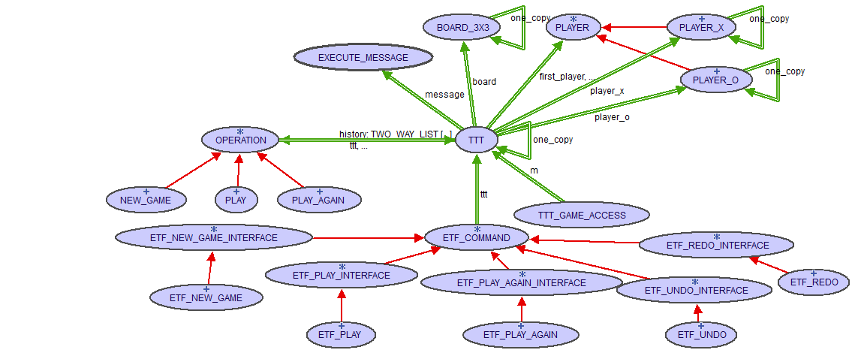

The key module is TTT one instance of which represents one Tic-Tac-Toe(TTT) game.

The user interface gets a TTT object (singleton) by using TTT_GAME_ACCESS

# Table of modules — responsibilities and information hiding

|  |  |  |  |
| --- | --- | --- | --- |
| 1 | TTT | **Responsibility**: A representation of a Tic-Tac-Toe game which stores the game state | **Alternative**: none |
| Concrete | **Secret**: The game state includes following information: 3x3 game board, player x, player o, game state message, game history, next turn, first player, game over. |

|  |  |  |  |
| --- | --- | --- | --- |
| 1.1 | BOARD_3x3 | **Responsibility**: A Tic-Tac-Toe game board | **Alternative**: none |
| Concrete | **Secret**: implemented via an array of size 9 |

|  |  |  |  |
| --- | --- | --- | --- |
| 1.2 | EXECUTE_MESSAGE | **Responsibility**: A message after execution of one game operation. It is either a success message or an error message. | **Alternative**: none |
| Concrete | **Secret**: Just a wrapper class for a message string |

|  |  |  |  |
| --- | --- | --- | --- |
| 1.3 | PLAYER | **Responsibility**: A Tic-Tac-Toe player | **Alternative**: none |
| Abstract | **Secret**: none |

|  |  |  |  |
| --- | --- | --- | --- |
| 1.3.1 | PLAYER_X | **Responsibility**: A Tic-Tac-Toe player who plays “X” | **Alternative**: none |
| Abstract | **Secret**: none |

|  |  |  |  |
| --- | --- | --- | --- |
| 1.3.2 | PLAYER_O | **Responsibility**: A Tic-Tac-Toe player who plays “O” | **Alternative**: none |
| Abstract | **Secret**: none |

|  |  |  |  |
| --- | --- | --- | --- |
| 2 | OPERATION | **Responsibility**: An operation on a Tic-Tac-Toe game | **Alternative**: none |
| Abstract | **Secret**: none |

|  |  |  |  |
| --- | --- | --- | --- |
| 2.1 | NEW_GAME | **Responsibility**: An operation that starts a new tic-tac-toe game. | **Alternative**: none |
| Concrete | **Secret**: none |

|  |  |  |  |
| --- | --- | --- | --- |
| 2.2 | PLAY | **Responsibility**: An operation that places “X” or “O” on a specified spot | **Alternative**: none |
| Concrete | **Secret**: none |

|  |  |  |  |
| --- | --- | --- | --- |
| 2.2 | PLAY_AGAIN | **Responsibility**: An operation that resets the game | **Alternative**: none |

# How to detect a winning game

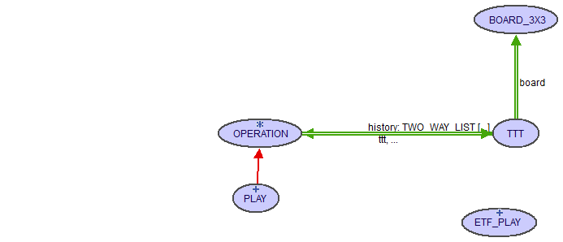

In order to detect a winning game, main classed involved are TTT, PLAY, BROAD_3x3

When playing using the command line user interface, the player directly communicates with one instance of the class ETF_PLAY. ETF_PLAY internally interacts with one singleton instance of the class TTT, and it invokes the command “play” of TTT

|  |
| --- |
| **note**  description: "TTT represents one tic-tac-toe game"  author: ""  date: "$Date$"  revision: "$Revision$"  **class** **interface**  TTT  **feature** --Commands   play (player_name: STRING_8; position: INTEGER_32) |

Since undo/redo design pattern is used in this project, inside the command above, it creates an object of the operation PLAY, and execute it, i.e. invoking the command execute of PLAY object.

|  |
| --- |
| **note**  description: "The operation PLAY"  author: ""  date: "$Date$"  revision: "$Revision$"  **class** **interface**  PLAY   **feature** --Commands   execute   **invariant**  position_within_bounds: position >= 1 **and** position <= 9 |

Inside the command execute, if passed player name and position are valid, then after put “X” or “O” onto the specified position, it checks the state of the current game board, if it’s “player x wins”, or “player o wins”, “draw” or “in progress”. For determining the state of the board, the query check_win in the class BOARD_3x3 is used.

|  |
| --- |
| **note**  description: "A 3x3 game board for Tic-Tac-Toe"  author: ""  date: "$Date$"  revision: "$Revision$"  **class** **interface**  BOARD_3X3   **feature** --Queries   check_win: INTEGER_32  -- returns a constant associated with the state of the game  -- If PLAYERX wins, returns 1.  -- If PLAYERO wins, returns 2.  -- If game is drawn, returns 3.  -- If game is in progress, returns 4. |

# Undo/redo design

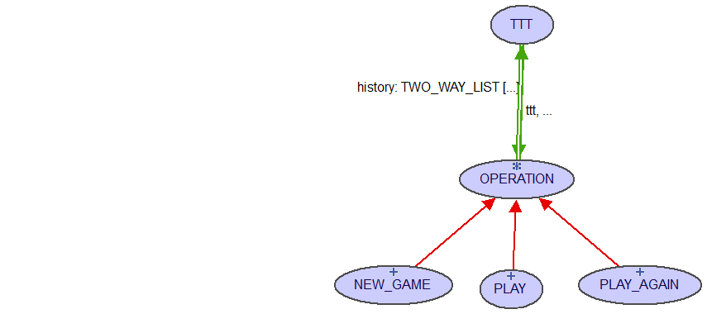

OPERATION is a deferred class that has three commands, “execute”, “undo” and “redo”.

Since it is a small game, I decide to store all the game state information, such that the implementations of “undo” and “redo” are the same for all descendant concrete classes. To avoid code being “smelly”, “undo” and “redo” are implemented in OPERATION, and “execute” is deferred. “undo” simply restores the old state to the current game, and “redo” simply calls the command “execute” to re-execute. All descendent classes of OPERATION implement their own “execute” based on their roles on the game.

|  |
| --- |
| **note**  description: "A deferred operation on the game Tic-Tac-Toe"  author: ""  date: "$Date$"  revision: "$Revision$"  **deferred** **class** **interface**  OPERATION  **feature** --Attrinutes   old_ttt: **detachable** TTT   has_error: BOOLEAN   ttt: TTT  -- points to the singleton TTT object(model)   **feature**    execute   undo  -- Revert to the state before the execution of an operation  **require**  has_been_executed: old_ttt /= **Void**   redo  -- by default "redo" just repeats execution   **end** |

To implement multi-level undo/redo, TTT must have an attribute, “history”, to store executed operations. TWO_WAY_LIST[OPERATION] is used to implement “history” with which I can move the cursor back and forth to go to different game states. The cursor is manipulated inside two commands of TTT, “undo” and “redo”, and new operations are appended to the end of the history when “new_game”, “play” and “play_again” are called.

|  |
| --- |
| **note**  description: "TTT represents one tic-tac-toe game"  author: ""  date: "$Date$"  revision: "$Revision$"  **class** **interface**  TTT  **feature** --Commands   new_game (playerx: STRING_8; playero: STRING_8)   play (player_name: STRING_8; position: INTEGER_32)   play_again   undo   redo |