First stage no smooth and 100 and second stage no smooth

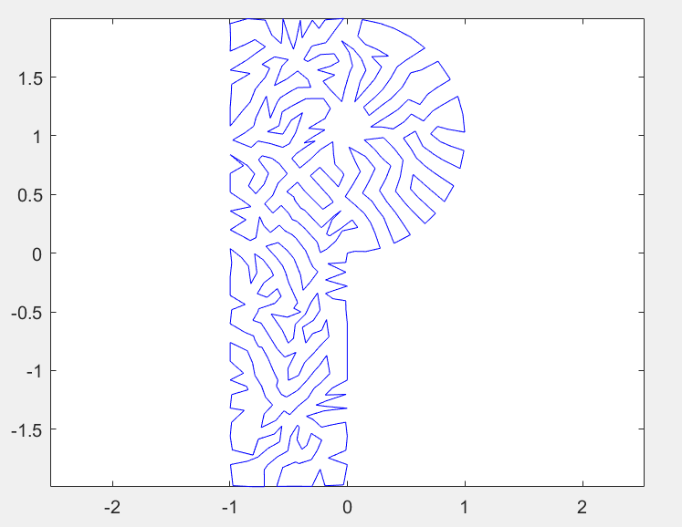

First stage no smooth and 100 and second stage half smooth

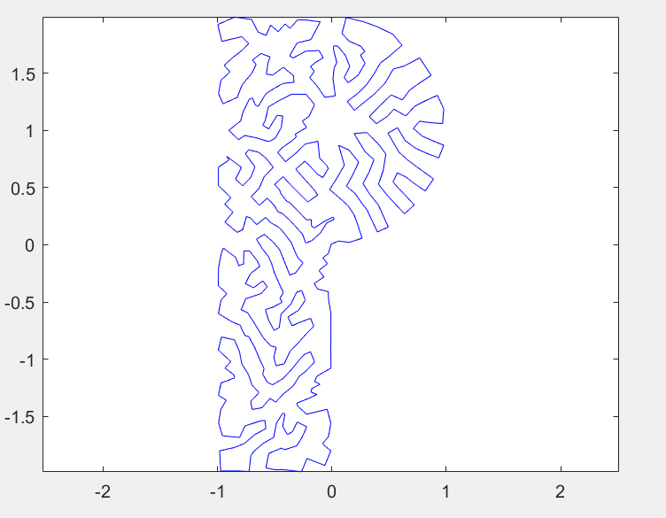

First stage no smooth and 100 and second stage smooth

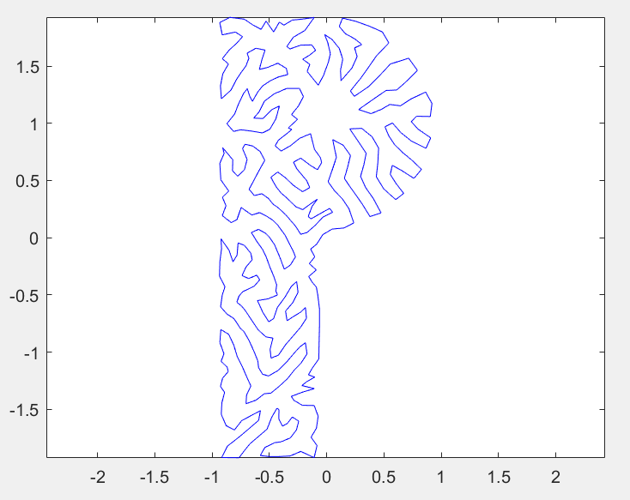

First stage half smooth and 200 and second stage no smooth

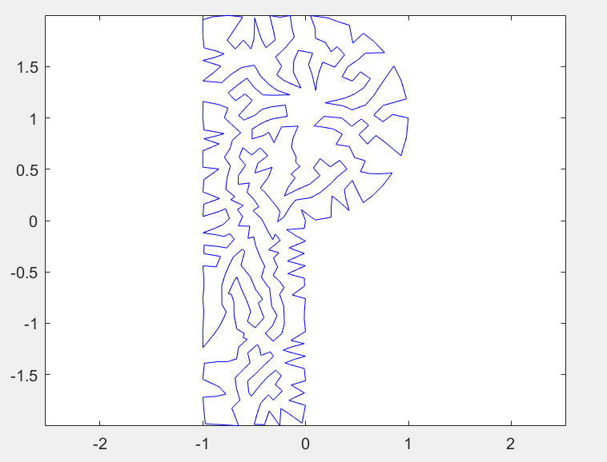

First stage half smooth and 200 and second stage half smooth

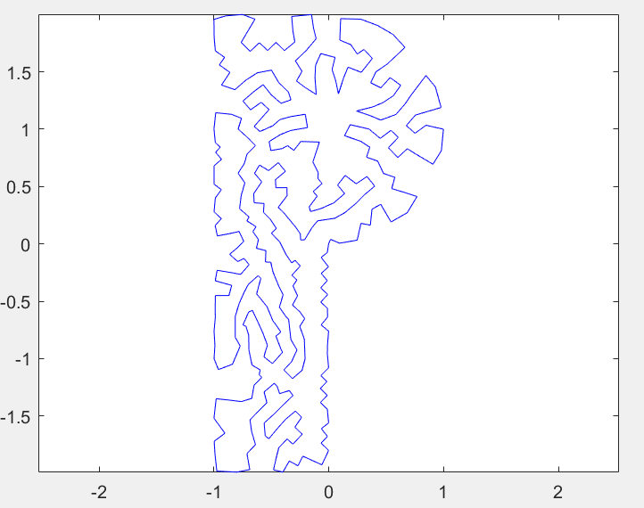

First stage half smooth and 200 and second stage smooth

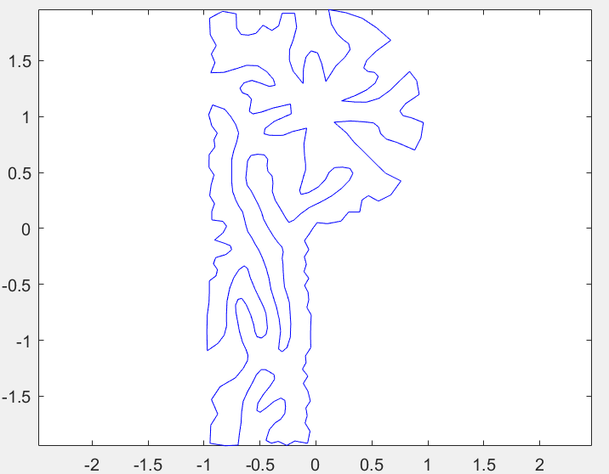

First stage smooth and 200 and second stage no smooth

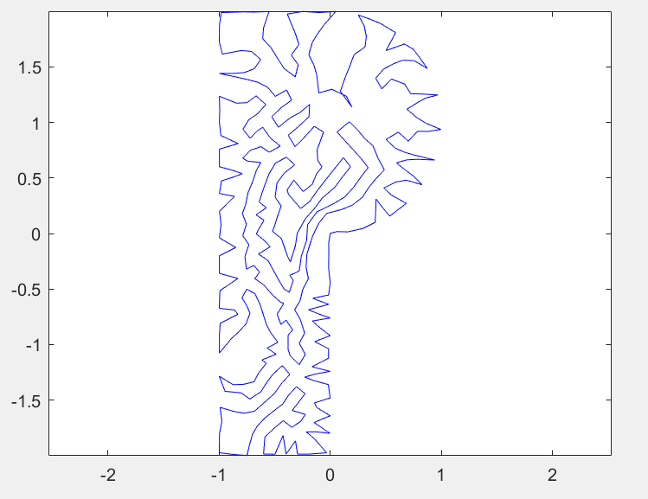

First stage smooth and 200 and second stage half smooth

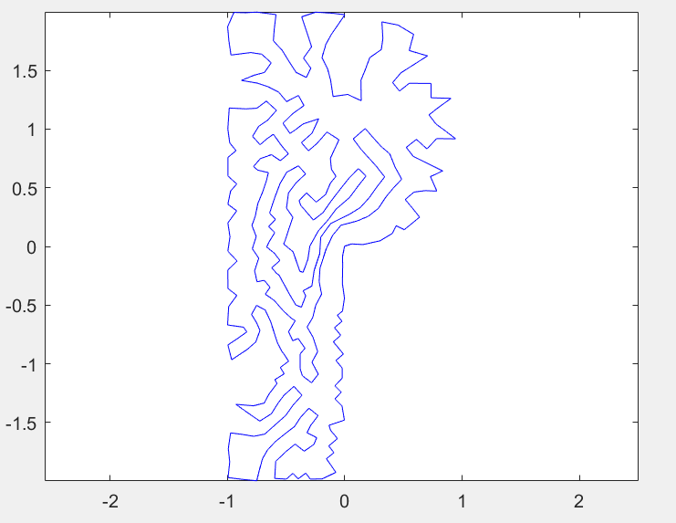

First stage smooth and 200 and second stage smooth

