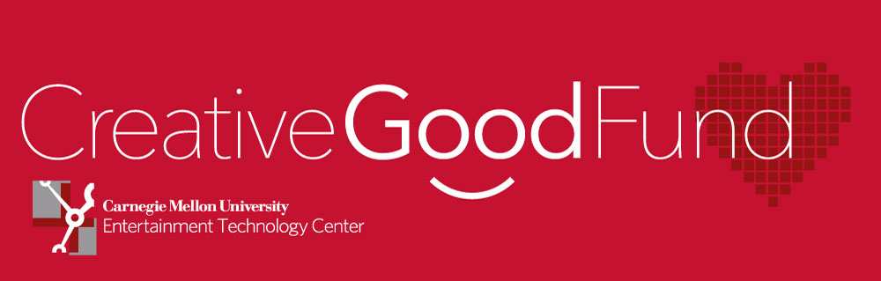

Dear Alums and Friends of the ETC,

It is our pleasure to share some great news with you about the Creative Good Fund!

A Carnegie Mellon alumni couple who believes strongly in the ETC and has close ties with the entertainment technology world has provided an unbelievable opportunity to establish the Creative Good Fund at a meaningful level: if we raise $25,000 for the Fund they will contribute an additional $275,000, an 11 to 1 match. This will enable us to endow the Fund and guarantee these internships continue far into the future. ETC students will make a difference across the country and across the world through the Creative Good Fund for years to come.

A little background about these internships:

**The Creative Good Fund** is for current students of Carnegie Mellon University’s [Entertainment Technology Center](http://www.etc.cmu.edu/) who are looking to gain experience with real-world Location-Based Entertainment (LBE) projects while making a positive impact on the world around us.

Non-profit organizations such as museums, libraries, zoos, arts and human service organizations find it challenging to keep up with the fast-pace of developments in education and entertainment technology – locking them out of important capabilities that could help fulfill their mission. ETC students, with the skills and expertise they acquire, can be invaluable to these organizations if their budgets allowed; and students would love the chance to work with non-profits if they could afford to forgo a paying internship.

The goal of the Creative Good Fund is to allow these students to spend a summer working with a non-profit organization to complete a technology-focused education or entertainment project – and make a difference in the lives of the people that organization serves.

Good news!

We have already raised over $5,000 towards our $25,000 goal. Thank you to those who have already given! We are on our way because of you.

Will you join us and help us meet this challenge or raising the remaining $20,000? Whether you can give $50 or $5,000, every gift plays a part in getting us to our $25,000 goal. Please [make your gift today](https://securelb.imodules.com/s/1410/giving/form.aspx?sid=1410&gid=1&pgid=382&cid=990&appealcode=A2125&dids=176) and join the many others who believe in the power of Creative Good!

With over 700 graduates, the ETC now has a large, experienced and successful alumni network poised to truly make a meaningful difference in our world.

Helping to create wonderful environments for learning and discovery is what we do best, so let’s take our skills to those who need it most. Please support the ETC Creative Good Fund. I encourage you to [make your gift today](https://securelb.imodules.com/s/1410/giving/form.aspx?sid=1410&gid=1&pgid=382&cid=990&appealcode=A2125&dids=176).

Please share this message with anyone you think would like to contribute, but most of all challenge your fellow alums to make this possible!

With warm regards,

p.s. Interested in helping further?

* Tell everyone you know to visit the [Creative Good Fund](http://www.lbe-internship.com/) website and donate! Contributions are tax-deductible in many countries.
* Check with your employer to see if they have a matching gift program.