MULTISTEP INPUT REDUCTION FOR HIGH DIMENSION
AL UNCERTAINTY QUANTIFICATION

First A. Author, Second B. Author
Department of Nuclear & Chemical Engineering
University of Palookaville, East Virginia, USA
f.a.author@upalookaville.edu
s.b.author@upalookaville.edu

Blank line, Third Author with different affiliation
Nuclear Systems Design and Analysis Division
Idaho National Laboratory, Idaho Falls, Idaho, USA
Third.Author@inl.gov

ABSTRACT

Use US Letter paper size, top and bottom margins of 1.0 “, left and right margins of 0.9”. The abstract should be 200 – 250 words long. Leave two blank lines before the header of the “ABSTRACT”, and leave one blank line after. For the abstract, use 11 point Times New Roman and single line spacing. The abstract gives a brief summary of the work, including a justification for the work, method of research, results, and conclusions in brief. Show that your work is new and how it relates to the state-of-the-art.

Key Words: list a minimum of 3 and a maximum of 6 key words, in boldface.

1. INTRODUCTION

There have been many recent advances in uncertainty quantification for engineering applications with many input dimensions [references from LDRD report]. In particular, adaptive stochastic collocation for generalized polynomial chaos (ASCgPC) filtered using adaptive high-dimensional model reduction have proven effective in comparison to Monte Carlo sampling for nearly a thousand input dimensions [ref Ayres]. For many problems of interest, ASCgPC is an efficient approach to uncertainty quantification.

However, forward uncertainty propagation, even when performed adaptively, struggles to converge efficiently for nonlinear responses with thousands of input dimensions due to the curse of dimensionality. A nuclear reactor criticality problem can exhibit tens of thousands of uncertain inputs [ref?]. In this instance traditional methods such as ASCgPC can be much less effective than even traditional Monte Carlo sampling. Without the benefits of an adjoint for the problem, there is always a significant computational cost to high-dimensional uncertainty quantification.

We propose a workflow for reducing the effective input dimensionality of a problem through multistage filtering. First, we correlations in the input space to construct a principal-component analysis (PCA) using input covariance. We then elect a cutoff level to include a few hundred terms in the PCA expansion to act as a surrogate input space. Second, we perform basic sensitivity analysis using first-order high-dimensional model reduction (HDMR) on the surrogate input space. These sensitivities are then used to weight the original input-input decomposition. The terms in the weighted PCA are then re-ordered, and an appropriate number retained as the final surrogate input space.

Finally, ASCgPC using adaptive HDMR is applied to the problem as a function of the surrogate input space. This polynomial chaos expansion in the surrogate input space can then generate a reduced-order model that captures the essential behavior of the original model. Preliminary efforts using an analytical model suggest this workflow can allow for efficient uncertainty propagation.

2. METHODS

For demonstrating the potential effectiveness of ASCgPC, we generate a random, high-order polynomial for both a five-input case and a ten-input case. The generator randomly creates combinations of terms including from a single input to all the inputs. Each variable in each of these terms is then raised to a random power from one to five. Each input variable is distributed uniformly from zero to one and is taken to be uncorrelated with the other inputs. This creates an eccentric polynomial with unpredictable behavior, but with an analytic mean and variance. We demonstrate convergence to these two statistical moments for SCgPC in comparison to Monte Carlo as preliminary expected results for the nuclear criticality problem.

2. GRAPHS, N=5
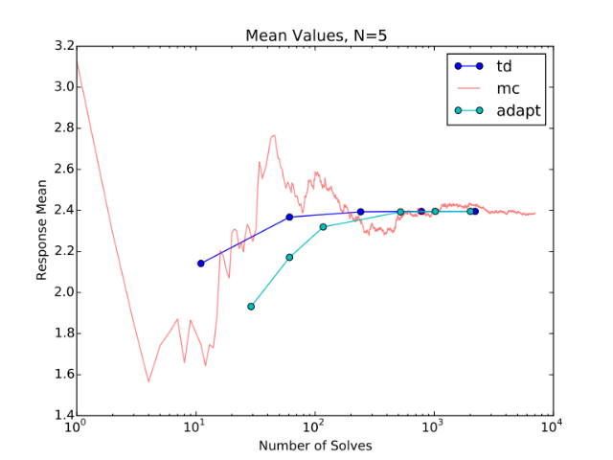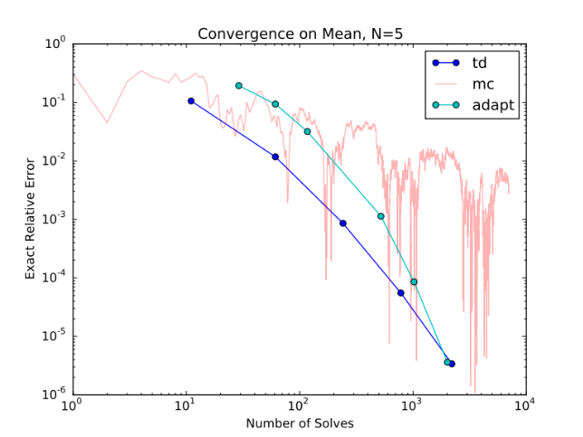
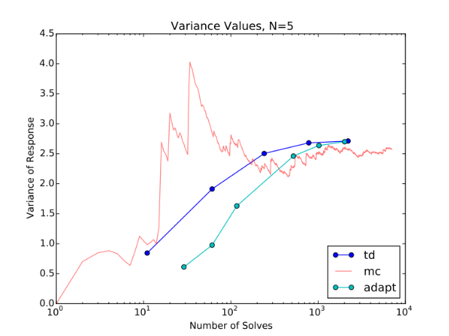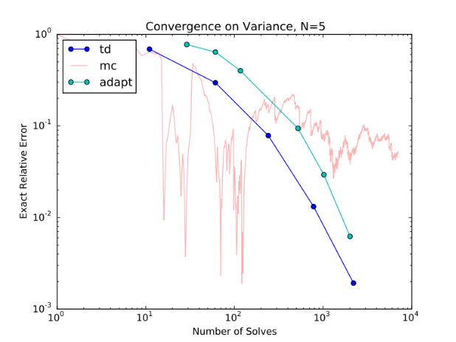
In Figures [ref] above, the left column show the values of the mean (top) and variance (bottom) as a function of computation solves for Monte Carlo, isotropic “total degree” (td) SCgPC, and adaptive SCgPC (adapt). The right column shows error convergence on a log-log scale for the same. It is obvious for the mean that the adaptive scheme is converging more quickly, despite showing more computational solves necessary to demonstrate the exponential convergence. A similar trend can be seen in the variance case. TODO comment on adaptive clenshaw Curtis line.
3. GRAPHS, N=10 (not finished yet, placeholders)
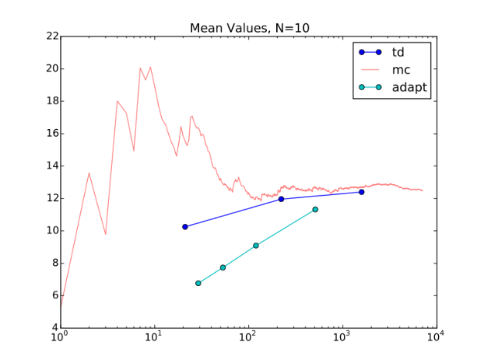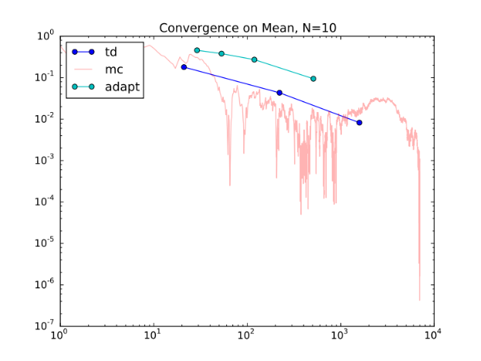
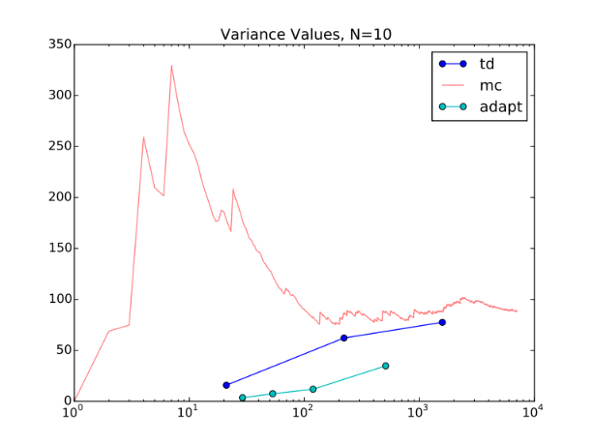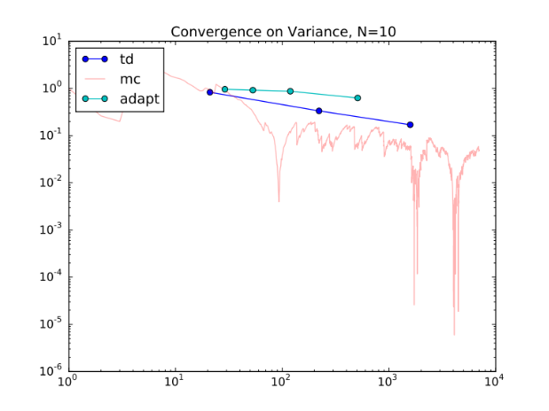
As with the five-input case, the adaptive method shows slower initial convergence, with exponential convergence over increasing runs. However, we see in this higher-dimension problem that even adaptive SCgPC struggles to outperform Monte Carlo method for these nonlinear polynomials. We expect that using adaptive HDMR filtering, we can improve significantly on all methods shown here. TODO comment on adaptive clenshaw Curtis line.

REFERENCES

- B. Authors, “Title”, Journal name italic, volume(number), pp. 25 – 34. URL http://dx.doi.org/doi_number (year)
- C.D. Authors, “Title”, Proc. Int. Conf. Conference name in italic (editor name if available), Organization, location & date, vol nr, pp. 25 – 34 (year)
- E.F. Author, Book title in italic, Publisher, City, Country, (year)
- “name of website”, available online. URL http://www.website.ext/ (2013)

APPENDIX A. HOW TO MAKE AN APPENDIX

Include appendices here. Appendices are numbered alphabetically (‘A’, ‘B’, ‘C’). The appendix header follows the rule for section headers: all capital letters. If one (or more) appendices are entered, then make sure that there are corresponding references from the main text. Appendices without references in the body of the paper (“dangling” appendices) are expressly forbidden.

Footnote Times New Roman 10 pt, in running text numbered with Arabic numerals. This would be a good place to include your internet address (home page, etc) if desired: www.nce.upalookaville.edu

