TITLE OF THE PAPER: CENTERED, UPPERCASE, 14 POINT TIMES, ON SECOND LINE FROM THE TOP MARGIN, NOT MORE THAN 3 LINES LONG
(Microsoft Word 2000 Paper Template)

Author First Last Name and Author Two First Last Name
Organization
Address
Author One e-mail Author Two e-mail (underline the corresponding author’s email)

Author Three First Last Name
Organization
Address
Author Three e-mail

Keywords: Three to five keywords

ABSTRACT
This file provides a template for submitting papers for the ANFM-2015 Conference. Because the conference proceedings will be published on CD-ROM, full papers must be provided in either Microsoft Word, or Adobe PDF electronic format. This document is in Word 2000 to ensure maximum backward compatibility. The abstract should have 100 to 200 words, and succinctly describe the contents of the paper. It should not exceed the first page of the paper.

1. INTRODUCTION
The proceedings for the ANFM-2015 conference will be published on CD-ROM. Those who have paid the conference registration fee receive one CD-ROM. Authors are encouraged to use color in their figures to enhance clarity, but also to remember that readers may print out the papers in black and white.
Each paper should contain three to five Keywords, an Abstract of 100 to 200 words, an Introduction, additional sections presenting the paper contents, Conclusions, Nomenclature (optional), Acknowledgments (optional), References, and Appendices (optional). The following sections of this template file discuss the formatting requirements for the ANFM-2015 papers.

2. PAPER FORMATTING
The use of CD-ROM publishing results in a substantial reduction in the proceedings publication cost, which is important in keeping the conference registration fee reasonable given rising costs in other areas. The largest costs for CD-ROM publication come from the work required to process, format, convert and assemble the electronic files for the papers. To minimize these costs, it is important that all papers be supplied electronically in the correct format. This can be done most easily if authors use this template file to construct their manuscripts, and follow the manuscript preparation and transmission guidelines carefully. Papers not meeting formatting requirements may not be published.

2.1 Fonts
Papers should use 12-point Times font, and 12-point Symbol font for all Greek characters. Subscripts and superscripts should be in 10-point font size, to make them more easily legible when viewed on a computer screen. Times, Symbol, Geneva, or Helvetica fonts can be used in figures. Other specialized fonts may not reproduce properly on the CD-ROM, and authors are discouraged from using other fonts.

2.2 Paragraph Formatting
This template file provides several styles for various paragraph types, including before equation for text paragraphs, equation for equations, after equation for paragraphs continuing after an equation, figure for figure captions, table for table captions, nomenclature for nomenclature items, reference for references, and three levels of heading styles. Using these styles can simplify correct formatting of the paper. A paragraph style can be set by clicking inside the paragraph, and then selecting the style from the style menu.
All text paragraphs are single spaced, with the first line indented 0.5 inches. Format should be for 8 1/2 inch by 11-inch paper, with 1.25-inch left and right margins and 1.0-inch top and bottom margins. Equations are numbered consecutively along the right-hand margin, as shown in Eq. (1) below. Subscripts and superscripts in equations should be in 10-point font, as illustrated below:
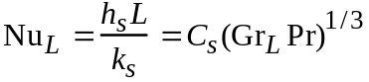 (1)
The continuation of a paragraph after an equation is not indented. All paragraphs are separated by one space (12 points). The before equation, equation, and after equation styles do this automatically.

2.3 Figures and Tables
All figures should be referenced in the text. Figures should be inserted in the paper close to where they are first referenced. While color is encouraged for clarity as used in Fig. 1 below, authors should remember that some readers will print papers on black and white printers. Figures should be centered above figure captions.
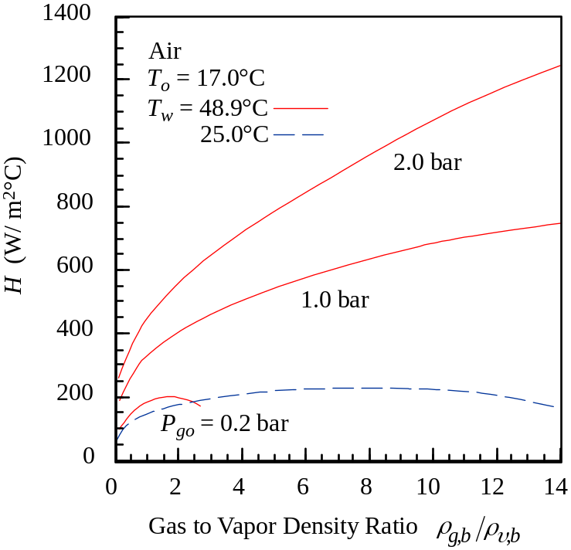
Fig. 1 Example figure.
Tables should also appear shortly after they are referenced in the text. Table headings should appear above tables, as shown in Table 1 below.
Table 1 Physical constants.
Avogadro's number | NA | = 6.024 × 1026 atoms/kmol
 |  | = 6.024 × 1023 atoms/gmol
Boltzmann constant | k | = 1.3806 × 10-23 J/K
Plank's constant | h | = 6.6262 × 10-34 J⋅s
Stefan-Boltzmann constant | σ | = 5.6697 × 10-8 W/m2⋅K4
Universal gas constant | R | = 8.315 kJ/kmol⋅K
Standard gravity | g | = 9.80665 m/s2
Temperature associated with 1eV | 1eV/k | = 11,605 K
Ionization potential of hydrogen atom |  | = 13.606 eV

2.4 References
References should be superscript as shown¹, where “1” is the reference numbering in the REFERENCES section. The reference format is the same as for Nuclear Technology. The references should be listed in the order they are referred to in the paper. See examples in the reference section of this paper template.

3. PAPER LENGTH
Authors are encouraged to limit their papers to 8-15 pages (in the conference single-spaced format), presenting their results as succinctly as possible. Authors must keep paper size less than 20 pages and file sizes, including graphics, less than 3 megabytes.

4. PAPER SUBMISSION
Final, electronic manuscripts for the ANFM-2015 conference are due February 13, 2015. Manuscripts must be submitted electronically through the conference website. For further instructions, please consult the website pages:
http://anfm2015.org
Please note that the submittal of the paper will be accepted as an electronic consent of author release form: “It is implicit that by submission of this paper attachment, the author gives full consent to its publication in the proceedings of the Advances in Nuclear Fuel Management IV, Hilton Head Island, South Carolina, March 29 - April 1, 2015. The author bears full responsibility to protect classified or proprietary information, and accepts the release of the paper for publication as is.”
In the event of special circumstances, authors should contact the Technical Program Co-Chair, Ivan Maldonado, at Ivan.Maldonado@utk.edu to see if alternate arrangements are possible.

4.1 Paper
Papers will not be accepted unless provided in the format already described.

5. CONCLUSIONS
The conclusion section provides a summary of the paper and highlights the key results presented.

NOMENCLATURE (optional)
Gr Grashof number
h heat transfer coefficient
Sh Sherwood number, hcL/kc
T absolute temperature
ρ mass density

Subscripts
b bulk
c condensation

Superscripts
s saturation

ACKNOWLEDGMENTS (optional)
This section allows authors to acknowledge other individuals and groups who have contributed to the manuscript.

REFERENCES
- R. L. BECK, “Research and Development of Metal Hydrides,” USAEC Report, Denver Research Institute LAR-10, November (1960). (For a laboratory report)
- J. N. BRADBURY and P. L. T. MORGAN, “Containment for a LMFBR (CFR),” Proc. Int. Conf. on Experience in the Design, Contruction and Operation of Prestressed Concrete Pressure Vessels and Containments for Nuclear Reactors, York, to appear. (For an unpublished paper)
- R. L. CROWTHER and J. E. WOOD, “Advances in BWR Core and Fuel Design,” Proc. Int. Reactor Physics Conf., Jackson Hole, Wyoming, September 18-22, 1988, Vol. I, p. 77, American Nuclear Society (1988). (For a paper in a contributed volume)
- H. L. LANGHARR and H. L. CHU, Development in Theoretical and Applied Mechanics, p. 553, Pergamon, New York (1970). (For a book)
- S. R. PARK, W. P. BAEK, S. H. CHANG, and B. H. LEE, “Development of an Uncertainty Quantification Method of the Best Estimate Large LOCA Analysis,” Nucl. Eng. Des., 135, 367 (1992). (For a paper in a journal)

APPENDIX A (optional)
If necessary, include Appendices numbered in upper case alphabetical order.
In order to ensure a uniform, professional look to the proceedings, please do not modify the format of this template without checking with the organizers first.

Footnote should be marked-up with symbols as shown here. The text should be 10-point Times font.

