FUEL RELIABILITY ANALYSIS USING BISON AND RAVEN'S STOCHASTIC COLLOCATION FOR GENERALIZED POLYNOMIAL CHAOS

Paul W. Talbot, Anil K. Prinja
University of New Mexico
Department of Nuclear Engineering
MSC01 1120; 209 Farris Engineering Center
Albuquerque, NM 87131, USA
talbotp@unm.edu, prinja@unm.edu

Cristian Rabiti, Andrea Alfonsi
Idaho National Laboratory
P.O. Box 1625 MS 3870
Idaho Falls, ID 83415-3860
cristian.rabiti@inl.gov, andrea.alfonsi@inl.gov

Keywords: Fuel, Uncertainty Quantification, Stochastic Collocation, Generalized Polynomial Chaos

ABSTRACT
The investigation of operation limits for nuclear fuel is a challenging subject and at the same time important to ensure reliability and safety of nuclear energy production. The parametric and probabilistic analysis of failure is a very expensive process that might require thousands of simulations while exploring the input space by altering the input parameters. Previously [rabiti], RAVEN was demonstrated as suitable for performing such analysis. It has been shown [xiu] that random processes, such as a solver with uncertain inputs, can often be represented to a high degree of accuracy with relatively low-order polynomials. Evaluating polynomials is generally less computationally expensive than running the original code. As a result, we can expect employing a polynomial representation as a surrogate model to increase the efficiency of an expensive task such as limit surface location generation.

We introduce the new RAVEN capability to construct a reduced-order model (ROM) using orthogonal polynomials to act as a surrogate model for computationally expensive solvers with uncertain inputs. The resulting ROM is then used in place of the solver for sampling for limit surface analysis. Using the same procedure as [rabiti], we demonstrate the capability of the ROM to provide similar failure probability statistics as the original solver.

1. INTRODUCTION
The investigation of operation limits for nuclear fuel is a challenging subject and at the same time important to ensure reliability and safety of nuclear energy production. The parametric and probabilistic analysis of failure is a very expensive process that might require thousands of simulations while exploring the input space by altering the input parameters. Previously [rabiti], RAVEN was demonstrated as suitable for performing such analysis. It has been shown [xiu] that random processes, such as a solver with uncertain inputs, can often be represented to a high degree of accuracy with relatively low-order polynomials. Evaluating polynomials is generally less computationally expensive than running the original code. As a result, we can expect employing a polynomial representation as a surrogate model to increase the efficiency of an expensive task such as limit surface location generation.
We introduce the new RAVEN capability to construct a reduced-order model (ROM) using orthogonal polynomials to act as a surrogate model for computationally expensive solvers with uncertain inputs. The polynomials are constructed using the generalized polynomial chaos method, where the solver with uncertain input is expanded in characteristic orthogonal Gauss polynomials. The necessary coefficients of expansion are found by making use of Smolyak style multidimensional sparse quadrature grids [smoljak]. The resulting ROM is then used in place of the solver for sampling for limit surface analysis. Using the same procedure as [rabiti], we demonstrate the capability of the ROM to provide similar failure probability statistics as the original solver.
This paper will review the creation of the ROM using stochastic collocation for generalized polynomial chaos, and the limitations of these methods with respect to the regularity and dimensionality of the uncertain input space. The original limit surface location and failure probability evaluation in [rabiti] will serve as a benchmark for the accuracy of the polynomial ROM.

2. STOCHASTIC COLLOCATION FOR GENERALIZED POLYNOMIAL CHAOS
The methodology of generalized polynomial chaos (gPC) involves creating a reduced-order model (ROM) using sets of orthogonal polynomials [xiu]. To generate the polynomials, we treat the deterministic transport solver non-intrusively as a functional of the uncertain input parameters. In this case, we treat any quantity of interest obtained from BISON outputs as , where is a vector of the uncertain input parameters . Generalized polynomial chaos represents the quantity of interest as

where is a polynomial of order from an orthonormal polynomial set, and is the index set of all desired polynomial orders up to order used in the ROM.

2.1 Index Sets
Several options for defining the index set are available. For the “tensor product” (TP) index set, all combinations of polynomial orders for each dimension are used up to order L. This index set rule makes use of many polynomial orders that have a combined order much higher than the truncation approximation. For example, in our case with three uncertain inputs, an L=3 tensor product index set includes an overall 27th order polynomial, while the truncation approximation is accurate up to third order polynomials. This index set is defined by

The “total degree” (TD) index set [bagby] limits polynomial combinations so the sum of the orders is no more than the truncation order L. This reduces the calculations necessary and removes unnecessarily-high-order polynomials. TD is particularly effective for quantities of interest that are regular with respect to the input parameters. This index set is defined by

The “hyperbolic cross” (HC) index set [bungartz] limits polynomial combinations by the product of the individual orders. This generates an even smaller index set than TD. HC is most effective for quantities of interest that have low-level regularity with respect to the input parameters. This index set is defined by
.

2.2 Collocation
In order to calculate the polynomial coefficients , we make use of numerical integration via quadrature sets. In general, integration by quadrature has the form

where is the probability distribution of and are weights and points from the quadrature set. The integral equation for is

In sparse grid collocation for generalized polynomial chaos, we make use of Smolyak-like sparse grids [smolyak] to calculate the coefficients . The sparse grid is generated by combining several small tensor grids, as

where is a quadrature rule. For typical Gauss quadrature (Legendre, Hermite, Laguerre, Jacobi),

3. LIMIT/RELIABILITY SURFACE

3.1 Limit Surface Definition
The nature of the limit surface and algorithms pertaining to its location are described in [rabitit], but we summarize here. Consider the system represented above, It is possible to introduce the failure function, a Boolean function whose evaluation depends on . Assuming the combined distribution of is a Louiville phase space, and there is nonzero regularity in said space, we consider the region of the input space that leads to the failure function evaluating to unity. The limit surface search algorithm attempts to locate the N-dimensional boundaries in the input space between inputs that lead to 0 and 1 in the failure region space.

Having defined the limit surface and described the failure function, we consider the failure probability of the system to be the integral probability the input space leading to a value of 0 in the failure space. This is also equal to the probability-weighted volume surrounded by the limit surface. An example of failure probability and limit surface is given in [1], along with the numerical algorithms used to approximate them.

4. EXAMPLE

4.1 BISON Test Case Description
The case examined is nearly identical as presented in [rabiti], a simplifed, axis-smmetric LWR fuel rodlet composed by 10 UO2 pellets, Zr-4 cladding, gap, and upper plenum. The problem is a power ramp up transient in which the linear power changes according to Table 1.

Table 1 Linear Power Time Evolution.
Time (s) | Linear Power (W/m)
0 | 0
1.00E+04 | 2.50E+04
1.50E+08 | 2.50Ε+04
We investigate as our quantity of interest the maximum Von Mises stress based on the three input parameters, whose properties are given in Table 2.
Table 1 Linear Power Time Evolution.
Variable | Distribution | Min | Max
Grain Radius | Uniform | 0.4 | 1.5
Fuel Thermal Expansion Coefficient | Uniform | 9E-6 | 1.1E-5
Linear Power Scaling Factor | Uniform | 0.95 | 1.05

4.2 BISON Test Case Results

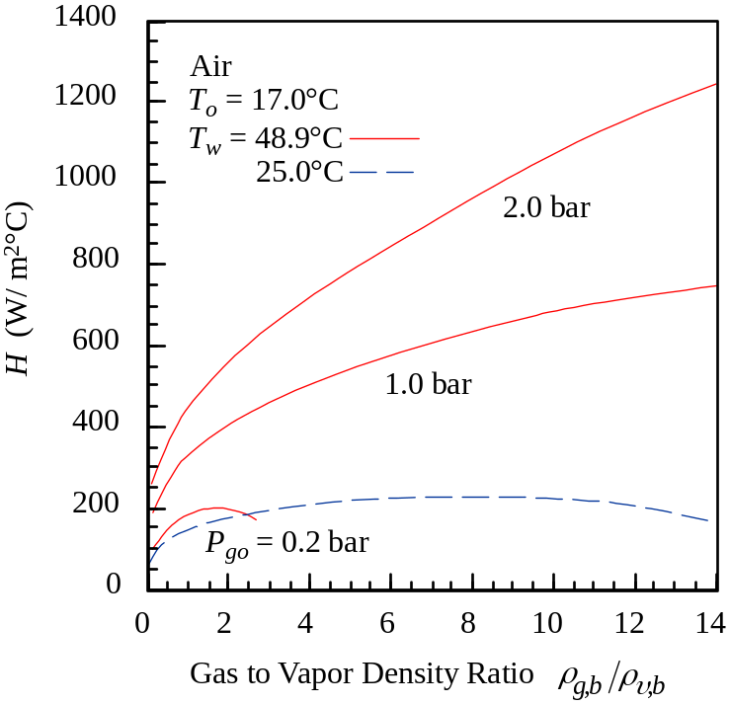
Fig. 1 Example figure.

5. CONCLUSIONS
The conclusion section provides a summary of the paper and highlights the key results presented.

NOMENCLATURE (optional)
Gr Grashof number
h heat transfer coefficient
Sh Sherwood number, hcL/kc
T absolute temperature
ρ mass density

Subscripts
b bulk
c condensation

Superscripts
s saturation

ACKNOWLEDGMENTS (optional)
This section allows authors to acknowledge other individuals and groups who have contributed to the manuscript.

REFERENCES
- C. RABITI, J. COGLIATI, G. PASTORE, R. J. GARDNER, and A. ALFONSI, “Fuel Reliability Analysis using Bison and Raven,” ---> I don't know where this got published.
- T. BAGBY, L. BOS, and N. LEVENBERG, “Multivariate Simultaneous Approximation,” Constr. Approx., 18, 569-577 (2002).
- S. A. SMOLJAK, “Quadrature and Interpolation Formulas for Tensor Products of Certain Classes of Functions,” Dokl. Akad. Nauk SSSR, 4, 1 (1963).
- H. BUNGARTZ, M. GRIEBEL, “Sparse Grids”, Acta Numerica, 13, 147-269, (2004).
- D. XIU and G. E. KARNIADAKIS, “The Wiener-Askey Polynomial Chaos for Stochastic Differential Equations,” SIAM J. Sci. Comp, 24, 2 (2002).

