**MULTISTEP INPUT REDUCTION FOR HIGH DIMENSION**

**AL UNCERTAINTY QUANTIFICATION**

**First A. Author, Second B. Author[1]**

Department of Nuclear & Chemical Engineering

University of Palookaville, East Virginia, USA

[f.a.author@upalookaville.edu](mailto:f.a.author@upalookaville.edu)

[s.b.author@upalookaville.edu](mailto:s.b.author@upalookaville.edu)

**Blank line, Third Author with different affiliation**

Nuclear Systems Design and Analysis Division

Idaho National Laboratory, Idaho Falls, Idaho, USA

[Third.Author@inl.gov](mailto:Third.Author@inl.gov)

**ABSTRACT**

Use US Letter paper size, top and bottom margins of 1.0 “, left and right margins of 0.9”. The abstract should be 200 – 250 words long. Leave two blank lines before the header of the “ABSTRACT”, and leave one blank line after. For the abstract, use 11 point Times New Roman and single line spacing. The abstract gives a brief summary of the work, including a justification for the work, method of research, results, and conclusions in brief. Show that your work is new and how it relates to the state-of-the-art.

*Key Words*: **list a minimum of 3 and a maximum of 6 key words, in boldface.**

**1. INTRODUCTION**

There have been many recent advances in uncertainty quantification for engineering applications with many input dimensions [references from LDRD report]. In particular, recently adaptive stochastic collocation for generalized polynomial chaos (ASCgPC) filtered using adaptive high-dimensional model reduction [ref Ayres] have proven effective in comparison to Monte Carlo sampling for nearly a thousand input dimensions. For many problems of interest, this ASCgPC approach is an efficient approach to uncertainty quantification.

However, forward uncertainty propagation, even when performed adaptively, struggles to converge efficiently for nonlinear responses with thousands of input dimensions due to the curse of dimensionality. An example nuclear reactor criticality problem can exhibit tens of thousands of uncertain inputs [ref?]. In this instance traditional methods such as ASCgPC can be much less effective than even traditional Monte Carlo sampling. Without the benefits of an adjoint for the problem, there is always a significant computational cost to high-dimensional uncertainty quantification.

We propose a workflow for reducing the effective input dimensionality of a problem through multistage filtering. First, we correlations in the input space to construct a principal-component analysis (PCA) using input covariance. We then elect a cutoff level to include a few hundred terms in the PCA expansion to act as a surrogate input space. Second, we perform basic sensitivity analysis using first-order high-dimensional model reduction (HDMR) on the surrogate input space. These sensitivities are then used to weight the original input-input decomposition. The terms in the weighted PCA are then re-ordered, and an appropriate number retained as the final surrogate input space.

Finally, ASCgPC using adaptive HDMR is applied to the problem as a function of the surrogate input space. This polynomial chaos expansion in the surrogate input space can then generate a reduced-order model that captures the essential behavior of the original model. Preliminary efforts using an analytical model suggest this workflow can allow for efficient uncertainty propagation.

**2. SECOND OR SUBSEQUENT MAJOR HEADING**

Provide a logical division of your paper into sections and subsections. For a conference paper, it is recommended to use two levels of sectioning (i.e. sections and subsections) but sub-sub-sections are acceptable if necessary.

**2.1. Subsection Title: First Letter of Each Non-Trivial Word is Capitalized**

Leave one empty line before and after headings. Secondary titles start flush left, 12 pt Times New Roman, boldface.

**2.1.1. Sub-subsection: only the first word is capitalized**

Sub-subsection headings use 11 pt Times New Roman boldface. Equations are to be set centered with an equation number, if present, set flush right. If an equation exceeds one line, the equation number is to be set at “centered” height. The easiest way to control the typesetting of equation and equation numbers is to include the equation and the number in a table, see Equation (1).

|  |  |
| --- | --- |
| $$\hat{Ω}∙∇ψ^{g}\left(r,\hat{Ω}\right)+Σ_{t}^{g}\left(r\right)=\int_{4π}{d{\hat{Ω}}^{'}\sum_{g^{'}=1}^{G}{Σ_{s}^{g^{'}→g}\left(r;{\hat{Ω}}^{'}∙\hat{Ω}\right)ψ^{g^{'}}\left(r,\hat{Ω}\right)}}+\frac{1}{4π}\frac{Χ^{g}}{k}\int_{4π}{d{\hat{Ω}}^{'}\sum_{g^{'}=1}^{G}{νΣ_{f}^{g^{'}}\left(r\right)ψ^{g^{'}}\left(r,\hat{Ω}\right)}}$$ | (1) |

Do not indent after an equation. Instead, leave one blank line before and after the equation. Traditionally, equations are only given a number if there is a reference to the equation. Indeed, without a reference, there is no need for an equation number. We leave it to the author to decide whether or not to apply an equation number to all equations or only to some equations.

**3. FIGURES**

A picture tells a thousand words, so please feel free to use appropriate illustrations. If you include figures into your manuscript, then please take the following into account:

* All fonts in your figures should be at least 10 pt in the final PDF. You are encouraged to use Times New Roman font in figures.
* If bitmapped material is used, note that JPG is most efficiently included in the final PDF, i.e. JPG will produce the smallest PDF file.
* For bitmapped material, minimum resolution is 300x300 dpi but coarser figures are acceptable if necessary.

Leave one blank line before the figure; leave one blank line after the figure, then start the caption. Leave at least one blank line after the caption. Avoid widows and orphans. Add blank lines after a caption to fill a page if necessary. Make sure that captions are not broken over the page! Figure captions are positioned below the figure; only the word “Figure” and the figure number are boldface. Captions run over the entire width of the text. If the caption spans only one line, the caption is centered; if the caption spans several lines, it is “justified”, i.e. left- and right-adjusted. Figures must be referenced in the text; if a figure is not referenced in the text, it should be deleted from the manuscript.

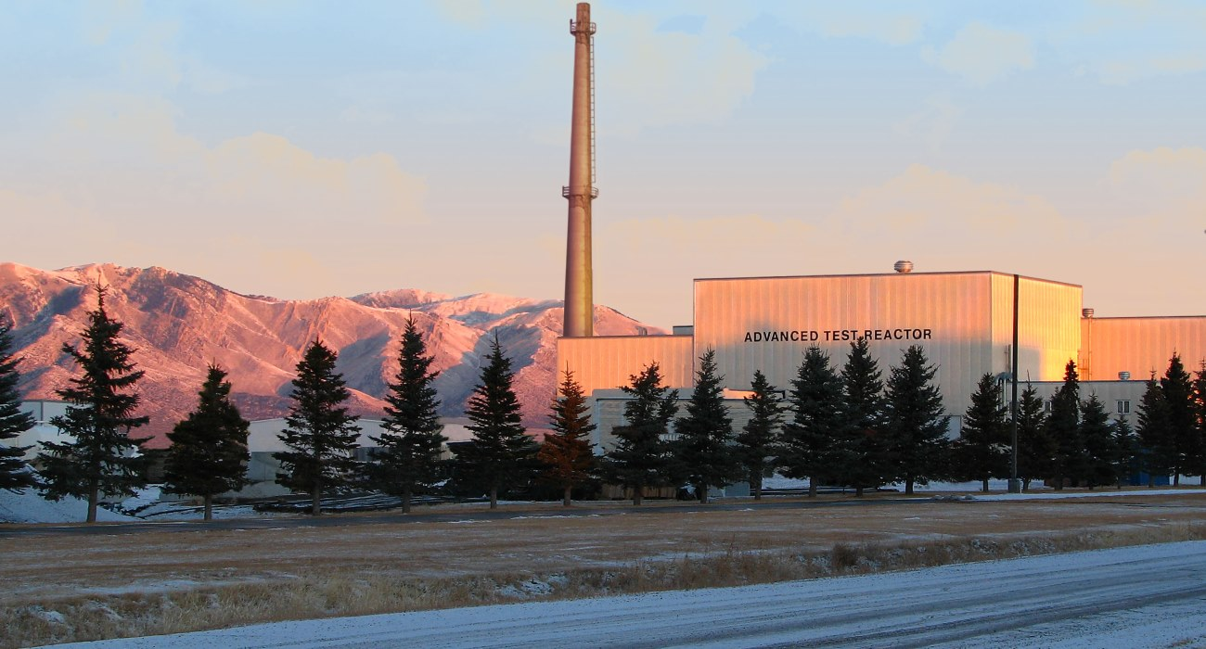

**Figure 1.** Figures are centered on the page. After the figure, leave one blank line, then start the caption. Captions run over the entire width of the page in normal font size (12 pt Times New Roman). If the caption spans one line, then it is centered; if the caption spans several lines, then it is “justified”, i.e. left- and right-adjusted. This photo shows the Advanced Test Reactor at Idaho National Laboratory at sunrise.

**4. TABLES**

The table captions are positioned above the table. Only “Table” and the table number are boldface. Leave two blank lines between the text and the table caption. Leave one blank line between the caption and the table body. Similar to figure captions, table captions are centered if they span less than a line. If the caption spans more than one line, it is “justified”, i.e. left- and right-adjusted. The layout of the table body is not prescribed.

**Table 1.** Some properties of nuclear reactor coolants. Table captions are positioned above the table, and may run over the entire width of the page. Leave one blank line between caption and the body of the table

|  |  |  |  |  |
| --- | --- | --- | --- | --- |
|  | **Water** | **Molten Salt** | **Sodium** | **Helium** |
| **Shiny** | Nope | Nope | Most definitely! | Nope |
| **Tasty** | Umm.. | Depends | In combination with Cl | Nope |
| **Good moderator** | Yes | No | Sometimes | Only in liquid form |
| **Makes you talk funny** | No | No | No | Yes |

**5. CONCLUSIONS**

Every paper needs a conclusion. Your conclusion is your opportunity to wrap up your paper in a tidy package and bring it home for your reader. It should also reinforce any assertions made in the introductory paragraphs. Thus, it should be manifest that if all the economists were laid end to end, they'd never reach a conclusion. Don’t not reach a conclusion.

**ACKNOWLEDGMENTS**

I would like to thank my sponsor, Bruce Wayne, my agent, Darth Vader, the game Tetris (for providing me with the skills to jam as many dishes as possible in my dishwasher), and my legs, for always supporting me. This template was originally written by W.F.G. van Rooijen, University of Fukui, Japan, and shamelessly plagiarized but substantially improved by M. D. DeHart, Idaho National Laboratory, USA.

**REFERENCES**

1. B. Authors, “Title”, *Journal name italic*, **volume(number)**, pp. 25 – 34. URL <http://dx.doi.org/doi_number> (year)
2. C.D. Authors, “Title”, Proc. Int. Conf. *Conference name in italic* (editor name if available), Organization, location & date, vol nr, pp. 25 – 34 (year)
3. E.F. Author, *Book title in italic*, Publisher, City, Country, (year)
4. “name of website”, available online. URL <http://www.website.ext/> (2013)

**APPENDIX A. HOW TO MAKE AN APPENDIX**

Include appendices here. Appendices are numbered alphabetically (‘A’, ‘B’, ‘C’). The appendix header follows the rule for section headers: all capital letters. If one (or more) appendices are entered, then make sure that there are corresponding references from the main text. Appendices without references in the body of the paper (“dangling” appendices) are expressly forbidden.

1. Footnote Times New Roman 10 pt, in running text numbered with Arabic numerals. This would be a good place to include your internet address (home page, etc) if desired: [www.nce.upalookaville.edu](http://www.nce.upalookaville.edu)