[**Create Mule Project using Mule Studio**](http://tapanavasthiliferay.blogspot.in/2012/01/fwd-create-mule-project-using-mule.html)

***Version 1.0***

**Step1: Start Mule Studio and create a workspace directory**

Click on the "New Mule Project" from the Welcome page or click on File -> New -> Mule Project from the Mule Studio menus.

[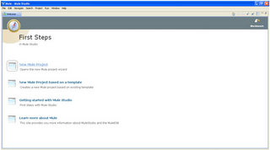](http://3.bp.blogspot.com/--ytxCPBzFyw/TwgnMZZVaDI/AAAAAAAAALY/-dQ2q5X3Zuk/s1600/1.png)

**Step 2: Enter the project name "Hello Mule" and click Next ,Create flow "hello" then click Next and Finished.**

[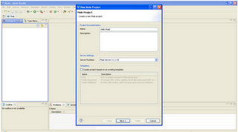](http://3.bp.blogspot.com/-9aWXuS5W0JE/TwgnOhYh2mI/AAAAAAAAALg/6PzIGWjAiJ0/s1600/2.png)

**Step3: After that you will get Mule flow GUI screen as follow.**

[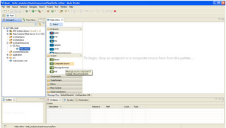](http://3.bp.blogspot.com/-Au5djfoQHKU/TwgnPdq7kqI/AAAAAAAAALo/fHCQcKtKGzU/s1600/3_1.png)

**Now we are ready to start using Mule Studio.**

[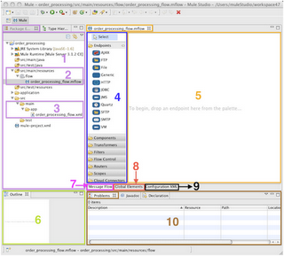](http://3.bp.blogspot.com/-dY6g_-FgqSw/TwgnQXnCQZI/AAAAAAAAALs/-iA6GPk-jo4/s1600/3_2.png)

|  |  |
| --- | --- |
| **No** | **Description** |
| **1.** | **Package Explorer Tree.** |
| **2.** | **src/main/resources where the flow/s is/are stored.** |
| **3.** | **scr/Main/app contains the flow xml files.** |
| **4.** | **Palette where Endpoints, components, transformers, filters, routers, scopes and cloud connectors are displayed in order to create the flow in the canvas.** |
| **5.** | **Canvas. Depending on 7, 8 and 9, different editor sections will be shown.** |
| **6.** | **Outline view.** |
| **7.** | **Message flow graphic editor.** |
| **8.** | **Global Elements view.** |
| **9.** | **Configuration XML editor.** |
| **10.** | **Problems section where errors are displayed.** |

**Step4: Create package under src/main/java and then create a class "HelloWorld", we can create a method "sayHi()" in HelloWorld**

[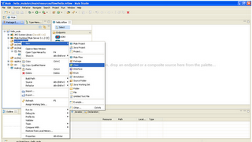](http://1.bp.blogspot.com/-p7AeGVHRG5o/TwgnQwSeFYI/AAAAAAAAAL0/9TVZ_HLDAQg/s1600/4_1.png)

[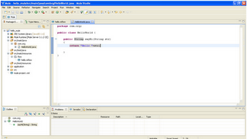](http://4.bp.blogspot.com/-F1tUIfvGxdo/TwgnRmivdrI/AAAAAAAAAL8/p1RgEeV5Cb4/s1600/4_2.png)

**Step5: Drag the HTTP endpoint and double click the HTTP endpoint,and change the host, port and path value.**

[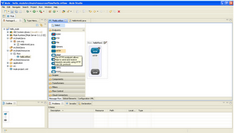](http://3.bp.blogspot.com/-7O6BLhPAy8Q/TwgnSS1UB9I/AAAAAAAAAME/KbeExd4ttjU/s1600/5_1.png)

[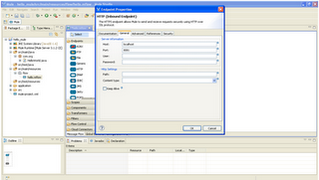](http://3.bp.blogspot.com/-Ov3EAXDTmyE/TwgnS2loIeI/AAAAAAAAAMQ/9ivT0umofXs/s1600/5_2.png)

**Step 6: Now drag the SOAP Web Service the component, double click the SOAP component, click the browse button and select a class which u created before and click OK.**

[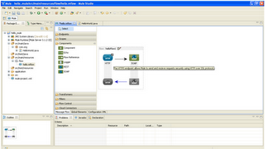](http://4.bp.blogspot.com/-zPFXSGiBMu8/TwgnTjX136I/AAAAAAAAAMU/PJN3ThX31X8/s1600/6_1.png)

[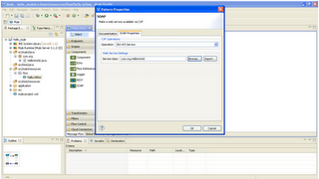](http://4.bp.blogspot.com/-UjzW1BavrBA/TwgnUBCVbpI/AAAAAAAAAMc/yCLT4_nzBjU/s1600/6_2.png)

**Step 7: after that u can drag the component from components drop down,double click the component and select the class using browse and click OK.**

[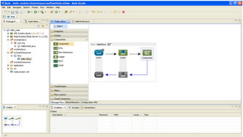](http://1.bp.blogspot.com/-1FJ0Y2KdYLI/TwgnU_8pRuI/AAAAAAAAAMk/vUPkYAE-bRU/s1600/7_1.png)

[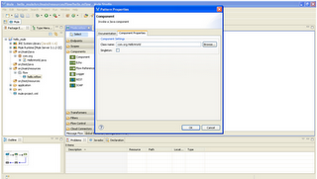](http://3.bp.blogspot.com/-6r-asyja4-E/TwgnVktpXyI/AAAAAAAAAMs/yj7WvdPhzjE/s1600/7_2.png)

**Step 8: Now run hellow.mflowfile , right click the hello.mflow file Go to Run-> click the Mule application.**

[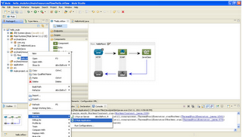](http://3.bp.blogspot.com/-ySly9Bs688Q/TwgnWFRctDI/AAAAAAAAAM0/HqKIer2TsGw/s1600/8_1.png)

[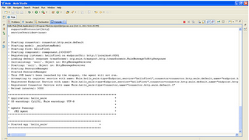](http://1.bp.blogspot.com/-LI_k0C7RpOs/TwgnXL8EQTI/AAAAAAAAAM8/SDj-cbZW5v8/s1600/8_2.png)

**Step 9: Go to http://localhost:8081 and enter and you should see the following results in your browser.**

[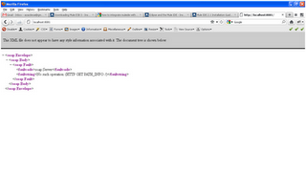](http://4.bp.blogspot.com/-8q6bEn-hmXY/TwgnXgf0-6I/AAAAAAAAANE/a8FoFMntmSo/s1600/9.png)