Laravel 12 Blog Post Project Setup Step by Step Process

1. Go to my github link
https://github.com/tapan-das/laravel12-blog-post
2. Download ZIP file.
3. Extract the ZIP file in xampp/lampp htdocs folder.

4. Please check example.txt file and convert it .env file.
5. Check the .env file and copy the database name ‘blog-post’ and create the same database name in MySQL.

6. I have included the database file name as “laravel12-blog-post-database”.
Please import this database file in ‘blog-post’ DB.

7. Please perform this command
$cd laravel12-blog-post-main
$php artisan migrate
$npm install
$npm run build
$composer run dev
$php artisan serve
8. Go to any browser and type this URL http://127.0.0.1:8000 (Frontend URL)
9. It will show like this -

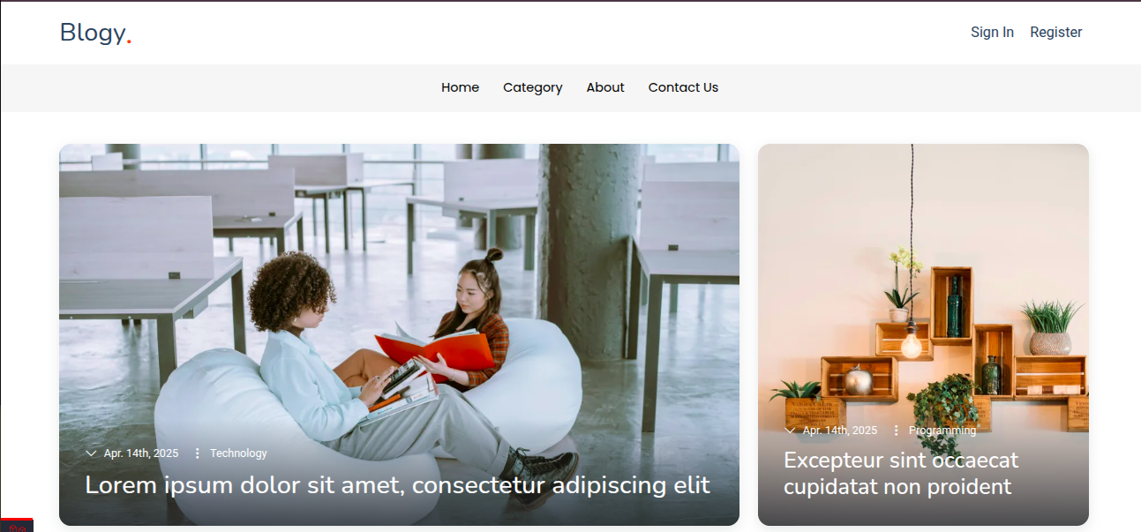
10. If you want to login admin dashboad, please type this URL http://127.0.0.1:8000/admin/login
11. It will show like this -

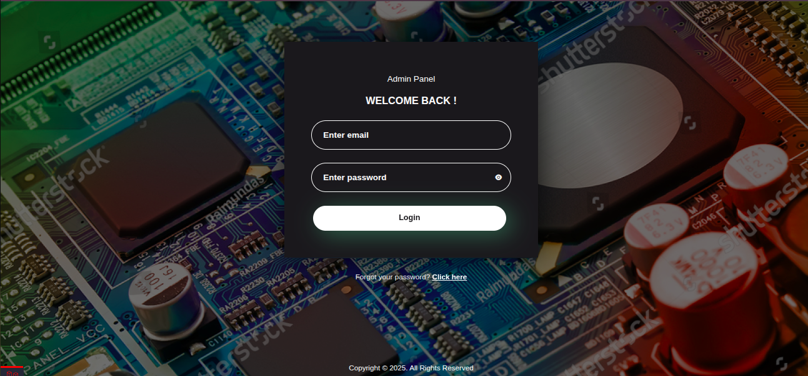
12. Admin credential are given below -
Email – superadmin@gmail.com
Password- Nopass@123

13. After Admin login it will show like this dashboard-

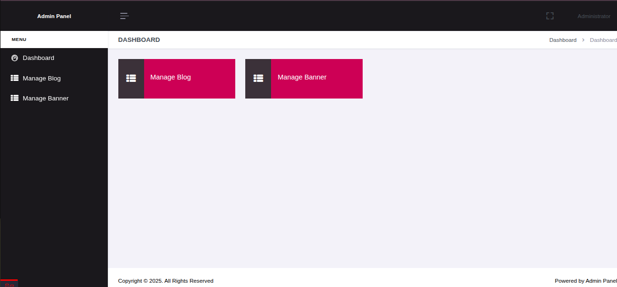
Please check at your convenience time and let me know for any assistance.
Thank you

