1. **Write a Java program to reverse a string with and without reverse() function?**

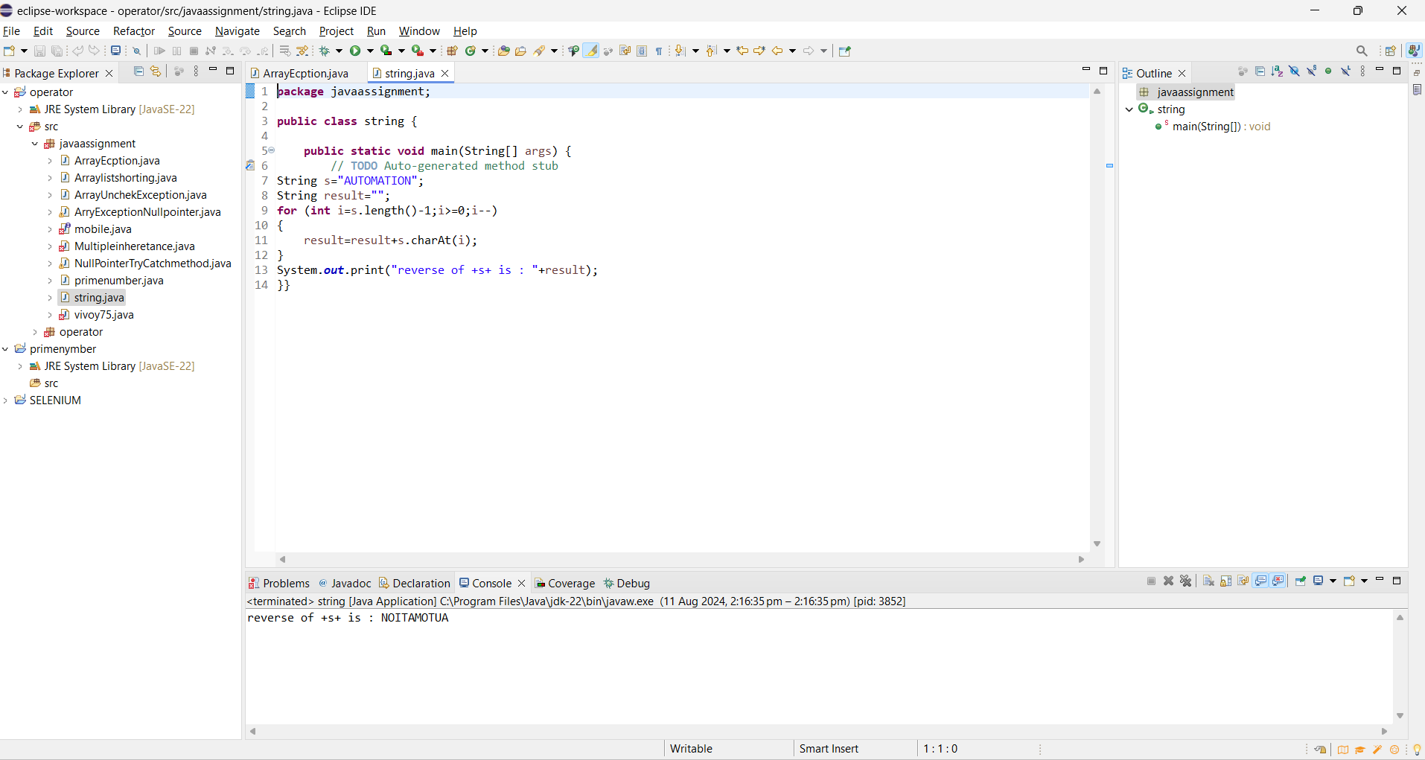

**2. Write a Java Program to find prime numbers between 1 to 100**

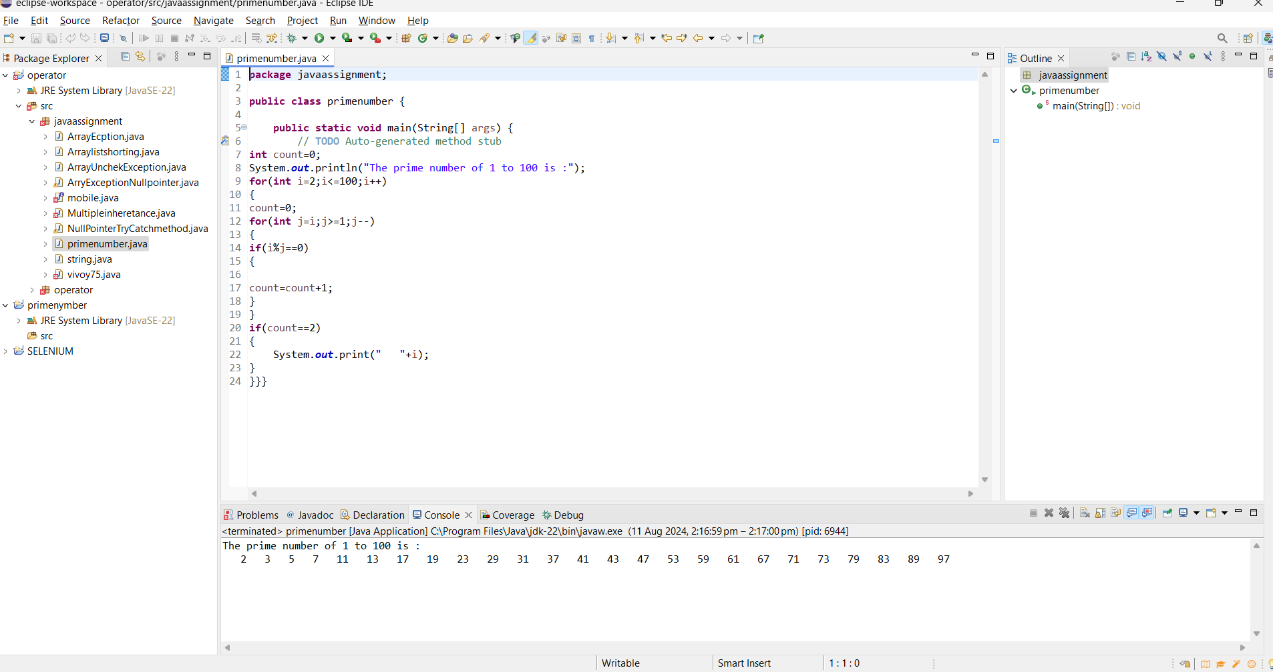

**Write a Java Program to handle given uncheck exception**

**a.ArrayIndexOutOfBound**

**b.NullPointerException**

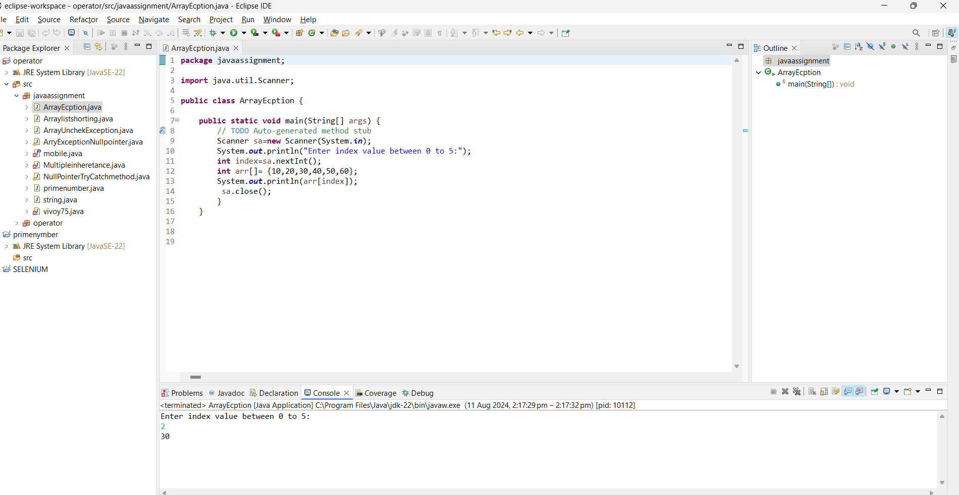

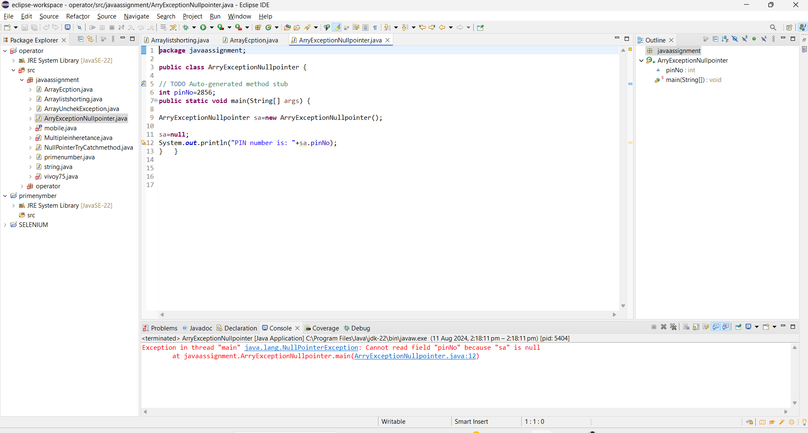

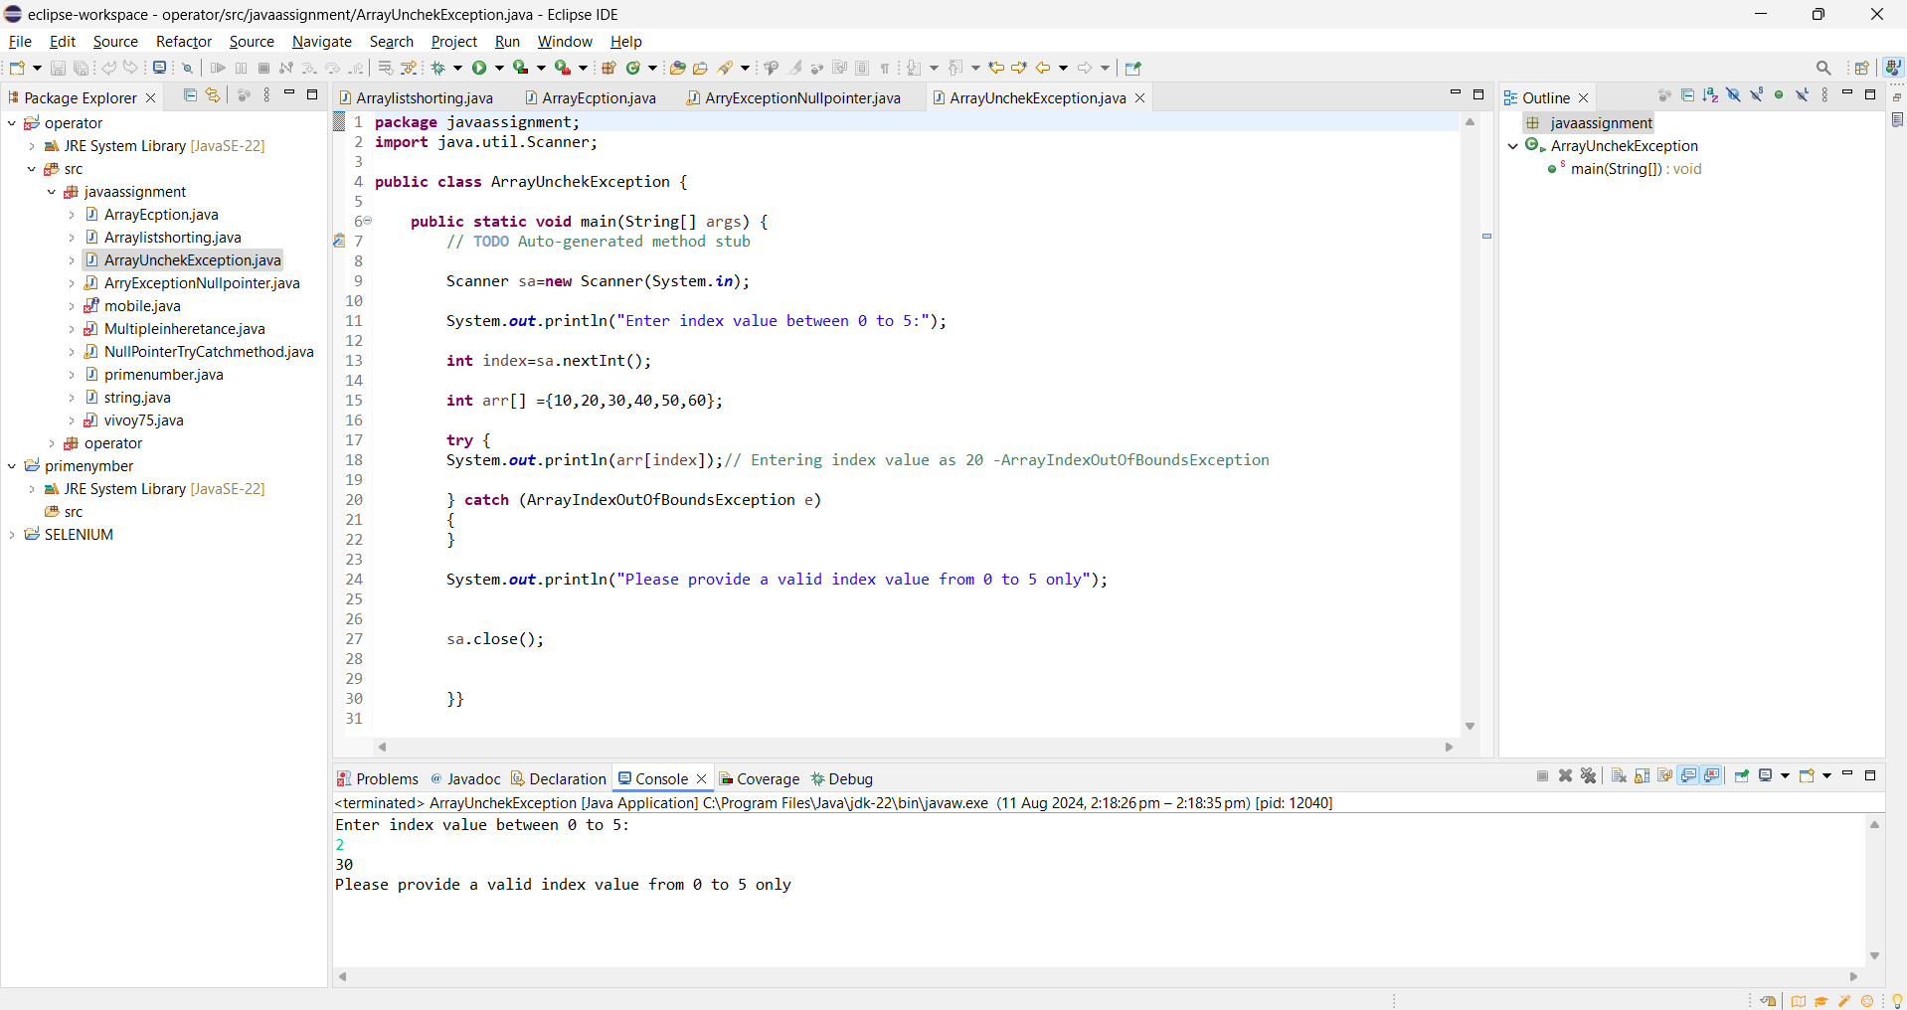

**4. Write a Java Program to sort the ArrayList in Ascending order**

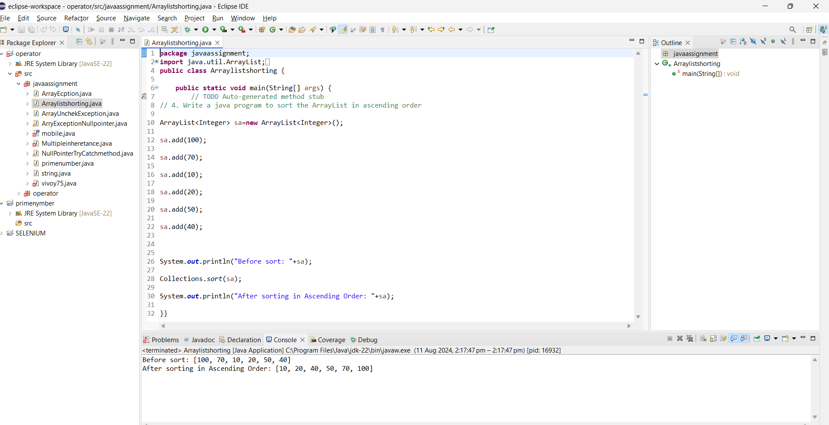

**5. Write a Java Program to implement multiple inheritance**

