MYCODEAGENT
Agentic Orchestration Architecture and Process Flow
Architecture status: Design baseline for review before coding
Meta-harness: Omnigent
Default role configuration: Codex initially; harness and model are configurable per sub-agent role
Primary task sources: TODO.md, GitHub Issues, and direct user instructions
Core architectural rule
Omnigent owns the main agentic loop and delegates bounded work to Codex sub-agents. Deterministic services enforce workspace isolation, execute tests, validate evidence, manage state, and perform approval-gated Git/PR delivery.

1. Purpose and Scope
MyCodeAgent is an agentic software-delivery orchestrator. It understands a requested task, feature, bug, review, or investigation; gathers repository context; forms a structured execution plan; invokes only the required sub-agents; validates their work; records a complete trace; and terminates only when the goal is satisfied, human input is required, a safety gate blocks execution, or bounded retries are exhausted.
This document defines the pre-coding architecture. MyCodeAgent owns task interpretation, orchestration state, the five-cycle limit, validation, and delivery decisions. Omnigent is the external meta-harness that executes the orchestrator and sub-agent sessions. Codex is the initial sub-agent brain; the configured model provider can later be changed through Omnigent/LiteLLM without changing MyCodeAgent workflow code.

1.1 Goals
- Intent understanding: interpret tasks from TODO.md, GitHub Issues, or direct instructions.
- Dynamic delegation: select sub-agents according to task intent, risk, and evidence—not a fixed sequence.
- Isolation: execute each task in a dedicated Git branch and worktree with enforced write boundaries.
- Evidence-based quality: rely on deterministic test, scope, artifact, and security results.
- Approval-gated delivery: no commit, push, or pull request until the reviewed change is approved.
- Observability: preserve correlated logs, traces, state transitions, tool calls, evidence, and delivery metadata.
- Recoverability: retain failed worktrees and artifacts and allow safe, idempotent resume.

2. System Context
Layer | Responsibility | Primary components
Task sources | Supply goals and supporting context | TODO.md adapter, GitHub Issue adapter, direct-request adapter
Meta-harness | Run the supervisor and sub-agents with shared context, policies, sandboxing, and sessions | Omnigent
Agentic orchestration | Observe, reason, choose an action, validate results, record evidence, and continue or stop | Main Orchestrator Agent
Sub-agents | Perform bounded reasoning and code-oriented work | Explorer, Implementer, Test Writer, and Reviewer agents (Codex initially)
Deterministic controls | Enforce rules and produce authoritative evidence | Worktree, path validator, pytest runner, scanners, state machine
Delivery | Create approved SCM artifacts | Changelog, commit, push, pull-request service
Observability | Correlate every decision and artifact | Structured logger, tracer, artifact store, metrics

3. Agentic Loop
The loop belongs to the MyCodeAgent main orchestrator running on Omnigent. It is bounded by deterministic state transitions and policies. The supervisor invokes one suitable capability at a time, evaluates the result, and decides the next action from an allowlist.
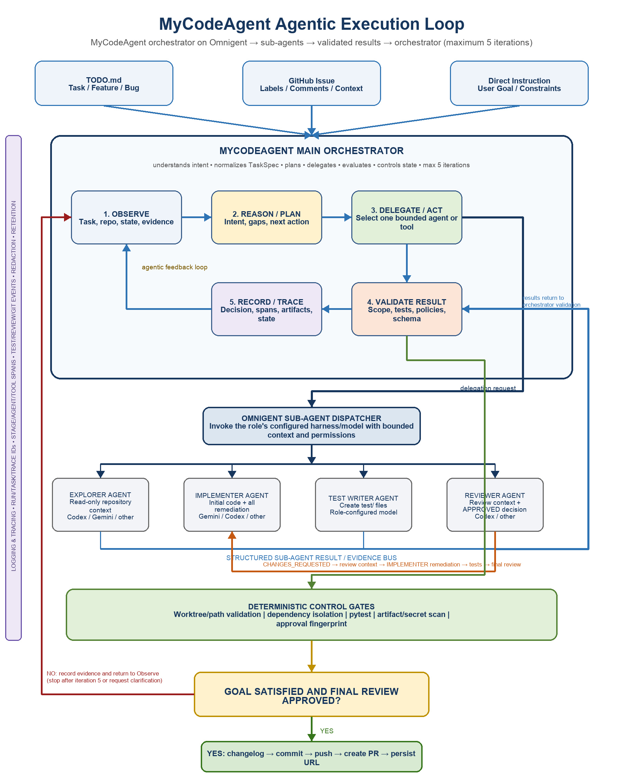
Figure 1. Agentic intent-to-delivery loop with logging and tracing across every stage.

3.1 Loop phases
- Observe: load the normalized task, repository/worktree state, previous agent results, test evidence, review findings, policies, retry counters, and user interventions.
- Reason and plan: determine the current intent, missing information, risk, acceptance gaps, and the smallest appropriate next action.
- Act: invoke exactly one bounded Codex sub-agent or deterministic tool with explicit inputs, permissions, output schema, timeout, and idempotency key.
- Validate: check the returned schema, file scope, task acceptance evidence, test results, generated artifacts, security policy, and allowed state transition.
- Record and trace: persist the observation, decision, action, result, validation, artifacts, timing, token/tool usage where available, and new workflow state.
- Continue or terminate: repeat from Observe, request clarification, fail safely, or deliver after tests and final review approval are bound to the same change fingerprint.

3.2 Allowed supervisor actions
Action | When selected | Executor
EXPLORE_REPOSITORY | Relevant code, conventions, dependencies, or test commands are unknown | Read-only Codex Explorer
REPRODUCE_BUG | A bug report requires confirmation and a regression test | Read-only/test-scoped Codex agent
IMPLEMENT_TASK | The normalized task is sufficiently specified | Coding-scoped Codex Implementer
WRITE_TESTS | Acceptance coverage is incomplete | Test-scoped Codex Test Writer
RUN_TESTS | Source or tests changed | Deterministic test runner
REVIEW_CHANGE | Scope and tests passed for the current fingerprint | Read-only Codex Reviewer
REMEDIATE | Tests fail or review returns actionable findings | Configured Implementer receiving ReviewContext
REQUEST_CLARIFICATION | A material decision cannot be inferred safely | Main orchestrator/user interaction
DELIVER | Final review approved and delivery was requested | Deterministic delivery service
FINISH | The requested goal is satisfied without further action | Main orchestrator

4. Task Ingestion and Intent Understanding
All source adapters produce the same validated TaskSpec. Downstream agents must not depend on whether the task originated in TODO.md, GitHub, or conversation.
Source | Required extraction
TODO.md | Complete task section: ID, state, priority, outcome, architecture, workspace boundary, required files, dependencies, acceptance criteria, approvals
GitHub Issue | Repository, issue number/URL, title, body, labels, comments, linked issues/PRs, reproduction information, decisions and acceptance criteria
Direct instruction | User goal, constraints, target repository/module, requested delivery level, inferred intent, assumptions and unresolved ambiguities

4.1 Normalized TaskSpec
- Identity: task ID, source type, immutable source reference, title, intent, priority, and risk.
- Goal: requested outcome, instructions, non-goals, and delivery expectation.
- Repository: approved repository, base branch, starting commit, task branch, and worktree path.
- Workspace: allowed read paths, allowed implementation paths, allowed test paths, and prohibited paths.
- Implementation contract: architecture, technologies, required files, dependency constraints, and security rules.
- Acceptance contract: criteria, test expectations, and evidence required for completion.
- Control context: retry limits, timeouts, current fingerprint, clarification items, and prior findings.

5. Component Responsibilities

5.1 Omnigent external meta-harness
- Executes the MyCodeAgent main orchestrator session and exposes configured sub-agents and tools.
- Maintains shared session context and supports interruption and human steering.
- Applies sandbox, access, cost, and contextual policies.
- Runs Codex as the current coding harness while permitting future harness substitution.
- Streams events to the logging/tracing layer with task and run correlation identifiers.

5.2 Main Orchestrator Agent
- Understands intent and normalizes task inputs.
- Creates a bounded plan and chooses the next allowed action.
- Delegates substantial implementation and review work instead of performing it itself.
- Evaluates structured results and deterministic evidence.
- Requests clarification only for material unresolved decisions.
- Stops on success, policy denial, non-retryable failure, needs-human state, or retry exhaustion.

5.3 Codex sub-agents
Sub-agent | Permissions | Responsibility
Repository Explorer | Read-only | Discover relevant files, conventions, dependencies, APIs, risks, and test commands
Bug Reproducer | Read plus test-write | Reproduce reported behavior and create a failing regression test without changing production code
Implementer | Coding path only | Create or modify application files required by the normalized task
Test Writer | Test path only | Create independent acceptance, edge, negative, and regression tests
Reviewer | Read-only | Review the exact diff and deterministic evidence; return structured approval or findings

5.4 Deterministic services
- Task parser and source adapters.
- Git repository policy and worktree manager.
- Changed-path, required-file, artifact, symlink, and secret validators.
- Dependency-isolated unit-test and quality-command runner.
- State-transition validator and persistent state store.
- Review-fingerprint binder that invalidates approval after any content change.
- Changelog, Git commit/push, and pull-request publisher.

6. Logging, Tracing, and Auditability
Observability is mandatory
No agent action, deterministic command, state transition, review decision, or delivery event is considered complete until its correlated event and required artifacts have been persisted. Logging explains what happened; tracing explains the causal path and duration across the agentic loop.

6.1 Components
Component | Responsibility
Structured Event Logger | Append JSON events for run, stage, agent, tool, validation, test, review, state, Git, PR, warning, and exception events
Trace Manager | Create a root run trace and nested task, loop-iteration, stage, agent, tool-call, test, review, and delivery spans
Artifact Store | Persist task snapshots, prompts where policy permits, diffs, stdout/stderr, test reports, review reports, fingerprints, commit and PR metadata
Metrics Emitter | Publish counts and durations for throughput, failures, retries, review cycles, tool errors, token/cost usage where available, and stale tasks
Redaction Filter | Remove credentials, access tokens, authorization headers, personal data, and configured sensitive values before persistence or display
Retention Manager | Apply configured retention periods; preserve failed-run evidence and delivery audit records according to policy

6.2 Correlation model
- run_id: identifies one end-to-end orchestration attempt.
- task_id: stable identifier from TODO.md, GitHub Issue, or generated direct-request identity.
- trace_id: correlates all spans for the run.
- span_id / parent_span_id: reconstructs supervisor, sub-agent, tool, test, review, and delivery causality.
- loop_iteration: identifies the observe–reason–act–validate cycle.
- agent_invocation_id: distinguishes retries and parallel or sequential sub-agent calls.
- workspace_id, branch, base_commit, and change_fingerprint: bind evidence and approval to exact repository state.

6.3 Minimum event schema
Field | Purpose
timestamp | UTC event time
run_id / task_id / trace_id | End-to-end correlation
span_id / parent_span_id | Causal trace structure
iteration / stage / actor | Agentic-loop position and event owner
event_type / severity | Machine-readable classification
action / decision_reason | Selected action and concise rationale
input_refs / output_refs | References to sanitized artifacts rather than large inline payloads
duration_ms / status | Performance and result
retryable / error_code | Recovery classification
fingerprint / commit / PR | Repository evidence when applicable

6.4 Required trace spans
- task.ingest and task.normalize
- repository.preflight and worktree.create
- loop.iteration.N
- agent.explore / agent.implement / agent.test_write / agent.review / agent.implement.remediation
- tool.<name> for every significant tool invocation
- validation.scope / validation.artifacts / validation.secrets
- test.install and test.run
- review.evaluate and review.decision
- delivery.changelog / git.commit / git.push / github.create_pr
- state.transition

6.5 Storage layout
.mycodeagent/
├── runs/<run-id>/status.json
├── runs/<run-id>/events.jsonl
├── runs/<run-id>/trace.json
├── runs/<run-id>/artifacts/
│ ├── task-spec.json
│ ├── diff.patch
│ ├── test-result.json
│ ├── review-result.json
│ └── delivery-result.json
└── tasks/<task-id>/latest.json
Runtime observability files must remain outside task source directories and must be ignored by Git unless a deliberate audit-export mechanism is used.

7. End-to-End Intent-Driven Flow
- Accept a task reference or direct instruction and assign run, task, and trace identifiers.
- Load the source through the matching adapter and normalize it into TaskSpec.
- Validate repository approval, task completeness, workspace paths, dependencies, model/harness availability, and delivery authority.
- Claim the task, transition to working, create a task branch/worktree, and record base commit and workspace identifiers.
- Enter the agentic loop. Observe context and select Explorer when repository understanding is insufficient.
- Select Bug Reproducer for bug intent, or Implementer for sufficiently specified feature/refactor work.
- Validate changed paths and required files after every write-capable agent invocation.
- Select Test Writer when acceptance coverage is missing; then run tests deterministically.
- On test failure, record TestFailureContext and route it to the Implementer; after changes, rerun all affected deterministic gates.
- When tests and validations pass, invoke the read-only Reviewer with the exact diff, task criteria, and evidence.
- On CHANGES_REQUESTED, persist the ReviewContext in Supervisor memory, route it to the Implementer for remediation, and invalidate prior test and review evidence affected by the change.
- On APPROVED, bind the decision to the current change fingerprint and transition to reviewed.
- If delivery was requested, perform final policy validation, update the changelog, commit, push, create the PR, and persist delivery metadata.
- Transition to delivered or finish at the requested terminal state. Preserve logs, traces, state, and artifacts.

8. State Model and Transition Gates
State | Meaning | Permitted progression
ready | Eligible normalized task | working
working | Agentic loop active | implemented, needs_input, failed
implemented | Required source/tests created and scope-valid | testing, failed
testing | Deterministic tests executing | tested, working, failed
tested | Tests passed for current fingerprint | reviewing
reviewing | Read-only review executing | reviewed, working, failed
reviewed | APPROVED for current fingerprint | delivering, complete
delivering | Deterministic Git/PR actions active | delivered, reviewed, failed
delivered | Commit pushed and PR recorded | terminal
needs_input | Material ambiguity requires user decision | working, failed
failed | Non-retryable failure or retry exhaustion | manual reset/resume

The Status Manager is the only component permitted to transition state. Every transition creates a structured event and trace span and records previous state, new state, actor, reason, fingerprint, and timestamp.

9. Control and Safety Rules
- The supervisor chooses actions only from an explicit allowlist.
- Each sub-agent receives the minimum read/write permissions required for its role.
- Every task uses a resolved, validated worktree path; path traversal and escaping symlinks are rejected.
- Tests run in a task-specific dependency environment and never modify the primary project virtual environment.
- Ordinary git diff is insufficient; review includes tracked, staged, modified, and untracked task files.
- Review approval is invalidated whenever the change fingerprint changes.
- Secrets and sensitive values are redacted before logs, traces, prompts, or artifacts are persisted.
- Retry counts and timeouts are bounded per stage and per run.
- Delivery validates approved Git identity, repository remote, branch, base, and final fingerprint.
- The system creates pull requests but does not merge them automatically.

10. Proposed Python Responsibility Map
File/module | Responsibility
__main__.py | Minimal module entry point; delegates to cli.main()
cli.py | Commands, arguments, user-facing status, and exit codes
orchestrator.py | Main agentic loop adapter, available-action calculation, result handling, and terminal decisions
models.py | TaskSpec, ActionDecision, AgentResult, TestResult, ReviewResult, TraceContext, and workflow-state models
sources/todo.py | Parse complete TODO.md task sections
sources/github.py | Retrieve and normalize GitHub Issues and comments
sources/direct.py | Normalize direct instructions and record assumptions/ambiguities
agents.py | Invoke Omnigent/Codex sub-agents with bounded prompts, permissions, schemas, and timeouts
workspace.py | Repository policy, branch/worktree creation, validated paths, snapshots, and cleanup
validator.py | Required-file, changed-path, artifact, symlink, secret, and evidence validation
test_runner.py | Dependency-isolated deterministic test execution and result parsing
state_store.py | Atomic state transitions, resume data, retry counters, fingerprints, and terminal state
observability/logger.py | Structured JSON event logging and redaction
observability/tracer.py | Root trace and nested iteration/stage/agent/tool spans
observability/artifacts.py | Durable sanitized evidence and artifact references
delivery.py | Approval-gated changelog, commit, push, PR creation, and delivery verification

11. Pre-Coding Acceptance Checklist
- MyCodeAgent remains the orchestrator, Omnigent remains the external meta-harness, and Codex remains the initial sub-agent brain.
- The main orchestrator contains a visible bounded observe–reason–act–validate–record loop.
- TODO.md, GitHub Issue, and direct-instruction sources normalize into one TaskSpec.
- Intent determines which sub-agents are invoked; the flow is not an unconditional fixed pipeline.
- Worktree, testing, validation, state, logging/tracing, and delivery controls are deterministic.
- Logging and tracing correlate every run, task, loop iteration, stage, agent, tool call, artifact, state transition, test, review, Git action, and PR.
- Reviewer and explorer are read-only; write-capable agents have narrow paths.
- Review approval is bound to the exact final change fingerprint.
- Failures preserve sanitized evidence and support bounded resume/remediation.
- PR creation is supported; automatic merge remains outside scope.

12. Decision Summary
Proceed to coding only after this architecture is accepted. MyCodeAgent Python modules provide structured inputs, the bounded orchestration contract, deterministic controls, state, evidence, logging/tracing, and delivery services. Omnigent executes the MyCodeAgent supervisor and bounded Codex sub-agents. LiteLLM/provider configuration remains external to the workflow logic.

13. Iteration Limit, Agent Handoffs, and Provider Portability

13.1 Hard maximum of five agentic iterations
A run may execute at most five complete implementation–test–review iterations. Iteration 1 is the initial implementation and review attempt; iterations 2–5 are remediation, retest, and rereview attempts. The counter is owned by the deterministic Status Manager and cannot be reset by a sub-agent.
- Before beginning an implementation or remediation cycle, the orchestrator checks iteration_count < 5.
- The counter increments once when a complete implementation/remediation cycle starts. Individual Explorer, Test Writer, test-runner, Reviewer, or tool calls receive their own attempt/span identifiers but do not consume additional workflow iterations.
- When review for iteration 5 is not APPROVED, the run transitions to needs_input or failed according to the failure classification.
- No sixth implementation–test–review cycle is permitted automatically.
- The final state, last findings, test evidence, worktree, logs, and trace are preserved for a human-controlled resume or reset.

13.2 Structured communication and remediation handoff
Sub-agents communicate through the Omnigent orchestrator and a shared structured evidence channel. They do not bypass the orchestrator with untracked peer-to-peer instructions. This preserves permissions, iteration accounting, traceability, and deterministic state transitions.
Producer | Structured handoff | Orchestrator routing | Consumer
Explorer | RepositoryContext | Attach to TaskContext | Implementer / Test Writer / Reviewer
Implementer | ImplementationResult + changed files + acceptance map | Run scope and test gates | Test Writer / Reviewer
Test Runner | TestResult + logs + fingerprint | On failure create remediation request | Implementer
Reviewer | ReviewResult with APPROVED or findings | APPROVED → approval gate/PR; CHANGES_REQUESTED → Implementer remediation | Delivery or Implementer
Implementer | ImplementationResult with a resolution mapped to every review finding | Rerun tests and invalidate prior approval | Reviewer

Required review-remediation cycle:
- Reviewer returns CHANGES_REQUESTED with structured, file-specific findings.
- The orchestrator persists the review result and checks the five-iteration limit.
- The orchestrator creates a RemediationRequest containing the exact findings, current TaskSpec, change fingerprint, and permitted write paths.
- The request is routed back to the configured Implementer role; no separate Remediator agent is created.
- The implementation role resolves only the supplied findings and returns a finding-to-fix mapping.
- Deterministic scope, artifact, security, and unit-test gates run again.
- The orchestrator invokes the configured Reviewer role again with the new fingerprint and evidence.
- Only APPROVED for that exact fingerprint permits deterministic PR creation.

13.3 Per-role swappable harness and model
Each logical role is independent of a particular LLM vendor. Configuration selects an Omnigent-supported harness and model per role. The workflow contracts—TaskSpec, permissions, result schema, evidence, and transition rules—remain stable when a provider is changed.
Logical role | Example harness/model | Portability rule
Explorer | codex or Gemini-compatible ACP harness | Read-only result must satisfy RepositoryContext schema
Implementer | Gemini, Codex, Claude, or registered ACP agent | Writes only approved Coding/ paths and returns ImplementationResult
Test Writer | Role-configured harness/model | Writes only approved test/ paths and returns acceptance mapping
Reviewer | Codex, Pi, Claude, or another read-only harness | Must return the same ReviewResult schema

Illustrative role configuration:
[agents.implementer]
harness = "acp:gemini-cli"
model = "configured-gemini-model"
[agents.reviewer]
harness = "codex"
model = "configured-codex-model"
[workflow]
max_iterations = 5

13.4 Updated termination rules
- APPROVED + deterministic gates passed + delivery authorized: create PR and terminate delivered.
- CHANGES_REQUESTED + iteration budget remains: route findings to implementation, retest, and rereview.
- CHANGES_REQUESTED at iteration 5: preserve evidence and terminate needs_input/failed; do not create PR.
- Provider/harness failure classified retryable: retry only if iteration budget remains and policy permits.
- Provider/harness unavailable or result schema repeatedly invalid: terminate safely with traceable diagnostics.

13.5 Final review, approval, and PR handoff
Agent model: Explorer, Implementer, Test Writer, and Reviewer are the only specialized agents. The Implementer performs both the initial implementation and all remediation.
- When tests fail, the Supervisor stores TestFailureContext and routes it to the Implementer.
- When review returns CHANGES_REQUESTED, the Reviewer supplies structured ReviewContext; the Supervisor stores it in execution memory and routes it to the Implementer.
- After any Implementer change, scope validation and the full applicable test suite run again. Previous test and review evidence becomes stale.
- Only after tests pass does the Supervisor invoke the Reviewer for final review of the current change fingerprint.
- The Reviewer returns APPROVED only when acceptance criteria, test evidence, architecture, security, and the exact fingerprint pass review.
- The deterministic Status Manager validates the result and persists state APPROVED. The Reviewer does not directly modify workflow state.
- APPROVED is passed to the deterministic PR-creation gate. CHANGES_REQUESTED never proceeds to PR creation.

